Biotechnology and nanotechnology in Poland
in 2022

In 2022, 187 firms conducted biotechnology activities, which constitutes an increase by 8.1%
in comparison to the previous year. Biotechnology intramural expenditures incurred by firms amounted to PLN 1952.7 million and increased by 41.4% on an annual basis. In 2022, 4317 persons were employed in biotechnology in firms. Biotechnology research and experimental development was conducted by 234 entities, that is, by 7.8% more in comparison with the previous year. Biotechnology R&D intramural expenditures amounted to PLN 1432.4 million and increased by 20.9% annually. 8431 persons were involved in biotechnology research and experimental development.
41.4%
An increase in biotechnology
intramural expenditures in firms year-on-year
70 firms, i.e. by 6.7% less than in the previous year, conducted nanotechnology activities. Intramural expenditures on nanotechnology incurred by firms amounted to PLN 485.9 million and were higher
by 13.7% in comparison with the previous year. 3687 persons were employed in the field
of nanotechnology, of which 1344 persons in firms. Research and experiemntal development in the field of nanotechnology were carried out by 125 entities, i.e. as many as a year ago. Nanotechnology R&D intramural expenditures amounted to PLN 399.9 million and were by 7.1% higher than in the previous year. 2817 persons were involved in nanotechnology research and experimental development.
7.1%
An increase in nanotechnology R&D intramural expenditures year-on-year

BIOTECHNOLOGY

Biotechnology in firms
In 2022, biotechnology research and experimental development was conducted in Poland
by 187 entities, called biotechnology firms. Among them 44.4% constituted dedicated biotechnology firms (DBF).
Biotechnology research and experimental development (R&D) firms (BRDF) constituted 66.3% of all biotechnology firms, of which 68.5% conducted only R&D in biotechnology.
The remaining firms (BRDF) combined R&D with biotechnology manufacturing.
Over a half of firms conducting biotechnology activities constituted small firms, that is, with the number of persons
employed below 50
Taking into account size classes, small firms (with the number of persons employed below 50) prevailed constituting 55.6% of the total number of biotechnology firms; the share
of medium firms (employing 50–249 persons) and large firms (250 and more persons) amounted to 27.8% and 16.6%, respectively.

Chart 1. Biotechnology firms conducting biotechnology activities
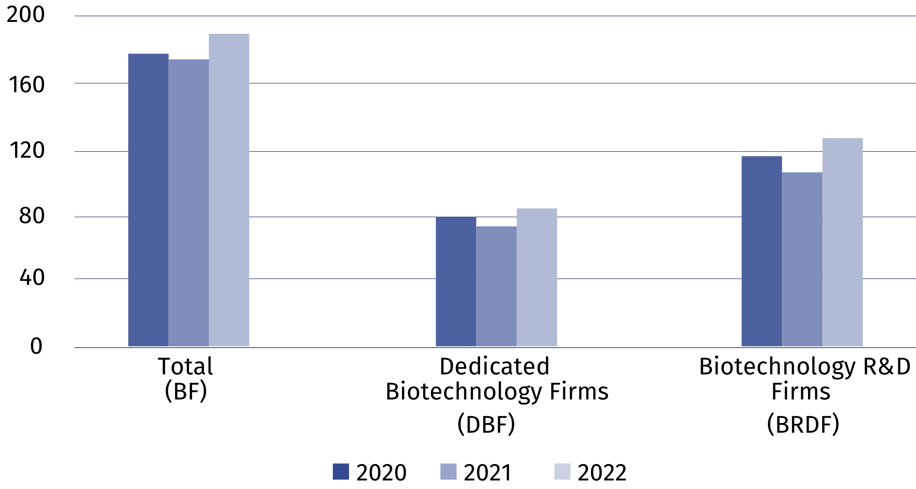

Biotechnology intramural expenditures of biotechnology firms
In 2022, intramural expenditures of firms incurred on biotechnology amounted to PLN 1952.7 million, of which internal funds of firms constituted 86.1%.
Over 40% of total expenditures on biotechnology was incurred by medium firms
Analysing size classes of firms, it can be noted that the highest expenditures on biotechnology, like in the previous year, were incurred by entities classified as medium – PLN 864.6 million.
Chart 2. Biotechnology intramural expenditures of biotechnology firms
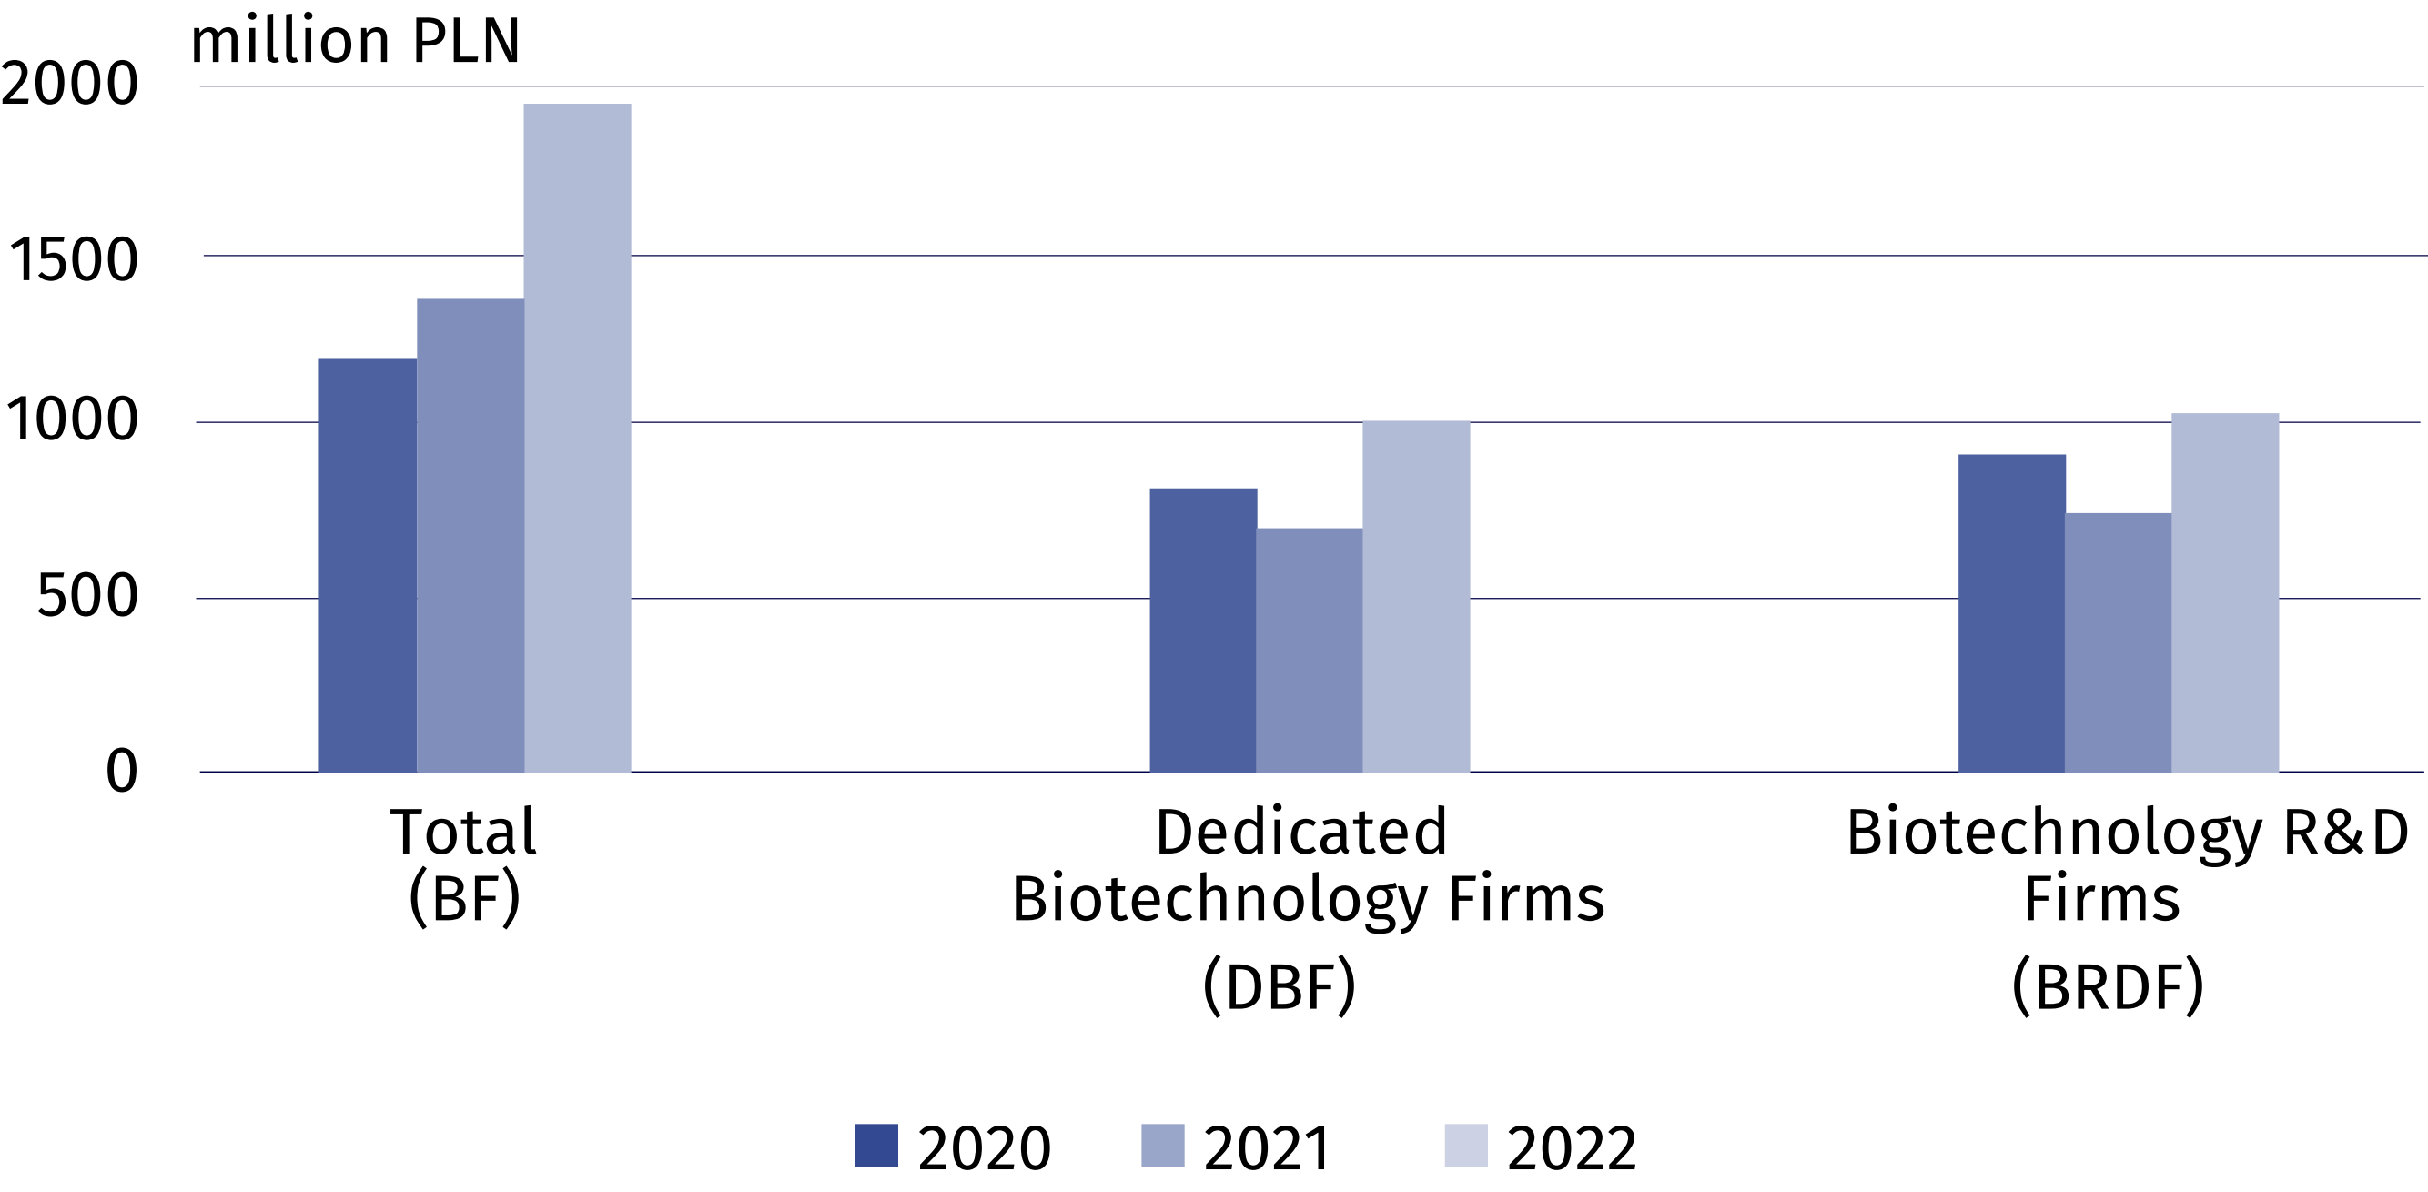

Biotechnology personnel
In 2022, the number of persons employed in biotechnology R&D firms (BRDF) increased
by 9.1%
In 2022, 10592 persons were involved in biotechnology (by 5.2% more than in the previous year), of which slightly over 40% worked in firms. Biotechnology research and experimental development in firms was performed by 2144 persons.

Chart 3. Biotechnology personnel in firms
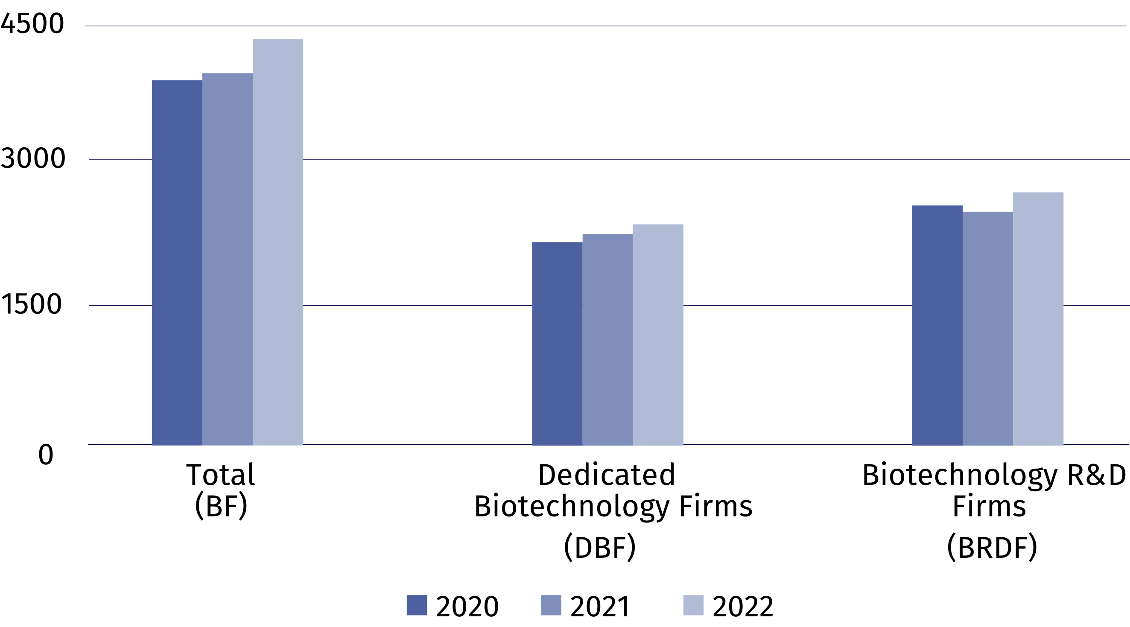

Biotechnology research and experimental development
In 2022, biotechnology research and experimental development was conducted in Poland
by 234 entities, of which over a half belonged to the business enterprise sector. The most
numerous group with regard to biotechnology applications was entities dealing with human health – 58.5% of the total number of entities conducting biotechnology R&D.
In 2022, biotechnology R&D intramural expenditures increased by 20.9% on an annual basis amounting to PLN 1432.4 million. Intramural expenditures of entities which belong to the higher education sector and the business enterprise sector constituted each 48.9% of this amount, while of the government and private non-profit sector – 2.2%.
8419 persons were engaged in biotechnology R&D in 2022. The number of persons employed increased by 2.6% in comparison with the previous year. Researchers constituted almost three-fourths of personnel involved in biotechnology R&D.
Table 1. Biotechnology R&D intramural expenditures by sectors of performance
Sectors of performance | 2020 | 2021 | 2022
Sectors of performance | in thousand PLN
TOTAL | 1 090 126.1 | 1 184 735.1 | 1 432 365.7
Business enterprise sector | 530 043.0 | 536 196.0 | 700 258.2
of which enterprises | 462 327.9 | 459 609.0 | 604 399.1
Government and private  non-profit sector | 20 044.0 | 23 055.5 | 31 492.1
Higher education sector | 540 039.1 | 625 483.6 | 700 615.4

NANOTECHNOLOGY

Nanotechnology in firms
In 2022, the number of firms which indicated conducting nanotechnology activities in the survey, i.e. used nanotechnology for the production of intermediate and final goods and/or conducted research and experimental development in the field of nanotechnology, amounted to 70, which means a decrease of 6.7% compared to the previous year.
Chart 4. Nanotechnology firms conducting nanotechnology activities
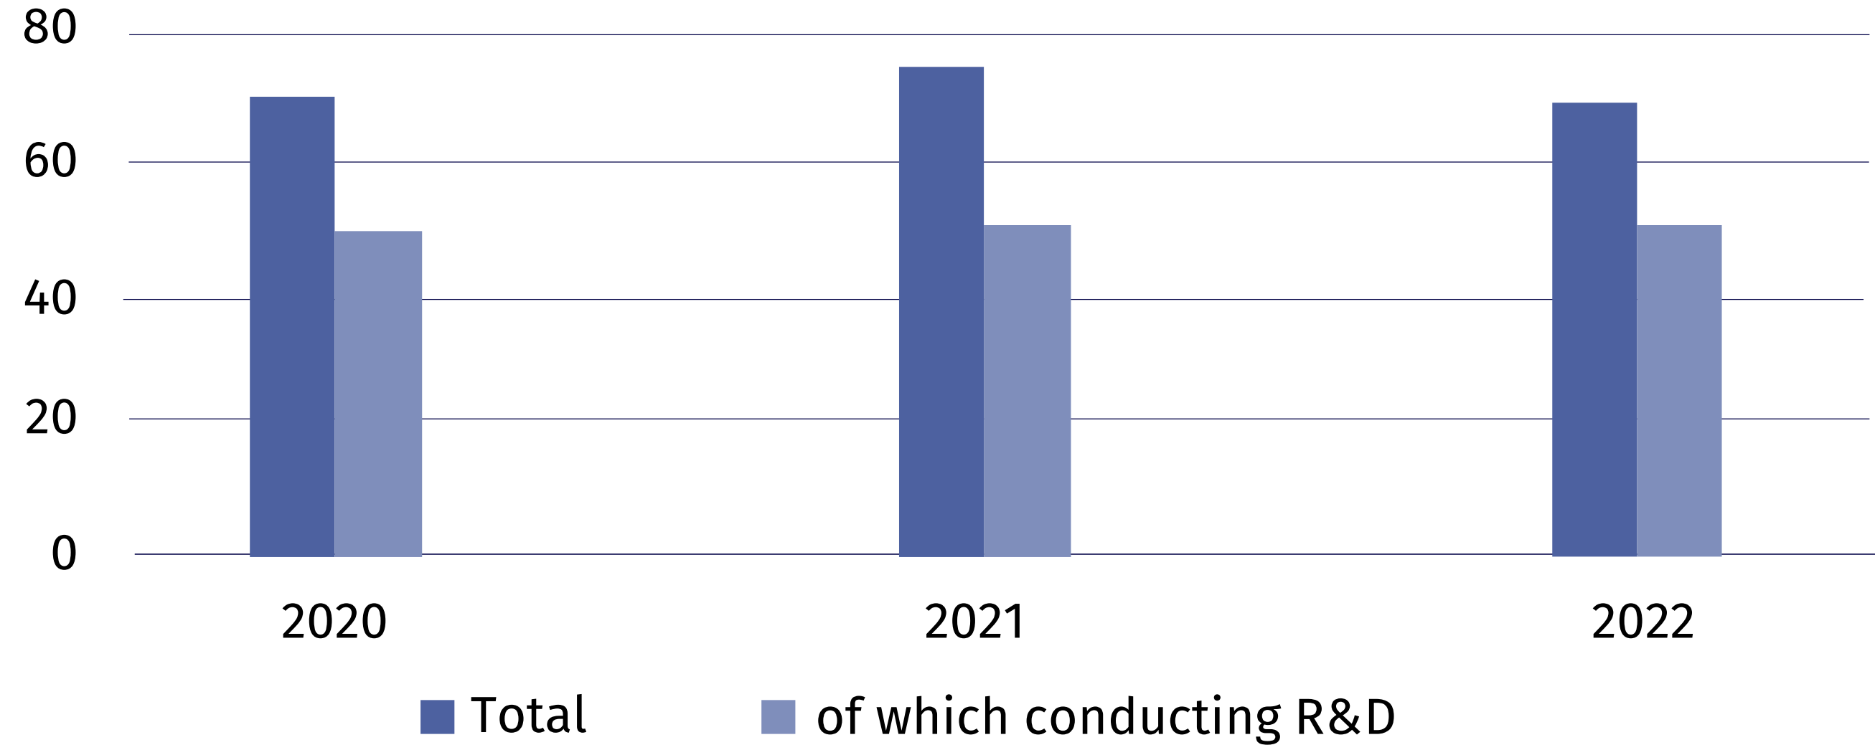

Nanotechnology activities in firms are related to production in which nanotechnology is used to produce intermediate and final goods. Applying nanotechnology in production also
includes indirect involvement of firms, as a user or an integrator. Nanotechnology is also used in research and development, i.e. in scientific research and experimental development.
In 2022, nanomaterials constituted the dominant area
of ​​nanotechnology application for 71.4% of surveyed firms
In the nanotechnology survey firms defined the areas of nanotechnology application in production as well as in research and experimental development as well as indicated the dominant area. In 2022, as in the previous years, nanomaterials constituted the dominant area of ​​nanotechnology application for the majority of firm; the number of such entities decreased annually by 15.3%.
Table 2. Firms according to the dominant area of ​​nanotechnology application
Application areas | 2020 | 2021 | 2022
Total | 71 | 75 | 70
Nanomaterials | 56 | 59 | 50
Nanoelectronics | 1 | – | 1
Nanophotonics | – | 1 | 1
Nanobiotechnology | 2 | 2 | 4
Nanomedicine | 2 | 2 | 2
Nanomechanics | – | – | 1
Modelling and simulation software | – | 1 | 1
Other | 1 | 1 | 10

Nanotechnology intramural expenditures of nanotechnology firms
Nanotechnology intramural expenditures are expenditure incurred for this purpose by firms in the reporting year, regardless of the source of the funds spent.
In 2022, PLN 485.9 million was allocated to nanotechnology activities, of which 88.0%
constituted own funds of enterprises. Compared to the previous year, expenditures on nano-technology increased by 13.7%.
Chart 5. Nanotechnology intramural expenditures of nanotechnology firms
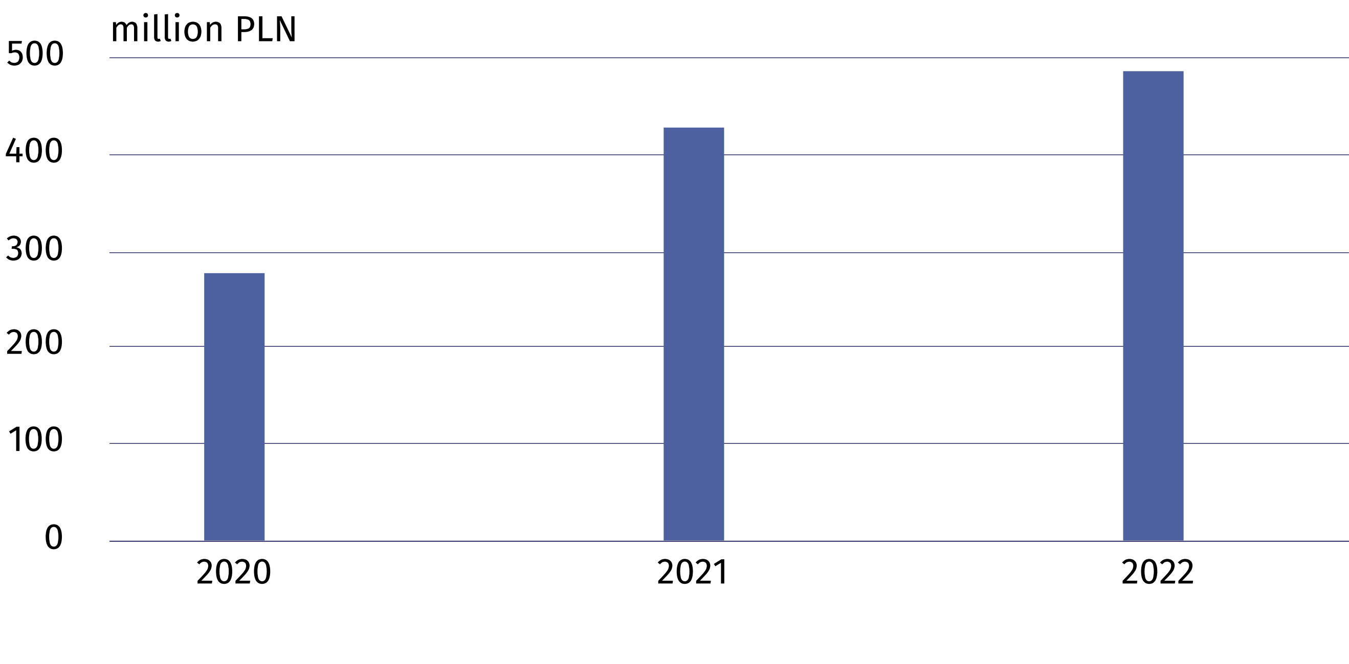

Nanotechnology personnel
In 2022, the number of persons employed in nanotechnology firms increased annually
by 7.7%
In 2022, 3687 persons were involved in nanotechnology activities (both in scientific units and firms). Firms employed 1344 persons, i.e. by 7.7% more than in the previous year. Research and experimental development in firms was carried out by 474 persons (including 187 women), which constituted 35.3% of the total number of persons employed in the field of nanotechno-logy.
Chart 6. Nanotechnology personnel in firms
As of 31 December
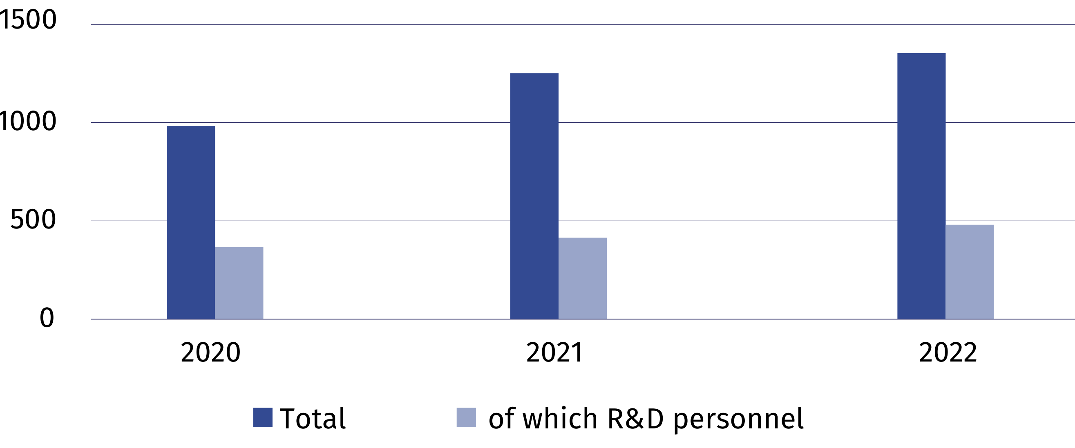

Nanotechnology research and experimental development
In 2022, the number of firms conducting research and experimental development in nanotechnology was by 3.8% lower than last year
The basic classification of research and experimental development is the division of entities into sectors of performance. In 2022, nanotechnology research and experimental development was carried out by 125 entities.
In 2022, nanotechnology R&D intramural expenditures amounted to PLN 399.9 million, i.e.
by 7.19% more than in the previous year. The higher education sector had the highest share in nanotechnology R&D intramural expenditures (56.7%).

Table 3. Nanotechnology R&D intramural expenditures by sectors of performance
Sectors of performance | 2020 | 2021 | 2022
Sectors of performance | in thousand PLN
Total | 296 736.6 | 373 386.9 | 399 929.5
Business enterprise sector | 72 099.5 | 166 965.3 | 154 476.3
of which enterprises | 60 608.7 | . | 83 639.9
Government and private non-profit  sector | 6 712.5 | . | 18 500.9
Higher education sector | 217 924.6 | 199 478.3 | 226 952.3

In 2022, 2817 persons, including 1119 women, were involved in research and experimental development in the field of nanotechnology. Compared to 2021, there was an increase in the number of R&D personnel in the field of nanotechnology by 7.3%, including women – by 0.4%.

In case of quoting Statistics Poland data, please provide information: “Source of data: Statistics Poland”, and in case of publishing calculations made on data published by Statistics Poland, please include the following disclaimer: “Own study based on figures from Statistics Poland”.

Prepared by:  Statistical Office in Szczecin  Director Magdalena Wegner  Phone: (+48 91) 459 77 00 | Issued by:  The Spokesperson for the President  of Statistics Poland  Karolina Banaszek  Phone: (+48) 695 255 011
Press Office  Phone: (+48 22) 608 38 04  e-mail: obslugaprasowa@stat.gov.pl |   stat.gov.pl/en/

@StatPoland

@GlownyUrzadStatystyczny

gus_stat

glownyurzadstatystycznygus

glownyurzadstatystyczny
Related information
Biotechnology and nanotechnology in Poland in 2021
Science and technology in 2021
Terms used inn official statistics
Biotechnology
The areas of activity in the field of biotechnology
Enterprise by type of biotechnology activity
Nanotechnology

