Research and experimental development in Poland in 2022
In 2022, gross domestic expenditure on R&D (GERD) amounted to 44.7 billion PLN and increased by 18.6% in comaparison to the previous year. R&D intensity indicator, which constitutes a share of intramural R&D expenditure in GDP, amounted to 1.46% (in 2021 – 1.43%). Gross domestic expenditure on R&D per capita amounted to 1 182 PLN and was higher
by 19.2% than in the previous year. The number
of R&D entities increased by 0.8% in comaparison to the previous year.
18.6%
An increase y/y in gross
domestic expenditure on R&D

Table 1. Selected data on R&D
Specification | 2015 | 2016 | 2017 | 2018 | 2019 | 2020 | 2021 | 2022
Number of entities in R&D | 4 427 | 4 871 | 5 102 | 5 779 | 5 863 | 6 381 | 7 370 | 7 431
Gross domestic expenditure on R&D (GERD) in million PLN | 18 061 | 17 943 | 20 578 | 25 648 | 30 285 | 32 402 | 37 676 | 44 702
Relation of GERD to GDP in % | 1.00 | 0.97ª | 1.04ª | 1.21 | 1.32 | 1.39 | 1.43ª | 1.46
a Data changed compared to previously published due to GDP revision.

INTRAMURAL EXPENDITURE ON RESEARCH AND DEVELOPMENT
R&D intensity (GERD/GDP) amounted to 1.46%
In the year 2022, like in the previous years, current expenditure prevailed in the structure
of intramural expenditure on R&D by type of costs. Their share in all incurred expenditure on scientific research and experimental development amounted to 85.1%.
Chart 1. Intramural expenditure on R&D by type of costs
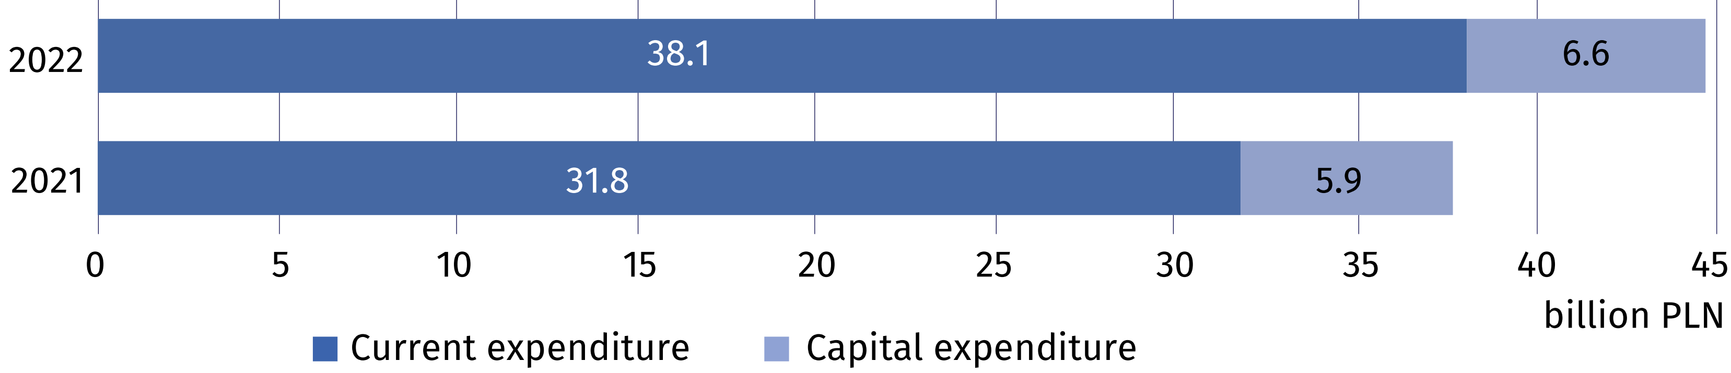
The business enterprise
expenditure on R&D (BERD) accounted for 65.9% of gross domestic expenditure on R&D (GERD)

The highest intramural expenditure on research and experimental development among
the sectors of performance were incurred by the business enterprise sector which allocated on conducting research and experimental development 29.5 billion PLN (by 23.9% more than in 2021). Expenditure of this sector accounted for 65.9% of gross domestic expenditure
on R&D in 2022 (compared to 63.1% in 2021). The share of other sectors of performance
in these expenditure amounted to: higher education – 32.0%, government – 1.9% and private non-profit – 0.2% (compared to 34.7%, 2.0% and 0.2% in 2021).

Table 2. Intramural expenditure on R&D by sectors of performance
Sectors of performance | 2021 | 2022
Sectors of performance | in million PLN
Total (GERD) | 37 675.8 | 44 702.4
Business enterprise (BERD) | 23 769.1 | 29 455.1
Government (GOVERD) | 770.3 | 863.7
Higher education (HERD) | 13 059.0 | 14 296.8
Private non-profit (PNPERD) | 77.5 | 86.8
In the year 2022, like in the previous years, main funding sectors for research and experimental development were the business enterprise sector and the government sector whose funds accounted for 54.8% and 33.5% of all intramural expenditure on R&D, respectively (compared to 50.9% and 37.4% in 2021).
Chart 2. Intramural expenditure on R&D by funding sectors
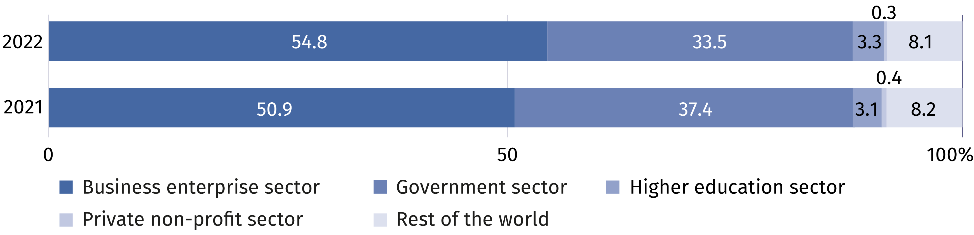

PERSONNEL IN RESEARCH AND DEVELOPMENT
Internal personnel accounted for 84.1% of R&D personnel
in FTE
The number of personnel involved in research and experimental development in 2022 amounted to 321.4 thousand persons, that is, by 5.2% more than in the previous year. Actual involvement of R&D personnel in research and experimental development in full-time equivalents amounted to 195.1 thousand FTE and increased by 5.3% on an annual basis. R&D was mainly performed by internal personnel which accounted for 81.8% of personnel
in headcount and 84.1% – in FTE in 2022 (in 2021 these shares amounted to 85.1% and 83.7%, respectively).
Chart 3. R&D personnel by main groups
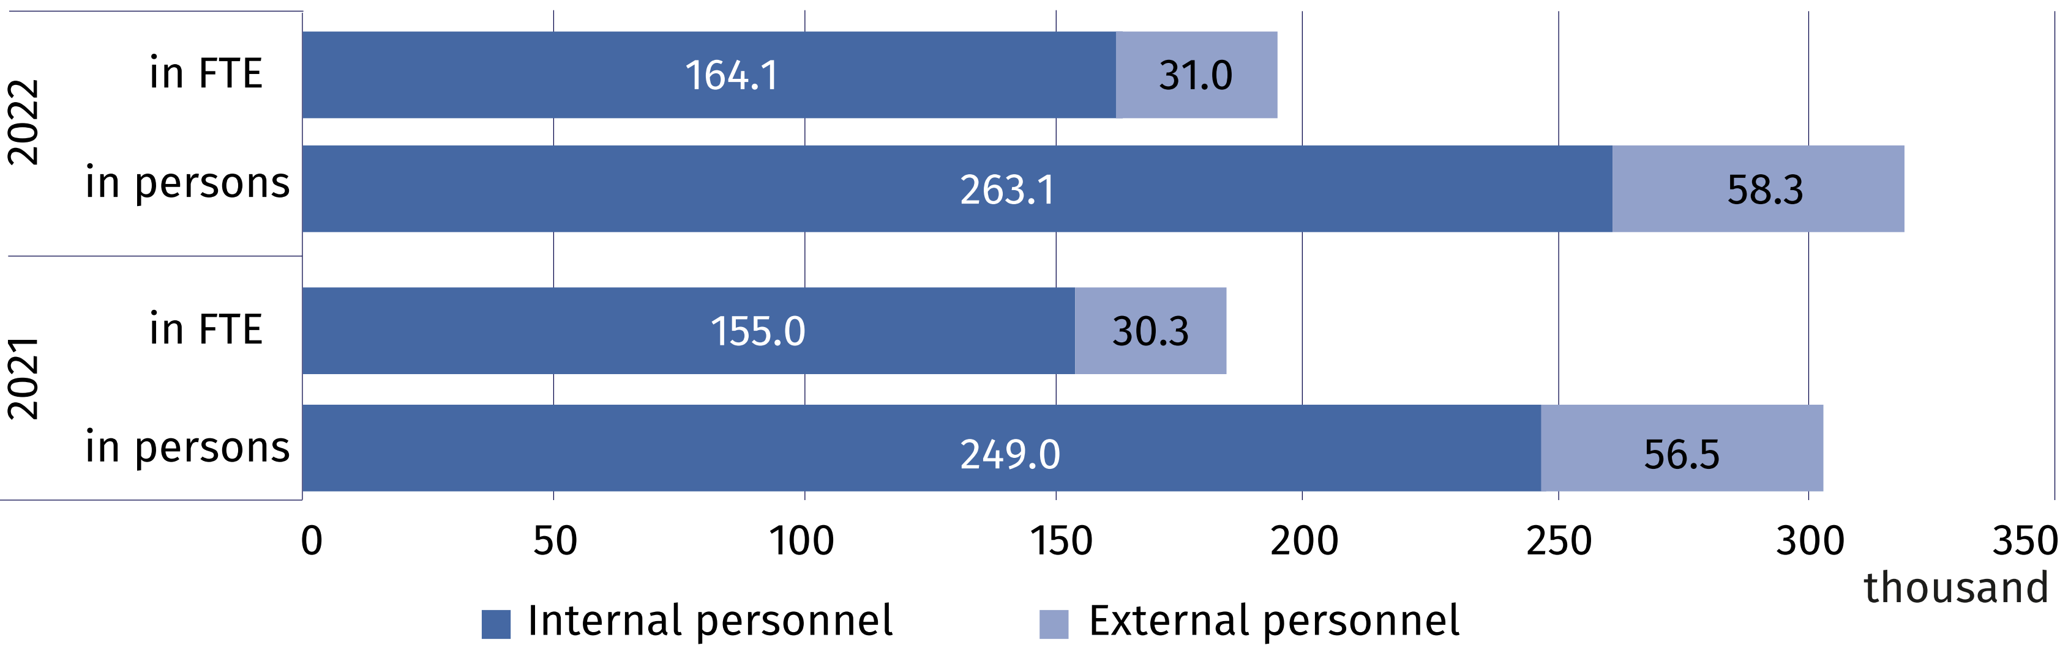
In 2022, researchers prevailed in the structure of persons engaged in research and experimental development by R&D functions. They accounted for 69.3% of internal personnel and 71.2% of external personnel in headcount (compared to 70.0% and 73.1% in 2021). In FTE,
researchers as the share of persons employed in R&D accounted for 72.5% and as the share of external contributors 71.7% (compared to 72.7% and 75.8% in 2021).
Table 3. Selected indicators on internal R&D personnel ª
Specification | 2015 | 2016 | 2017 | 2018 | 2019 | 2020 | 2021 | 2022
per 1000 active population ^{b}
Internal R&D personnel | 6.4 | 6.6 | 7.1 | 7.8 | 8.1 | 8.6 | 9.0 | 9.5
of which researchers | 4.9 | 5.2 | 5.7 | 5.8 | 5.9 | 6.2 | 6.5 | 6.9
per 1000 persons employed ^{c}
Internal R&D personnel | 6.9 | 7.0 | 7.5 | 8.1 | 8.4 | 8.8 | 9.3 | 9.8
of which researchers | 5.3 | 5.5 | 6.0 | 6.1 | 6.1 | 6.4 | 6.8 | 7.1
a In full-time equivalents (FTE). In 2015 – employees. b Active population aged 15-89 years according to the LFS – average annual data. c Persons employed aged 15-89 years according to the LFS – average annual data.

In 2022, the business enterprise sector and higher education sector had the highest share
in the structure of internal R&D personnel by sectors of performance. The percentage of internal personnel in these sectors accounted for 57.1% and 40.3% of total number of internal personnel engaged in conducting research and experimental development. On an annual basis, the number of person included in internal personnel increased by 9.0% in the business enterprise sector and by 2.0% in the higher education sector. The highest value of full-time equivalent was noted in the business enterprise sector (101.6 thousand FTE) which
increased by 8.9% in comparison to 2021.
Chart 4. Internal R&D personnel by sectors of performance
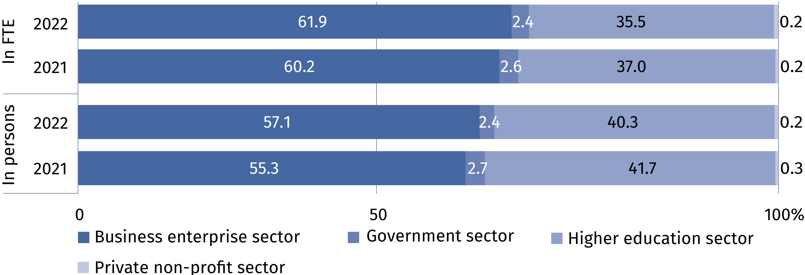

Persons with other tertiary education prevailed among both internal personnel and external personnel – they accounted for 57.0% and 67.5% of a given R&D personnel group, respectively. Among internal R&D personnel 31.6% of persons held at least the scientific degree
of doctor (PhD) and among external personnel this share amounted to 19.9%.

Table 4. R&D personnel by educational level and main groups
Specification  a – 2021  b – 2022 |  | Total | With tertiary education |  |  |  |  |  |  |  |  | Persons with other  educational level
 |  | Total | with  professor title |  | with scientific degree of |  |  |  |  | other |  | Persons with other  educational level
 |  | Total |  |  | habilitated doctor |  |  | doctor (PhD) |  |  |  | Persons with other  educational level
 |  | in headcount
Total | a | 305 563 |  | 14 645 |  | 25 619 | 51 980 |  | 175 659 |  | 37 660
Total | b | 321 391 |  | 14 760 |  | 25 989 | 53 872 |  | 189 237 |  | 37 533
Internal  personnel | a | 249 014 |  | 113 33 |  | 22 761 | 47 307 |  | 139 139 |  | 28 474
Internal  personnel | b | 263 057 |  | 11 248 |  | 22 859 | 48 932 |  | 149 870 |  | 30 148
External  personnel | a | 56 549 |  | 3 312 |  | 2 858 | 4 673 |  | 36 520 |  | 9 186
External  personnel | b | 58 334 |  | 3 512 |  | 3 130 | 4 940 |  | 39 367 |  | 7 385

When citing data from the Central Statistical Office, please include the following information: "Source of CSO data", and in the case of publishing calculations made on the data published by the Central Statistical Office, please include the following information: "Own study based on GUS data"

Prepared by:  Statistical Office in Szczecin  Director Magdalena Wegner  Phone: (+48 91) 459 77 00 | Issued by:  The Spokesperson for the President  of Statistics Poland  Karolina Banaszek  Phone: (+48) 695 255 011
Press Office  Phone: (+48 22) 608 38 04  e-mail: obslugaprasowa@stat.gov.pl |   stat.gov.pl/en/

@StatPoland

@GlownyUrzadStatystyczny

gus_stat

glownyurzadstatystycznygus

glownyurzadstatystyczny
Related information
Research and experimental development in Poland 2021
Science and technology in 2021
Methodological report. Research and experimental development
Data available in databases
Macroeconomic Data Bank (BDM)
Local Data Bank (BDL)
Knowledge Databases (DBW)
Strateg
Terms used inn official statistics
Research and experimental development (R&D)
Gross domestic expenditures on research and development (GERD)
Intramural expenditures on R&D
Basic research
Applied research
Experimental development
R&D personnel
Internal R&D personnel
External R&D personnel

