Physical education in 2022
10.0%
Increase in the number of persons practicing sports in sports clubs compared to 2020
In 2022, there were 14,476 sports clubs and 70 Polish sports associations. Compared to 2020, the number of sports clubs increased by 1.6%. With respect to 2021, the number of Polish representatives, judges and coaches holding licenses of the Polish sports associations increased, while the number of competitors and instructors decreased. Compared to 2018, the number of stadiums and sports fields for big games increased by 3.4%, sports halls and gyms by 5.2%, and indoor swimming pools by 5.7%.

Sports clubs
The largest number of sports clubs operated in Mazowieckie Voivodship (10.1%), followed by Małopolskie Voivodship (10.0%), Śląskie Voivodship (9.9%) and Wielkopolskie Voivodship (9.8%), and the smallest in Świętokrzyskie Voivodship (2.0%).

In 2022, sports clubs had 1.1 million members and persons practicing sports. Compared to 2020, both the number of members (up 5.6%) and the number of persons practicing sports (up 10.0%) increased. As in previous years, the vast majority of persons practicing sports were men - 72.5%. Invariably, young people under the age of 18 prevailed among persons practicing sports - 71.0%.
In the structure of sports clubs, the largest share was held by sports clubs that did not declare affiliation with any sports division - 50.7%. Their number increased by 5.5% compared to 2020. Next in terms of numbers were student sports clubs (32.8%) and sports clubs belonging to the „Rural Sports Teams” Association (15.0%), whose number decreased compared to 2020 (by 1.7% and 5.0%, respectively).
As in previous years, the most popular among those practicing was football (excluding beach and indoor football), which was practiced by 35.9% of those practicing sports. Compared to 2020, the number of those practicing this sports game increased by 6.7%. Sport shooting ranked second, and was practiced by 7.2% of those practicing in sports clubs (an increase of 22.4% compared to 2020). Volleyball (excluding beach volleyball) ranked third (5.9% of those practicing, up 11.4% compared to 2020). The next places, in terms of the number of persons practicing sports, included karate (including traditional karate) and swimming - 4.7% each, as well as basketball - 3.7% and athletics - 3.6%.
The number of people practicing football increased by 6.7% from 2020, while those practicing volleyball increased by 11.4%
More than half of the persons practicing sports practiced team sports. Combat sports were practised by a total of 13.0% of persons. Of these, karate and judo were the most popular. Water sports were practiced by 6.2% of persons, while winter sports were practiced by 1.4%.
The number of persons practicing sports per 1,000 population of Poland in 2022 was 29 (in 2020 - 26). The highest value of the indicator was recorded in Podkarpackie Voivodship - 36, followed by Dolnośląskie, Małopolskie and Opolskie Voivodships - 34 each, and the lowest in Świętokrzyskie Voivodship (18).
Table 1. Basic information on sports clubs
SPECIFICATION | 2020 | 2022
SPECIFICATION | In absolute numbers |  | 2020=100
Sports clubs | 14 245 | 14 476 | 101.6
Members (in thousand) | 1 041 | 1 099 | 105.6
Persons practising sports (in thousand) | 1 011 | 1 112 | 110.0
of which:
females | 262 | 306 | 116.8
aged up to 18 | 710 | 789 | 111.1
Coaching staff | 55 396 | 58 669 | 105.9
coaches | 30 945 | 33 079 | 106.9
instructors | 17 383 | 18 107 | 104.2
other persons running sports classes | 7 068 | 7 483 | 105.9
Chart 1. Persons practising sports in sports sections by selected kinds of sports in 2022
a Excluding indoor football and beach football. b Excluding beach volleyball.
In 2022, in sports clubs, the coaching staff (including social workers) numbered 58.7 thousand, including 18.2% females. Coaches accounted for 56.4%, instructors - 30.9%, and other persons running sports classes - 12.8%. Compared to 2020, the number of coaches increased by 6.9%, instructors by 4.2%, and other persons running sports classes by 5.9%.

The largest number of coaches worked in sports clubs in Śląskie Voivodship (12.4%), followed by instructors working in Mazowieckie Voivodship (13.7%). The least number of coaches and instructors worked in Świetokrzyskie Voivodship (1.9% and 1.8%, respectively).
In 2022, there were 5.3 members of the coaching staff (instructors, coaches or other persons running sports classes) per 100 persons practicing sports in Poland. This indicator reached its highest value in Warmińsko-Mazurskie Voivodship - 6.0, while the lowest in Mazowieckie Voivodship - 4.6 (for Poland, it was 5.5 in 2020).
Map 1. Persons practising sports in sports clubs by voivodship in 2022
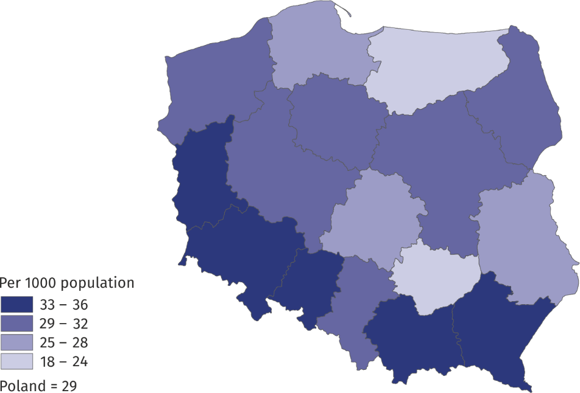
Polish sports associations
In 2022, the Polish sports associations selected 12 127 members of the national team
As of 2022, there were a total of 70 Polish sports associations and 513 district sports associations. The status of a Polish sports association was granted to 5 new associations: the Polish Karate Union, the Polish Freediving Association, the Polish Underwater Hockey Association, the Polish Dance Sports Association and the Polish Surfing Association, while the status was lost to the Polish Teakwon-Do Association.
Polish sports associations selected 12.1 thousand members of the national team, of whom 47.3% were females. The most numerous group of Polish representatives were juniors (45.7%). Compared to 2021, the number of Polish representatives increased by 15.4%. The number of representatives who are members of foreign clubs decreased by more than 21%.

Table 2. Basic information on Polish sports associations in 2022
SPECIFICATION | Total | Of which females
Polish representatives | 12 127 | 5 738
of which:
juniors | 5 543 | 2 829
Competitorsª | 759 232 | 149 728
of which:
junior competitors^{b} | 468 894 | 114 586
Coaching staff^{c}
coaches | 34 708 | 3 063
instructors | 11 270 | 3 346
Judges^{c} | 43 293 | 8 970
of which:
with international class | 1 853 | 403
a Including foreign competitors performing in Poland. The competitors can be shown several times if they are licensed in several sports supervised by one sports association. b Total juniors, younger junior "cadets", sub-juniors and children. c Members of the coaching staff and judges can be shown several times if they are li-censed in several sports supervised by one sports association.
In 2022, the largest number of national team members was reported by the Polish Equestrian Federation (2,031), the Polish Volleyball Federation (1,476) and the Polish Swimming Federation (601). In 2021, the Polish Volleyball Federation had the largest number of representatives (1,527 representatives).
Chart 2. Polish representatives in 2022
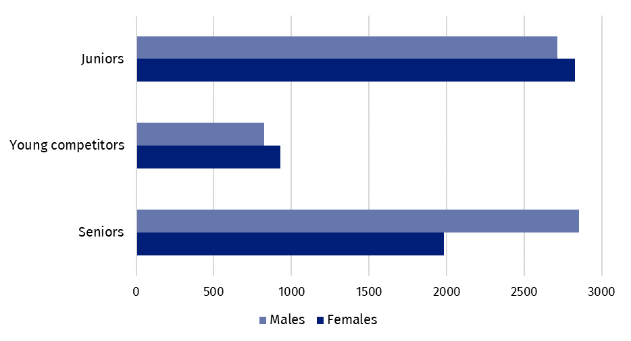
The licenses of Polish sports associations in 2022 were held by 759.2 thousand competitors (1,022.5 thousand in 2021), of whom 19.7% were females. There were 34.0% competitors in the senior category. Competitors holding licenses from the Polish Football Association dominated, with 48.4%, followed by the Polish Shooting Sports Association, with 7.8%, the Polish Swimming Association, with 6.0%, and the Polish Volleyball Association, with 5.1%.
The number of competitors with disabilities with licenses in Polish sports associations in 2022 was 3 075 people, 74.9% of whom were males. The percentage of competitors with disabilities was 0.4% (in 2021 - 0.3%).
In 2022, the number of coaches licensed by the Polish sports association increased by 1.0% compared to 2021, and instructors decreased by 4.1%
Foreign competitors with Polish sports association licenses in 2022 formed 1.0% of all competitors. The most popular sports practiced by them in Poland were football (63.3%) and ice hockey (6.3%).
Current licenses of Polish sports associations in 2022 were held by 34.7 thousand coaches and 11.3 thousand instructors. Compared to the previous year, the number of coaches increased by 0.3 thousand and instructors decreased by 0.5 thousand.
Chart 3. Coaching staff in Polish sports associations in 2022

In 2022, there were 43.3 thousand sports judges registered in Polish sports associations (a 7.5% increase compared to 2021). Of these, 20.7% were females. The percentage of judges with an international class was 4.3%. The largest number of judges held licenses in sport shooting (26.8%). Football (18.4%) and athletics (6.5%) judges were a significant group. Females as judges predominated mainly in artistic gymnastics - 98.8% and synchronized swimming - 97.2%.
Achievements of Polish competitors in the international arena
In 2022, Polish representatives won 1 Olympic medal and 757 medals at World and European Championships
In 2022, the Polish national team competed for the 24th time in the Winter Olympic Games, held in Beijing. Poland was represented by 30 women and 27 men, who competed in 10 of the 15 program disciplines. From the 24th Olympic Winter Games, the Polish team brought back one bronze medal in ski jumping.
The Polish team at the 2022 World Championships had a total of 384 competitors, who won medal places 277 times (232 in 2021). They won 79 golds, 98 silver and 100 bronze medals. The most medal places in 2022 were won by competitors in kick-boxing (60 medals), followed by air sport (36 medals) and canoeing (31 medals) competitions.
Significantly more competitors represented Poland at sports events of the rank of European Championships⁵, where the Polish team numbered 920 person. In 2022, Poles won a total of 480 European Championship medals (463 in 2021), including: 125 gold, 155 silver and 200 bronze. The most medals were won in sumo (74 medals), followed by the competitions of air sport (47 medals), canoeing (39 medals) and kick-boxing (36 medals).
In 2022, Polish competitors with disabilities won 177 medals at World and European Championships
Competitors with disabilities won a total of 59 World Championship medals (18 gold, 19 silver, 22 bronze) and 118 European Championship medals (38 gold, 41 silver and 39 bronze).
Table 3. Medals won by Polish competitors in the international arena in 2022
SPECIFICATION | Medals
SPECIFICATION | total | gold | silver | bronze
24th Olympic Winter Games Beijing 2022 | 1 | - | - | 1
World Championships | 277 | 79 | 98 | 100
of which young competitors and juniors | 169 | 43 | 59 | 67
European Championships | 480 | 125 | 155 | 200
of which young competitors and juniors | 257 | 74 | 74 | 109
World Championships for persons with disabilities | 59 | 18 | 19 | 22
European Championships for persons with disabilities | 118 | 38 | 41 | 39

Physical education organizations
In 2022, physical education organizations such as the Academic Sports Association (AZS), „Rural Sports Teams” Association (LZS), The Polish Sports Association for the Disabled ’’Start’’ (PZN "Start") and the Society for the Promotion of Physical Education (TKKF) showed a total of 6.7 thousand organizational units (an increase of 0.5% over 2021), 316.6 thousand members (0.6 thousand less than the previous year) and 302.7 thousand competitors (an increase of 26.1 thousand people). The most numerous, both in terms of the number of members and those actively practising, was the „Rural Sports Teams” Association (208.7 thousand members, 186.5 thousand practising). The Society for the Promotion of Physical Education also had a large membership base (63.9 thousand members and 78.3 thousand practising). The Academic Sports Association recorded 41.8 thousand members and 36.0 thousand practising members, and the Polish Sports Association for the Disabled "Start" showed 2.3 thousand members and 1.9 thousand practising members.
The largest number of members of physical education organizations was registered Zachodniopomorskie Voivodship (13.0% of all organization members). The largest number of persons actively practising sports was registered in Wielkopolskie Voivodship - 13.3% of all practising members.
Sports facilities
In 2022, with respect to 2018, the number of stadiums and sports fields for big games increased by 3.4%
In 2022, athletes in Poland had 2,244 sports stadiums at their disposal, of which 55.2% were football stadiums, 40.8% were multi-purpose stadiums, 2.9% were athletics stadiums and 1.1% each were speedway and rugby stadiums. The largest number of stadiums operated in Podkarpackie Voivodship (14.6%), followed by Wielkopolskie Voivodship (9.7%) and Małopolskie Voivodship (9.0%). Among stadiums, those with auditoriums of up to 3,000 seats dominated (85.7%).
In Poland, there were more than 3 times as many sport fields for big games ⁹ (7,705) as stadiums. Similar to 2018, the vast majority of them were football fields (99.3%). Compared to 2018, the number of stadiums and sports fields for big games increased by 3.4%.
In 2022, there were 3,751 sports fields for small games (for basketball, handball, beach handball, volleyball and beach volleyball), 3,389 universal-multi-purpose sports fields and 2,289 tennis courts.
Map 2. Stadiums and sports fields for big games by voivodship in 2022
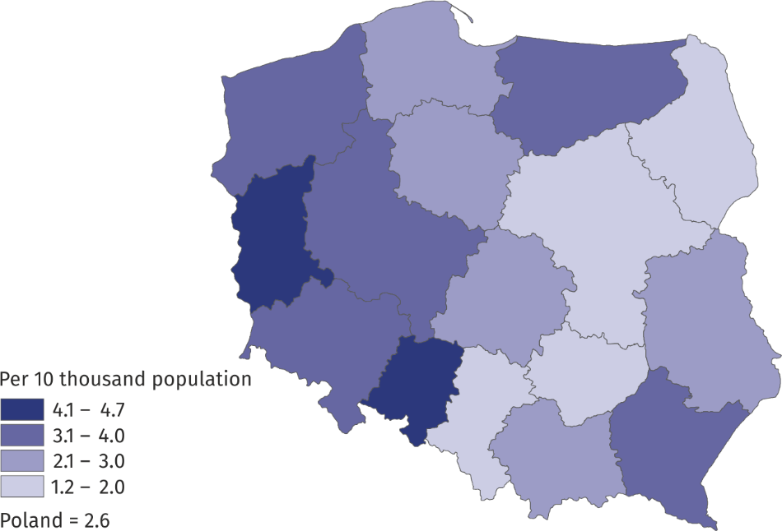
In Poland in 2022, there were 705 large multifunctional sports halls (with dimensions of 44x22 m or larger). The largest number of halls of this type was located in Wielkopolskie Voivodship - 101, and the smallest in Podlaskie Voivodship - 14. Sports halls and gyms with smaller dimensions dominated in Mazowieckie Voivodship (12.8%), while their lowest percentage in Świętokrzyskie Voivodship - 1.9%. 36 large sports halls had auditoriums with a seating capacity of more than 3,000. Compared to 2018, the number of sports halls and gyms increased by 5.2%.
In 2022, the number of sports halls and gyms increased by 5.2%, compared to 2018
Map 3. Sports halls and gyms by voivodship in 2022

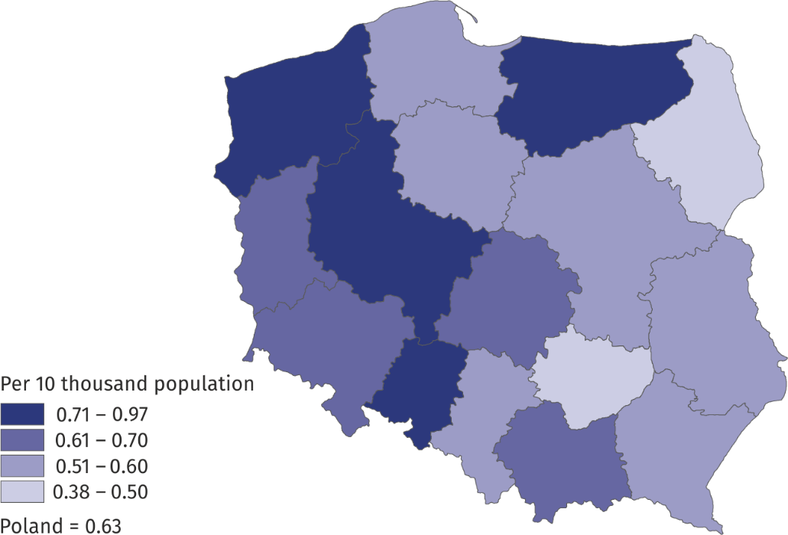
In 2022, there were 609 indoor swimming pools and 261 open swimming pools in Poland. The largest number of indoor swimming pools was located in Mazowieckie Voivodship (14.1%), followed by Śląskie Voivodship (11.7%). Compared to 2018, there was a 5.7% increase in the number of facilities of this type.
Map 4. Indoor swimming pools by voivodship in 2022
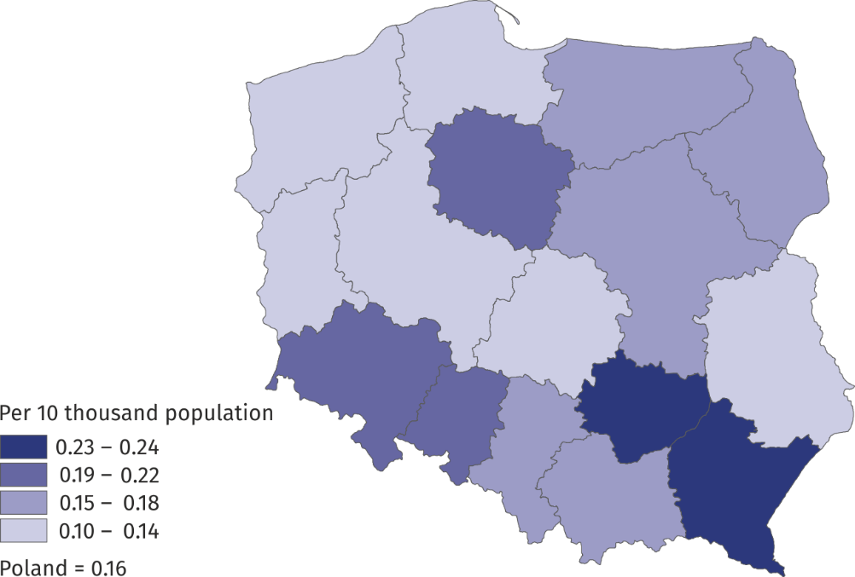
Winter sports enthusiasts had at their disposal 295 artificial ice rinks, 22 ski jumps, 15 luge runs, 6 skating tracks, and 321.6 km of downhill skiing and 728.3 km of cross-country skiing trails.
When quoting Statistics Poland data, please provide information: “Source of data: Statistics Poland”, and when publishing calculations made on data published by Statistics Poland, please provide information: “Own study based on Statistics Poland data”.

Prepared by:  Statistical Office in Rzeszów  Director Marek Cierpiał-Wolan  Phone: (+48 17) 853 52 10 | Issued by:  The Spokesperson for the President  of Statistics Poland  Karolina Banaszek  Phone: (+48) 695 255 011
Press Office  Phone: (+48 22) 608 38 04  e-mail: obslugaprasowa@stat.gov.pl |   stat.gov.pl /en/

@StatPoland

@GlownyUrzadStatystyczny

gus_stat

glownyurzadstatystycznygus

glownyurzadstatystyczny
Related information
Physical education in the years 2019 and 2020
Data available in databases
Local Data Bank

Terms used in official statistics
Person practising sport
Other person running sports classes
Sports instructor
Sports club
Sports facility
District sports association
Organisation of physical education
Sports judge
Sport
Sports
Sports coach
Competitor
Sports association

The sources of data used in the release are the results of surveys conducted by Statistics Poland on sports clubs (conducted every 2 years), Polish sports associations and physical culture organizations (conducted every year) and sports facilities (conducted every 4 years).
Sports associations according to the list of Polish sports associations announced by the Minister of Sport - Communication of 15 November 2022. Data are preliminary.
Members of the coaching staff may be shown more than once if they hold licenses in several sports supervised by one sports association.
Sports judges can be shown more than once if they hold licenses in several sports.
In sports supervised by sports associations with the status of a Polish sports association.
In sports supervised by sports associations with the status of a Polish sports association.
This news release covers: in AZS - clubs, in LZS - teams, sports clubs and student sports clubs, in PZSN "Start" - organizational units, in TKKF - centres and clubs.
Without school facilities.
Including part-size sports fields.

