Tourist accommodation establishments in coastal areas in July and August 2023
(concerns tourist accommodation establishments with 10 or more bed places)
0.6%
Decrease in the number of tourists in tourist accommodation establishments in coastal areas in July and August 2023 compared to the corresponding months of previous year

In July and August 2023, 1.8 million tourists were accommodated in tourist accommodation establishments located in coastal areas, and 8.0 million overnight stays were provided for them. Compared to the same period last year, the number of tourists was lower by 0.6%, and number of overnight stays decreased by 4.8%.

Coastal gminas according to Eurostat methodology
According to the Eurostat methodology, 55 gminas of the voivodships: Pomorskie (26), Zachodniopomorskie (23) and Warmińsko-Mazurskie (6) are classified as coastal areas in Poland. They are situated by the Baltic Sea or are in direct proximity to the sea. They cover 2.5% of Poland's territory (7.9 thousand square kilometres) and are inhabited by 4.2% of the country's population (1.6 million people).
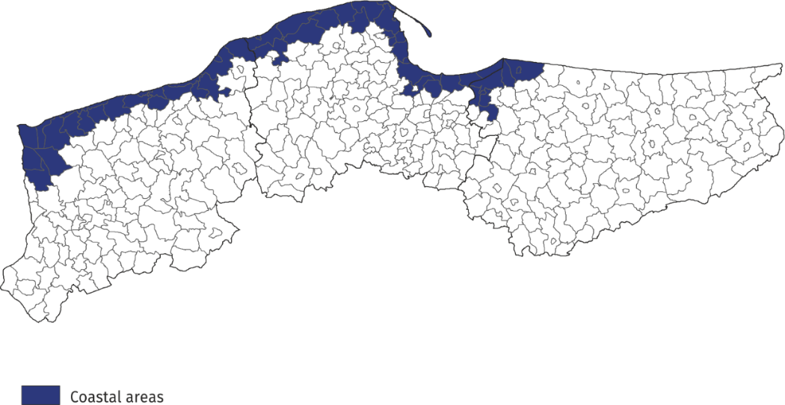
Map 1. Coastal gminas

Tourist accommodation establishments in coastal areas
As of the end of July 2023, 2286 tourist accommodation establishments operated in coastal areas, i.e. almost 1/4 of all establishments in Poland. The vast majority of them (almost 70%) operated on a seasonal basis (the percentage of seasonal establishments in Poland was less than 30%).
Almost half of the holiday centres operating in the country functioned here, as well as
42.5% of rooms for guest, 40.5% of complexes of tourist cottages, 38.0% of holiday youth centres and 31.3% of camping sites. Compared to the previous year, the number of accommodation establishments in coastal areas increased by 3, i.e. by 0.1%.
The structure of accommodation establishments in coastal areas is fundamentally different from the structure of establishments in total in Poland. Rooms for guests prevail – at the end of July this year there were 842 of them and they accounted for 36.8% of all establishments in these areas. There were numerous holiday centres – 438 (19.2% of all establishments in coastal area) and complexes of tourist cottages – 235 (10.3%). Hotels accounted for 10.6% of tourist accommodation establishments in coastal areas (26.3% in Poland).
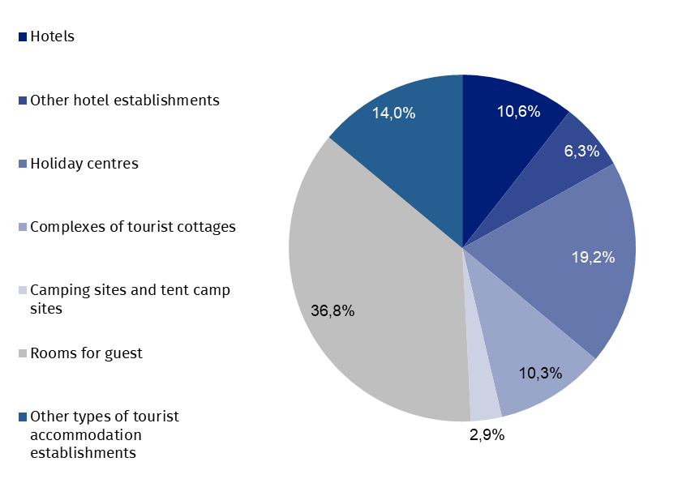
Chart 1. Tourist accommodation establishments in coastal areas in 2023
as of 31 July
At the end of July 2023, tourist accommodation establishments located in coastal gminas had 217.7 thousand bed places, which accounted for 27.5% of the total number of bed places in accommodation establishments in Poland, and it was 1.7 thousand (0.8%) more than a year ago. Compared to the corresponding period of the previous year, the number of bed places increased, among other things, in hotels (by 2.4 thousand), other types of tourist accommodation establishments (by 0.9 thousand), other hotel establishments (by 0.8 thousand), hostels (by 0.6 thousand), health establishments and rooms for guests/private lodgings
(by 0.2 thousand each).

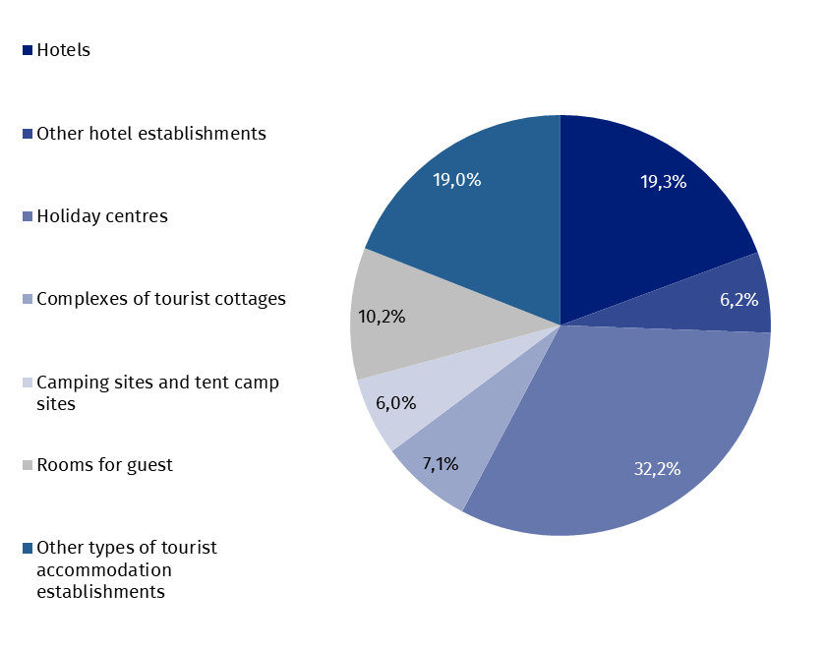
Chart 2. Bed places in coastal areas in 2023
as of 31 July
The largest number of bed places was offered by holiday centres – 70.0 thousand, i.e. 32.2% of the total number of bed places in the area. Hotels had 42.1 thousand (i.e. 19.3%) places prepared for tourists, while rooms for guest had 22.2 thousand (i.e. 10.2%). Among other types of establishments, 15.4 thousand bed places were available for tourists in complexes of tourist cottages, and 13.1 thousand in health establishments.
Establishments in coastal areas are larger than the average in Poland. One establishment functioning in coastal areas had an average of 95 places (81 places in the country).
In 2023, the density index of the accommodation establishments in coastal areas was 27.4 places per 1 square kilometre of area (in the country – 2.5).
Tourists accommodated in tourist accommodation establishments
Tourists accommodated in establishments in coastal areas during the holiday period 2023 constituted 21.3% of all tourists accommodated in the whole country during that period

During the holiday season (i.e. in July and August) of 2023, 1.8 million tourists were accommodated in accommodation establishments located in coastal gminas (909.3 thousand – in July and 859.3 thousand – in August), i.e. 21.3% of tourists accommodated in accommodation establishments throughout the country during this period (in the corresponding period of 2022 this percentage amounted to 21.7%). Compared to the corresponding period of 2022, the number of tourists using overnight stays in July and August was lower by 10.3 thousand,
i.e. by 0.6% (in July higher by 1.2% and in August lower by 2.4%).
Over 1/3 of tourists (621.4 thousand) staying in these areas were accommodated in hotels.
A large number of tourists chose to stay in holiday centres – 428.5 thousand (24.2%) and in other types of establishments – 157.0 thousand (8.9%).
Among the total number of tourists accommodated in tourist accommodation establishments 82.2% (1.5 million) were domestic tourists, and 17.8% (0.3 million) were foreign tourists. In relation to the same period of 2022, the number of domestic tourists was lower by 3.6% and the number of foreign tourists by 16.1%.

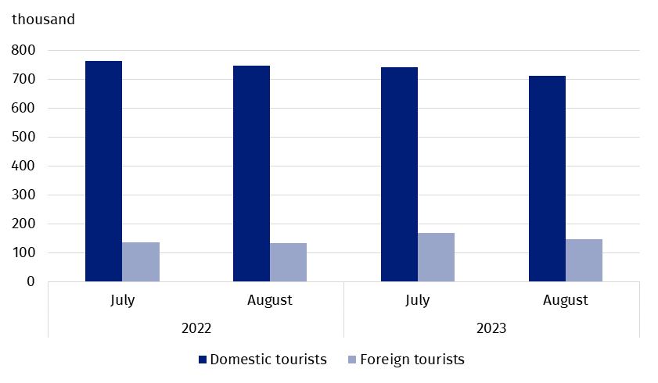
Chart 3. Tourists accommodated in coastal areas in July-August
In July and August 2023, as in previous years, the majority of foreign tourists accommodated in coastal areas were from Germany. During this period, 167.4 thousand of them arrived and compared to the same period last year there were more of them by 10.1 thousand, but their share in the total number of foreign tourists was lower than the year before and amounted to 53.1% – in the same period of 2022 they accounted for 58.0% of the total number of foreign tourists. The share of guests from other countries did not exceed 7.0%; most of them were from Czechia (21.7 thousand), followed by Sweden (19.2 thousand) and Norway
(14.6 thousand), who constituted, respectively 6.9%, 6.1% and 4.6% of the total number
of foreign tourists accommodated in coastal areas.
Overnight stays provided at tourist accommodation establishments
Overnight stays provided in July and August in coastal areas accounted for 32.0% of all overnight stays in Poland during this period

A total of 8.0 million overnight stays were provided for tourists staying in coastal areas in July and August this year, which accounted for 32.0% of all overnight stays provided at tourist accommodation establishments in Poland during that period. In the same period last year, the share was 0.9 percentage points higher.
This year a little more overnight stays were provided to tourists in July (4.1 million), than in August (3.9 million). Compared to the same period in 2022, the total number of overnight stays provided in July and August this year was lower by 4.8% (i.e. 406.9 thousand) – in July by 3.9% (165.4 thousand), and in August by 5.8% (241.6 thousand).
On average, 4.6 overnight stays were provided for tourists during their holiday trips, while the average length of a tourist stay in Poland during that period was 3 nights.
6.9 million overnight stays were provided for domestic tourists (6.7% less than in July and August last year) in the period July-August 2023, and they accounted for 85.4% of the total number of overnight stays in coastal areas and 32.4% of the total number of overnight stays provided for domestic tourists in the same period in Poland. A total of 1.2 million overnight stays were provided for foreign tourists, which was 7.9% more than in the previous year. Most overnight stays were provided to tourists from countries neighbouring Poland, i.e. Germany (750.3 thousand – 64.0% of overnight stays of foreign tourists), Czechia (83.0 thousand – 7.1%) and Sweden (49.0 thousand – 4.2%).

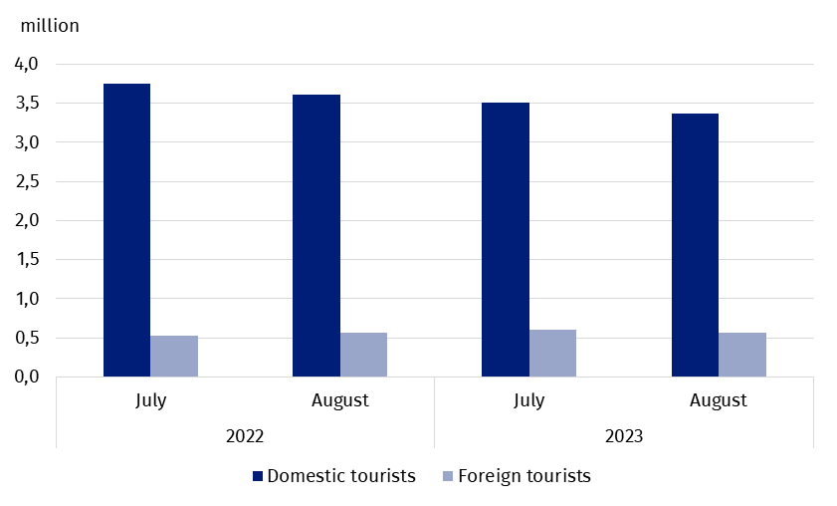
Chart 4. Overnight stays provided tourist accommodation establishments in coastal areas
in July-August
Occupancy rate of bed places in tourist accommodation establishments
During the holiday season (July, August), places in tourist accommodation establishments located in coastal gminas are usually better occupied than in other areas of the country.
The occupancy rate of bed places in coastal gminas was higher than the national average and amounted to 61.2% in July and 59.0% in August

In July, the occupancy rate of bed places amounted to 61.2%, and in August – 59.0%, while the average for the entire country amounted to 51.2% and 51.6%, respectively.
Similarly, in the corresponding months of 2022, the indicator for coastal areas was higher than for the country – in July 64.0% and 53.2%, and in August, 62.6% and 53.8%, respectively.
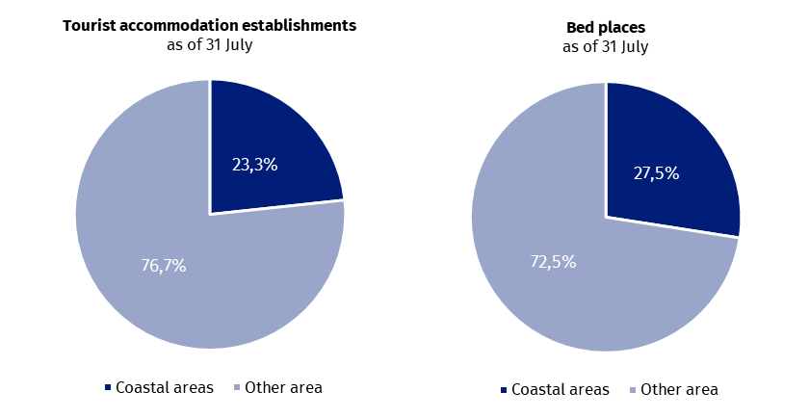
Chart 5. Tourism in coastal areas in comparison with the country in July-August 2023
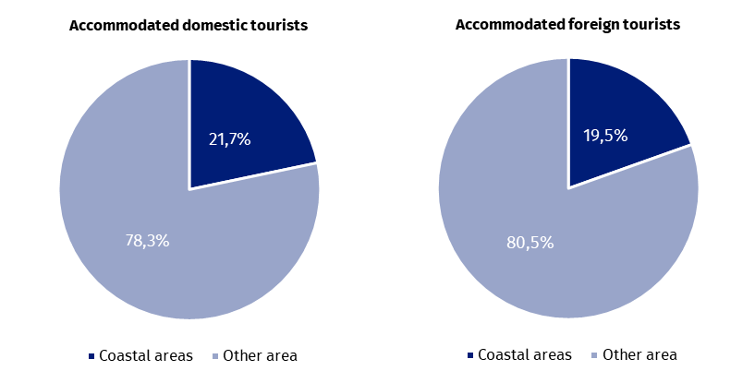
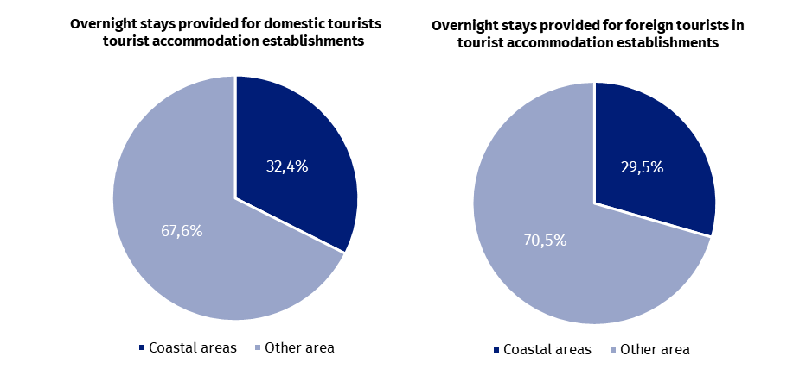

Occupancy of tourist accommodation establishments in gminas located in coastal areas in July and August 2023
In the coastal areas in July and August this year the highest number of overnight stays were provided in accommodation establishments located in Kołobrzeg urban gmina - 930.7 thousand, which constituted over 1/10 of all overnight stays provided in this area. 171.1 thousand tourists were accommodated there. This means that during the two holiday months, there were 390 tourists using the accommodation establishment and 2121 overnight stays per
100 inhabitants of the city.
In the period July-August, the largest number of overnight stays in coastal gminas was provided in Kołobrzeg and Gdańsk

Large tourist traffic was also recorded in Gdańsk, where in July-August with almost 850.5 thousand overnight stays were provided to 304.6 thousand tourists. For 100 inhabitants of this city there were 63 tourists and 175 overnight stays.
From approximately 600 thousand up to 400 thousand overnight stays were provided in 4 gminas: Rewal – 581.5 thousand, Mielno – 544.0 thousand, Władysławowo – 521.0 thousand, and Świnoujście – 465.6 thousand.
After over 300 thousand overnight stays were recorded in tourist night establishments in the following gminas: Ustronie Morskie (384.5 thousand), Kołobrzeg rural gmina (359.7 thousand) and Łeba (309.7 thousand).
Table 1. Tourist accommodation establishments and its occupancy in the period July-August in 2023
Gmina | Overnight stays provided |  |  | Tourists accommodated
Gmina | in thousand | July-August 2022=100 | in per-centages | in thousand | July-August 2022=100
Coastal area  of which: | 8 047.9 | 95.2 | 100.0 | 1 768.6 | 99.4
Kołobrzeg  (urban gmina) | 930.7 | 104.8 | 11.6 | 171.1 | 107.6
Gdańsk | 850.5 | 102.5 | 10.6 | 304.6 | 104.8
Rewal | 581.5 | 94.1 | 7.2 | 111.9 | 103.1
Mielno | 544.0 | 80.2 | 6.8 | 96.9 | 83.2
Władysławowo | 521.0 | 96.9 | 6.5 | 117.0 | 107.8
Świnoujście | 465.6 | 96.9 | 5.8 | 103.3 | 98.1
Ustronie Morskie | 384.5 | 91.7 | 4.8 | 68.1 | 93.8
Kołobrzeg  (rural gmina) | 359.7 | 95.6 | 4.5 | 67.5 | 104.5
Łeba | 309.7 | 97.8 | 3.8 | 62.4 | 92.1
In total, over 60% of tourist traffic from coastal areas was concentrated in the above-mentioned 9 gminas, both in terms of the number of tourists using accommodation establishments and overnight stays.
In case of quoting Statistics Poland data, please provide information: “Source of data: Statistics Poland”, and in case of publishing calculations made on data published by Statistics Poland, please include the following disclaimer: “Own study based on figures from Statistics Poland”.

Prepared by:  Statistical Office in Rzeszów  Director Marek Cierpiał-Wolan  Phone: (+48 17) 853 52 10 | Issued by:  The Spokesperson for the President  of Statistics Poland  Karolina Banaszek  Phone: (+48) 695 255 011
Press Office  Phone: (+48 22) 608 38 04  e-mail: obslugaprasowa@stat.gov.pl |   stat.gov.pl/en/

@StatPoland

@GlownyUrzadStatystyczny

gus_stat

glownyurzadstatystycznygus

glownyurzadstatystyczny
Related information
Occupancy of tourist accommodation establishments in the first quarter of 2023
Tourism in 2022
Data available in databases
Local Data Bank
Terms used in official statistics
Tourist
Tourist accommodation establishment
Bed places in tourist accommodation establishments
Foreign tourists in tourist accommodation establishments
Nights spent (overnight stays) in tourist accommodation establishments.
Duration of stay
Occupancy rate of bed places or rooms

According to the Eurostat methodology, coastal areas are classified on the basis of the distance of a given gmina from the sea: if a gmina borders on the sea, it is, as a rule, a coastal gmina; if a gmina does not border on the sea but 50% of its area is within 10 km from the sea, it is also considered a coastal gmina. In Poland, in agreement with Eurostat, the following gminas: Słupsk (rural gmina), Główczyce, Gniewino, Pruszcz Gdański (rural gmina), Cedry Wielkie, Koszalin (urban gmina) and Sianów (urban-rural gmina), are additionally considered to be coastal gminas. The list of coastal gminas is included in Annex 4 of the Methodological report "Tourist accommodation statistics" available on the website https://stat.gov.pl/obszary-tematyczne/kultura-turystyka-sport/turystyka/zeszyt-metodologiczny-statystyka-turystycznej-bazy-noclegowej,15,1.html

