Occupancy of tourist accommodation establish-ments in the first quarter of 2023
(concerns tourist accommodation establishments with 10 or more bed places)
18.1%
Increase in the number of tourists in tourist accommodation establishments in the 1st quarter of 2023 compared to the corresponding period of 2022
In the first quarter of 2023, 7.0 million tourists were accommodated in tourist accommodation establishments, with 17.4 million overnight stays provided to them. Compared to the first quarter of 2022, the number of tourists staying in accommodation establishments increased by 18.1%, while the number of overnight stays provided to them increased by 12.0%.

In the first quarter of 2023, there was an increase in the occupancy of tourist accommo-dation establishments in Poland compared to the same period of 2022.
Occupancy of tourist accommodation establishments in the first quarter of 2023
In the first quarter of 2023, 0.4 million more foreign tourists were accommodated in tourist accommodation establishments than in the first quarter of 2022
According to the results obtained from the tourist accommodation establishments survey, 7.0 million tourists were accommodated in tourist accommodation establishments in the first quarter of 2023, of which 5.7 million were domestic tourists and 1.3 million were foreign tourists. Compared to the first quarter of 2022, the number of total tourists increased by 18.1%, of which the number of domestic tourists increased by 13.2% and foreign tourists by 45.1%.
Among foreign tourists, visitors from Europe were the most frequent users of accommodation establishments – 1.2 million. They accounted for 86.0% of all foreign tourists and their number was over 44.6% more than in the first quarter of 2022. The largest number of tourists came from Germany (284.4 thousand), followed by tourists from Ukraine (222.5 thousand) and tourists from the United Kingdom (140.4 thousand). Tourists from these three countries constituted together 48.1% of the total number of foreign tourists who were accommodated in tourist establishments in Poland in the first quarter of 2023.
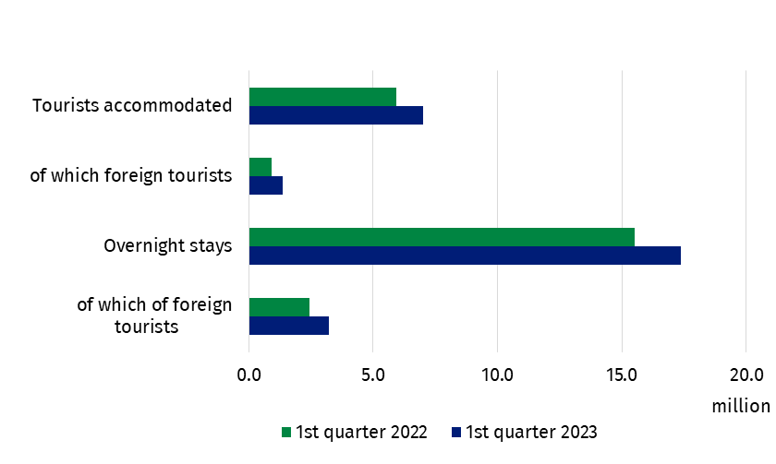
Chart 1. Tourists in tourist accommodation establishments and overnight stays
Compared to the same period last year, 14 of the 20 types of establishments saw an increase in the number of tourists. The largest increase in the number of tourists occurred at camp sites (up 102.1%). Tourists also significantly increased at youth shelters (by 56.4%), creative arts centres (by 39.8%) and hostels (by 29.9%). A decrease in the number of tourists compared to the first quarter of the previous year was recorded to the greatest extent at camping sites (by 26.6%), followed by holiday youth centres (by 26.3%) and excursion hostels (by 20.2%). In the first quarter of 2023, tourists were most likely to choose to stay in hotels, where 5.3 million people stayed. Overnight statys in these establishments were provided to 73.4% of all domestic tourists and 84.4% of all foreign tourists.
In the first quarter of 2023, 4.2 million domestic tourists were accommodated in hotels
Table 1. Occupancy of tourist accommodation establishments by type of establishment
Specification | Tourists accommodated |  | Overnight stays provided
Specification | in thousand | Q1/2022=100 | in thousand | Q1/2022=100
Total | 7 022.9 | 118.1 | 17 383.0 | 112.0
Hotels and similar establishments | 5 949.7 | 119.3 | 11 972.0 | 112.4
hotels | 5 305.3 | 121.1 | 10 409.2 | 114.4
motels | 41.2 | 120.4 | 72.5 | 114.2
boarding houses | 104.8 | 100.0 | 266.8 | 96.9
other hotel establishments | 498.4 | 107.1 | 1 223.5 | 100.9
Other establishments | 1 073.1 | 112.0 | 5 411.0 | 111.1
excursion hostels | 7.5 | 79.8 | 32.8 | 68.2
shelters | 32.3 | 92.1 | 58.6 | 91.4
youth shelters | 10.4 | 156.4 | 31.3 | 161.2
school youth shelters | 31.4 | 106.6 | 121.2 | 100.3
holiday centres | 210.2 | 102.8 | 913.4 | 108.2
holiday youth centres | 4.1 | 73.7 | 18.3 | 56.7
training-recreational centres | 131.3 | 111.2 | 479.6 | 106.2
creative arts centres | 5.5 | 139.8 | 21.1 | 128.4
complexes of tourist cottages | 14.6 | 114.2 | 57.0 | 138.2
camping sites and tent camp sites | 2.7 | 85.2 | 7.4 | 92.8
hostels | 146.7 | 129.9 | 322.8 | 105.8
health establishments | 192.1 | 116.6 | 2 393.1 | 119.3
rooms for guests | 168.8 | 119.3 | 528.3 | 106.0
agritourism lodgings | 15.2 | 88.7 | 62.0 | 88.8
other not classified | 100.4 | 107.2 | 364.2 | 105.4
An increase in the number of tourists accommodated was recorded in all voivodships compared with the first quarter of 2022, with the largest in Mazowieckie Voivodship (by 28.3%). The smallest increase was recorded in Podkarpackie Voivodship (by 0.3%). Nearly half of tourists (48.4%) accommodated in the first quarter of 2023, stayed in three voivodships: Mazowieckie, Małopolskie and Dolnośląskie (3.4 million in total). The fewest tourists (68.2 thousand) stayed in establishments located in Opolskie Voivodship – 1.0% of the total.
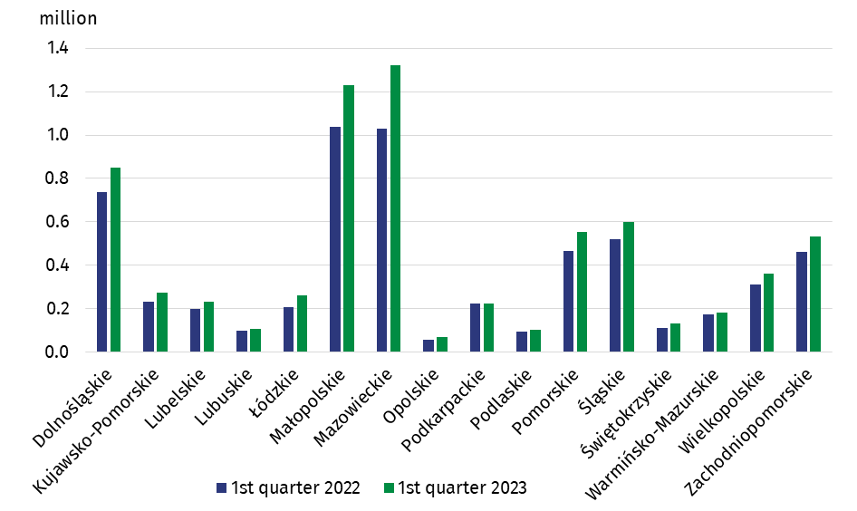
Chart 2. Tourists accommodated by voivodship
In the first quarter of 2023, tourists made 17.4 million overnight stays, i.e. almost 12.0% more than in the corresponding quarter of 2022. Domestic tourists made 14.2 million overnight stays, while foreign tourists from 3.2 million. Compared to the first quarter of 2022, there was an 8.2% increase in the number of overnight stays provided to domestic tourists and a 32.6% increase in overnight stays provided to foreign tourists. Tourists were most likely to choose hotels, where they made 10.4 million overnight stays i.e. 14.4% less than a year ago.
In the first quarter of 2023, 1.9 million more overnight stays were provided to tourists than in the same quarter last year
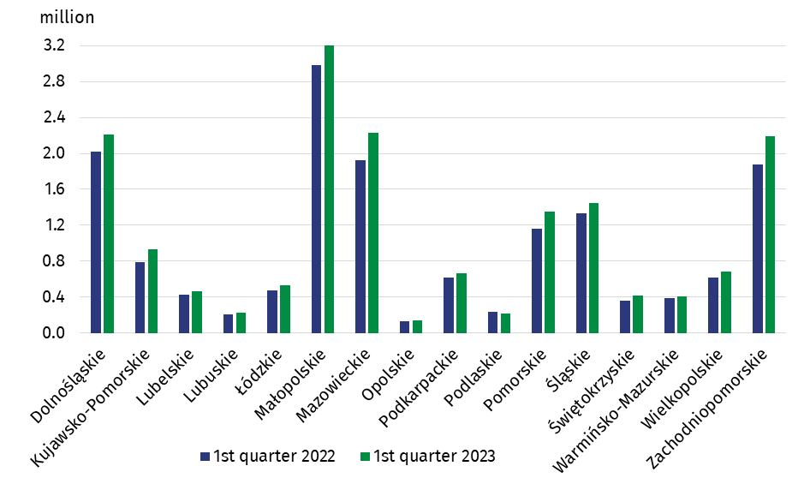
Chart 3. Overnight stays provided in tourist accommodation establishments by voivodship

The highest number of overnight stays was provided in Małopolskie Voivodship – 3.3 million (18.9% of the total), and the lowest in Opolskie Voivodship – 139.5 thousand (0.8%). The increase in the number of overnight stays was recorded in all the voivodships exept Podlaskie Voivodship, where 19.9 thousand fewer overnight stays were provided than in the first quarter of 2022 (down 8.5%). The largest increase occurred in Kujawsko-Pomorskie Voivodship (by 18.4%), and the smallest in Warmińsko-Mazurskie Voivodship (by 4.7%).
In the first quarter of 2023, the occupancy rate was 35.7% and was 3.5 pp higher than in the first quarter of last year. The lowest occupancy rate was recorded in January – 33.0% (up 6.0 pp). In February this year, the value of this rate was 39.6% (an increase of 4.7 pp), while in March this year it decreased minimally and amounted to 34.9%, compared to 35.2% a year ago.
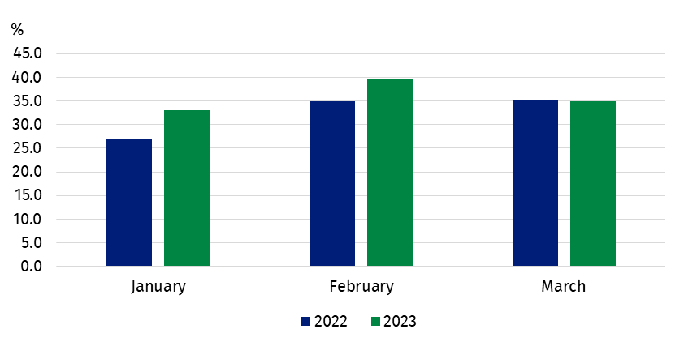
Chart 4. Occupancy rate of bed places
In the first quarter of 2023, the occupancy rate of bed places in accommodation
establishments was 44.9%
In hotels and similar establishments, 7.1 million rooms were rented in the first quarter of this year (6.0 million in the same period of 2022), while the occupancy rate was 44.9%, 5.7 pp higher than in the first quarter of last year.
When quoting Statistics Poland data, please provide information: “Source of data: Statistics Poland”, and when publishing calculations made on data published by Statistics Poland, please provide information: “Own study based on Statistics Poland data”.

Prepared by:  Statistical Office in Rzeszów  Director Marek Cierpiał-Wolan  Office: tel. (+48 17) 853 52 10 | Issued by:  The Spokesperson for the President  of Statistics Poland  Karolina Banaszek  Mobile: (+48) 695 255 011
Press Office  Phone: (+48 22) 608 34 91, 608 38 04  e-mail: obslugaprasowa@stat.gov.pl |   stat.gov.pl/en/

@ StatPoland

@GlownyUrzadStatystyczny

gus_stat

glownyurzadstatystycznygus

glownyurzadstatystyczny
Related information
Occupancy of tourist accommodation establishments in March 2022 in the face of the inflow of refugees from Ukraine and the absence of restrictions related to the COVID-19 pandemic
Occupancy of tourist accommodation establishments in 2022
Occupancy of tourist accommodation establishments in the first quarter of 2022
Tourism in 2021
Data available in databases
Local Data Bank
Terms used in official statistics
Tourist
Tourist accommodation establishment
Bed places in tourist accommodation establishments
Foreign tourists in tourist accommodation establishments
Nights spent (overnight stays) in tourist accommodation establishments
Duration of the stay
Occupancy rate of bed places in tourist accommodation establishments

