Energy consumption in households in 2021
Households in Poland had a significant share in gross inland energy consumption (excluding motor fuels). Average electricity consumption in households in 2021 increased by 20,9 % compared to 2002.
20.2%
Share of households in gross
inland energy consumption

Structure of household energy consumption
In 2021 in Poland share of households in gross inland energy consumption (excluding motor fuels) amounted to 20.2%. On average, households used approximately 24.6 GJ of energy per 1 inhabitant, which placed Poland at the European average level of
24.5 GJ/1 inhabitant.
In the structure of energy consumption in households in Poland, most relevant were solid fuels, mainly hard coal (which is an exception in the European Union) and fuel wood. They were most frequently used for space heating (by 32.8% of households). These fuels were used also for water heating (22.5% of households) and much less for cooking (1.7%).
District heating (52.2%) and solid fuels (32.8%) played a key role in space heating
Table 1. Structure of energy consumption in households by type of use (in %)
65.1 per cent of the energy consumed by households was used for space heating. The share of energy used for space heating decreased by 3.7 p.p. compared to 2012
Specification | 2012 | 2015 | 2018 | 2021
Space heating | 68,8 | 65,5 | 65,1 | 65,1
Water heating | 14,8 | 16,2 | 16,6 | 17,3
Cooking | 8,3 | 8,5 | 8,5 | 8,5
Lighting (including electrical equipment) | 8,1 | 9,8 | 9,8 | 9,0
A highly relevant energy carrier is district heating, which was used for space heating in
52.2% of all dwellings, mainly in cities where it was the predominating commodity (74,3%). Moreover 41.1% of households, i.e. 78.2% of all district heating consumers, obtained heated water from the district installation.
Natural gas was used in 56.6% of households, but 30.8%of consumers used it only for cooking, and only 14.5% for space heating. This structure of gas consumption was the result of the long-standing practice of installing gas networks in multi-family buildings for the sole purpose of cooking meals. In those areas of the country which have no access to natural gas,
the use of LPG was more common (30.6%), though it was almost exclusively used for
cooking (30.5%).
Fuel wood was used by 21.0% of households. It was the only renewable energy commodity used by households on a massive scale. It was usually burnt in the same boilers and
stoves as hard coal, either together with coal or interchangeably. Apart from fuel wood,
households also used other types of biomass, though they were far less common than wood.
In 2021, firewood was used in one in five households

Solar collectors were used by one out of 38 households, and heat pumps by as few as one out of 132 households.
Electricity was commonly used by households, mainly for lighting as well as power supply for electrical appliances and electronic devices. The use of electricity for heating
purposes was insignificant (5.5%), due to high prices and availability of cheaper
substitutes. Electricity was also used for cooking and space heating, usually on a secondary basis, whereas its use for water heating was common mainly in those areas which
did not have access to the heating or gas network.

Table 2: Share of households using various energy carriers for space heating (in %)
Specification | 2012 | 2015 | 2018 | 2021
Electricity | 5,4 | 4,5 | 5,1 | 5,5
District heat | 41,5 | 41,7 | 40,4 | 52,2
Natural gasª | 8,8 | 10,1 | 14,0 | 14,6
LPG | 0,3 | 0,3 | 0,5 | 0,8
Heating oil | 0,4 | 0,4 | 0,5 | 0,3
Hard coal | 40,8 | 40,4 | 36,5 | 20,9
Brown coal | 1,4 | 1,1 | 0,5 | 0,4
Coke | 0,7 | 0,8 | 0,6 | 0,2
Fuel wood | 40 | 41,7 | 28,8 | 20,7
Other types of biomass | 4,3 | 3,0 | 1,3 | 2,3
Solar energy | 0,07 | 0,15 | 0,13 | 0,40
Heat pumps | 0,05 | 0,07 | 0,28 | 0,69
a - data for 2012 refer to high-methane gas

Appliances for space and water heating
In dwellings equipped with central heating boilers (for solid fuels or natural gas), double-function boilers were most frequent present (26.3%) and used simultaneously for water heating. Single-function boilers were less popular (15.1%), though still more common than fireplaces (2.4%).

Chart 1: Space heating by heating techniques in 2021 (in %)
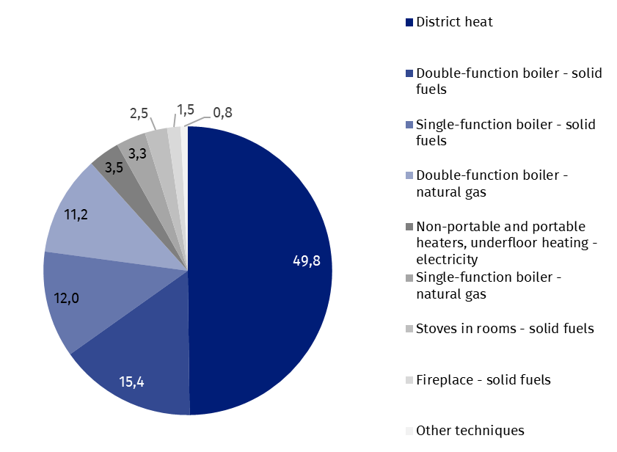
The most common way to obtain hot water was through a district heating installation (41.1% of households), a significant share constituted also electric boilers or water heaters (19.5%) as well as bathroom heaters for natural gas (13.4%), while double-function boilers or water heaters for solid fuels were used in 13,5% of households and for natural gas in 11.2%.
Chart 2: Water heating by heating techniques in 2021 (in %)
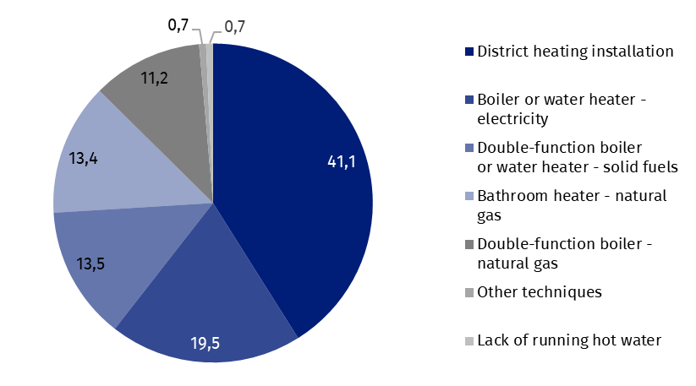
Households equippedwith energy-consuming appliances
Most households were well-equipped with basic energy-consuming devices, both those which satisfied the principal heating needs and those which improved the living comfort of inhabitants. A vast majority of households owned the most important electric appliances, such as TV sets (89.9%), automatic washing machines (89.6%), combined fridge-freezers (81.3%).

Energy poverty
Between 2012 and 2021, all 5 measures of energy poverty showed a downward trend. The highest value in 2021 was recorded for double median of energy expenditures, according to which in 18.8 % of households were characterised by energy poverty. Compared to 2012, the decrease was small (by 0.7 p.p.). The second of the objective indicators - high costs, low income – which covers both the technical condition of the buildings by determining the required energy costs and material status of households decreased from 11.1 % in 2012 to 10.5% in 2021.
Subjective indicators, which also relate to the severity of energy poverty, include the ability to pay bills on time - only a negligible number (0.8% in 2021) of households were unable to pay their bills on time which is a decrease of 2.8 p.p. compared to 2015.
Two indicators related to the technical and functional qualities of the buildings (buildings with leaking roofs and insufficient thermal comfort), had similar values, respectively: 3.5% and 5.2% in 2021, representing significant decreases in these compared to 2012. (7.0 p.p. and 7.9 p.p. respectively).
Chart 3. Energy poverty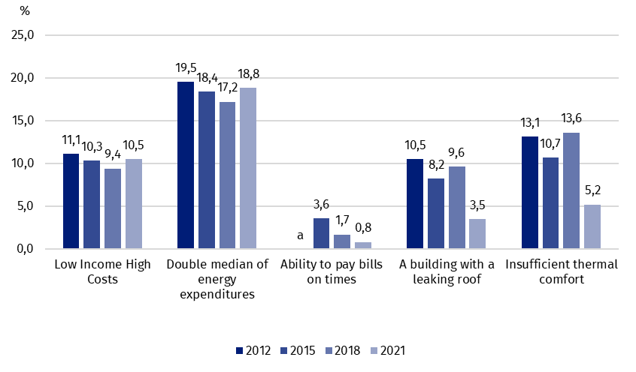
a. not available
When quoting Statistics Poland data, please provide information: “Source of data: Statistics Poland”, and when publishing calculations made on data published by Statistics Poland, please provide information: “Own study based on Statistics Poland data”.

Prepared by:  Statistical Office in Rzeszów  Director Marek Cierpiał-Wolan  Phone: (+48 48) 17 853 52 10 | Issued by:  The Spokesperson for the President  of Statistics Poland  Karolina Banaszek  Phone: (+48) 695 255 011
Press Office  Phone: (+48 22) 608 38 04  e-mail: obslugaprasowa@stat.gov.pl |   stat.gov.pl/en/

@StatPoland

@GlownyUrzadStatystyczny

gus_stat

glownyurzadstatystycznygus

glownyurzadstatystyczny
Related information
Energy statistics
Energy efficiency in Poland 2010-2020
Lorem ipsum dolor sit amet, consectetur
Data available in databases
Knowledge Database – Energy statistcs
Poland macroeconomic indicators
Macroeconomic Data Bank
Terms used inn official statistics
Primary energy
Derived energy
Energy consumption

Relative numbers were calculated on the basis of absolute data expressed with greater precision than given in the tables.

