Culture satellite account for 2018
2.8%
The share of the culture area in generating the gross added value in 2018
The share of culture in the national economy accounted for 2.8%, which was mainly due to the activity of entities in Advertising domain. Audio-visual arts and multimedia as well as Books and press had also a significant share. As in 2017 these domains dominated most of the transactions that made up the culture satellite account in 2018.

The share of the culture area in the national economy
The culture satellite account makes it possible to estimate the contribution of the area of culture, understood as the activity of local government and state cultural institutions, non-governmental organisations operating in the field of culture, and entities belonging to the cultural and creative industries, to the national economy. The share of the culture area in the national economy is best assessed by the gross added value of the area of culture in relation to the gross value added of the entire economy. In 2018 that value amounted to 2.8%. Compared to the previous year, this value slightly decreased – by 0.1 percentage point. The share of gross output of culture in relation to the gross output of the entire economy (2.9%) remained at the same level as a year earlier, as did the share of compensation of employees (2.7%). It is also worth noting a relatively large increase in the share of other subsidies on production in the area of culture (by 1.9 percentage points from 1.1% in 2017 to 3.0% in 2018) and the share of other taxes on production in culture (by 0.8 percentage points from 1.8% in 2017 to 2.6% in 2018). The increase in the first value was due mainly to the increase in subsidies in the area of Audio-visual arts and multimedia as well as in Artistic education domain.

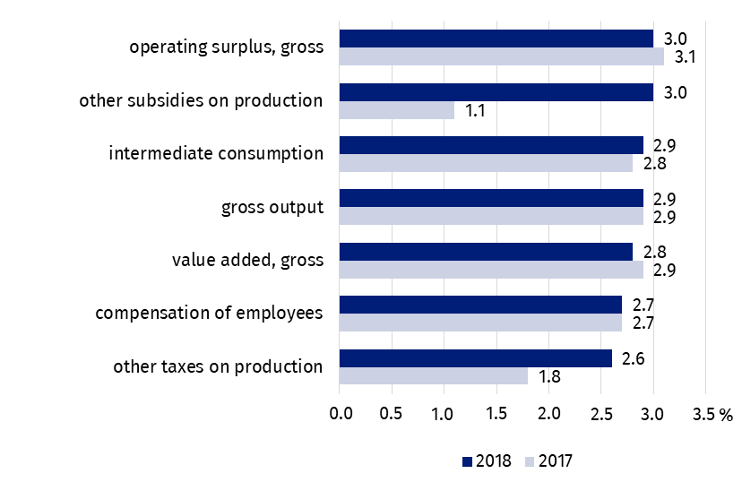
Chart 1. Share of the area of culture in selected transactions of the production account and the income generation account of the national economy
The largest share in the creation of the gross value added in the area of culture belonged to the entities included in the Advertising domain (20.9% of the value added in the area of culture). Audio-visual arts and multimedia (17.3%) and Books and press (13.8%) had also significant share. The smallest share in the generation of gross value added had Culture management and administration domain (0.5%). Compared to the previous year, the greatest decrease of share was observed for Culture management and administration domain (by 20.0%), while the biggest increase for Visual arts domain (by 12.2%).

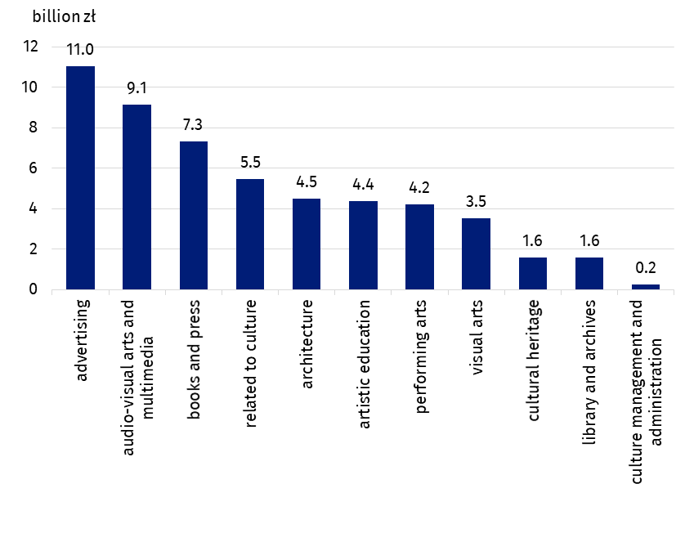
Chart 2. Gross value added in the area of culture by cultural domains in 2018 r.
The entities included in Advertising domain had the largest share in generating gross value added in the area of culture (20.9%)
The comparison of the area of culture with other sectors of the national economy, taking into account the Polish Classification of Activities (PKD), shows the real role of the area of culture in the national economy and, therefore, its contribution to the creation of Poland's Gross Domestic Product (GDP). Gross value added generated by entities operating within the PKD classes included in the area of culture was in 2018 by 0.1 percentage points higher than the gross value added generated by entities included in section A grouping entities from sector agriculture, forestry, hunting and fishery; and it was by 1.0 percentage points higher than the gross value added generated by entities classified in section B – mining and quarrying.

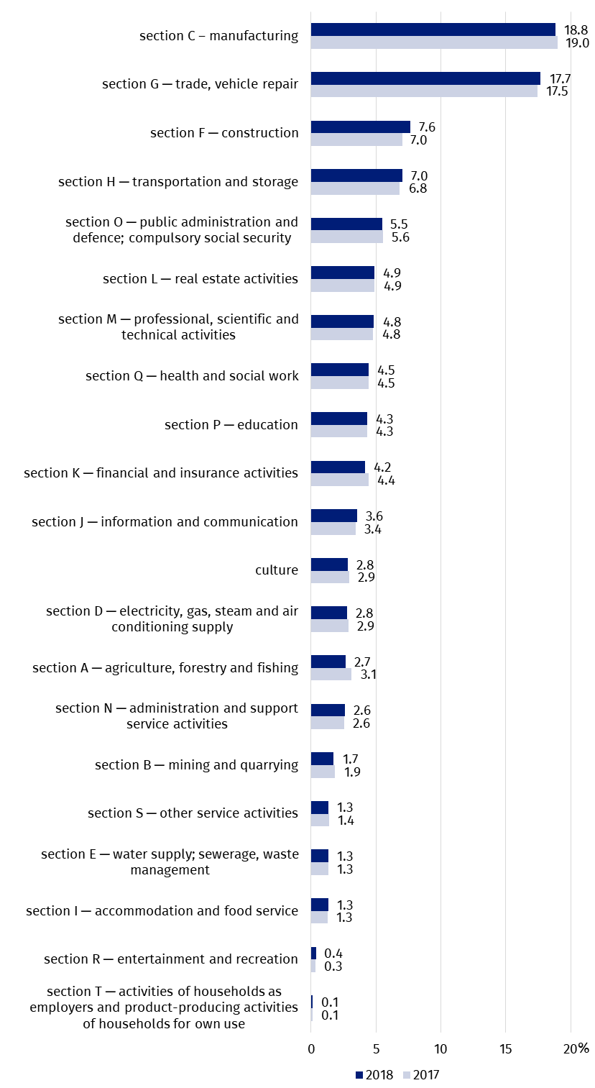
Chart 3. Share of the culture area in generating gross value added as compared to other sections of national economy in 2018 (according to PKD 2007)
The contribution of the cultural area to the national economy, counted by the gross value added, was 2.8%. It was by 0.1 percentage point lower than in 2017

Transactions in the culture satellite account
70.4% of the total global output in culture was generated by four domains: Advertising, Audio-visual arts and multimedia, Related to culture and Books and press
In 2018, the value of the gross output of the culture area amounted to PLN 124,847.7 million, i.e. PLN 9,878.1 million more than in 2017. The highest value of gross output was recorded in the Advertising domain (PLN 34,944.4 million, i.e. 28.0% of the gross output for the entire area of culture). The following domains also had a significant share: Audio-visual arts and multimedia (19.1% - increase by 5.2% as compared with 2017) and Related to culture (11.8%, increase by 2.8%) and Books and press (11.5%, an increase of 0.6%). The total share of the gross output generated by these four fields amounted to 70.4% of the total gross output in the area of culture. The smallest contribution to the gross output of the area of culture was made by entities from the Culture management and administration domain (0.5%, i.e. 15.1% less than in 2017). The largest increase in the value of gross output was recorded in the Visual arts domain (by 19.0% as compared to 2017).
The value of intermediate consumption, measuring the value of goods and services used as inputs in the production process, amounted to PLN 71,938.8 million (PLN 8,091.6 million more than in 2017), while the total gross value added for the entire area of culture amounted to PLN 52,909.0 million (PLN 1,786.5 million more than in 2017). Domains such as Libraries and archives and Artistic education deserve attention, as in their case the gross value added was almost twice as high as the value of the intermediate consumption. By comparison, in the case of among others Advertising, Audio-visual arts and multimedia, and the domain Related to culture, intermediate consumption was higher than the gross value added generated (more than twice in the case of Advertising and by almost 2/3 in the case of Audio-visual arts and multimedia and Related to culture domains).
In 2018 compensation of employees amounted to PLN 22,214.8 million (an increase by 1,574.9 million as compared with the previous year). The structure of compensation of employees is dominated by entities from the domains of Advertising (14.9%) and Books and press (13.8%). On the other hand, the share of entities in the domain Culture management and administration was the smallest (1.1%). The following domains had also a small share: Visual arts (2.9%), Architecture (4.7%), Cultural heritage (5.3%), and Libraries and archives (6.2%).
Gross operating surplus, constituting the difference between gross value added and compensation of employees and other taxes related to production diminished by other subsidies related to production, amounted to PLN 30,485,2 million (by PLN 356.7 million more than in 2017). The highest result was related to the Advertisement domain (PLN 7,698.7 million, although compared to 2017, the gross operating surplus for this domain decreased by a record 717,1 million which means the largest decrease (by 8.5%) among all domains of culture. The highest increase in the gross operating surplus compared to 2017 was recorded in the domain Audio-visual arts and multimedia (by 18.7%).
The highest other subsidies on production were received by entities in the domain of Audio-visual arts and multimedia (55.8% of other subsidies on production). The highest taxes on production were recorded also for entities in the Audio-visual arts and multimedia domain (60.0% of total other taxes on production).
In the analysed year, gross capital formation in the area of culture, measuring the increase in wealth, reached PLN 6,594.9 million (compared to PLN 2,989.0 million in 2017). The highest accumulation value was recorded in the Architecture domain (PLN 3,996.7 million vs. PLN 1,394.5 million in 2017).
In 2018 final consumption expenditure amounted to PLN 52,329.8 million (PLN 4,136.1 million more than in 2017) of which 72.2% related to households. In their case, the highest value of consumption was recorded in Audio-visual arts and multimedia domain (PLN 21,927.5 million, i.e. by PLN 5,282.6 million more than in 2017). In the general government sector (25.2% of final consumption expenditure), the highest value of consumption was observed in Performing arts domain (PLN 7,805.2 million, i.e. almost the same as in the previous year), and the lowest – in Related to culture (PLN 71.8 million). In the sector of non-profit institutions serving households which are related to culture, final consumption expenditure amounted to PLN 1,355.2 million (PLN 383.6 million more than in 2017). The highest value of expenditure was recorded in Performing arts (PLN 397.1 million), and the lowest in Audio-visual arts and multimedia (PLN 3.6 million).
More than 72% of final consumption expenditure was attributable to households, where the highest values were recorded in Audio-visual arts and multimedia domain

Table 1. Main transactions in culture satellite account according to cultural domains in 2018
Specification | Gross output | Interme-diate consump-tion | Value added, gross | Compensation of employ-yees | Other taxes on produc-tion | Other subsidies on produc-tion | Operating surplus, gross
Specification | in PLN million
Total | 124,847.7 | 71,938.8 | 52,909.0 | 22,214.8 | 958.5 | 749.5 | 30,485.2
Cultural heritage | 3,296.0 | 1,725.9 | 1,570.1 | 1,170.3 | 33.7 | 0.6 | 366.7
Library and archives | 2,418.9 | 850.0 | 1,568.9 | 1,368.9 | 16.4 | 0.3 | 183.8
Books and press | 14,411.9 | 7,102.3 | 7,309.6 | 3,073.3 | 46.1 | 15.3 | 4,205.5
Visual arts | 6,444.8 | 2,927.2 | 3,517.6 | 646.8 | 16.4 | 2.2 | 2,856.6
Performing arts | 8,677.8 | 4,459.9 | 4,217.9 | 2,942.5 | 117.6 | 1.5 | 1,159.4
Audio-visual arts and multi-media | 23,844.9 | 14,714.7 | 9,130.2 | 2,853.3 | 575.6 | 418.5 | 6,119.8
Architecture | 8,476.7 | 4,002.8 | 4,473.9 | 1,041.0 | 25.4 | 7.2 | 3,414.6
Advertising | 34,944.4 | 23,902.8 | 11,041.6 | 3,308.9 | 60.0 | 26.0 | 7,698.7
Artistic education | 7,020.2 | 2,651.8 | 4,368.5 | 2,704.7 | 30.1 | 201.0 | 1,834.6
Related to culture | 14,712.7 | 9,244.1 | 5,468.6 | 2,865.8 | 34.9 | 65.8 | 2,633.7
Culture management and administration | 599.2 | 357.1 | 242.1 | 239.3 | 2.4 | 11.2 | 11.7

Table 1. Main transactions in culture satellite account according to cultural domains in 2018 (cont.)
Specification | Final consumption expenditure |  |  | Gross capital formation | Imports of goods and services | Exports of goods and services
Specification | by house-holds | by non-profit institu-tions | by general govern-ment | Gross capital formation | Imports of goods and services | Exports of goods and services
Specification | in PLN million
Total | 37,779.9 | 1,355.2 | 13,194.6 | 6,594.9 | 20,367.6 | 25,467.2
Cultural heritage | 2,130.8 | 327.9 | 179.8 | -0.8 | 194.7 | 366.3
Library and archives | – | 108.8 | 927.8 | -0.3 | – | –
Books and press | 6,487.6 | 34.1 | 1,073.0 | 299.9 | 2,553.0 | 5,959.8
Visual arts | 1,048.6 | 55.9 | 82.5 | 0.4 | 58.9 | 57.0
Performing arts | 3,373.1 | 397.1 | 7,805.2 | 1,639.3 | 716.3 | 269.8
Audio-visual arts and multimedia | 21,927.5 | 3.6 | 337.6 | 684.0 | 11,058.8 | 8,286.4
Architecture | – | – | 207.6 | 3,996.7 | 155.6 | 183.9
Advertising | – | – | – | -14.1 | 5,603.6 | 10,202.5
Artistic education | 955.9 | 184.2 | 2,509.3 | 1.1 | – | –
Related to culture | 1,856.5 | 4.5 | 71.8 | -12.2 | 26.7 | 141.6
Culture management and administration | – | 239.1 | – | 0.7 | – | –

In 2018, there was a positive balance in foreign trade in cultural and creative goods and services in the amount of PLN 5,099.6 million, i.e. by PLN 959.6 million less than in 2017. The positive balance of foreign trade was mainly due to the commercial activity of entities from the Advertising domain (the balance of PLN 4,598.9 million, PLN 632.3 million more than in 2017) and Books and press (the balance of PLN 3,406.8 million, PLN 119.7 million less than in 2017). The Audio-visual arts and multimedia, Performing arts and Visual arts domains recorded a negative balance in 2018 (respectively: - PLN 2,772.4 million, - PLN 446.5 million, - PLN 1.9 million). The same fields accounted for the amount of exports as in 2017, although their percentage share in total exports changed slightly. Most goods and services were exported in the Advertising domain (40.1%). Audio-visual arts and multimedia (32.5%) and Books and press (23.4%) also had a large share in exports. In the case of imports, the following domains dominated: Audio-visual arts and multimedia (54.3%), Advertising (27.5%) and Books and press (12.5%).
In the case of quoting data from the Statistics Poland, please provide information: "Statistics Poland data source", and in the case of publishing calculations made on data published by the Statistics Poland, please provide information: "Own study based on Statistics Poland data".
Prepared by:  Statistical Office in Kraków  Director Agnieszka Szlubowska  Phone: (+48 12) 420 40 50 | Issued by:  The Spokesperson for the President  of Statistics Poland  Karolina Banaszek  Phone: (+48) 695 255 011
Press Office  Phone: (+48 22) 608 38 04  e-mail: obslugaprasowa@stat.gov.pl |   stat.gov.pl/en/

@StatPoland

@GlownyUrzadStatystyczny

gus_stat

glownyurzadstatystycznygus

glownyurzadstatystyczny
Related information
Report on methodological work. Culture Satellite Account (PL version only)
Cultural satellite account for 2017
Cultural and creative industries 2014-2016
Culture and creative industries in 2021
Culture and national heritage in 2021
Terms used in official statistics
Gross capital formation
Exports of goods and services
Imports of goods and services
Compensation of employees
Operating surplus, gross
Gross output
Gross Domestic Product (GDP)
Final consumption expenditure
Value added, gross
Intermediate consumption

In order to present the data according to PKD sections, it was necessary to exclude from some sections of the national economy individual classes that were included in the calculations for the area of culture. The area of culture includes the following classes: 18.11; 18.12; 18.20; 32.20; 47.61; 47.62; 47.63; 58.11; 58.13; 58.14; 58.21; 59.11; 59.12; 59.13; 59.14; 59.20; 60.10; 60.20; 63.91; 71.11; 73.11; 74.10; 74.20; 74.30; 77.22; 90.01; 90.02; 90.03; 90.04; 91.01; 91.02; 91.03 and for data concerning the general government sector also some part of classes: 84.11; 84.12; 84.25, 94.12 and in the field of artistic education some part of classes: 85.10; 85.20; 85.31; 85.32; 85.41; 85.42; 85.52; 85.59; 85.60.
Data on final consumption expenditure, gross accumulation and foreign trade in Culture satellite account are calculated on the basis of data by balance groups presented in the supply and use tables.

