Cinematography in 2022
2.1 million screenings were shown in indoor cinemas, watched by 41.4 million viewers. As of the end of 2022, there were 532 indoor cinemas operating in Poland. In 2022, 367 films were produced in Poland for presentation in cinemas and television.
50.8%
Increase of the audience in indoor cinemas in comparison to 2021

Cinemas activity
There were 1.6 thousand screens with 296.9 thousand seats for the audience in indoor cinemas. Compared to 2021, the number of screenings increased by 57.2% and audience by 50.8%. Mazowieckie voivodship definitely prevailed in terms of the number of screenings in indoor cinemas (83). Śląskie (54), Wielkopolskie (50), Dolnośląskie (49) and Małopolskie (46) voivodships also stood out. The largest number of screenings per 1 indoor cinema was recorded in Kujawsko-Pomorskie voivodship (119.2 thousand), and the least in Świętokrzyskie Voivodship (48.7 thousand).

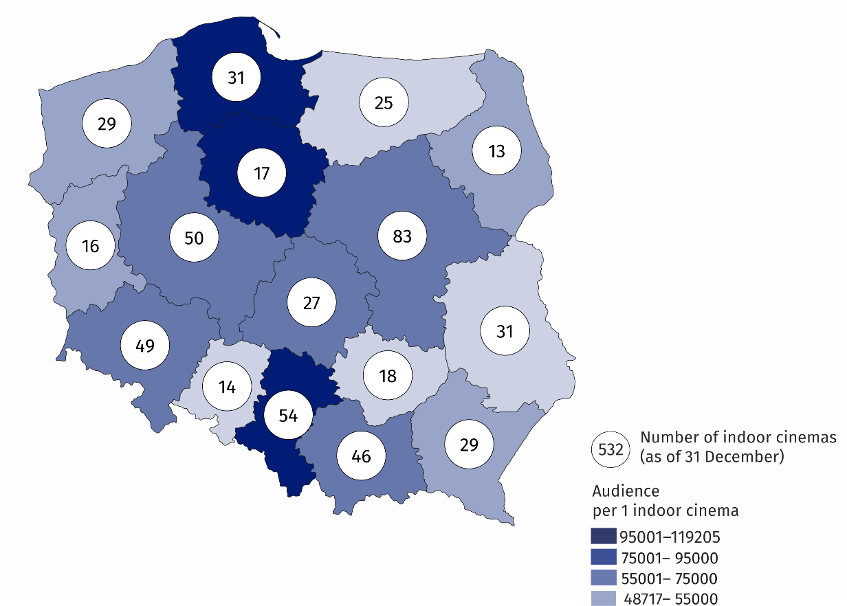
Map 1. Indoor cinemas in 2022
18.5% of the total number of audience in indoor cinemas watched films in Mazowieckie voivodship
In the year under review there were 360 indoor cinemas with one or two screens, 111 miniplexes (with 3 to 7 screens) and 61 multiplexes (with 8 or more screens). The multiplexes displayed 49.3% of the total number of screenings, watched by 47.6% of the total audience. The miniplexes displayed 37.8% of the total number of screenings, watched by 37.6% of the total audience. One multiplex had an average of 2.0 thousand seats for the audience and displayed an average of 17.2 thousand screenings.
67.7% of the total number of cinemas had 1–2 screens

Chart 1. The structure of indoor cinemas by number of screens in 2022

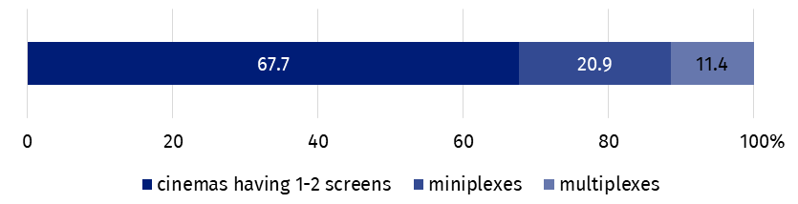
As of 31 December

Film production
112 full-length films and 255 medium- and short-length films (intended for cinemas and television) were produced in Poland (85 and 217 respectively in 2021). On an annual basis, the number of produced full-length feature films increased by 41.7% (from 60 to 85), of which cinema feature films increased by 34.1% (from 41 to 55) and television feature films increased by 57.9% (from 19 to 30). The number of full-length documentary films increased by 25.9% (from 166 to 209) with the increase mainly in medium- and short-length films (29.2%). 178 documentary films were intended for television and 31 for cinemas.

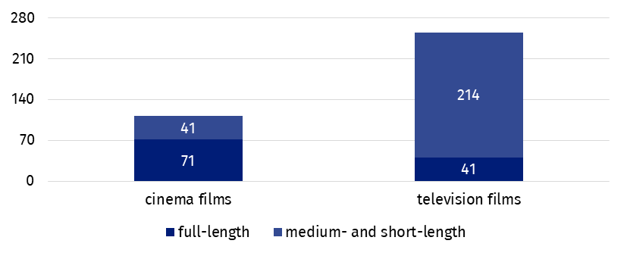
Chart 2. Films produced in 2022
Documentary films accounted for 56.9% of the total number of films
The most frequently produced type of full-length films were feature films which accounted for 75.9% of the total number of cinema and television feature films, while documentary films dominated among medium- and short-length films (72.9% of the total number of cinema and television medium- and short-length films).

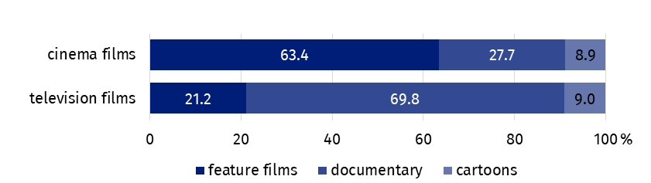
Chart 3. The structure of films by type in 2022
In the case of quoting data from the Statistics Poland, please provide information: "Statistics Poland data source", and in the case of publishing calculations made on data published by the Statistics Poland, please provide information: "Own study based on Statistics Poland data".
Prepared by:  Statistical Office in Kraków  Director Agnieszka Szlubowska  Office: tel. (+48 22) 420 40 50 | Issued by:  The Spokesperson for the President of Statistics Poland  Karolina Banaszek  Mobile: (+48) 695 255 011
Press Office  Office: tel: +48 22 608 38 04  e-mail: obslugaprasowa@stat.gov.pl |   stat.gov.pl/en

@StatPoland

@GlownyUrzadStatystyczny

gus_stat

glownyurzadstatystycznygus

glownyurzadstatystyczny
Related information
Culture and national heritage in 2021
Cinematography in 2021
Terms used in official statistics
Indoor cinema
Audience
Film

