Cultural and creative industries in 2021
130.0 thousand enterprises belonging to the cultural and creative industries operated in 2021. The overwhelming majority of entities (99.2%) were micro-enterprises, comprising 75.8% of those working in the area of cultural and creative industries. Gross monthly salary per employee amounted to PLN 6,927, i.e. PLN 592 more than in 2020; it was higher by PLN 994 in comparison with all non-financial enterprises.
8.8%
The increase in the number of enterprises belonging to the cultural and creative industries as compared with 2020.
The results for 2021 suggest that after a temporary slowdown and declines recorded in the area of cultural and creative industries in 2020, in many cases one can talk about a slight improvement and return to pre-pandemic trends.

The number and types of enterprises belonging to the cultural and creative industries
Since 2015, an increase in the number of entities included in the cultural and creative industries has been recorded annually. In 2021, the growth rate was higher than in previous years – the number of entities increased by 8.8% and amounted to 135.0 thousand. Entities categorized the cultural and creative industries accounted for 5.7% of all non-financial enterprises.

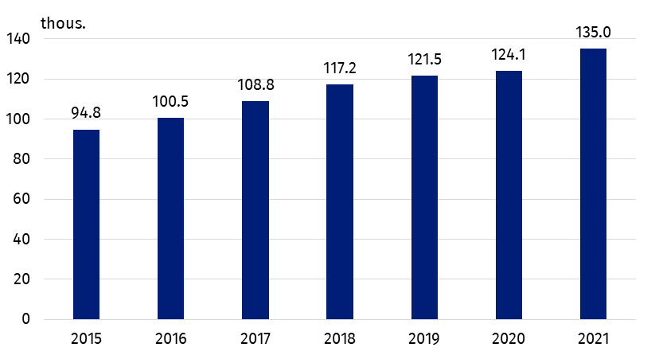
Chart 1. Number of enterprises belonging to the cultural and creative industries
The largest number of enterprises belonging to the cultural and creative industries operated in the domain of Visual arts (26,3%).
The largest number of the entities conducted activities related to the field of Visual Arts (26.3%). Compared to 2020, the largest increase in the number of operating entities was recorded in the field of Architecture (by 5.8 percentage points). The decrease in the number of entities occurred mainly in the field of Audio-visual Arts and Multimedia (by 9.8 percentage points). In the years 2015-2021, the share of entities in the field of Visual Arts in the total number of entities classified as cultural and creative industries almost doubled, while the share of entities operating in the field of Books and Press decreased by more than half.

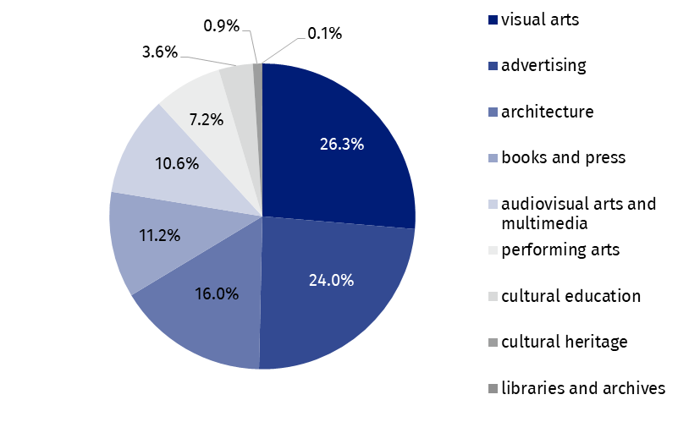
Chart 2. The structure of entities belonging to the cultural and creative industries by domain of culture in 2021
Most of the entities classified as cultural and creative industries were micro-enterprises. They accounted for 5.9% of all non-financial micro-enterprises.

The majority of entities were classified as micro-enterprises (99.2% of all entities belonging to the cultural and creative industries). In total, in 2021 there were 133.9 thousand of them, which accounted for 5.9% of all non-financial micro-enterprises. In other size classes of enterprises, the share of cultural and creative industries in the group of non-financial enterprises was as follows: small enterprises – 1.8%, medium and large – 1.2% each.

Employed persons, average employment and salaries
Gross monthly remuneration per 1 employee in the cultural and creative industries was higher by PLN 994 compared to the total non-financial enterprises
As compared to 2020, the number of employees increased by 6.1% and reached 257.3 thousand people. This accounted for 2.5% of the total number of employees in non-financial enterprises (0.1 percentage point more than in 2020). The percentage of people working in micro-enterprises amounted to 75.8% (an increase by 1.9 percentage points). Despite the greater number of large enterprises, the percentage of employees working in entities of this size class decreased (by 1.1 percentage points) and amounted to 10.6% of all culture and creative industries. Small enterprises employed 7.0% of the total number of employees in the cultural and creative industries, and medium-sized enterprises – 6.7%. The analysis of average employment allowed to conclude that the structure of employment was more balanced: out of the total number of 100.1 thousand full-time jobs, 43.3 thousand of them were in micro-enterprises (43.2%), large enterprises offered 25.0 thousand full-time jobs (24.9%), small enterprises – 16.1 thousand (16.1%), and the medium - 15.8 thousand (15.8%).
Both in non-financial enterprises and in the cultural and creative industries, the gross monthly salary per 1 employee increased compared to the previous year (by 10.0% and 9.3%, respectively). In the cultural and creative industries, the monthly gross remuneration per employee amounted to PLN 6,927 and was PLN 592 higher than in the previous year. The increase in salaries was visible in all size classes of entities classified as cultural and creative industries, with the highest increase in medium-sized enterprises (by PLN 1,102). The monthly gross remuneration per 1 employee in large enterprises increased by PLN 901, in small enterprises by PLN 624, and in micro-enterprises by PLN 438. Regardless of the size class of enterprises, in the cultural and creative industries, the monthly gross remuneration per 1 employee was higher than in all non-financial enterprises together. In total, this difference was PLN 994, but in the largest group of entities, i.e. in micro-enterprises, it was only PLN 340 (in small enterprises – PLN 1,944, in medium enterprises – PLN 2,825 and in large ones – PLN 3,038). The share of gross salaries in the total costs in the case of enterprises classified as cultural and creative industries amounted to 10.7%.

Table 1. Employed persons, average paid employment, gross wages, and salaries in the cultural and creative industries in 2021
Specification | Number of persons  employedª | Average paid employment | Gross wages and salaries in thousands PLN | Monthly gross wages and salary per 1 paid employee in PLN
Total | 257,298 | 100,135 | 8,323,965 | 6,927
Micro-enterprises | 194,947 | 43,267 | 2,172,718 | 4,185
Small enterprises | 17,895 | 16,105 | 1,436,787 | 7,434
Medium enterprises | 17,170 | 15,809 | 1,737,957 | 9,161
Large enterprises | 27,286 | 24,954 | 2,976,503 | 9,940
a As of December 31.

Financial results
Entities classified as cultural and creative industries generated total revenues of PLN 90.8 billion (PLN 6.3 billion more than in 2020), with total costs of PLN 77.5 billion (PLN 4.8 billion more than in the year before). Thus, as in previous years, a surplus of total revenues over total costs, amounting to PLN 13.4 billion, was recorded (PLN 1.6 billion more than in 2020). The cost level indicator (a ratio of total costs to total revenues) for all enterprises included in the cultural and creative industries amounted to 85.3% (a decrease of 0.7 percentage points from the 2020 level) and compared to the indicator for all non-financial enterprises was lower by 5.6 percentage points – cultural and creative activities were, therefore, less cost-intensive.
The surplus of total revenues over total costs for cultural and creative industries amounted to PLN 13.4 billion.
Total costs per 1 entity classified as part of the cultural and creative industries amounted to PLN 573.7 thousand, while their total revenues were PLN 672.7 thousand. The share of both total revenues and total costs generated by enterprises classified as cultural and creative industries in total revenues and total costs achieved by all non-financial enterprises amounted to 1.4% in both cases.
Enterprises from the cultural and creative industries group generated the value added of PLN 25.4 billion (PLN 738.8 million more than in 2020), which accounted for 1.8% (a decrease of 0.1 percentage point compared to until 2020) of the value added generated by all non-financial enterprises in the analysed year. Almost half of the value added was provided by micro-enterprises – PLN 11.7 billion. In the case of large enterprises, it was PLN 7.0 billion, and small and medium-sized enterprises generated PLN 3.1 billion and PLN 3.6 billion of the value added respectively. Calculated per 1 enterprise, the total value added of the cultural and creative industries was 3.3 times lower than the value added per 1 non-financial enterprise.

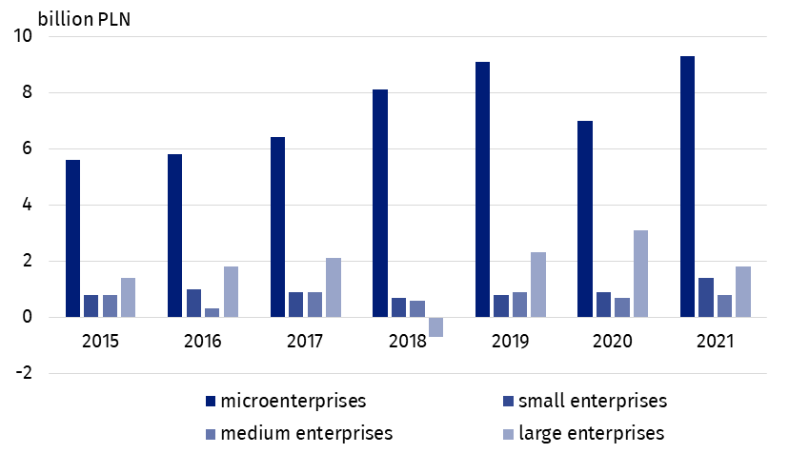
Chart 3. The surplus of total revenues over total costs in enterprises belonging to the cultural and creative industries by enterprise size class

International trade in cultural and creative goods and services
In 2021, cultural and creative goods worth PLN 18,055.6 million were sold abroad, i.e. PLN 1,075.1 million (6.3%) more than in the previous year. Imports of cultural and creative goods also increased, by 16.7%, reaching PLN 12,593.8 million. Thus, the foreign trade balance amounted to PLN 5,461.8 million. The largest amount was obtained from the sale of goods within the field of Books and Press (PLN 8,136.5 million), followed by Audio-visual Arts and Multimedia (PLN 7,986.1 million). In case of Books and Press a positive balance of turnover was recorded (PLN 4,992.9 million), whereas the area of Audio-visual Arts and Multimedia showed the largest negative balance of all fields (PLN -374.7 million). These are completely different results than those of 2020, where the latter field not only recorded the highest sales amounts, but also showed a positive foreign trade balance.
In 2021, a positive balance of international trade of cultural and creative goods was recorded, amounting to PLN 5,461.8 million. The balance of trade of cultural and creative services was negative, at the level of -PLN 1,429.0 million.
Compared to 2020, the largest increase in the value of exported cultural and creative goods was observed in the case of Cultural Heritage (by 363.8%). A large increase was also recorded in such fields as: Arts and Crafts (113.0%), Visual Arts (65.9%), Performing Arts (32.9%), Books and Press (15.8%) and Advertising (7.3%).
In 2021, cultural and creative services worth PLN 12,855.3 million were delivered abroad (i.e. PLN 1,610.9 million more than in 2020), while cultural and creative services worth PLN 14,284.4 million were purchased. This resulted in a negative foreign trade balance of services in the amount of PLN -1,429.0 million. The areas with a positive foreign trade balance were: Advertising (PLN 1,212.7 million), Architecture (PLN 95.2 million) and Cultural Heritage (PLN 15.8 million). A negative trade balance in services was recorded in the field of Audio-visual Arts and Multimedia (PLN -2,013.5 million), where imports exceeded exports by more than 2.7 times, Books and Press (PLN -69.6 million) and Performing Arts (PLN -169.5 million). The highest value of exports of cultural and creative services was recorded in the field of Advertising (PLN 10,835.7 million), significantly exceeding the value of exports in the following areas: Audio-visual Arts and Multimedia (PLN 1,163.9 million) and Cultural Heritage (PLN 318.7 million). The highest value of imports was recorded in the field of Advertising (PLN 9,623.0 million), which is much more than in the fields of Audio visual Arts and Multimedia (PLN 3,177.4 million) and Books and Press (PLN 705.8 million).
In the structure of Poland's foreign trade, trade in cultural and creative goods and services played a relatively small role and in recent years this share has oscillated around the same values. The share of cultural and creative goods in the export of goods in 2021 amounted to 1.4% (a decrease of 0.2 percentage points), while in imports it was 1.0% (a decrease of 0.1 percentage points). The share of cultural and creative services in the foreign trade of services was slightly higher and amounted to 4.1% and 7.5% for exports and imports, respectively (a decrease in the share in exports by 0.3 percentage points and an increase in the share in imports by 0.2 percentage points).

Table 2. Foreign trade in cultural and creative goods and services by domain of culture in 2021
Specification | Cultural and creative goods |  | Cultural and creative services
Specification | export | import | export | import
Specification | in million PLN
Total | 18,055.6 | 12,593.8 | 12,855.3 | 14,284.3
Cultural heritage | 57.8 | 286.5 | 318.7 | 303.0
Books and press | 8,136.5 | 3,143.6 | 136.1 | 705.8
Visual arts | 312.4 | 186.9 | – | –
Architecture | 2.2 | 8.7 | 238.9 | 143.7
Performing arts | 241.6 | 363.4 | 162.0 | 331.5
Audio-visual arts and multimedia | 7,986.1 | 8,360.8 | 1,163.9 | 3,177.4
Advertising | 1,318.3 | 241.1 | 10,835.7 | 9,623.0
Arts and crafts | 0.8 | 2.8 | – | -
The recipients of Polish cultural and creative goods were primarily economically developed countries, especially the EU countries (88.9% of all turnover), including the Euro area members (76.8% of all turnover). The situation was similar in the case of imports of goods, where the main turnover was with developed countries, although to a lesser extent with the EU (53.4%) or the euro area itself (49.6%). The geographical structure of trade in cultural and creative services was similar. Most services were exported and imported to and from economically developed countries (94.7% and 95.6%, respectively), half of which to and from euro area countries.
In the case of quoting data from the Statistics Poland, please provide information: "Statistics Poland data source", and in the case of publishing calculations made on data published by the Statistics Poland, please provide information: "Own study based on Statistics Poland data".
Prepared by:  Statistical Office in Kraków  Director Agnieszka Szlubowska  Office: tel. (+48 22) 420 40 50 | Issued by:  The Spokesperson for the President of Statistics Poland  Karolina Banaszek  Mobile: (+48) 695 255 011
Press Office  Office: tel: +48 22 608 38 04  e-mail: obslugaprasowa@stat.gov.pl |   stat.gov.pl/en

@StatPoland

@GlownyUrzadStatystyczny

gus_stat

glownyurzadstatystycznygus

glownyurzadstatystyczny
Related works
Cultural and creative industries 2014–2016
Cultural and creative industries in 2020
Culture and national heritage in 2021
Terms used in the official statistics
Exports of goods and services
Imports of goods and services
Total costs
Average monthly gross wages and salaries
Average paid employment
Total revenues
Balance foreign trade commodity turnover
Balance of services
Cost level indicator
Gross earnings

