Market of the works of art and antiques in 2022
In 2022 the total amount of sold art and antiques amounted to PLN 650.7 million. The largest part of the total value of sales of works of art and antiques was obtained by entities through organisation of auctions – PLN 434,1 million.
10.1%
Increase in the sales of works of art and antiques in comparison to 2021.
The information received from 204 entities operating on the works of art and antiques market shows that 60.8% of them were exclusively engaged in the sale of art and antiques, while the others additionally conducted exhibition activities.
The largest number of entities on the market of works of art and antiques operated in Mazowieckie voivodship - 52 (25.5% of the total number of entities), including 44 entities selling works of art and antiques in Warszawa. There were 38 entities (18.6%) in Małopolskie voivodeship, of which 34 operated in Kraków. As in the previous year, the majority of entities (69.1%) involved in the sale of works of art and antiques were based in the capitals of voivodships.
25.5% of the total number of entities dealing in the sale of works of art and antiques were based in Mazowieckie voivodeship
The total amount of sold works of art and antiques amounted to PLN 650.7 million and increased by 10.1% in comparison to 2021. As in the previous year, the most works of art and antiques were sold in Mazowieckie voivodship - for the amount of PLN 508.0 million, which accounted for 78.1% of the total amount of sales of works of art and antiques in Poland.
The largest amount was obtained from the sale of works of art and antiques in the field of painting - PLN 563.0 million (i.e. 86.5% of the total amount of sales), including old painting - PLN 342.8 million (52.7% of the total amount of sales), and contemporary painting – PLN 220.2 million (33.8%). Compared to 2021, there was a 20.2% increase in sales of paintings, with the sale of old paintings increasing by 42.8% and the sale of contemporary paintings decreasing by 3.6%.
Most works of art and antiques were sold in the field of painting (86.5% of the total sales amount)

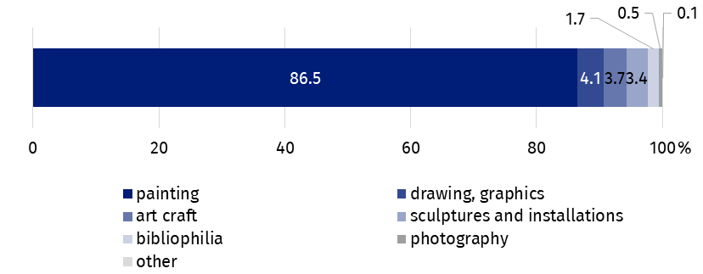
Chart 1. The structure of sale of works of art and antiques by type in 2022
The largest amount from the sale of works of art and antiques was obtained by entities through auctions - PLN 434.1 million (66.7%), including online auctions - PLN 16.3 million (3.7%).
Another distribution channel, significant in terms of the total sales value, was sales in retail outlets. Its value amounted to PLN 175.7 million, which accounted for 27.0% of the total amount of sales. Sales of works of art and antiques in retail outlets increased by 24.4% compared to the previous year.
Works of art and antiques were sold via the Internet (e.g. online stores, sales platforms) for the amount of PLN 33.3 million (5.1% of the total sales value)

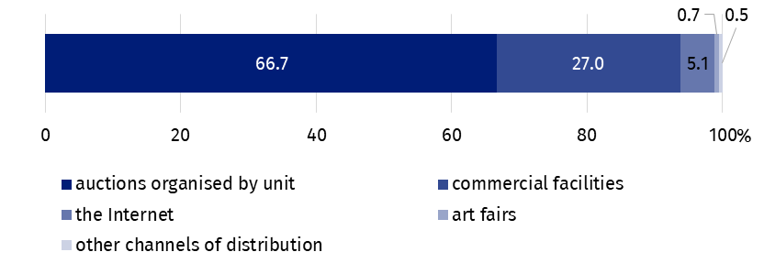
Wykres 2. The structure of sale of works of art and antiques by distribution channels in 2022
Two-thirds (66.7%) of the value of the sale of works of art and antiques was obtained through auctions

In the year under review, 21.6% of entities operating on the works of art and antiques market actively participated in art fairs, of which 77.3% in domestic art fairs.
In the case of quoting data from the Statistics Poland, please provide information: "Statistics Poland data source", and in the case of publishing calculations made on data published by the Statistics Poland, please provide information: "Own study based on Statistics Poland data".
Prepared by:  Statistical Office in Kraków  Director Agnieszka Szlubowska  Office: tel. (+48 22) 420 40 50 | Issued by:  The Spokesperson for the President of Statistics Poland  Karolina Banaszek  Mobile: (+48) 695 255 011
Press Office  Office: tel: +48 22 608 38 04  e-mail: obslugaprasowa@stat.gov.pl |   stat.gov.pl/en

@StatPoland

@GlownyUrzadStatystyczny

gus_stat

glownyurzadstatystycznygus

glownyurzadstatystyczny
Related information
Culture and national heritage in 2021
Market of works of art and antiques in 2021
Terms used in official statistics
Works of art
Antiques
Art gallery

