Mass events in 2022
77.0%
Increase of the number of organised mass events in comparison to 2021
In 2022, 5.2 thousand mass events were organised, including 2.4 thousand artistic and entertainment events. Mass events gathered a total of 23.0 million participants, including 9.5 million participants of artistic and entertainment events.
Compared to 2021, when most activities were limited due to the COVID-19 pandemic, the number of organised mass events increased by 77.0%, of which artistic and entertainment events - by 169.3% and sports events - by 36.9%. In terms of the number of organised mass events, Śląskie voivodship was clearly dominant (828 events) and among other voivodships the following stood out: Mazowieckie (577), Kujawsko-Pomorskie (514) and Dolnośląskie (501). The fewest mass events were organised in Podlaskie voivodship (102).

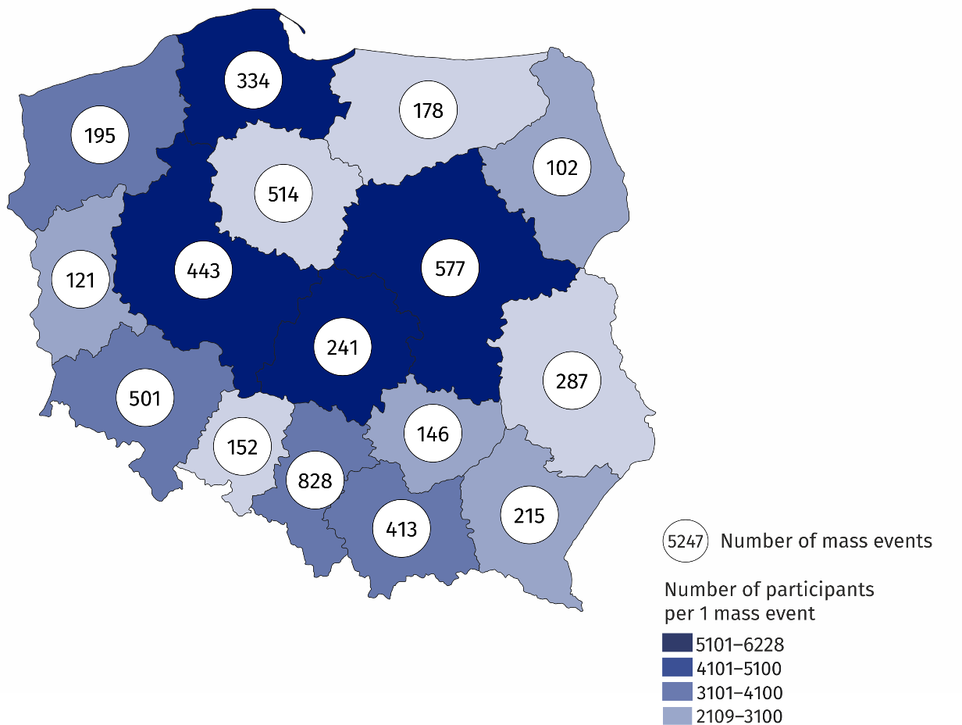
Map 1. Mass events in 2022
4.4 thousand people on average participated in 1 mass event
Among mass events, sports events were the most popular (53.9% of the total number of mass events). As part of mass artistic and entertainment events, more than half were concerts (68.6%).
Compared to 2021, the number of participants in mass events was more than 2 times higher (by 12.0 million people), while the number of participants in mass art and entertainment events increased more than 3 times (by 6.7 million people), and sports events – over
1.5 times (by 5.4 million people). The vast majority of participants of mass events took part in paid events (85.6%). Paid participation mainly concerned sports events (97.2%). In case of mass artistic and entertainment events, 68.9% of participants took part in paid events.
Most mass events were organised in closed facilities (3.1 thousand, 47.5% more than in 2021). In the open area, 2.1 thousand events were organised (153.0% more than in the previous year).

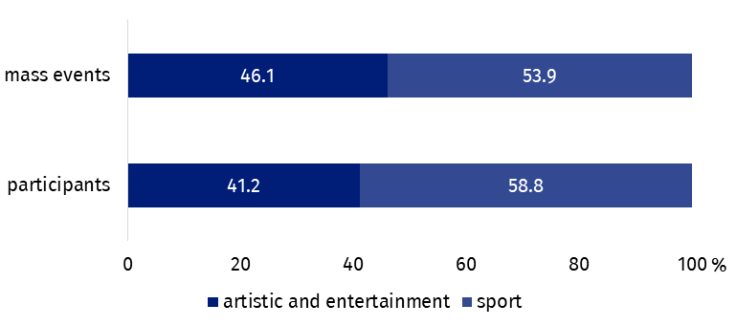
Chart 1. The structure of mass events by type in 2022

The majority of mass events were organised by legal entities (89.9% of total number of mass events). The remaining mass events were organised by organisational units without legal personality (5.4%) and natural persons (4.7%).
In the case of quoting data from the Statistics Poland, please provide information: "Statistics Poland data source", and in the case of publishing calculations made on data published by the Statistics Poland, please provide information: "Own study based on Statistics Poland data".
Prepared by:  Statistical Office in Kraków  Director Agnieszka Szlubowska  Office: tel. (+48 22) 420 40 50 | Issued by:  The Spokesperson for the President of Statistics Poland  Karolina Banaszek  Mobile: (+48) 695 255 011
Press Office  Office: tel: +48 22 608 38 04  e-mail: obslugaprasowa@stat.gov.pl |   stat.gov.pl/en

@StatPoland

@GlownyUrzadStatystyczny

gus_stat

glownyurzadstatystycznygus

glownyurzadstatystyczny
Related information
Culture and national heritage in 2021
Mass events in 2021
Terms used in official statistics
Mass event
Event participant

