Activity of centres of culture, cultural establishments, cultural centres, clubs and community centres in 2022
As of the end of 2022, there were 3958 operating centres of culture, cultural establishments, cultural centres, clubs and community centres. During the year these entities organised 227.3 thousand events, in which took part 27.3 million participants.
45.2%
Increase of number of events organised by centres of culture, cultural centres, clubs and community centres in comparison to 2021
Most centres of culture, cultural establishments, cultural centres, clubs and community centres were operating in Małopolskie Voivodship (431), and the least in Lubuskie Voivodship (75). Taking into account the type of entities, the most numerous group constituted community centres (33.1% of the total number of entities), whereas the least numerous were clubs (7.3%). Most of the entities (61.0%) were located in the countryside.

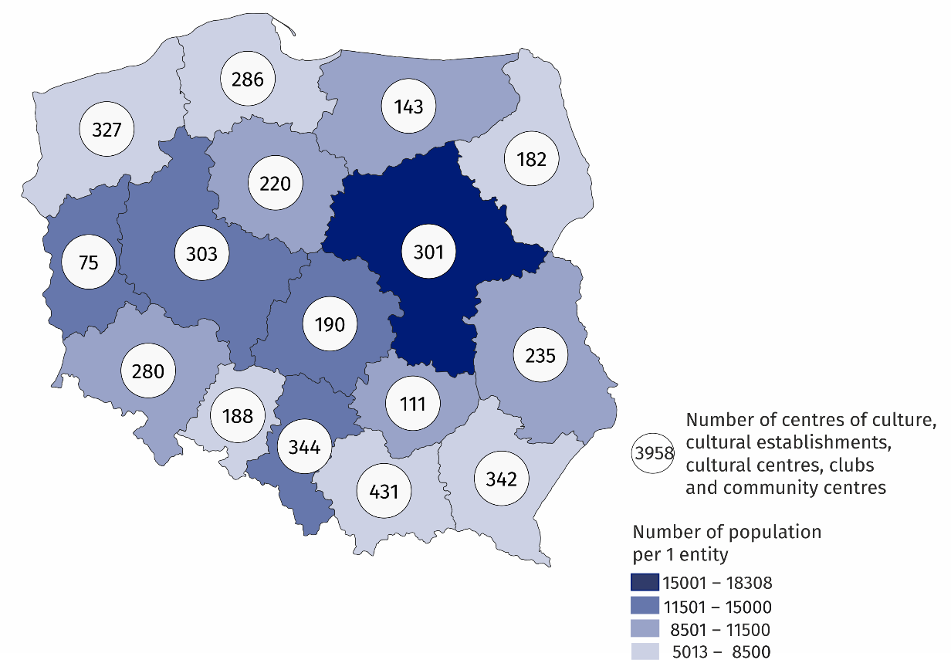
Map 1. Centres of culture, cultural establishments, cultural centres, clubs and community centres in 2022
10.9% of the total number of entities were operating in Małopolskie Voivodship
The prevalent part (93.2%) of centres of culture, cultural establishments, cultural centres, clubs and community centres belonged to the public sector. The entities of local government units at the level of gmina were organisers of 90.3% of all public entities.
Centres of culture, cultural establishments, cultural centres, clubs and community centres organised a total of 227.3 thousand events, in which 27.3 million people took part. The largest number of events (88.2 thousand) was organised by cultural centres, and the least – by community centres (16.2 thousand). Compared to 2021, both the number of organised events and the number of their participants increased (by 45.2% and 49.6%, respectively).
Workshops were most frequently organised (29.4% of the total number of events). On average 120 people took part in one event. Festivals and artistic reviews were the most numerous in this respect – on average 642 people attended one event.
13.1% of centres of culture, cultural establishments, cultural centres, clubs and community centres conducted online cultural activities and shared 3.2 thousand events and 0.4 thousand courses.
As of the end of 2022, 23.3 thousand various types of groups (clubs/sections) were operating in centres of culture, cultural establishments, cultural centres, clubs and community centres, into which 455.0 thousand members belonged to. Art and technical classes (6.2 thousand) were mostly organised within the activity of groups (clubs/sections). The most participants (98.4 thousand) were taking part in activity of senior clubs and The Third Age Universities.
In 2022 centres of culture, cultural establishments, cultural centres, clubs and community centres conducted a total of 4.9 thousand courses. 62.0 thousand people obtained the graduated status of the course (an increase of 6.8% in comparison to 2021). Foreign languages courses (23.9% of the total number of courses) and learning to play the instruments (18.7%) were among the most popular courses.
Chart 1. The structure of groups (clubs, sections) and their participants in centres of culture, cultural establishments, cultural centres, clubs and community centres in 2022
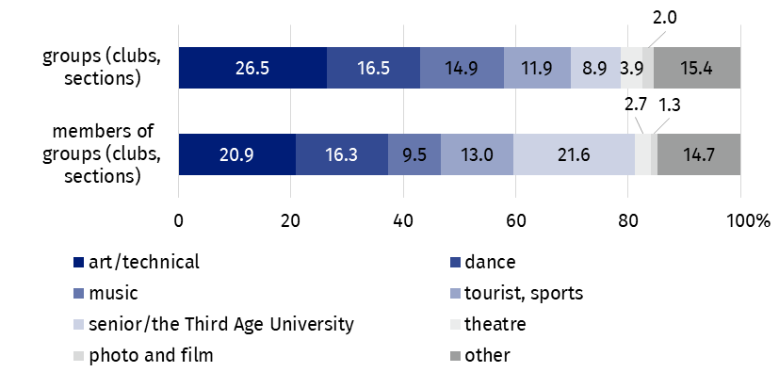
As of 31 December
As of the end of 2022, 14.3 thousand artistic groups were operating in centres of culture, cultural establishments, cultural centres, clubs and community centres, among which the most numerous were dance groups (3.7 thousand). From the total number of 241.4 thousand artistic groups participants, 63.3% were school children and youth. Every fifth artistic groups participant was person above 60 years old.
Chart 2. The structure of artistic gropus and their participants in centres of culture, cultural establishments, cultural centres, clubs and community centres in 2022
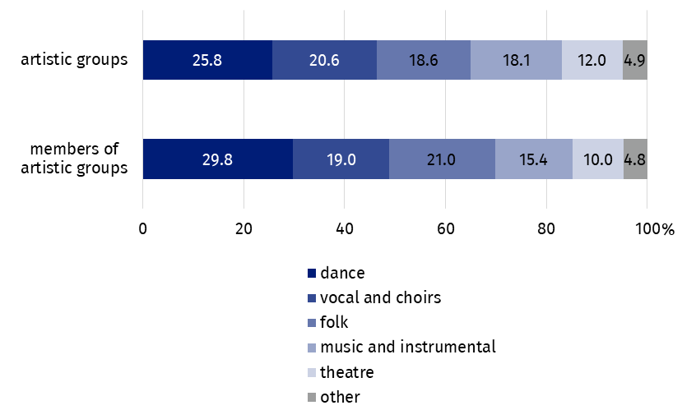
As of 31 December
In the case of quoting data from the Statistics Poland, please provide information: "Statistics Poland data source", and in the case of publishing calculations made on data published by the Statistics Poland, please provide information: "Own study based on Statistics Poland data".
Prepared by:  Statistical Office in Kraków  Director Agnieszka Szlubowska  Office: tel. (+48 22) 420 40 50 | Issued by:  The Spokesperson for the President of Statistics Poland  Karolina Banaszek  Mobile: (+48) 695 255 011
Press Office  Office: tel: +48 22 608 38 04  e-mail: obslugaprasowa@stat.gov.pl |   stat.gov.pl/en

@StatPoland

@GlownyUrzadStatystyczny

gus_stat

glownyurzadstatystycznygus

glownyurzadstatystyczny
Related information
Culture and national heritage in 2021
Activity of centres of culture, cultural centres and establishments, clubs and community centres in 2021
Terms used in official statistics
Cultural establishment
Show (event)
Club
Group in cultural institution
Unit’s organiser
Cultural centre
Performance hall
Community centre
Event participant

