Activity of art galleries in 2022
In 2022, 310 art galleries were operating, which organised 3.5 thousand exhibitions in Poland for 3.0 million visitors. Compared to the previous year, the number of exhibitions in the country increased by 16.0%, while number of visitors decreased by 13.8%.
16.0%
Increase in the number of organised exhibitions in Poland in comparison to 2021
Most art galleries were located in Małopolskie (58), Mazowieckie (52), Łódzkie (37) and Śląskie (34) voivodships. In the aforementioned voivodships, galleries also attracted the largest number of visitors: in Małopolskie (876.7 thousand), Mazowieckie (576.8 thousand), Śląskie (296.5 thousand) and Łódzkie (188.5 thousand) voivodships. The fewest art galleries were in Opolskie Voivodship (2), and the number of visitors was in Lubuskie Voivodship (22.4 thousand). Public art galleries were the most popular – they gathered 89.4% of visitors. Visitors to open-air exhibitions accounted for 28.7% of all visitors.
The largest number of visitors - nearly 49.0% visited art galleries in Małopolskie and Mazowieckie voivodships
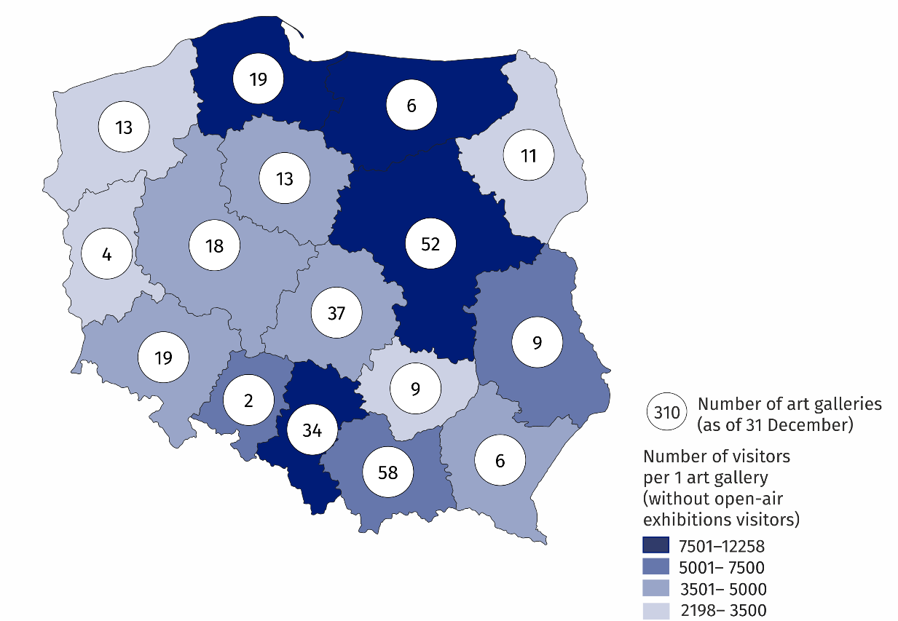
Map 1. Art galleries in 2022

Art galleries organised 3,548 exhibitions which included: national exhibitions (3,186), international (223) and exhibitions from abroad (139). In addition, Polish art galleries organised 59 exhibitions abroad.
Chart 1. The structure of public art galleries own collections in 2022
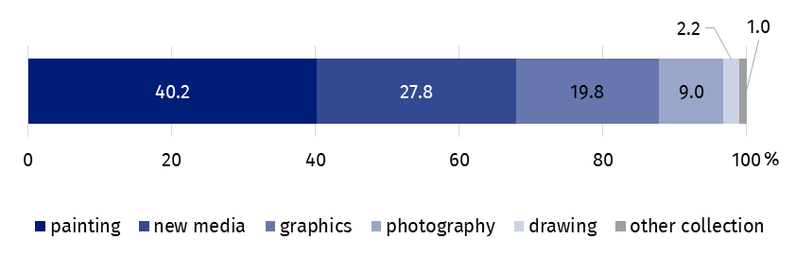
As of 31 December
Objects from the category of new media, graphic art and photography together constituted half of the own collections of public galleries (56.6%), while painting constituted the largest part of the own collections (40.2%).
The overwhelming number of art galleries in Poland belonged to the public sector (63.9%), and for most of the entities the organiser was a local government unit. The remaining art galleries belonging to the private sector were run by individuals and non-governmental organisations.
In the case of quoting data from the Statistics Poland, please provide information: "Statistics Poland data source", and in the case of publishing calculations made on data published by the Statistics Poland, please provide information: "Own study based on Statistics Poland data".
Prepared by:  Statistical Office in Kraków  Director Agnieszka Szlubowska  Office: tel. (+48 22) 420 40 50 | Issued by:  The Spokesperson for the President of Statistics Poland  Karolina Banaszek  Mobile: (+48) 695 255 011
Press Office  Office: tel: +48 22 608 38 04  e-mail: obslugaprasowa@stat.gov.pl |   stat.gov.pl/en

@StatPoland

@GlownyUrzadStatystyczny

gus_stat

glownyurzadstatystycznygus

glownyurzadstatystyczny
Related information
Culture in 2021
Activity of art galleries in 2021
Terms used in official statistics
Art gallery
Unit’s organiser
Exhibition
Open-air exhibition in the galleries
Exposition
Visitor

