Activity of museums in 2022
45.4%
Increase of the number of visitors in museums and museum branches in comparison to 2021
In 2022 there were 963 museums and museums branches, visited by 36.7 million people. Museums presented 2.6 thousand regular exhibitions and organised 4.4 thousand temporary exhibitions in Poland.
In terms of the number of museums and museum branches, two voivodships dominated – Mazowieckie and Małopolskie. In 2022, 140 and 107 entities respectively operated there. In these voivodeships, visitors accounted for 60.3% of the total number of visitors to museums and museum branches. The fewest museums and visitors were recorded in Lubuskie voivodship (17 museums and 228.7 thousand visitors). The number of museum visitors in Poland per 1,000 population was 970.
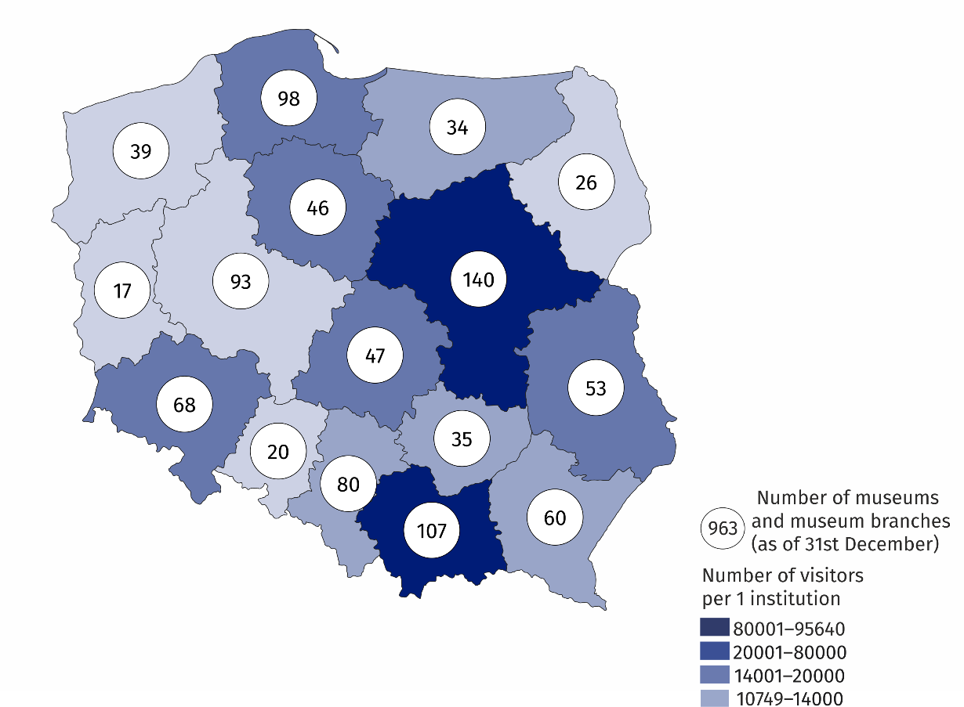
Map 1. Museums and museum branches in 2022
25.6% of the total number of museums operated in Mazowieckie and Małopolskie voivodships
71.8% of museums belonged to the public sector, the vast majority of which were organised by local government units (84.4%). Within the private sector, museum organisers were most often natural persons (53.3% of private museums).
Museums and museum branches were visited by 36.7 million people, including 14.2 million free of charge
71.8% of museums and museum branches belonged to the public sector
Museums and museum branches were visited by 36.7 million people, of which 14.2 million free of charge. Organised groups of school youth accounted for 10.7% of all visitors (in 2021 - 8.0%). Historical museums were the most popular among visitors, visited by 11.9 million people (32.4% of the total number of visitors).
The annual “Night of Museums” was attended by 619.6 thousand visitors (in 2021 - 160.5 thousand). Historical museums were the most popular during this event, with 231.8 thousand visitors (in 2021 - 80.3 thousand).
As at the end of 2022, the total number of museum collections amounted to 20.9 million items, 3.9% more than in the previous year. Museum exhibits from the field of archaeology dominated (25.6%), while geology and cartography exhibits were the least numerous (0.2% each). Interdisciplinary museums held the largest number of museum collections (31.3% of the total number of collections). A large group (22.9%) of museum objects included in the "other" category were, among others, collections from the following fields: archives (4.9%), technology (3.4%) and military (1.5%).

Chart 1. The structure of museum collections according to branches in 2022

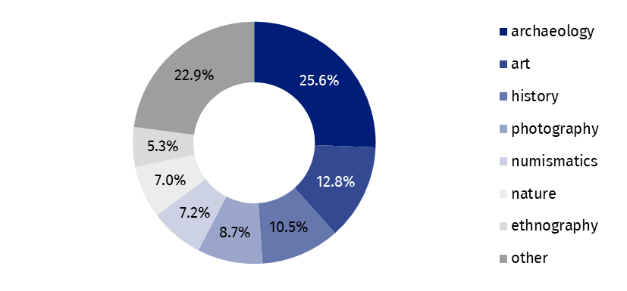
As of 31 December
Museums presented 2.6 thousand permanent exhibitions (3.2% more than in 2021) and 4.4 thousand temporary exhibitions (23.6% more). The largest number of temporary exhibitions was organised by history museums (2.2 thousand).
The number of cultural and educational events increased by 75.4% compared to the previous year
In addition to the primary activity of collecting and presenting collection, museums also organised 132.6 thousand events in 2022, attended by 5.8 million people. The largest number of museum lessons took place - 95.8 thousand, attended by 2.0 million people.
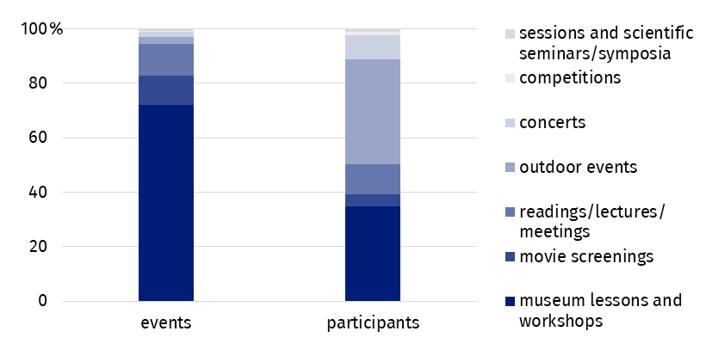
Chart 2. The structure of cultural and educational activity of museums and museum branches in 2022
In the case of quoting data from the Statistics Poland, please provide information: "Statistics Poland data source", and in the case of publishing calculations made on data published by the Statistics Poland, please provide information: "Own study based on Statistics Poland data".
Prepared by:  Statistical Office in Kraków  Director Agnieszka Szlubowska  Office: tel. (+48 22) 420 40 50 | Issued by:  The Spokesperson for the President of Statistics Poland  Karolina Banaszek  Mobile: (+48) 695 255 011
Press Office  Office: tel: +48 22 608 38 04  e-mail: obslugaprasowa@stat.gov.pl |   stat.gov.pl/en

@StatPoland

@GlownyUrzadStatystyczny

gus_stat

glownyurzadstatystycznygus

glownyurzadstatystyczny
Related information
Culture and national heritage in 2021
Activity of museums in 2021
Terms used in official statistics
Museum
Museum branch
Unit’s organiser
Museum lesson
Exhibits
Temporary exhibitions
Permanent exhibitions
Visitor

