Activity of theatres and music institutions in 2022
96.2%
Increase of the number of au-dience in theatres and music institutions in comparison to 2021

In 2022 theatres and music institutions presented 53 thousand performances and concerts, with 9.3 million audience. 771 premieres took place. Theatres and music institutions had 5.0 thousand performances and concerts in their repertoir.
Stage activities were conducted by 208 theatres and music institutions, of which 182 had their own artistic ensemble. The largest number of theatres and music institutions with their own artistic ensembles operated in Voivodships: Mazowieckie (42), Małopolskie (28) and Śląskie (23), and the fewest - in Lubuskie, Opolskie, Podkarpackie and Świętokrzyskie Voivodships (4 each). A total of 53 thousand performances/concerts were staged on 359 stages in Poland.
82.7% of theatres and musical institutions belonged to the public sector. Local government units were organisers for 93.0% of public entities.
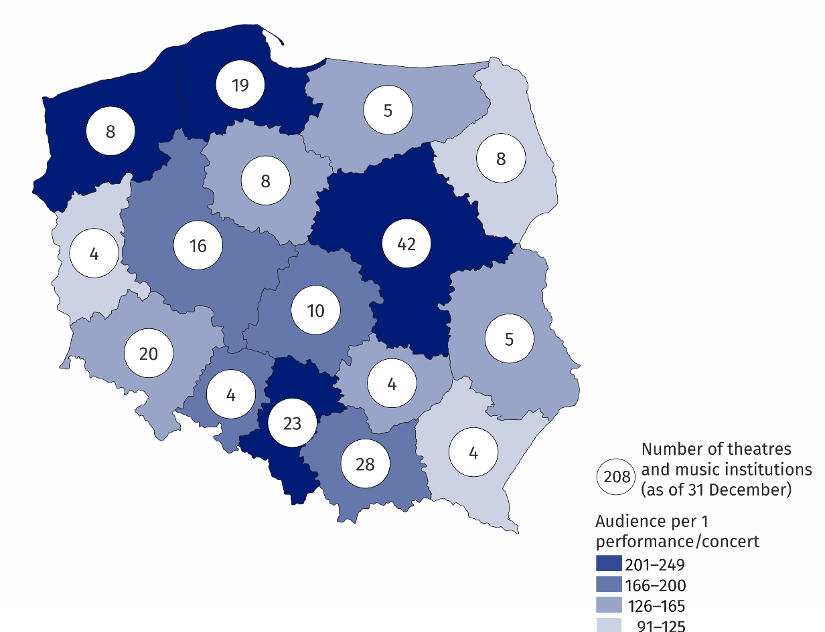
Map 1. Theatres and music institutions in 2022

After months in which the COVID-19 pandemic limited or prevented stage activities, there was an increase (by 96.2% compared to 2021) in the number of audience in 2022. Performances/concerts organised by theatres and musical institutions were attended by 9.3 million audience. The largest number of audience was recorded in the theatres and music institutions in Mazowieckie Voivodship - 2.6 million people (more than twice as many as in Śląskie Voivodship, which was next in terms of the number of audience). The smallest number of audience attended performances and concerts in the theatres and music institutions in Voivodships: Lubelskie (131.8 thousand), Opolskie (141.2 thousand), Świętokrzyskie (152.3 thousand) and Podkarpackie (157. 9 thousand).

Chart 1. The structure of theatres and music institutions by type in 2022

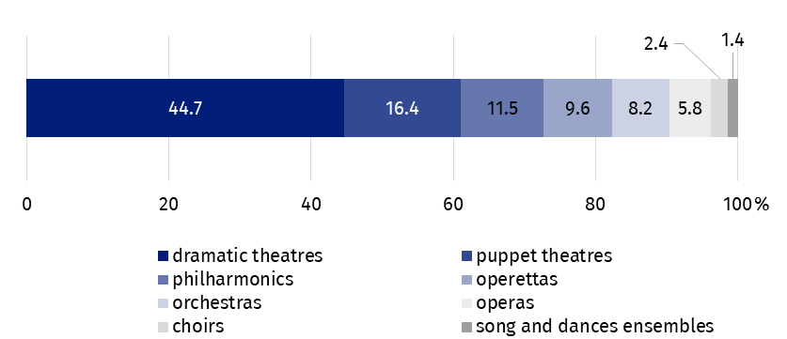
As of 31 December
Dramatic and puppet theatres and music theatres, i.e. operas and operettas, presented 771 premiere shows, of which 618 took place in drama and puppet theatres and 153 in music theatres.
Theatres and musical institutions presented 839 performances and concerts abroad (more than four times as many as in 2021), attended by 387.9 thousand audience (57.2% more than in 2021).
In the case of quoting data from the Statistics Poland, please provide information: "Statistics Poland data source", and in the case of publishing calculations made on data published by the Statistics Poland, please provide information: "Own study based on Statistics Poland data".
Prepared by:  Statistical Office in Kraków  Director Agnieszka Szlubowska  Office: tel. (+48 22) 420 40 50 | Issued by:  The Spokesperson for the President of Statistics Poland  Karolina Banaszek  Mobile: (+48) 695 255 011
Press Office  Office: tel: +48 22 608 38 04  e-mail: obslugaprasowa@stat.gov.pl |   stat.gov.pl/en

@StatPoland

@GlownyUrzadStatystyczny

gus_stat

glownyurzadstatystycznygus

glownyurzadstatystyczny
Related information
Culture and national heritage in 2021
Activity of theatres and music institutions in 2021
Terms used in official statistics
Choir
Artistic activities and entertainment
Philharmonic
Music institution
Concert
Orchestra
Premiere
Performance
Scene
Theatre
Audience
Own artistic team
Song and dance ensemble

