Financial results of cultural institutions in the first half of 2023
In the first half of 2023, the financial results of cultural institutions increased compared to those obtained in the corresponding period of the previous year. Total revenues increased by 17.4% and investments outlays increased by 15.1% during this period.
17.4%
Total revenues increase y/y
Total revenues of cultural institutions in the first half of 2023 were 17.4% higher than in the previous year and amounted to PLN 6,775.8 million. The structure of the revenues was composed of net revenues from sales of products, goods and materials (92.9%), other operating revenues (6.8%) and financial revenues (0.3%). More than 25% of the total revenues were generated by cultural institutions from Mazowieckie Voivodship.
On average total revenues per one cultural institution amounted to PLN 1,440.7 thousand. The highest total revenues per one institution were achieved by cultural institutions in Mazowieckie Voivodship – PLN 2,638.2 thousand and the lowest in Lubelskie Voivodship – PLN 703.9 thousand. Total revenues of national cultural institutions in the first half 2023 amounted to PLN 1,225.9 million, while total revenues of local government cultural institutions amounted to PLN 5,549.9 million. Entities conducting operation of arts facilities had the largest share in total revenues of all cultural institutions – 40.7%.
Total revenues of gminas local cultural institutions in the first half of 2023 amounted to PLN 3,886.8 million
Total costs during this period were 16.5% higher than in the previous year and amounted to PLN 6,323.4 million. The structure of costs was composed of operating costs (99.3%), other operating costs (0.6%) and financial costs (0.1%). More than 25% of the total costs were incurred by cultural institutions from Mazowieckie Voivodship. Entities conducting operation of arts facilities had the largest share in total costs – 39.9%.
Net financial result of cultural institution in the first half of 2023 amounted to PLN 451.5 million
Gross financial result amounted to PLN 452.4 million (gross profit PLN 521.0 million, gross loss PLN 68.6 million). Net financial result amounted to PLN 451.5 million (PLN 340.3 million in the previous year), with an increase in net profit (by 22.7%) and a decrease in net loss (by 17.9%).

Table 1. Financial results of cultural institutions
Specification | 01–06 2022 | 01–06 2023 | 01–06 2022=100
Specification | in PLN million |  | 01–06 2022=100
Total revenues | 5,769.8 | 6,775.8 | 117.4
Total costs | 5,428.7 | 6,323.4 | 116.5
Gross financial result | 341.1 | 452.4 | 132.6
Net financial result | 340.3 | 451.5 | 132.7
Net profit | 424.0 | 520.3 | 122.7
Net loss | 83.8 | 68.7 | 82.1
Investment outlays | 573.4 | 660.1 | 115.1
Outlays on intangible fixed assets | 9.8 | 19.2 | 195.9
The investment outlays of cultural institutions in the first half of 2023 were 15.1% higher than in the previous year and amounted to PLN 660.1 million. Almost 35% of total investment outlays were investment outlays of cultural institutions from Mazowieckie Voivodship.
Investment outlays incurred by local government cultural institutions amounted to PLN 388.6 million, i.e. 58.9% of the total amount of investment outlays.

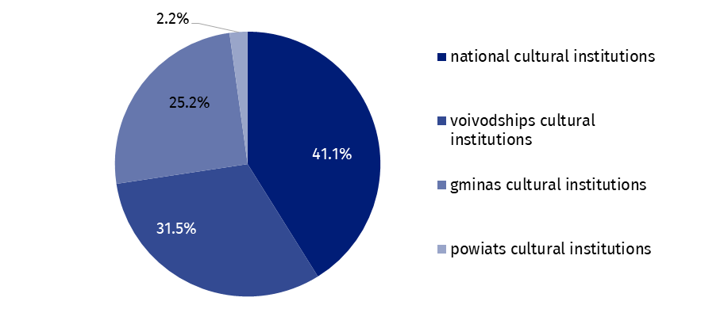
Chart 1. The structure of investment outlays of cultural institutions by legal forms in the first half of 2023
In the first half of 2023 outlays of cultural institutions on intangible and legal assets were 95.9% higher compared to the corresponding period of the previous year and amounted to PLN 19.2 million. Most of outlays on intangible and legal assets were from Mazowieckie Voivodship (58.0%).

Table 2. Total revenues and total costs of cultural institutions by selected divisions and classes of PKD classification in the first half of 2023
Specification | Number of cultural institutions | Total revenues | Total costs
Specification | Number of cultural institutions | in PLN million
Grand total | 4,703 | 6,775.8 | 6,323.4
local government units property | 4,628 | 5,549.9 | 5,210.9
government property | 75 | 1,225.9 | 1,112.5
of which:
creative, arts and entertainment activities | 2,328 | 4,132.1 | 3,848.7
of which:
performing arts activities | 152 | 1,291.4 | 1,254.0
operation of arts facilities | 2,165 | 2,758.8 | 2,523.4
libraries, archives, museums and other cultural activities | 2,369 | 2,551.4 | 2,382.3
of which:
libraries and archives activities | 1,971 | 1,107.4 | 1,051.8
museums activities | 390 | 1,403.8 | 1,294.8
The data presented in this study were prepared on the basis of the form with the symbol
F-01/dk Quarterly report on the finances of cultural institutions.
In the case of quoting data from the Statistics Poland, please provide information: "Statistics Poland data source", and in the case of publishing calculations made on data published by the Statistics Poland, please provide information: "Own study based on Statistics Poland data".

Prepared by:  Statistical Office in Kraków  Director Agnieszka Szlubowska  Office: tel. (+48 22) 420 40 50 | Issued by:  The Spokesperson for the President of Statistics Poland  Karolina Banaszek  Mobile: (+48) 695 255 011
Press Office  Office: tel: +48 22 608 38 04  e-mail: obslugaprasowa@stat.gov.pl |   stat.gov.pl/en

@StatPoland

@GlownyUrzadStatystyczny

gus_stat

glownyurzadstatystycznygus

glownyurzadstatystyczny
Related information
Financial results of cultural institutions in the first quarter of 2023
Methodological report. Non-financial enterprises surveys 2019
Terms used in official statistics
Total revenues
Total costs
Gross financial result
Net financial result
Investment outlays
Outlays on intangible fixed assets
Cultural institution

