Outpatient health care in 2022
At the end of 2022, outpatient health care was carried out by 22.6 thousand outpatient departments and 3.5 thousand doctors and dentists practices providing services funded by public sources. During the year, 297.6 million doctors consultations and 33.2 million stomatological consultations were provided. Over 13% of total doctors consultations in primary health care were provided via telephone.
6.0%
Increase in the number of specialised doctors consultations compared to 2021

Outpatient departments and medical practices
At the end of 2022, outpatient consultations were provided by 22.6 thousand outpatient departments and 3.5 thousand doctors and dentists practices providing services funded by public sources
At the end of 2022, 26.1 thousand providers of ambulatory health care were operating –22.6 thousand outpatient departments and 0.6 thousand doctors practices and 2.8 thousand dentists practices providing services funded by public sources. 20.6 thousand providers of ambulatory health care were located in urban areas, and 5.5 thousand in rural areas.
The most outpatient departments were operating in Mazowieckie Voivodship (3 412), and the lowest – in Opolskie Voivodship (551). The highest number of practices providing health services funded by public sources was recorded in Wielkopolskie Voivodship (418), while the lowest – in Małopolskie Voivodship (123).

Chart 1. Outpatient departments by class of locality and voivodships in 2022
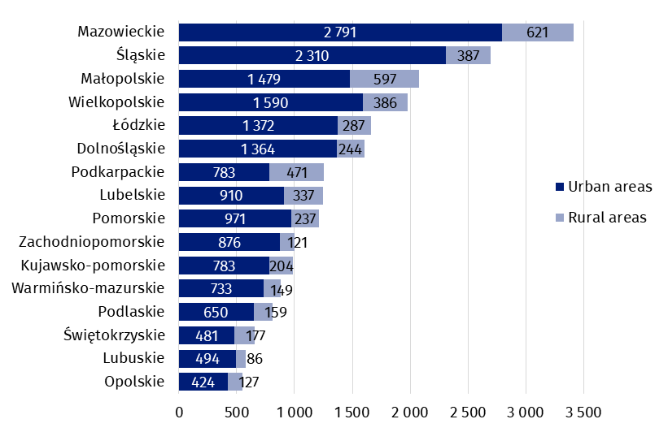
As of 31 December

Chart 2. Doctors and dentists practices providing health services funded by public sources by class of locality and voivodships in 2022

As of 31 December
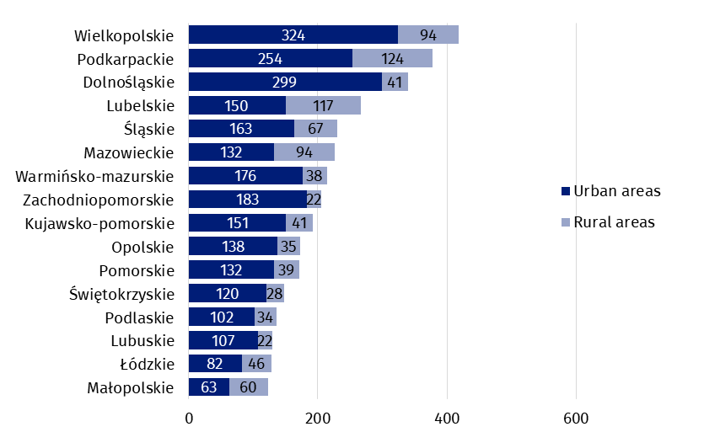In Poland, the number of population per one provider of ambulatory health care amounted to 1 448 persons (by 33 less than in the previous year). The highest value was recorded Pomorskie Voivodship (1 710 persons), while the lowest – in Podlaskie Voivodship (1 210).

Map 1. The number of population per 1 provider of ambulatory health care by voivodships in 2022

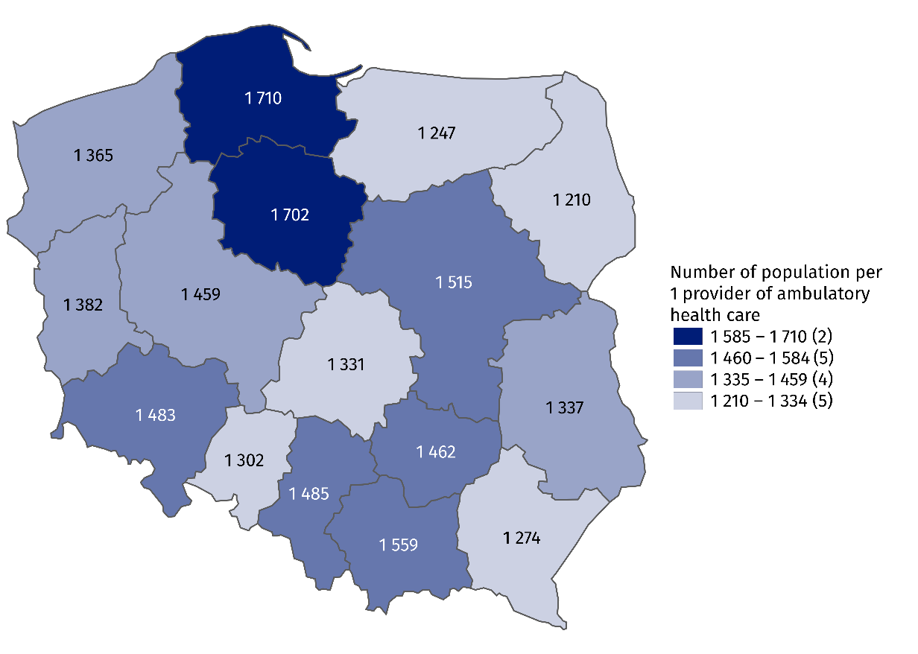
As of 31 December

Outpatient consultations
In 2022, there were provided 297.6 million doctors consultations and 33.2 stomatological consultations in outpatient health care
In 2022, there were provided 330.8 million outpatient consultations – 297.6 doctors consultations (increase of 4.1% compared to the previous year) and 33.2 million stomatological consultations (by 7.9% more than a year earlier). 176.1 million doctors consultations were in primary health care (by 2.8% more than in 2021), and 121.5 million – in specialised health care (increase of 6.0% compared to the previous year).
In primary health care children and youth in age up to 18 years had 37.1 million consultations (increase of 15.3% compared to the previous year), while people aged 65 years and more – 60.6 million (by 1.9% more than a year earlier). There were 15.7 million specialised consultations provided to children and youth in age up to 18 years (by 12.7% more than in 2021) and 36.0 million consultations provided to people aged 65 years and more (by 7.4% more than in the previous year).

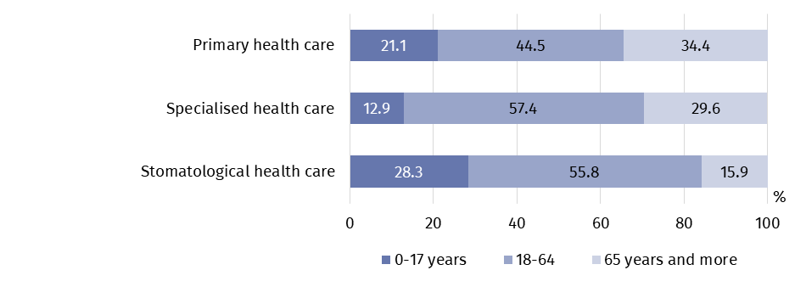
Chart 3. Outpatient consultations by type of consultation and patients’ age in 2022
In 2022, 23.5 million doctors consultations in primary health care and 10.6 million in specialised health care were provided via telephone (by 51.6% and 27.2% respectively less than in previous year). 43.3 thousand stomatological consultations were provided remotely.

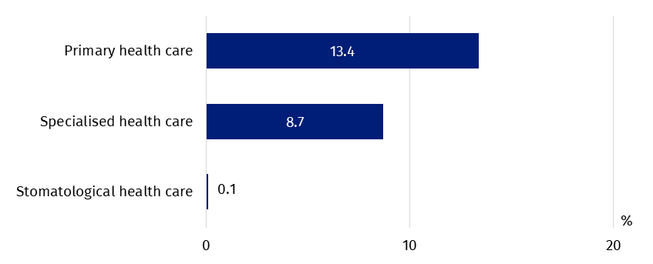
Chart 4. The share of telephone consultations in outpatient consultations by type of consultation in 2022

In specialised health care, the highest share of consultations was in surgical clinic (17.7%), then in gynecological and obstetrical clinics (10.7%) and ophthalmology clinics (8.9%).
Most doctors consultations in specialised outpatient health care were provided in surgical clinics
(approximately 21 million)

Chart 5. Specialised doctors consultations by type of clinic in 2022
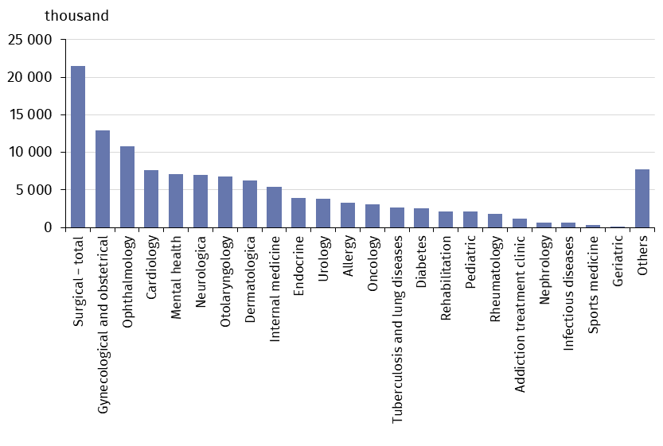
In 2022, the average number of outpatient consultations per capita was 8.7. The highest value was recorded in Mazowieckie Voivodship (9.7), while the lowest – in Opolskie Voivodship (7.3).
In 2022, the average number of outpatient consultations per capita was 8.7

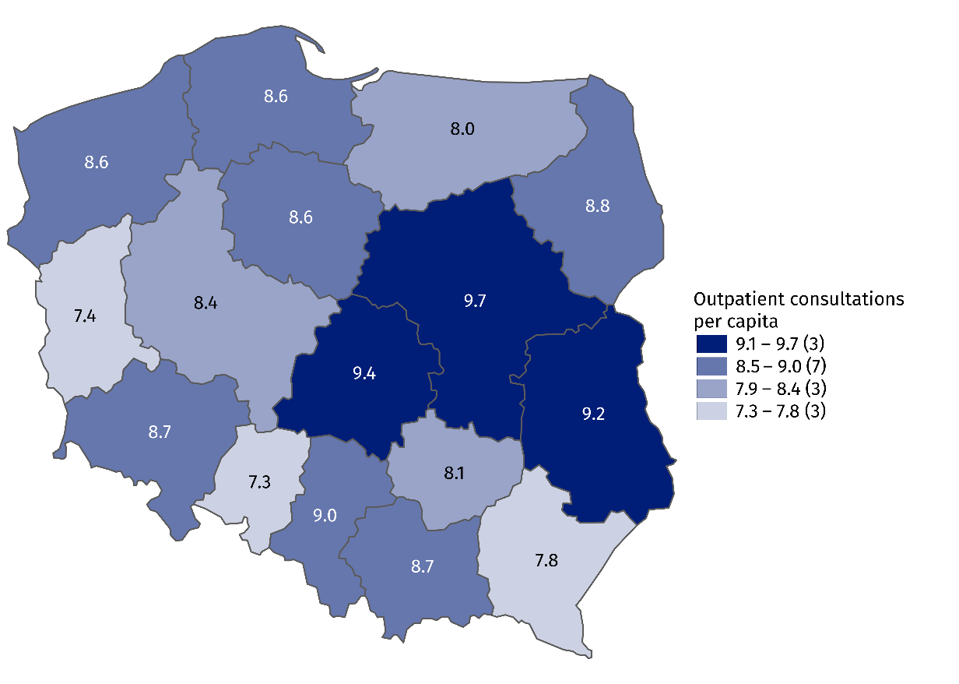
Map 2. Outpatient consultations per capita by voivodships in 2022

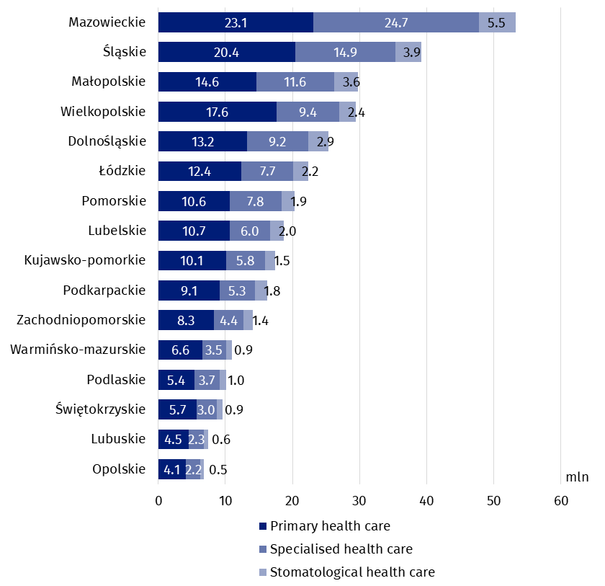
Chart 6. Outpatient consultations by type of consultation and voivodships in 2022
In the case of quoting data from the Statistics Poland, please provide information: "Statistics Poland data source", and in the case of publishing calculations made on data published by the Statistics Poland, please provide information: "Own study based on Statistics Poland data".

Prepared by:  Statistical Office in Kraków  Director Agnieszka Szlubowska  Phone: (+48 12) 420 40 50 | Issued by:  The Spokesperson for the President  of Statistics Poland  Karolina Banaszek  Phone: (+48) 695 255 011
Press Office  Phone: (+48 22) 608 38 04  e-mail: obslugaprasowa@stat.gov.pl |   stat.gov.pl/en/

@StatPoland

@GlownyUrzadStatystyczny

gus_stat

glownyurzadstatystycznygus

glownyurzadstatystyczny
Related information
Health and health care in 2021
Methodological report. Health and health care statistics − Statistics Poland’s reports
Data available in databases
Local Data Bank -> Health care, social welfare and benefits to the family
Knowledge Databases -> Health and Health care
Terms used in official statistics
Specialised out-patient services
Out-patient health care services
Primary health care
Consultation
Medical practice
An out-patient department

Including outpatient departments of the Ministry of National Defence and the Ministry of the Interior and Administration.
Including holiday and night time medical services. There are health care benefits in primary health care, provided from 6 pm to 8 am on the following day and 24 hours on public holidays. Including also holiday and night time medical services given as a subcontract with a hospital.

