Emergency rescue services activity in 2022
In 2022, fire brigades intervened in 608.8 thousand events. Interventions concerned 136.0 thousand fire events, 425.0 thousand local threats, and 47.9 thousand false alarms.
5.0%
Increase in the number of interventions of fire brigades in 2022 compared to 2021
447 drowning accidents, of which 422 people died, including 47 women, were reported to the Police.
Water life rescue services carried out 1 813 rescue actions.

Fire safety
In 2022, throughout the country, fire brigades intervened in 608.8 thousand events (increase by 5.0% in comparison with 2021). Most of the interventions of fire brigades were recorded in Mazowieckie Voivodship (90.6 thousand), the lowest number of events was in Opolskie Voivodship (16.1 thousand). Indicator of the number of events requiring intervention of fire brigades per 1 thousand persons, reached the highest level in Lubuskie Voivodship (20.9), and the lowest in Małopolskie Voivodship (13.6).
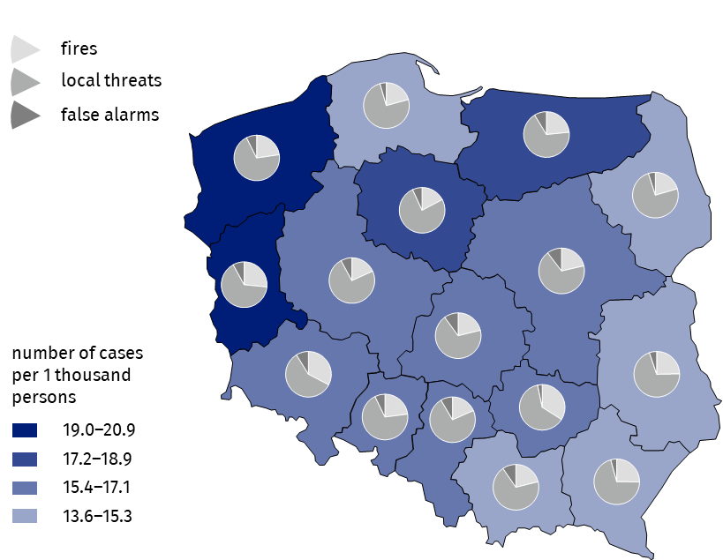
Map 1. Interventions of fire brigades in 2022
Source: National Headquarters of the State Fire Service.
Interventions concerned 425.0 thousand local threats (by 0.7% less than in 2021), 136.0 thousand fires (more by 27.7%) and 47.9 thousand false alarms (more by 5.9%).
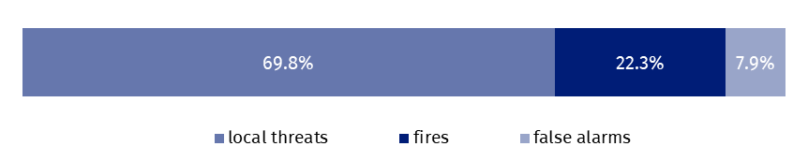
Chart 1. Structure of events involving fire brigades in 2022
Source: National Headquarters of the State Fire Service.
In 2022, 95.3% of all fires were classified as small fires
Small fires – 129.6 thousand – constituted the largest share of all fires (95.3% of all fires), while 87 fire cases were classified as very big fires (0.1%).
In case of local threats per 1 thousand persons, requiring the participation of fire brigades, the highest value of the indicator was in Kujawsko-Pomorskie Voivodship (14.3), while the lowest value was in Dolnośląskie Voivodship (9.3). The most common local threats requiring the intervention of fire brigades were windstorms (125.4 thousand). The number, in comparison with 2021, increased by 64.8%.
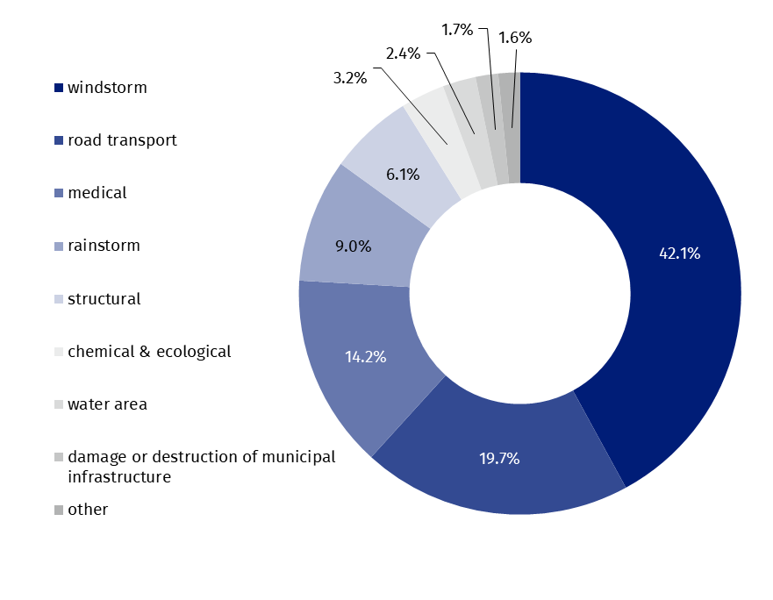
Chart 2. Structure of local threats by type in 2022
Windstorms were the most common local threats requiring the intervention of fire brigades (42.1% cases)
Source: National Headquarters of the State Fire Service.
As in previous years, more than a half of all false alarms i.e. 26 941 (56.3%) were reported in good faith.
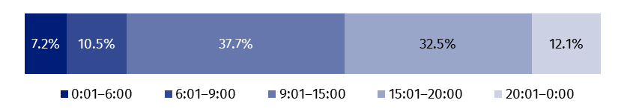
Chart 3. Structure of events requiring intervention of fire brigades by time of spotting in 2022
Source: National Headquarters of the State Fire Service.
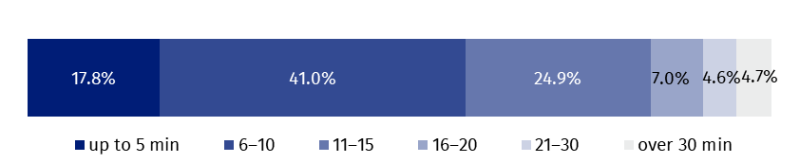
Chart 4. Structure of events requiring intervention of fire brigades by drive time in 2022
In more than 40% of incidents, the drive time of arrival at the location of the accident was between 6 and 10 minutes
Source: National Headquarters of the State Fire Service.
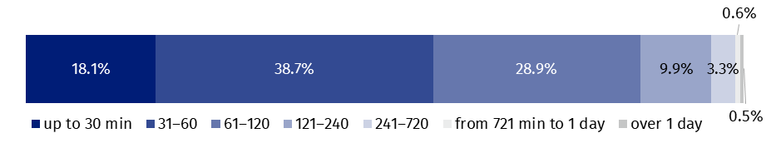
Chart 5. Structure of events requiring intervention of fire brigades by duration of intervention in 2022
In almost 40% of incidents, the duration of the intervention of the fire protection units was between 31 and 60 minutes

Source: National Headquarters of the State Fire Service.
4 301.3 thousand firefighters were involved in interventions of fire brigades, including 2 276.1 thousand volunteer firefighters, 1 019.6 thousand vehicles were used in rescue actions, of which 824.7 thousand fire engines. As a result of fires and local threats, 9.3 thousand persons died (including two firefighters) and 46.1 thousand were injured (including 266 firefighters).
Table 1. Events involving fire brigades in 2022
Specification | Total | Fires | Local threats | False alarms
POLAND | 608 818 | 135 965 | 424 958 | 47 895
Dolnośląskie | 45 640 | 14 900 | 26 723 | 4 017
Kujawsko-pomorskie | 37 660 | 6 478 | 28 605 | 2 577
Lubelskie | 28 753 | 7 108 | 20 141 | 1 504
Lubuskie | 20 523 | 5 447 | 13 436 | 1 640
Łódzkie | 36 923 | 7 838 | 25 374 | 3 711
Małopolskie | 46 499 | 9 808 | 32 239 | 4 452
Mazowieckie | 90 614 | 19 407 | 61 807 | 9 400
Opolskie | 16 091 | 3 704 | 11 219 | 1 168
Podkarpackie | 29 868 | 7 495 | 21 103 | 1 270
Podlaskie | 16 810 | 3 448 | 12 532 | 830
Pomorskie | 35 361 | 7 337 | 26 421 | 1 603
Śląskie | 73 500 | 13 512 | 53 778 | 6 210
Świętokrzyskie | 18 200 | 6 179 | 11 432 | 589
Warmińsko-mazurskie | 25 477 | 5 961 | 17 316 | 2 200
Wielkopolskie | 53 696 | 9 794 | 39 653 | 4 249
Zachodniopomorskie | 33 203 | 7 549 | 23 179 | 2 475
Source: National Headquarters of the State Fire Service.

Drowning events
In 2022, 422 persons drowned, that is 14 persons more than in the previous year
In 2022, 447 drowning events were reported to the police (by 5.9% more than in 2021), resulting in 422 deaths (by 3.4% more), including 47 women (17.5% more than in the previous year).
Most victims of drowning events were recorded in Mazowieckie Voivodship (69), the smallest number of them in Lubuskie Voivodship (10).
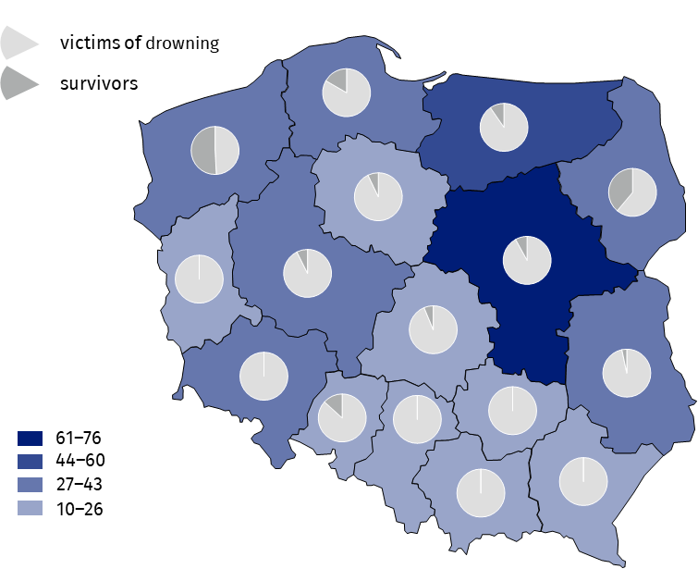
Map 2. Drowning incidents by voivodships in 2022
Source: data on the basis of data from registered proceedings by Police offices.
206 victims of drowning were over 50 years of age (48.8% of all victims)
Persons over 50 years of age were most frequent victims of drowning (206 persons), while children between 8–14 years of age were the least frequent victims (6 persons). No drowning incidents were reported in the group of children under 7 years of age.
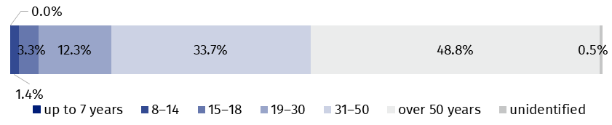
Chart 6. Structure of victims of drowning by age in 2022
Source: National Headquarters of Police.
The highest numbers of drowning accidents were recorded on Sundays (92), while the lowest numbers of them were recorded on Tuesdays (36).
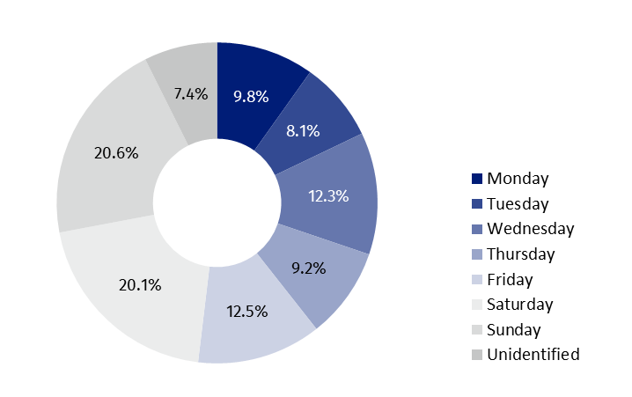
Chart 7. Structure of drowning incidents by days of the week in 2022
Source: National Headquarters of Police.
Most of victims drowned in lakes (105), of which the biggest number in Warmińsko-Mazurskie Voivodship (29). No victim of drowning in the lakes in Małopolskie, Dolnośląskie, Łódzkie and Podkarpackie Voivodships was recorded. 103 persons drowned in rivers. The biggest number of victims of drowning in the rivers was recorded in Mazowieckie Voivodship (22), while the smallest number of such victims was recorded in the Śląskie voivodship (1). 16 persons drowned in the sea, i.e. by 10 persons less than in 2021, (10 victims in Pomorskie Voivodship and 6 victims in Zachodniopomorskie Voivodship).
Most of victims drowned in the lakes (105 cases)
At the time of the incident, 109 drowning victims were intoxicated whereas 22 were sober. In 291 events of drowning (69.0%) state of consciousness (i.e. sober, intoxicated or under influence of drugs) could not be determined.
Specification | Drowning incidents | Victims of drowning | Survivors
POLAND | 447 | 422 | 42
Dolnośląskie | 27 | 27 | –
Kujawsko-pomorskie | 26 | 26 | 2
Lubelskie | 30 | 29 | 1
Lubuskie | 10 | 10 | –
Łódzkie | 15 | 15 | 1
Małopolskie | 16 | 17 | –
Mazowieckie | 74 | 69 | 6
Opolskie | 15 | 13 | 2
Podkarpackie | 22 | 22 | –
Podlaskie | 29 | 22 | 14
Pomorskie | 43 | 40 | 8
Śląskie | 16 | 16 | –
Świętokrzyskie | 13 | 13 | –
Warmińsko-mazurskie | 52 | 47 | 5
Wielkopolskie | 27 | 25 | 2
Zachodniopomorskie | 32 | 31 | 1
Table 2. Drowning incidents in 2022
42 persons were rescued from drowning incidents
Note: There can be more than one person per incident.
Source: data on the basis of data from registered proceedings by Police stations.

Actions of water rescue services
In 2022, 119 entities were eligible to water rescue
As of 31 December 2022, 119 entities received permission to water rescue service and they employed 13 165 water lifeguards.
Water lifeguards carried out 1 813 rescues operations, most of them in inland and coastal water area (1 168) and least in places occasionally used for bathing (39).
Water lifeguards carried out 1 813 rescue operations
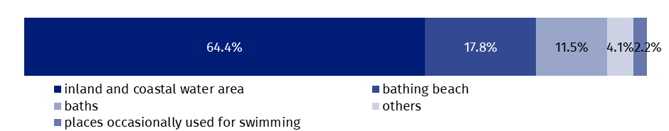
Chart 8. Structure of rescue operations to save drowning people by place of rescue in 2022
Source: Ministry of Interior and Administration.
Water lifeguards carried out 5 904 actions requiring professional first aid. Most rescue actions occurred in the inland and coastal water area (1 392), such interventions were the least frequent in places occasionally used for swimming (41).
In the analysed period 721 actions dealt with transporting victims of the incidents or in danger of losing health or life in water area to a location where it was possible to perform medical rescue actions by the units of the State Medical Emergency³.
Water lifeguards saved lives of 1 388 drowning persons
Water lifeguards took part in 579 actions of searching for missing people. They saved 1 388 persons.
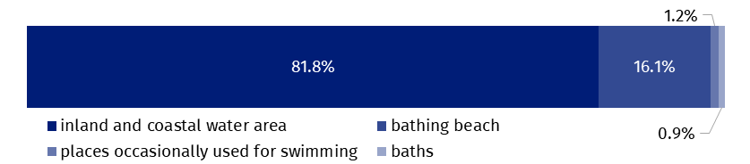
Chart 9. Structure of actions of searching for missing persons in water area by place of rescue in 2022
Source: Ministry of Interior and Administration.
Entities, eligible to water rescue, were carrying out training activities in the area of water rescue. In 2022 they delivered 531 training courses, including 508 training courses dedicated to water lifeguards. 18 courses were delivered for instructors of water rescue and 5 courses for rescue dogs with the guide. 5 321 persons were awarded with the certificate of acquired qualifications.
In the case of quoting data from the Statistics Poland, please provide information: “Statistics Poland data source”, and in the case of publishing calculations made on data published by the Statistics Poland, please provide information: “Own study based on Statistics Poland data”.
Prepared by:  Statistical Office in Kraków  Director Agnieszka Szlubowska  Phone: (+48 12) 420 40 50 | Issued by:  The Spokesperson for the President  of Statistics Poland  Karolina Banaszek  Phone: (+48) 695 255 011
Press Office  Phone: (+48 22) 608 38 04  e-mail: obslugaprasowa@stat.gov.pl |   stat.gov.pl/en/

@GUS_STAT

@GlownyUrzadStatystyczny

gus_stat

glownyurzadstatystycznygus

glownyurzadstatystyczny
Related information
Emergency rescue services activity in 2021
Emergency rescue services activity in 2020
Data available in databases
Database Local Data Bank – organisation of the state and justice

Data based on events reported to the Police.
Data based on reports of services entitled to water life savings reported to the Ministry of Interior and Administration. 3 Reference to Article 32(1) Act of 8 September 2006 on Medical State Emergency. Journal of Laws 2022, pos. 1720 and further amendments.

