Stationary social welfare facilities in 2022
As of 31 December 2022, in Poland there were 2 082 stationary social welfare facilities, which had 131.5 thousand places in total. 118.8 thousand residents stayed in stationary social welfare facilities, including 58.6 thousand women.
131.5 thousand
The number of places in stationary social welfare facilities in 2022

Facilities
Social assistance houses accounted for over 43% of all stationary social welfare facilities

Social assistance houses accounted for over 43% of all stationary social welfare facilities operating at the end of 2022. Establishments ensuring 24-hour care for disabled persons, chronic patients or elderly persons within the scope of economic activity or their statutory activity accounted for 30.4% and hostels for homeless persons for 14.0%. Family-based assistance houses, community self-help centres (with round-the-clock available places), houses for mothers, night shelters and other centres jointly accounted for 12.3% of all facilities.

Table 1. Stationary social welfare facilities by typeª in 2022
As of 31 December
SPECIFICATION | Centres | Places | Residents
Stationary social welfare facilities | 2 082 | 131 542 | 118 775
Social assistance houses | 902 | 84 617 | 80 604
Family-based assistance houses | 24 | 196 | 181
Centres run within the scope of economic or statutory activity^{b} | 632 | 26 007 | 22 371
Community self-help centres^{c} | 7 | 145 | 131
Houses for mothers | 54 | 1 358 | 876
Night shelters | 85 | 2 757 | 1 999
Hostels for homeless persons | 292 | 14 729 | 11 908
Others | 86 | 1 733 | 705
a Centres excluding branches. Places and residents including branches. b Establishments ensuring 24-hour care for disabled persons, chronic patients or elderly persons within the scope of economic activity or their statutory activity. c Including round-the-clock places.
Local government has been a governing body for 36.3% stationary social welfare facilities. Legal and natural persons, associations, churches and religious unions, foundations and social organizations have managed 63.7% facilities.
Over 88% of the facilities had buildings accessible for the disabled persons. The most frequently reported amenities were bathrooms for persons with disabilities, 69.5% facilities were equipped with them. 65.6% facilities were equipped with ramps, ascents and platforms easing the entrance and 63.0% with lifts. Remaining facilities, predominantly hostels for homeless persons and night shelters, did not have any conveniences for persons with disabilities.

Places
About 64% of all places in stationary social welfare facilities are located in social assistance houses

At the end of 2022, the places in social assistance houses accounted for 64.3% of all places in stationary social welfare facilities, 19.8% for establishments ensuring 24-hour care for disabled persons, chronic patients or elderly persons within the scope of economic activity or their statutory activity and 11.2% for hostels for homeless persons. Family-based assistance houses, community self-help centres (with round-the-clock available places), houses for mothers, night shelters and others accounted jointly for 4.7% of all places.
The biggest number of places in stationary social welfare facilities was in Mazowieckie Voivodship and the smallest one in Lubuskie Voivodship. The biggest number of places in stationary social welfare facilities per 10 thousand persons was in Opolskie Voivodship (51.7) and the smallest one in Wielkopolskie Voivodship (28.1). The indicator for Poland amounted to 34.8.

Map 1. Places in stationary social welfare facilities per 10 thousand persons in 2022
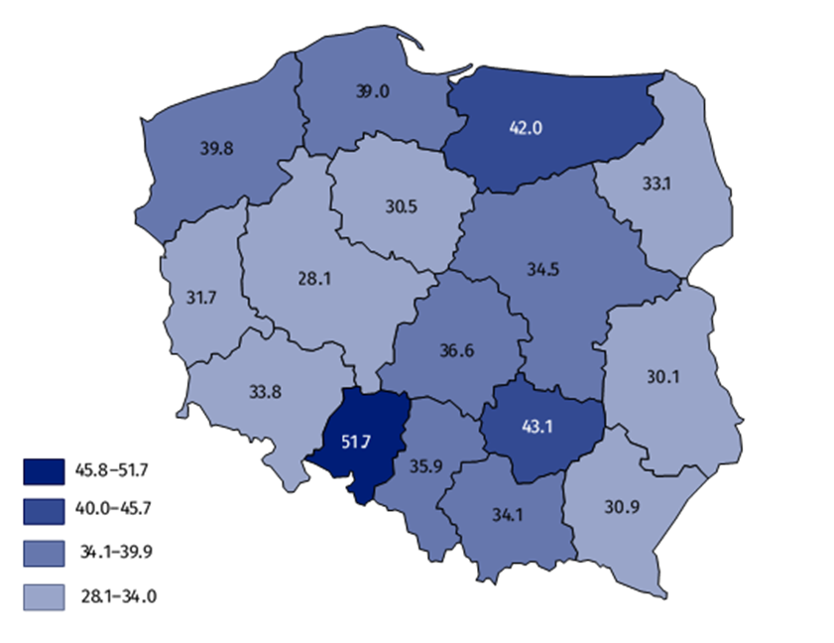
As of 31 December

Residents
Nearly 68% residents of social welfare facilities stayed in social assistance house
As of 31 December, in stationary social welfare facilities, there were 118.8 thousand residents. The major group of residents constituted men – 50.6%. Out of all residents, 67.9% stayed in social assistance houses. 18.8% of all residents stayed in establishments ensuring 24-hour care for disabled persons, chronic patients, or elderly persons within the scope of economic activity or their statutory activity, 10.0% residents were in hostels for homeless persons, 1.7% in night shelters, 0.7% in houses for mothers and 0.2% in family-based assistance houses. The residents in community self-help centres (with round-the-clock available places) accounted only for 0.1% of all residents.
Over 84% of the residents in stationary social welfare facilities paid, at least partly, for their accommodation from own income, e.g. old age pension, disability pension. The cost of accommodation for 7.5% of residents was covered completely by their families, while the accommodation for 6.6% was paid entirely by the local government. About 2% of the residents were exempted from the payment.

Chart 1. Structure of residents in stationary social welfare facilities by age in 2022
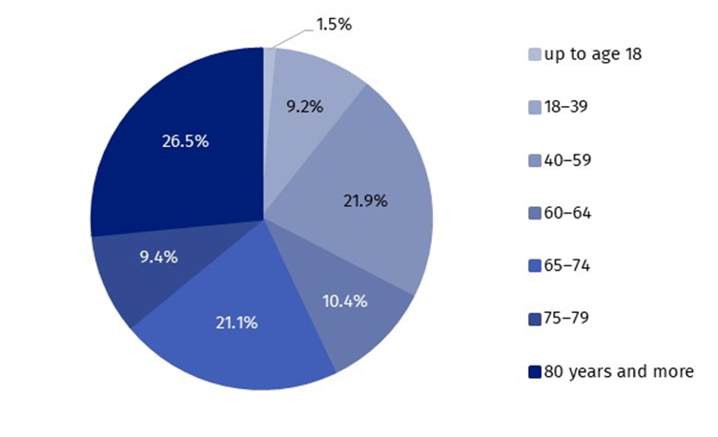
As of 31 December
The persons over 65 years old amounted to over a half of all residents in stationary social welfare facilities. Every fifth of the residents was a person at age of 40-59. The residents at age of 17 and less constituted the smallest age group (1.8 thousand).

Chart 2. Residents in stationary social welfare facilities by groups in 2022
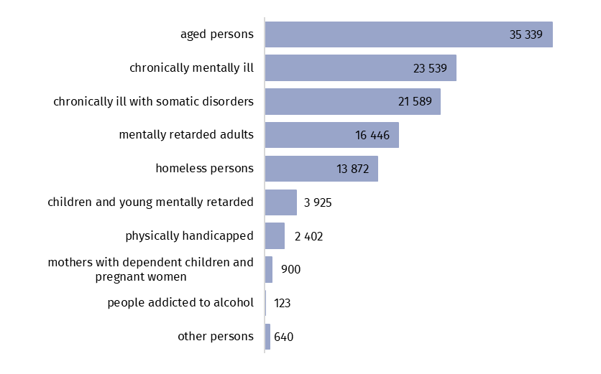
As of 31 December
The most of residents stayed in facilities for aged persons (29.8% of total number of residents), less in centres for chronically mentally ill (19.8%), and in centres for chronically ill with somatic disorders (18.2%). The smallest share referred to people addicted to alcohol (0.1%).

Table 2. Stationary social welfare facilities by voivodshipsª in 2022
As of 31 December
SPECIFICATION | Centres | Places | Residents
POLAND | 2 082 | 131 542 | 118 775
Dolnośląskie | 140 | 9 767 | 8 872
Kujawsko-pomorskie | 95 | 6 124 | 5 449
Lubelskie | 91 | 6 092 | 5 319
Lubuskie | 51 | 3 110 | 2 865
Łódzkie | 121 | 8 707 | 7 843
Małopolskie | 176 | 11 681 | 10 941
Mazowieckie | 310 | 18 998 | 16 778
Opolskie | 78 | 4 877 | 4 404
Podkarpackie | 94 | 6 433 | 5 565
Podlaskie | 64 | 3 788 | 3 441
Pomorskie | 159 | 9 201 | 8 308
Śląskie | 264 | 15 586 | 14 106
Świętokrzyskie | 81 | 5 076 | 4 702
Warmińsko-mazurskie | 98 | 5 743 | 5 267
Wielkopolskie | 165 | 9 822 | 9 021
Zachodniopomorskie | 95 | 6 537 | 5 894
a Centres excluding branches. Places and residents including branches.
In the case of quoting data from the Statistics Poland, please provide information: “Statistics Poland data source”, and in the case of publishing calculations made on data published by the Statistics Poland, please provide information: “Own study based on Statistics Poland data”.

Prepared by:  Statistical Office in Kraków  Director Agnieszka Szlubowska  Phone: (+48 12) 420 40 50 | Issued by:  The Spokesperson for the President  of Statistics Poland  Karolina Banaszek  Phone: (+48) 695 255 011
Press Office  Phone: (+48 22) 608 38 04  e-mail: obslugaprasowa@stat.gov.pl |   stat.gov.pl/en/

@StatPoland

@GlownyUrzadStatystyczny

gus_stat

glownyurzadstatystycznygus

glownyurzadstatystyczny
Related information
Social assistance, child and family services in 2021
Data available in databases
Database Local Data Bank – health care and social welfare
Terms used in official statistics
Community self-help centre
Establishment ensuring 24-hour care for disabled persons, chronic patients, or elderly persons within the scope of economic activity or their statutory activity
Family-based assistance house
Hostel for homeless persons
House for mothers with children under age and pregnant women
Night shelter
Social assistance house

