Disabled persons in 2022
In December 2022 in Poland there were 2.3 million persons receiving old-age and other pension benefits or reported for insurance to the Social Insurance Institution by social contribution payers, who had a certificate of disability, a certificate of level of disability (issued by the medical examination committees) or a certificate of inability to work (issued by the Social Insurance Institution) .
2.3 million
Persons with a certificate of disability, level of disability or level of inability to work in the Social Insurance Institution data sets

Persons with a certificate of disability, level of disability or level of inability to work in the Social Insurance Institution data sets
Out of all persons with a disability, level of disability or level of inability to work in the Social Insurance Institution data sets, 51.1% were male
In the surveyed population with a certificate of disability, level of disability or level of inability to work, men prevailed and accounted for 51.1%. Most of them were men at age of 64 (50.5 thousand), while women were at age of 73 (31.8 thousand). The average age of men was 62 and the average age of women was 64.
Chart 1. Persons with a certificate of disability, level of disability or level of inability to work in the Social Insurance Institution data sets by sex and age in 2022
As of 31 December
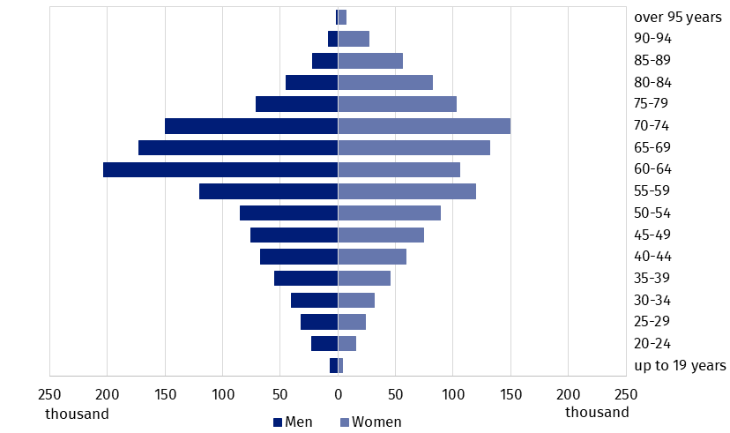
Source: General IT System of the Social Insurance Institution.

Persons, reported for insurance to the Social Insurance Institution by social contribution payers, who had a certificate of disability, level of disability or level of inability to work
Nearly 700 thousand persons reported for insurance to the Social Insurance Institution by social contribution payers have a certificate of disability or level of disability (issued by the medical examination committees) or a certificate of inability to work (issued by the Social Insurance Institution). The structure of those persons by level of disability was the following: 11.4% with a severe level of disability, 59.3% with a moderate level of disability and 29.0% with a slight level of disability. Other persons had a certificate of disability without a specific level due to age (up to 16 years of age).
Out of all persons with a certificate of disability, level of disability or level of inability to work, 17.4% were an entitled to disability pension and 11.8% to old-age pension. Other persons were not entitled to old age or disability pension (70.8%). Most persons were covered by social and health insurance under the employment contract (55.3%). In case of 16.2% of persons insurance contributions were paid by social assistance organisational unit or by gmina mayor, town mayor or president of city. Moreover, 6.9% persons were the unemployed with no allowance or traineeship. In addition, 6.7% of insured persons were employed on agency agreement, civil law contract or contract for service delivery.
The index of the number of persons with a certificate of disability, level of disability or level of inability to work per 10 thousand population reached the highest level in Lubuskie Voivodship (319)
The largest number of men declared the Mazowieckie Voivodship as their place of residence (40.7 thousand) and the largest number of women declared the Śląskie Voivodship (32.8 thousand). The least number of surveyed persons declared Opolskie Voivodship as their residence (5.8 thousand women and 8.7 thousand men). The highest number of persons per 10 thousand population assigned the Lubuskie Voivodship as their place of residence in (319) and the lowest number the Mazowieckie Voivodship (127).
Map 1. Persons, reported for insurance to the Social Insurance Institution by social contribution payers, who had a certificate of disability, level of disability or level of inability to work per 10 thousand population by voivodship in 2022
As of 31 December
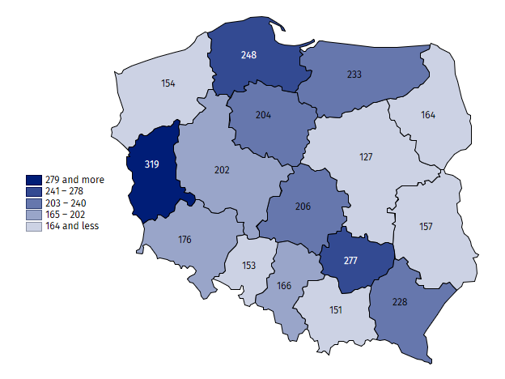
Source: General IT System of the Social Insurance Institution.

Education of students with disabilities and students with special educational needs
In the school year 2022/23 7.5 thousand children with disabilities attended special nursery schools and 47.8 thousand children with disabilities attended other pre-primary education facilities
In the school year 2022/23, there were 350 special nursery schools with 7.5 thousand children with disabilities. The greatest number, namely 26.7% of children in special nursery schools, aged 7 years. Most children in special nursery schools were males (70.8%). There were 47.8 thousand children z with disabilities in other nursery schools and other pre-primary education facilities, which accounted for, 3.1% of the total number of children. Most children with disabilities attended general nursery schools (78.7%), including nursery schools with integrated sections (11.6%) and integrated nursery schools (11.8%).
Table 1. Pre-primary education facilities in the school year 2022/23
As of 30 September
SPECIFICATION | Facilities | Sections | Children
SPECIFICATION | Facilities | Sections | total | of whose with disabili-ties
TOTAL | 22 505 | 76 002 | 1 534 212 | 47 798
Nursery schools | 13 756 | 60 538 | 1 249 173 | 37 630
Special | 350 | 1 547 | 7 486 | .
Integrated | 424 | 1 610 | . | 5 627
With integrated sections | 511 | 3 449 | . | 5 521
With special sections | 79 | 500 | . | 1 349
With integrated and special sections | 121 | 938 | . | 3 558
Other nursery schools | 12 271 | 52 494 | . | 21 575
Pre-primary education units | 45 | 45 | 664 | 16
Pre-primary centres | 1 399 | 1 399 | 24 140 | 4 913
Pre-primary sections in primary schools | 7 305 | 14 020 | 260 235 | 5 239
a Excluding children in special facilities.
There were 51.8 thousand children and youth in special primary schools. In addition, 113.8 thousand pupils with special educational needs attended the sections of general primary schools. Total number of children with disabilities covered by special education at the primary level amounted to 165.6 thousand, which accounted for 5.3% of total number of children. Most pupils were males (68.6%). Out of 3.6 thousand children educated individually 43.8% were the children with special educational needs.
In the school year 2022/2023 there were 221.6 thousand children and youth with special educational needs in mainstream schools (excluding schools for adults), who accounted for 4.3% of the total number of students

Special education and care centres and special educational centres are organised for pupils with the certificate for special educational needs on the basis of disabilities but, for that reason, could not attend the nursery school or school in their place of residence. In the school year 2022/23 there were 354 such centres. 53.7% out of the 18.8 thousand available places were used. Persons with intellectual disability accounted for 55.7% graduates. Subsequently, the centres provided care for children and youth with multiple disabilities (26.5%), deaf and hearing impaired (5.7%) and blind and vision impaired (3.2%).
Children and youth with a severe intellectual disability with the certificate of rehabilitation and education classes as well as children and youth with multiple disabilities, including intellectual disability with the certificate of special educational needs could fulfil one-year introductory school section obligation, full-time compulsory education and part-time compulsory education by attending rehabilitation and education centres. As of 30 September 2022, 191 rehabilitation and education centres provided 7.0 thousand places, out of which 88.4% were used. Centres offered classes for pupils with multiple disabilities (3.3 thousand) and for pupils with severe intellectual disability (2.6 thousand).
Post-primary education for youth with special educational needs was provided mainly in special schools. The majority of special schools were special vocational training schools and first degree sectoral vocational special schools, skills acquisition in specific professions. 29.2 thousand students attended all special schools. In addition, 26.6 thousand students with special educational needs attended the sections of secondary schools, including 42.2% students in the sections of general secondary schools, 33.5% students in the sections of technical secondary schools and 23.5% students in the sections of special first degree sectoral vocational schools. A total number of children and youth in special education at post-primary level amounted to 55.7 thousand and accounted for 3.2% of total.
280 students with special educational needs attended post-secondary schools, prevailingly in special post-secondary schools (88.9%).
In the academic year 2022/23, 20.9 thousand persons certified with the level of disability attended higher education institutions (1.7% of the total number of students) and 5.4 thousand persons graduated (1.8% of the total number of graduates). There were 0.6 thousand doctoral students certified with the level of disability, who accounted for 6.6% of all doctoral students.

Methodological notes
- The present release news is the fifth nationwide study on the subject of disabled persons, developed by the workers of the Statistical Office in Kraków. The scope of presented data does not cover the entire issue of disability due to its complex nature and diversity.
- The disability certification system in Poland is not uniform. It is defined by two fundamental legal acts:
- The Act of 27 August 1997 on Vocational and Social Rehabilitation and Employment of Disabled Persons (uniform text, Journal of Laws 2023 items 100, 173, 240, 852, 1234, 1429) – in Art. 2, disability is defined as permanent or temporary inability to fulfil social roles due to permanent or long-term impairment of the body efficiency, in particular resulting in inability to work. Art. 3 defines the level of disability: severe, moderate and slight, while Art. 4a mentions children up to 16 years of age who are certified without determining their level of disability. Disability adjudication institutions are powiat (first instance) and voivodship (second instance) disability adjudication units. The final instance constitutes regional labour courts and social security courts;
- The Act of 17 December 1998 on old age pensions and disability pensions from the Social Insurance Fund (uniform text, Journal of Laws of 2023, items 1251, 1429, 1672) – Art. 12 defines person unable to work as one who has completely or partially lost the ability to work for paid employment due to a deterioration of the physical health and is not expected to regain the ability to work after retraining. Decisions on: inability to work, incapacity for independent existence and purposefulness of retraining, issued by the Social Insurance Institution, are converted into certificates on the level of disability in accordance with Art. 5 of the aforementioned Act on Vocational and Social Rehabilitation and Employment of Disabled Persons.
- Other decisions that can be converted into disability certificates providing they were issued before 1 January 1998 and still are in force, are:
- certificates of inability to work on farm, issued by the Agricultural Social Insurance Fund;
- decisions on inability to service, issued by medical examination committees subordinated to the Ministry of National Defence or the Ministry of Internal Affairs and Administration.
A person must have one of the above-mentioned certificates to be certified as disabled legally and formally.
- The release news takes advantage from:
- The data sets of the Social Insurance Institution on old-age and other pension benefit recipients with a certificate on the level of inability to work, as well as on persons reported for social and health insurance by contributors who have presented a certificate on disability, degree of disability or degree of inability to work, issued by a relevant authority;
- The data provided by the Ministry of Science and Higher Education on children and youth with the opinion of the public psychological and educational counselling centre (or other public specialist outpatient clinic) on the need for special education and on students and doctoral students with a certificate on the level of disability issued by authorised institution;
Special education is organised for children and youth with disabilities, socially maladjusted and at risk of social maladjustment, requiring special forms of learning and methods of work. It may be organised in the general school system or individually. Children and youth with the certificate of special educational needs are not necessarily disabled in compliance with the provisions of the Act on Occupational and Social Rehabilitation and Employment of Persons with Disabilities. Likewise, students with disabilities do not need a certificate of special needs issued by an authorised institution.
- The Statistical information from the Statistics Poland’s reports also was used to develop the news release.

In the case of quoting data from the Statistics Poland, please provide information: "Statistics Poland data source", and in the case of publishing calculations made on data published by the Statistics Poland, please provide information: "Own study based on Statistics Poland data".
Prepared by:  Statistical Office in Kraków  Director Agnieszka Szlubowska  Phone: (+48 12) 420 40 50 | Issued by:  The Spokesperson for the President of Statistics Poland  Karolina Banaszek  Phone: (+48) 695 255 011
Press Office  Phone: (+48 22) 608 38 04  e-mail: obslugaprasowa@stat.gov.pl |   stat.gov.pl/en

@StatPoland

@GlownyUrzadStatystyczny

gus_stat

glownyurzadstatystycznygus

glownyurzadstatystyczny
Related information
Social assistance, child and family services in 2022
Disabled people in 2021
Terms used in official statistics
Disabled person
Disabled person with legal confirmation
Level of disability

Produced on the basis of compiled data sets from information systems of the Social Insurance Institution.
According to Art. 5 of the Act of 27 August 1997 on Vocational and Social Rehabilitation and Employment of Disabled Persons (Journal of Laws 2023 items 100, 173, 240, 852,1234,1429), the proof of decision of the Social Insurance Institution physician who certifies inability to work, incapacity for independent existence and the counselling on retraining is submitted with the application for certification of the level of disability.
In most cases, the declared voivodship as the place of residence corresponded with the declared voivodship of the residential address. In some cases, when the place of residence address was not known, it was decided on the basis of the residential address or, if both addresses were missing, on the basis of the mailing address.
Without double counting, by main type of disability.
Graduates in the academic year 2021/22.

