Foster care in 2022
11.05.2023
At the end of 2022, 72.8 thousand children deprived entirely or partly of their own family, were staying in foster care, of which 56.2 thousand in family foster care and 16.6 thousand children in institutional foster care. In comparison to 2021 the number of children in foster care increased by 0.7%.
0.7%
Increase in the number of children in foster care compared to 2021

Forms of family foster care
Related families accounted for over a half of all foster families
At the end of 2022 family foster care functioned in the form of related, not professional and professional families which amounted to 35 439 and in the form of foster homes – 781 units. Among foster families, related families accounted for 64.1%, not professional families –30.1%, and professional families – 5.8%.

Family foster care
52,8% of persons performing the function of foster family were at age of 51–70
The function of foster family was fulfilled by 18 409 married couples and by 17 030 lone persons. The families which admitted one child accounted for 72.6%, two children – 18.1%, three children – 5.4%, and four or more children 3.8% of all foster families. 52.8% of the total number of persons performing the role of foster family were persons at age of 51–70. Foster homes were run by 666 married couples and by 115 lone persons. Most persons (77.8%) performing the function of a family foster home were in the 41–60 age group.

Children in family foster care
Among children who were provided with family types of foster care, 6 565 had legal confirmation of disability

There were 56 240 children in family foster care, including 5 580 children in foster homes. Among all children who were provided with foster care 6 565 had legal confirmation of disability, moderate disability or severe disability and 2 719 were orphans. Considering age of children placed in family foster care, children at age of 7–13 constituted the major group (19 469) both in foster families and in foster homes, while children at age under 1 were in the smallest group of the family foster care (936). In 2022 there were 9 953 children who were admitted for the first time in family foster care. In 2022, 7655 children up to age of 18 left family foster care. The majority of them (31.0%) returned to their own families. 1 483 children went to adoption families, while 2 107 children to other forms of family foster care. 1 078 children left family foster care because they were moved to institutional foster care and 29 children left family foster care, because of transferring them to social assistance house. Out of 4 539 adult residents who left foster care in 2022, 2 277 set up their own households, and 163 returned to their own families or relatives. Among the residents who left foster care at age over 18, 1 723 did not start to lead independent life.

Chart 1. Structure of children in family foster care by age groups in 2022
As of 31 December
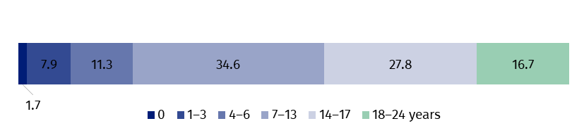

Institutional foster care facilities
Socialisation centres accounted for 61.7% of all institutional foster care facilities
At the end of 2022 in Poland there were 1 307 institutional foster care facilities, including 1 294 education and care facilities, 10 regional care and therapy centres and 3 intervention pre-adoptive centres. The care and education facilities encompass socialisation centres (807), family centres (209), intervention centres (56), specialist therapy centres (32) and tasks combining centres (190).

Places in institutional foster care
There were 16 923 places in institutional foster care facilities, including 10 797 places in socialisation centres, 3 065 places in task combining centres and in family, intervention and specialist therapy centres 1 590, 725 and 374 respectively. In other facilities there were 372 places in total.

Chart 2. Structure of places in institutional foster care facilities by type of facility in 2022
As of 31 December
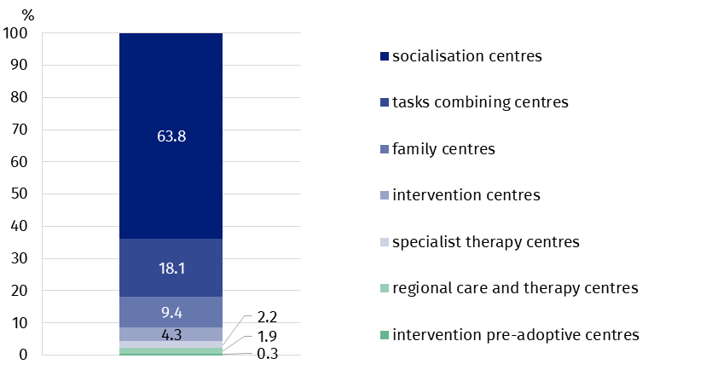

Residents in institutional foster care
Children at age of 14–17 constituted the major group of residents in institutional foster care (46.0%)
At the end of 2022, there were 16 572 residents in institutional foster care. Residents at age of 14–17 constituted the major group (7 622 children). The second biggest group (4 258 persons) were children at age of 10–13. The smallest was the youngest age group under age of 1 (170 residents). In institutional foster care facilities there were 1 327 adult residents who continued their education.

Chart 3. Structure of residents in institutional foster care by age groups in 2022
As of 31 December
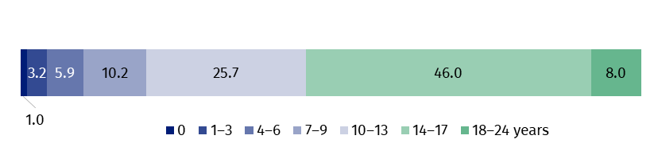
Throughout the year 2022, 4 313 residents up to age of 18 left institutional foster care facilities. The major group (39.4%) were residents who returned to their own family. Transfer to other type of institutional foster care was the reason for leaving the facilities for 24.4% of children. 20.6% of residents were placed in family foster care, while 5.6% went to adoption families. Out of 2 077 residents at age over 18 who left the facilities, 1 199 set up their own household and 697 returned to their own family.

Volunteers in institutional foster care
In 2022, 1 203 volunteers did charity work in institutional foster care. 1 117 persons attended the works of care and education facilities, 53 persons worked for regional care and therapy centres and 33 volunteers were involved in the works of pre-adoptive intervention centres. Among care and education centres most volunteers supported the activities of socialisation centres (70.0%) and the smallest group worked in intervention centres (4.0%).

Legally disabled persons in institutional foster care
Among all residents of institutional foster care the disabled persons accounted for 12.3%

By the end of 2022 there were 2 033 disabled residents of institutional foster care. In care and education centres there were 1 811 persons certified as disabled while in regional care and therapy centres 222 persons. There were no disabled people in pre-adoptive intervention centres. In socialisation centres the disabled persons accounted for 65.3% of total of disabled residents in care and education centres, 15.0% in tasks combining centres, 8.8% in family centres, 7.8% in specialist therapy centres and 3.1% in intervention centres.

Table 1. Foster care by voivodships in 2022
As of 31 December
Voivodships | Family care |  | Institutional care
Voivodships | families | children | facilities | residents
POLAND | 3 6220 | 56 240 | 1 307 | 16 572
Dolnośląskie | 3 992 | 5 982 | 158 | 2 025
Kujawsko-pomorskie | 2 149 | 3 450 | 90 | 1 238
Lubelskie | 1 706 | 2 634 | 94 | 986
Lubuskie | 1 284 | 1 968 | 41 | 503
Łódzkie | 2 754 | 3 957 | 81 | 1 101
Małopolskie | 1 983 | 3 025 | 98 | 1 068
Mazowieckie | 4 089 | 6 083 | 137 | 1 725
Opolskie | 980 | 1 543 | 27 | 420
Podkarpackie | 1 136 | 1 738 | 47 | 659
Podlaskie | 898 | 1 362 | 29 | 384
Pomorskie | 2 357 | 4 248 | 81 | 1 070
Śląskie | 4 762 | 7 389 | 181 | 2 294
Świętokrzyskie | 976 | 1 387 | 44 | 579
Warmińsko-mazurskie | 1 734 | 2 789 | 68 | 857
Wielkopolskie | 3 189 | 4 949 | 72 | 899
Zachodniopomorskie | 2 231 | 3 736 | 59 | 764
In the case of quoting data from the Statistics Poland, please provide information: “Statistics Poland data source”, and in the case of publishing calculations made on data published by the Statistics Poland, please provide information: “Own study based on Statistics Poland data”.
Prepared by:  Statistical Office in Kraków  Director Agnieszka Szlubowska  Phone: (+48 12) 420 40 50 | Issued by:  The Spokesperson for the President  of Statistics Poland  Karolina Banaszek  Phone: (+48) 695 255 011
Press Office  Phone: (+48 22) 608 38 04  e-mail: obslugaprasowa@stat.gov.pl |   stat.gov.pl/en/

@StatPoland

@GlownyUrzadStatystyczny

gus_stat

glownyurzadstatystycznygus

glownyurzadstatystyczny
Related information
Social assistance, child and family services in 2021
Data available in databases
Database Local Data Bank – health care and social welfare
Terms used inn official statistics
Pre-adoptive intervention centre
Family foster care coordinator
The organiser of family foster care
Foster care
Centres combining tasks of the centres
Care and education centre for children and young people
Intervention centre
Family centre
Socialization centre
Specialist therapy centre
Poviat centre for family support
Regional care and therapy centre

