Nurseries and children’s clubs in 2022
At the end of 2022, there were 5.3 thousand nurseries and children’s clubs, which provided 206.0 thousand places. The index of the number of children up to age of 3 increased from 155 in 2021 to 180 in 2022.
7.5%
Growth of the number of places in nurseries and children’s clubs compared to 2021

Facilities
Nearly 84% of all facilities for children up to age of 3 are nurseries
As of 31 December 2022, in Poland there were 5.3 thousand facilities for children up to age of 3, including 4.4 thousand nurseries. Facilities in private sector (74.8%) accounted for three times more than facilities in public sector (25.2%). Most of nurseries and children’s clubs in private sector were run by physical person (66.2%). Local government run the largest number of nurseries and children's clubs in the public sector (96.8%).
Chart 1. Facilities for children up to age of 3 by type of property in 2022
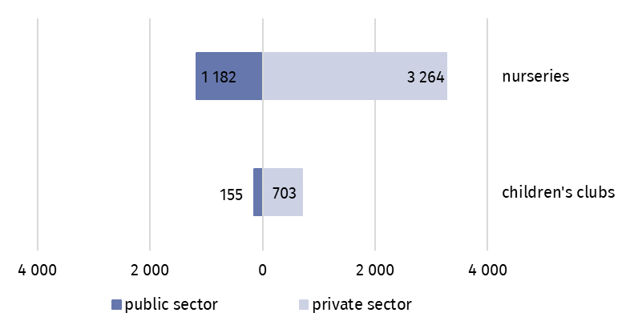
As of 31 December
66.5% of all facilities for small children were open 5 to 10 hours a day, 32.9% provided care for over 10 hours a day, while remaining 0.6% accounted for children’s clubs open up to 5 hours a day.
59.5% of facilities for small children were equipped with amenities for children with disabilities. Ramps, rapids and platforms facilitating entry into the building were the most frequent amenities (36.6% of total number of facilities). 28.9% facilities were equipped with bathrooms adapted for disabled children, while 28.4% had non-slip floors.
Places
Nearly 61% of all places in facilities for children up to age of 3 are places in private sector facilities
The number of places in all facilities for children up to age of 3 amounted to 206.0 thousand (increase by 7.5%, compared with last year), including 124.6 thousand places in private sector.
In private sector, there were 31 places per one nursery on average and in public sector average value was two times higher – 61 places.

Children
The number of children in nurseries and children’s clubs increased by 13.7 thousand (8.4%) compared to 2021
At the end of the analysed period, there were 177.1 thousand children in nurseries and children’s clubs. Most of them stayed in nurseries (nearly 92%). The highest value for the index of the number of children up to age of 3 per 1 thousand population was (as in the previous year) in Dolnośląskie Voivodship (258), while the lowest value was recorded in the Warmińsko-Mazurskie Voivodship (127).
Map 1. Care for children up to age of 3 in 2022
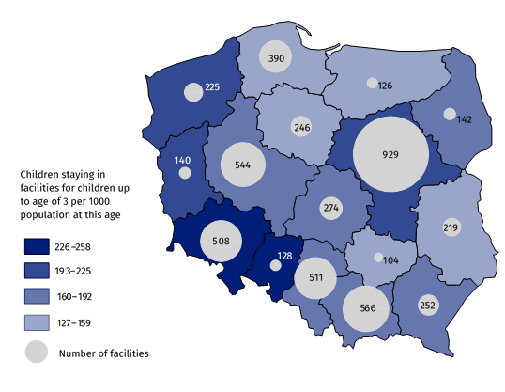
As of 31 December
Two-year olds constituted the largest group in facilities – 53.1%. The share of one-year-old children and infants (0–1) accounted for 39.6% and 1.2% respectively. The girls accounted for 48.3% of the total number of children in facilities.
Chart 2. Children in facilities for children up to age of 3ª by sex and age in 2022
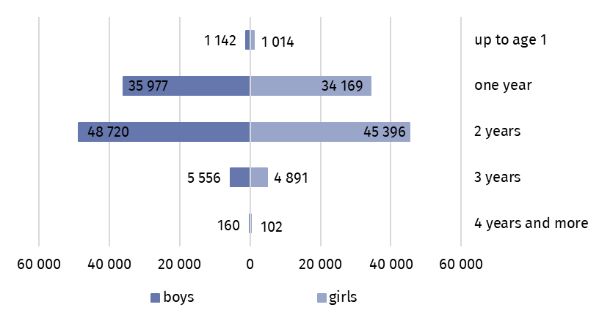
As of 31 December
a Child care may be performed up to the end of the school year when child reaches age of 3 or when it is either impossible or impeded to provide child with pre-school education – up to age of 4.
Throughout 2022, 279.9 thousand children stayed in facilities, including 1.6 thousand disabled children. Local government covered, partly or entirely, the costs of accommodation in facilities for 66.8% of children.

Staff
33.9 thousand women worked in nurseries and children’s clubs, which accounted for 99.3% of all employees

34.2 thousand people worked in facilities for children at age up to 3. Children’s carers constituted the major group of the employees in facilities – 73.9%. Teachers accounted for 8.1% of the total number of employees. The vast majority of employees were women – 99.3%. Facilities for children up to age of 3 were the main workplace for 94.8% of children’s carers and 90.6% teachers. In the case of midwives and nurses, the share was evidently lower and accounted for 44.0% and 37.3% respectively.

Chart 3. Structure of employees cares in nurseries and children’s clubs in 2022
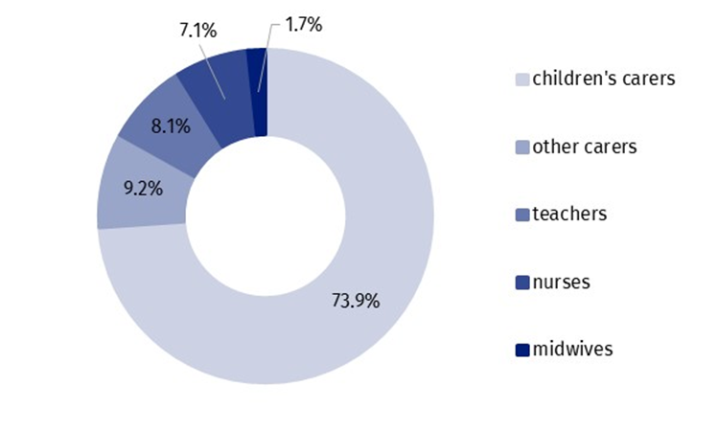
As of 31 December
The functioning of nurseries and children’s clubs were supported by 607 volunteers. Their number increased by more than 25% compared to the previous year.
Table 1. Care facilities for children up to age of 3 by voivodships in 2022
As of 31 December
Voivodships | Facilities | Places | Children
POLSKA | 5 304 | 206 016 | 177 127
Dolnośląskie | 508 | 21 552 | 18 634
Kujawsko-pomorskie | 246 | 10 018 | 7 782
Lubelskie | 219 | 8 601 | 7 350
Lubuskie | 140 | 5 697 | 5 166
Łódzkie | 274 | 10 746 | 9 594
Małopolskie | 566 | 20 306 | 16 829
Mazowieckie | 929 | 35 334 | 31 084
Opolskie | 128 | 6 141 | 5 339
Podkarpackie | 252 | 9 866 | 8 937
Podlaskie | 142 | 5 842 | 5 144
Pomorskie | 390 | 13 748 | 10 709
Śląskie | 511 | 21 109 | 17 922
Świętokrzyskie | 104 | 3 963 | 3 614
Warmińsko-mazurskie | 126 | 4 645 | 4 115
Wielkopolskie | 544 | 19 260 | 16 677
Zachodniopomorskie | 225 | 9 188 | 8 231
In the case of quoting data from the Statistics Poland, please provide information: “Source of Statistics Poland data”, and in the case of publishing calculations made using data published by the Statistics Poland, please provide information: “Own study based on Statistics Poland data”.
Prepared by:  Statistical Office in Kraków  Director Agnieszka Szlubowska  Phone: (+48 12) 420 40 50 | Issued by:  The Spokesperson for the President  of Statistics Poland  Karolina Banaszek  Phone: (+48) 695 255 011
Press Office  Phone: (+48 22) 608 38 04  e-mail: obslugaprasowa@stat.gov.pl |   stat.gov.pl/en/

@StatPoland

@GlownyUrzadStatystyczny

gus_stat

glownyurzadstatystycznygus

glownyurzadstatystyczny
Related information
Social assistance, child and family services in 2021
Availability in databases
Database Local Data Bank – health care, social welfare and benefits to the family
Terms used in official statistics
Nursery, children's club

