Family benefits in 2022
In 2022, PLN 11.4 billion was allocated to support families in the form of family benefits. PLN 1.2 billion was spent on social security and health insurance contributions. In addition, PLN 3.5 billion was paid out from the family care capital, and PLN 1.4 billion under the "Good Start" programme. The Large Family Card was held by 1.5 million families. The total amount of alimony fund benefits paid was nearly PLN 1 billion. Under the government's "Family 500 plus" programme, PLN 41.9 billion was transferred for child-raising benefits.
3.5%
Increase in the amount of family benefits paid y/y

Total family benefits
PLN 11.4 billion was transferred to the beneficiaries of family benefits to support families with children and with disabled persons

In 2022, 11.4 billion zlotys were allocated for family benefits, aimed at financially supporting families with children or persons with disabilities, i.e. by PLN 388.1 million (by 3.5%) more than in 2021. These benefits were used by an average of 1.5 million beneficiaries per month, and on average 3.2 million benefits were paid per month. The largest amount of funds, as in 2021, was spent on assistance directed to people with disabilities, i.e. on care benefits, which accounted for 69.8% of total spending. Expenditures on aid directed to families with children, i.e. family allowances with supplements, childbirth allowances and parental benefits, accounted for 30.2% of the total amount of expenditures.

Chart 1. Structure of expenditure on family benefits in 2022
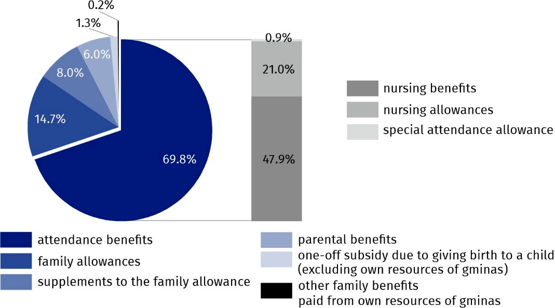
Source: National Family Benefits Monitoring System, Ministry of Family and Social Policy.

Total care benefits
PLN 8.0 billion allocated to care benefits
In the total amount of family benefits paid in 2022, 69.8% (PLN 8.0 billion) were benefits aimed at disabled people, i.e. care benefits. These include nursing benefits, nursing allowances and special care allowance. Compared to 2021, the amount of care benefits increased by 14.1% (by PLN 980.5 million). Nursing benefits were allocated PLN 5.5 billion, which accounted for 68.7% of the total care benefits paid. The remainder was nursing benefits (PLN 2.4 billion) and special care benefits (PLN 98.6 million). Nursing benefits were paid monthly to an average of 923.5 thousand people, up from 911.6 thousand people in 2021. In the structure of nursing care benefits, the highest share – 72.2% was paid to people aged 16–74. Allowances for disabled children under the age of 16 accounted for 26.0%, while those for those aged 75 and over accounted for 1.8%. In the year under review, nursing benefits were paid monthly to an average of 239.8 thousand children under the age of 16, which accounted for 3.8% of the total number of children of that age. In 2022, monthly nursing benefit was granted to 217.5 thousand people, and special care allowance to 13.4 thousand people.

Family benefits and supplements to family allowances
In 2022, family benefits of PLN 1.7 billion were paid, i.e. PLN 307.8 million (by 15.5%) less than in 2021. On average, family benefits were collected monthly by 552.7 thousand families, i.e. 126.3 thousand (by 18.6%) fewer families than in 2021. Benefits for one or two children were collected by 385.1 thousand families, which accounted for 69.7% of families collecting family benefits. Among families collecting family allowances, full families accounted for 76.2% (421.2 thousand families). In 2022, 82.9 thousand families with a child with disabilities benefited from family benefits, accounting for 15.0% of all families collecting family benefits. Among families collecting family benefits, 51.0% (281.7 thousand families) had a per capita income of no more than PLN 400, and 41.7% (230.5 thousand families) had a per capita income between PLN 400 and the income criterion level. Income above the income criterion level was achieved by 7.3% of families receiving family benefits (40.5 thousand).
Family allowance was received on average by 552.7 thousand families per month

Chart 2. Structure of families receiving the family allowance in 2022
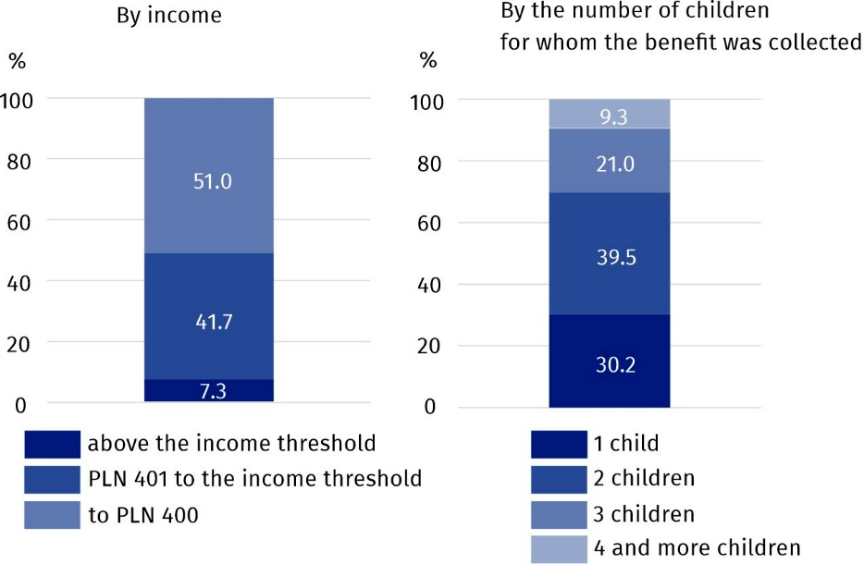
Source: National Family Benefits Monitoring System, Ministry of Family and Social Policy.
Family benefits were paid monthly to an average of 1 231.2 thousand children, with the largest group being children aged 6–12 (468.2 thousand – 38.0%). The percentage of children under the age of 6 (377.5 thousand) was 30.7%, children aged 13–17 were 24.9%, and those aged 18 and over who were dependent mainly due to education were 6.4%.
Parents received family benefits for 16.5 % of children under the age of 18

The share of children under the age of 18 for whom parents received family benefits in the total number of children of that age was 16.5%, down 3.1 pp from 2021. This indicator reached its lowest value in the Lower Silesia province (11.9%) and the highest in the Lublin province (21.9%).
More than 1/4 of expenses on supplements to family allowances were supplements due to multi-children parenthood

In 2022, family benefit recipients received supplements to allowances in the amount of PLN 909.8 million, which accounted for 8.0% of the total amount of family benefits. On average, 710.8 thousand supplements to family benefits were paid monthly, i.e by 96.1 thousand (by 11.9%) less than in 2021. Expenditures on supplements to family allowances were financed from the state budget, and in addition, gminas spent PLN 9.4 million from their own funds to increase these amounts.
Of the expenditures on family allowances, the largest amount – PLN 280.4 million was paid for raising a child in a large family, and the smallest amount – PLN 47.7 million was paid for the birth of a child.

Map 1. Share of children under the age of 18 for whom parents received the family allowance in the total number of children at this age in 2022
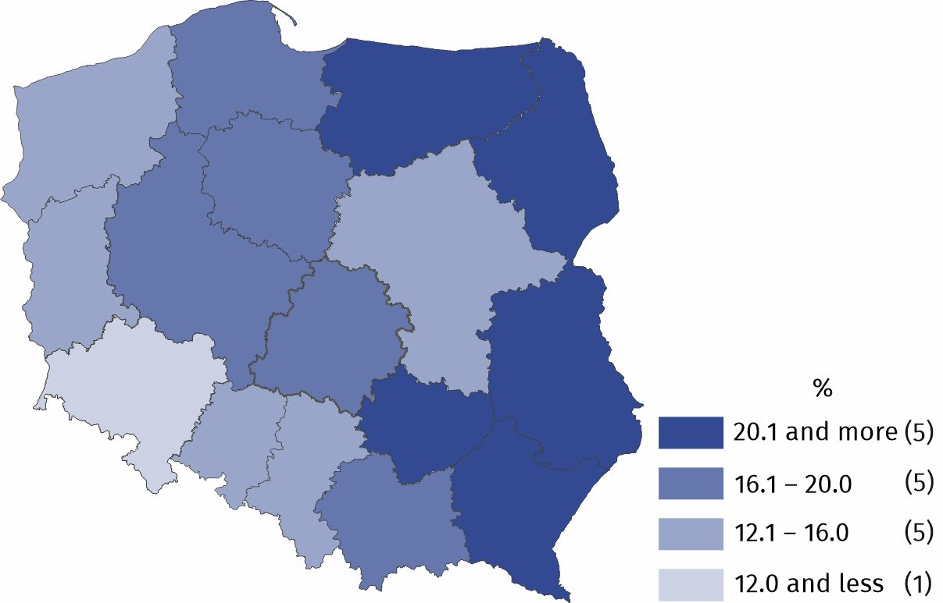
Source: National Family Benefits Monitoring System, Ministry of Family and Social Policy.

Parental benefits
On average 62.3 thousand people collected parental benefits monthly
Introduced as of January 1, 2016, parental benefits are available to women who have given birth to a child and who do not receive maternity allowance. In 2022, spending on parental benefits amounted to PLN 678.5 million and accounted for 6.0% of all spending on family benefits. On average, 62.3 thousand eligible persons received them monthly. Compared to the previous year, both the amount and the monthly average number of parental benefits paid decreased by 13.5% and 14.2%, respectively.

One-off subsidies due to giving birth to a child
Parents of 153.0 thousand children received subsidies due to giving birth to a child ("baby bonus")

In 2022, one-time benefits for the birth of a child, the so-called "baby bonus” (becikowe) were directed to the parents of 153.0 thousand children, and this was 36.4 thousand less (by 19.2%) than in the previous year. Expenditures on "baby bonus" payments financed from the state budget amounted to PLN 153.0 million, which accounted for 1.3% of total expenditures on family benefits. Among families receiving one-off subsidies due to giving birth to a child – 41.0% were families with one child, and families with two children – 37.1%, large families (with three children and more) – 21.9% of the collective in question. In 2022, an additional 7.8 thousand childbirth allowances were paid from own funds of gminas in the total of PLN 5.5 million.

Social security and health insurance contributions
In 2022, PLN 1.0 billion was spent on pension and disability insurance premiums for recipients of nursing benefits or special care allowance. Monthly premiums were paid on average for 164.9 thousand benefit recipients. Health insurance contributions were also paid for recipients of the aforementioned benefits on a monthly average for 104.2 thousand eligible persons. PLN 214.5 million was paid out on this account.

Family care capital
Introduced as of January 1, 2022, the family care capital (RKO) benefit is available for each second and subsequent child in the family between the ages of 12 and 35 months, in the maximum amount of PLN 12,000 per child. When applying, the child's parent/receiver decides on the form of payment, i.e. whether he or she wants to receive a benefit of PLN 500 for 24 months or PLN 1 000 for 12 months. In 2022, capitals for a total value of PLN 3.5 billion were paid out, with a monthly average of 271,200 capitals. Among the paid capitals, benefits paid in the amount of PLN 1,000 predominated (85.5%).

Benefits from the "Good Start" programme
As part of the "Good Start" programme, the families of pupils and students received PLN 1.4 billion

As of 2018, aid to families with children has been expanded to include the payment of a school starter benefit once a year (in the amount of PLN 300), for each studying child starting the school year. The benefit is paid under the "Good Start" programme and is independent of earned income. In 2022, 4.6 million students received support under the program, with a value of PLN 1.4 billion.

The Large Family Card
Nearly 1.5 million people had the Large Family Card
The Large Family Card is a system of discounts and additional entitlements for large families with a minimum of three children. It is granted regardless of the amount of income per person in the family and supports the budgets of families with many children and facilitates access to many goods and services. Among other things, holders of the Large Family Card can enjoy discounts on train travel, free admission to national parks, lower passport fees, as well as discounts on the purchase of food, clothing, cosmetics, books or fuel. In 2022. Nearly 1.5 million families had the Large Family Card, compared to more than 1.1 million a year earlier (increase by 27.1%).

Alimony fund benefits
The value of benefits paid from the alimony fund amounted to PLN 952.5 million
The alimony fund may be used by a person entitled to alimony in case of ineffective enforcement of alimony from the debtor. In 2022, 2.3 million alimony fund benefits were paid (in 2021 – 2.5 million). These benefits were paid for a total amount of PLN 952.5 million, 7.6% less than in the previous year. An average of 189.4 thousand benefits were paid monthly, with an average amount of PLN 419.0, compared to an average of 207.0 thousand benefits with an average amount of PLN 415.0 paid monthly in 2021.

Child-raising benefits
PLN 42.0 billion was paid under the government programme "Family 500 plus"

The PLN 500 child-raising benefit paid under the government's "Family 500 plus" programme is due for each child up to the age of 18, regardless of the per capita income received in the family. In 2022, spending on the child-raising benefit amounted to PLN 42.0 billion. On average, the benefit was paid monthly to 6.9 million children.
Table 1. Amounts of family benefits paid by voivodships in 2022
Specification | Amount of family benefits paid | Amount of benefits paid from the alimony fund |  | Amount of child-  -raising benefits paid from the “Family 500 plus” programme
Specification | million PLN
Polska | 11397.58 |  | 952.46 |  | 42043.69
Dolnośląskie | 692.55 |  | 80.38 |  | 3110.55
Kujawsko-pomorskie | 739.22 |  | 67.10 |  | 2175.7
Lubelskie | 686.95 |  | 58.92 |  | 2144.35
Lubuskie | 368.10 |  | 30.28 |  | 1076.75
Łódzkie | 645.17 |  | 55.55 |  | 2518.57
Małopolskie | 871.75 |  | 56.71 |  | 3991.2
Mazowieckie | 1310.37 |  | 110.29 |  | 6641.49
Opolskie | 225.78 |  | 21.53 |  | 928.29
Podkarpackie | 887.13 |  | 40.67 |  | 2247.03
Podlaskie | 363.27 |  | 26.17 |  | 1209.42
Pomorskie | 878.46 |  | 72.93 |  | 2851.4
Śląskie | 1117.66 |  | 108.98 |  | 4630.75
Świętokrzyskie | 496.12 |  | 30.22 |  | 1162.69
Warmińsko-mazurskie | 518.35 |  | 53.50 |  | 1464.36
Wielkopolskie | 1128.14 |  | 82.13 |  | 4183.54
Zachodniopomorskie | 468.55 |  | 57.10 |  | 1697.38
Wnioskodawca o adresie zagranicznym | – |  | – |  | 10.22
Source: National Family Benefits Monitoring System, Ministry of Family and Social Policy and Central Statistical Application – the area of Child-raising Benefit of the Ministry of Family and Social Policy.
In the case of quoting data from the Statistics Poland, please provide information: "Statistics Poland data source", and in the case of publishing calculations made on data published by the Statistics Poland, please provide information: "Own study based on Statistics Poland data".

Prepared by:  Statistical Office in Kraków  Director Agnieszka Szlubowska  Phone: (+48 12) 420 40 50 | Issued by:  The Spokesperson for the President of Statistics Poland  Karolina Banaszek  Phone: (+48) 695 255 011
Press Office  Phone: (+48 22) 608 38 04  e-mail: obslugaprasowa@stat.gov.pl |   stat.gov.pl/en/

@StatPoland

@GlownyUrzadStatystyczny

gus_stat

glownyurzadstatystycznygus

glownyurzadstatystyczny
Related information
Social assistance, child and family services in 2021
Data available in databases
Database Local Data Bank – HEALTH CARE AND SOCIAL WELFARE
Terms used inn official statistics
Beneficiaries from family benefits
Alimony fund benefits
Benefits within the "Family 500+" Programme

Beneficiaries of family benefits are families receiving family benefits for dependent children and adults entitled to benefits for themselves.
The income criterion determining the payment of family benefits is PLN 674 of the average monthly family income per capita or PLN 764 for families with a disabled child.
Pursuant to Art. 17c of the Act of 28 November 2003 on family benefits (Journal of Laws 2016 item 1518, with later amendments), the parental benefit apart from the child's mother is also granted to the father, actual guardian, foster family in cases specified in the Act.
Act of 17 November 2021, Journal of Laws 2021 item 2270, Journal of Laws 2022 item 2140.
The value of paid childcare benefits is given together with benefits paid for children in foster care and for children who came from Ukraine in connection with the armed conflict. Benefits paid abroad (PLN 28.5 thousand) are not included.

