Gross domestic product and gross value added
in regional breakdown in 2021
In 2021, more than 1/2 of the national value
of gross domestic product was generated in the
5 regions: Warszawski stołeczny, Śląskie, Wielkopolskie, Dolnośląskie and Małopolskie.
55.9%
Percentage of GDP value generated in the 5 regions in 2021

Gross domestic product
In 2021, value of the generated gross domestic product amounted to 2 631 302 million PLN.
In comparison to 2020, it grew by 12.6% at current prices.
In 2021, all regions recorded an increase in GDP at current prices compared to the previous year
The increase in gross domestic product at current prices compared to 2020 was recorded
in all regions, the largest in Pomorskie region – by 16.0%, and the smallest in Warszawski stołeczny region – by 10.0%.
In 2021, the shares of individual regions in the generation of GDP ranged from 2.1% in Lubuskie and Opolskie regions to 17.3% in Warszawski stołeczny region. Value of GDP generated
in Warszawski stołeczny region in 2021 was above 8 times higher than in Opolskie region (in 2020 almost 9 times higher).
In the group of regions with high shares in the generation of GDP in 2021, apart from Warszawski stołeczny region, there were also the following regions: Śląskie, Wielkopolskie, Dolnośląskie and Małopolskie. Entities acting in the 5 above-mentioned regions, in which 51.5% of total employed persons in the national economy worked, jointly generated 55.9%
of the national value of GDP.
Graph 1. Share of regions in the generation of gross domestic product in 2021 (current prices)
Świętokrzyskie 2.3%
Opolskie 2.1%
Podlaskie 2.2%
Lubuskie 2.1%
Warszawski stołeczny 17.3%
Warmińsko-mazurskie 2.6%
Zachodniopomorskie 3.7%
Lubelskie 3.7%
Podkarpackie 3.9%
Kujawsko-pomorskie 4.4%
Pomorskie 6.0%
Łódzkie 6.1%
Mazowiecki regionalny 5.3%
Wielkopolskie 9.9%
Dolnośląskie 8.5%
Małopolskie 8.2%
POLAND
2 631.3 bn PLN
Śląskie 12.0%
In 2021, the following regions were in the group of regions with low shares in the GDP generation (less than 3% each): Lubuskie, Opolskie, Podlaskie, Świętokrzyskie and Warmińsko-mazurskie. Their total share in the GDP generation amounted to 11.3% and employment in these regions constituted 12.7% of the total employed persons in the national economy.
In 2021, the average level of gross domestic product per capita in Poland amounted to
69 263 PLN. In comparison with 2020, it was higher by 13.1% at current prices. The increase
in GDP per capita at current prices compared to 2020 was recorded in all regions – from 9.7% in Warszawski stołeczny region to 16.1% in Opolskie and Śląskie regions.
In the regional breakdown, the level of GDP per capita in 2021 was differentiated. Indicator
of dispersion of GDP per capita, calculated at the regions’ level for Poland in 2021 amounted to 21.3%. In comparison to 2020, a decrease of this indicator by 0.4 pp was noted.
Level of GDP per capita exceeding the national average was obtained in 4 regions: Warszawski stołeczny, Dolnośląskie, Wielkopolskie and Śląskie
The highest level of GDP per capita in 2021 was noted for Warszawski stołeczny region –
140 534 PLN, exceeding twice the national average. In 2021 the level of GDP per capita above the national average was also observed in Dolnośląskie region – by 10.8%, Wielkopolskie region – by 7.2% and Śląskie region – by 3.4%.
The highest level of GDP per capita, obtained in 2021 in Warszawski stołeczny region, exceeded 3-times the value of GDP per capita of Lubelskie region, in which the lowest level
of GDP per capita was recorded.
All regions of Eastern Poland recorded a GDP per capita level below 75% of the national average
Low level of GDP per capita (less than 75% of the national average) in 2021 was observed
in the regions of Eastern Poland: Lubelskie, Podkarpackie, Warmińsko-mazurskie, Podlaskie and Świętokrzyskie. In 2021, the value of GDP per capita in these regions varied from 68.7%
to 73.1% of the national average.
The lowest level of GDP per capita in 2021, noted in Lubelskie region, represented 33.9%
of the level of this indicator for the best in this regard Warszawski stołeczny region.
Map 1. Gross domestic product per capita by regions in 2021 (current prices)

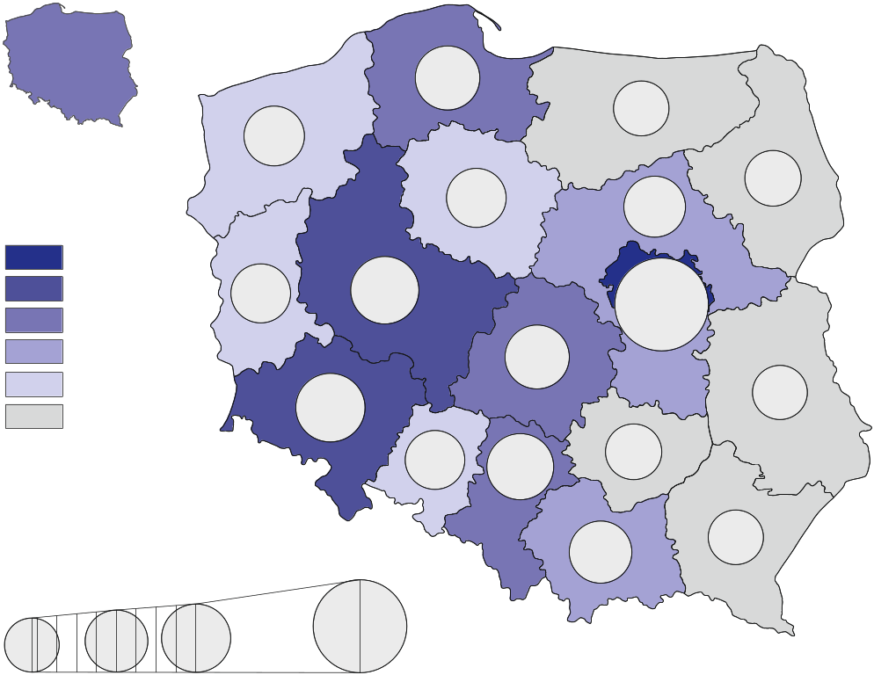
47.6-54.0
68.7%
90.0%
110.0%
82.0%
81.9%
96.6%
70.9%
84.2%
73.1%
87.9%
107.2%
202.9%
95.9%
68.7%
69.3
thousand
PLN

72.1-78.0
78.1-140.5
66.1-72.0
60.1-66.0
54.1-60.0
110.8%
73.1%
202.9%
In thousand PLN
81.8%
103.4%
70.1%
90.8%
Poland=100

Table 1. Gross domestic product by regions in 2021 (current prices)
Regions | Total |  |  | Per capita
Regions | in million PLN | in percent | previous year=100 | in PLN | Poland=100 | previous year=100
POLAND | 2 631 302 | 100.0 | 112.6 | 69 263 | 100.0 | 113.1
Dolnośląskie | 222 670 | 8.5 | 113.8 | 76 748 | 110.8 | 114.4
Kujawsko-pomorskie | 114 909 | 4.4 | 112.2 | 56 774 | 82.0 | 113.0
Lubelskie | 97 523 | 3.7 | 111.5 | 47 611 | 68.7 | 112.4
Lubuskie | 56 102 | 2.1 | 112.1 | 56 701 | 81.9 | 112.9
Łódzkie | 159 665 | 6.1 | 110.5 | 66 393 | 95.9 | 111.5
Małopolskie | 215 847 | 8.2 | 113.9 | 62 908 | 90.8 | 114.1
Mazowiecki regionalny | 138 444 | 5.3 | 113.5 | 60 915 | 87.9 | 114.3
Opolskie | 53 994 | 2.1 | 115.2 | 56 689 | 81.8 | 116.1
Podkarpackie | 101 498 | 3.9 | 113.7 | 48 544 | 70.1 | 114.2
Podlaskie | 58 369 | 2.2 | 111.0 | 50 628 | 73.1 | 111.7
Pomorskie | 157 785 | 6.0 | 116.0 | 66 920 | 96.6 | 116.0
Śląskie | 314 500 | 12.0 | 115.2 | 71 595 | 103.4 | 116.1
Świętokrzyskie | 60 381 | 2.3 | 111.9 | 50 604 | 73.1 | 113.0
Warmińsko-mazurskie | 67 755 | 2.6 | 111.7 | 49 098 | 70.9 | 112.5
Warszawski stołeczny | 455 370 | 17.3 | 110.0 | 140 534 | 202.9 | 109.7
Wielkopolskie | 259 958 | 9.9 | 111.3 | 74 224 | 107.2 | 111.6
Zachodniopomorskie | 96 531 | 3.7 | 111.9 | 58 323 | 84.2 | 112.6
Gross value added by kind of activity
In 2021, 28.7% of the national gross value added was generated by the entities engaged in activities in the area of services covering trade; repair of motor vehicles; transportation and storage; accommodation and catering; information and communication. In the individual
regions, the shares of these entities in the generation of gross value added in 2021 ranged between 21.8% in Mazowiecki regionalny region and 36.9% in Warszawski stołeczny region.
In 2021, 10 regions recorded the largest share of industry
in creating GVA
In 2021, entities engaged in industry generated 26.7% of the national gross value added.
In the regions’ breakdown, in 2021 significant variation of the shares of industry was observed – from 13.1% in Warszawski stołeczny region to 36.1% in Mazowiecki regionalny region.
In 2021, entities engaged in other services (including public administration and defence; compulsory social security) generated 26.3% of the national gross value added. In 2021, Małopolskie region was characterised by the highest share of other services – 30.0% while Mazowiecki regionalny region was marked by the smallest share – 20.1%.

Entities engaged in financial and insurance activities; real estate activities in 2021 generated 9.0% of the national gross value added. In the individual regions, the shares of entities acting in the field of financial and insurance activities; real estate activities in the generation
of gross value added in 2021 ranged between 6.1% in Mazowiecki regionalny region and 14.0% in Warszawski stołeczny region.
In 2021, entities active in construction generated 6.7% of the national gross value added.
In the regions’ breakdown in 2021, the shares of units engaged in construction in the generation of gross value added ranged from 5.5% in Łódzkie region to 8.1% in Małopolskie region.
The share of agriculture, forestry and fishing in the generation of the national gross value added in 2021 amounted to 2.5%. In the individual regions, in 2021 the shares of entities conducting activity in the range of agriculture, forestry and fishing were significantly differentiated – from 0.6% in Warszawski stołeczny region to 9.1% in Mazowiecki regionalny region.
Graph 2. Gross value added by kind of activity and regions in 2021 (current prices)
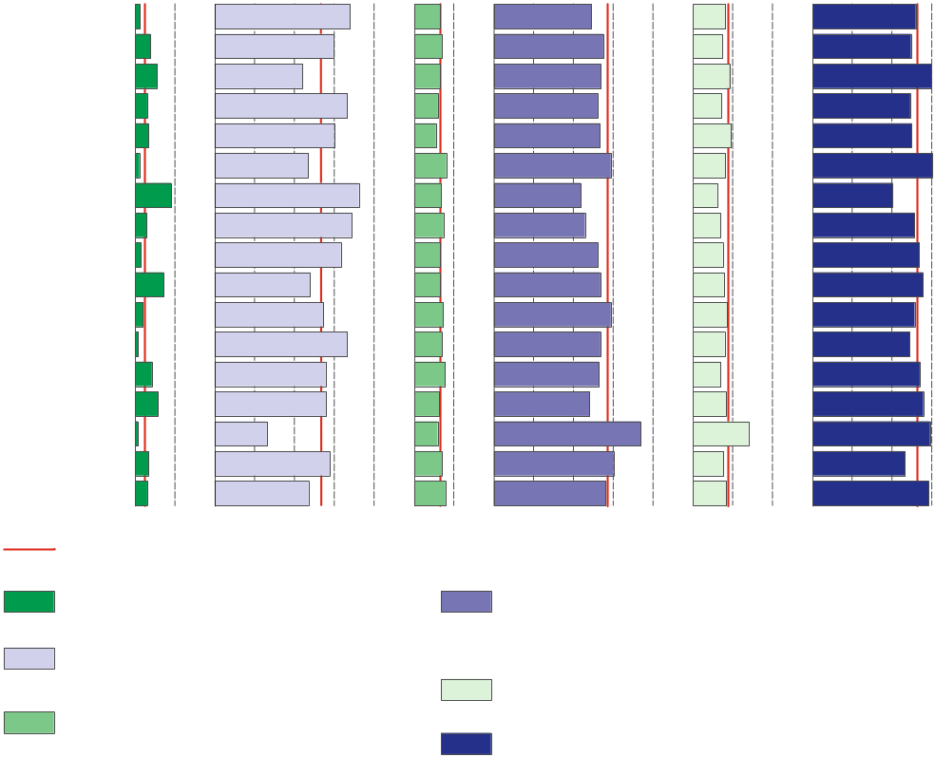
Table 2. Gross value added by kind of activity and regions in 2021 (current prices)
Dolnośląskie
Kujawsko-pomorskie
Lubelskie
Lubuskie
Łódzkie
Małopolskie
Mazowiecki regionalny
Opolskie
Podkarpackie
Podlaskie
Pomorskie
Śląskie
Świętokrzyskie
Warmińsko-mazurskie
Warszawski stołeczny
Wielkopolskie
Zachodniopomorskie
In % of total
Other services
Financial and insurance activities; real estate activities^{Δ}
Construction
Poland
Agriculture, forestry and fishing
Trade; repair of motor vehicles^{Δ};
transportation and storage; accommodation and catering^{Δ}; information and communication
Industry
0 10 0 10 20 30 40 0 10 0 10 20 30 40 0 10 20 0 10 20 30
REGIONS  a – in million PLN  b – in % of total  c – previous year=100 |  | Total | Agriculture, forestry  and fishing | Industry | Construction | Trade; repair of motor vehicles^{Δ};  transportation and storage;  accommodation and catering^{Δ};  information and communication | Financial and insurance activities;  real estate activities^{Δ} | Other services
POLAND | a | 2 289 681 | 58 379 | 611 382 | 154 008 | 656 155 | 206 649 | 603 107
 | b | 100.0 | 2.5 | 26.7 | 6.7 | 28.7 | 9.0 | 26.3
 | c | 111.2 | 98.1 | 115.7 | 96.6 | 113.7 | 105.1 | 112.1
Dolnośląskie | a | 193 761 | 2 188 | 65 730 | 12 359 | 47 435 | 15 897 | 50 153
 | b | 100.0 | 1.1 | 33.9 | 6.4 | 24.5 | 8.2 | 25.9
 | c | 112.4 | 96.5 | 117.8 | 97.1 | 114.2 | 104.6 | 111.9
Kujawsko-pomorskie | a | 99 991 | 3 837 | 29 668 | 7 030 | 27 480 | 7 294 | 24 682
 | b | 100.0 | 3.8 | 29.7 | 7.0 | 27.5 | 7.3 | 24.7
 | c | 110.8 | 99.8 | 114.5 | 98.8 | 113.2 | 105.3 | 111.4
Lubelskie | a | 84 861 | 4 661 | 18 673 | 5 560 | 22 816 | 7 773 | 25 377
 | b | 100.0 | 5.5 | 22.0 | 6.6 | 26.9 | 9.2 | 29.9
 | c | 110.1 | 99.5 | 114.2 | 97.1 | 112.0 | 106.4 | 112.2
Lubuskie | a | 48 818 | 1 478 | 16 212 | 2 910 | 12 719 | 3 521 | 11 978
 | b | 100.0 | 3.0 | 33.2 | 6.0 | 26.1 | 7.2 | 24.5
 | c | 110.8 | 110.0 | 111.3 | 97.4 | 114.8 | 105.8 | 111.2
Łódzkie | a | 138 935 | 4 586 | 41 601 | 7 656 | 37 117 | 13 387 | 34 588
 | b | 100.0 | 3.3 | 29.9 | 5.5 | 26.7 | 9.6 | 24.9
 | c | 109.2 | 97.4 | 108.0 | 97.7 | 114.5 | 102.8 | 112.5
Małopolskie | a | 187 824 | 1 944 | 43 888 | 15 148 | 55 307 | 15 260 | 56 277
 | b | 100.0 | 1.0 | 23.4 | 8.1 | 29.4 | 8.1 | 30.0
 | c | 112.5 | 85.5 | 120.4 | 97.5 | 116.6 | 104.9 | 111.1
Mazowiecki regionalny | a | 120 470 | 11 000 | 43 465 | 8 204 | 26 231 | 7 405 | 24 165
 | b | 100.0 | 9.1 | 36.1 | 6.8 | 21.8 | 6.1 | 20.1
 | c | 112.1 | 95.8 | 122.9 | 98.6 | 112.3 | 104.4 | 110.8
Opolskie | a | 46 984 | 1 344 | 16 127 | 3 477 | 10 783 | 3 257 | 11 996
 | b | 100.0 | 2.9 | 34.3 | 7.4 | 22.9 | 6.9 | 25.5
 | c | 113.8 | 106.9 | 121.4 | 97.7 | 113.7 | 106.2 | 112.9
Podkarpackie | a | 88 320 | 1 276 | 27 881 | 5 845 | 23 053 | 6 597 | 23 668
 | b | 100.0 | 1.4 | 31.6 | 6.6 | 26.1 | 7.5 | 26.8
 | c | 112.3 | 94.5 | 116.5 | 96.8 | 114.4 | 106.0 | 113.0
Podlaskie | a | 50 791 | 3 682 | 12 119 | 3 373 | 13 591 | 3 940 | 14 086
 | b | 100.0 | 7.2 | 23.9 | 6.6 | 26.8 | 7.8 | 27.7
 | c | 109.6 | 104.9 | 109.2 | 94.6 | 115.4 | 104.7 | 111.7
Pomorskie | a | 137 300 | 2 661 | 37 357 | 10 031 | 40 370 | 11 794 | 35 087
 | b | 100.0 | 1.9 | 27.2 | 7.3 | 29.4 | 8.6 | 25.6
 | c | 114.6 | 99.5 | 128.2 | 97.6 | 115.8 | 101.9 | 112.2

Table 2. Gross value added by kind of activity and regions in 2021 (cont.)
REGIONS  a – in million PLN  b – in % of total  c – previous year=100 |  | Total | Agriculture. forestry  and fishing | Industry | Construction | Trade; repair of motor vehicles^{Δ};  transportation and storage;  accommodation and catering^{Δ};  information and communication | Financial and insurance activities;  real estate activities^{Δ} | Other services
Śląskie | a | 273 668 | 1 851 | 90 816 | 18 823 | 73 341 | 21 975 | 66 862
 | b | 100.0 | 0.7 | 33.2 | 6.9 | 26.8 | 8.0 | 24.4
 | c | 113.8 | 96.3 | 121.2 | 98.4 | 113.9 | 106.1 | 112.7
Świętokrzyskie | a | 52 542 | 2 200 | 14 612 | 4 072 | 13 849 | 3 701 | 14 108
 | b | 100.0 | 4.2 | 27.8 | 7.8 | 26.4 | 7.0 | 26.9
 | c | 110.5 | 97.5 | 114.4 | 96.7 | 113.8 | 106.0 | 111.6
Warmińsko-mazurskie | a | 58 958 | 3 367 | 16 462 | 3 713 | 14 142 | 4 885 | 16 388
 | b | 100.0 | 5.7 | 27.9 | 6.3 | 24.0 | 8.3 | 27.8
 | c | 110.3 | 100.8 | 116.3 | 93.9 | 112.7 | 105.1 | 110.8
Warszawski stołeczny | a | 396 249 | 2 208 | 51 849 | 23 577 | 146 189 | 55 547 | 116 879
 | b | 100.0 | 0.6 | 13.1 | 5.9 | 36.9 | 14.0 | 29.5
 | c | 108.7 | 102.8 | 106.7 | 91.4 | 111.4 | 104.8 | 112.4
Wielkopolskie | a | 226 208 | 7 543 | 65 169 | 15 572 | 68 126 | 17 392 | 52 406
 | b | 100.0 | 3.3 | 28.8 | 6.9 | 30.1 | 7.7 | 23.2
 | c | 110.0 | 92.7 | 108.2 | 100.0 | 115.2 | 107.7 | 112.9
Zachodniopomorskie | a | 83 999 | 2 551 | 19 753 | 6 658 | 23 606 | 7 025 | 24 405
 | b | 100.0 | 3.0 | 23.5 | 7.9 | 28.1 | 8.4 | 29.1
 | c | 110.5 | 111.7 | 115.7 | 94.2 | 111.5 | 107.6 | 111.5

Symbol (∆) — categories of applied PKD 2007 classification (link) are presented in abbreviated form.
Data from regional accounts included in this note have been revised in relation to those published on 31 December 2022 and balanced with annual national accounts data included
in the publication “National accounts by institutional sectors and sub-sectors 2018-2021”. They will be subject to further revision, in accordance to the revision policy applied in national and regional accounts (link). Complete range of data for the year 2021 will be available in November of the current year.
In case of quoting Statistics Poland data, please provide information: “Source of data: Statistics Poland”, and in case of publishing calculations made on data published by Statistics Poland, please include the following disclaimer: “Own study based on figures from Statistics Poland”.
Prepared by:  Statistical Office in Katowice  Director Aurelia Hetmańska  Phone: (+48 32) 779 12 48 | Issued by:  The Spokesperson for the President  of Statistics Poland  Karolina Banaszek  Phone: (+48) 695 255 011
Press Office  Phone: tel: (+48 22) 608 38 04  e-mail: obslugaprasowa@stat.gov.pl |   stat.gov.pl/en/

@StatPoland

@GlownyUrzadStatystyczny

gus_stat

glownyurzadstatystycznygus

glownyurzadstatystyczny
Related information
Gross domestic product - regional accounts in the years 2018-2020
Methodological report. Gross domestic product and its elements in the regional breakdown
National accounts by institutional sectors and sub-sectors 2018-2021
Provisional estimates of gross domestic product in regional breakdown in 2021
Real GDP grew in all regions in 2021 except three - Products Eurostat News - Eurostat (europa.eu)
Data available in databases
Knowledge Databases -> National and regional accounts -> Regional accounts
Local Data Bank -> Regional accounts
Terms used in official statistics
Gross domestic product
Regional accounts
Value added, gross

