Index numbers of construction and assembly
production in August 2023
According to preliminary data construction and assembly production (in constant prices) carried out domestically by construction enterprises employing more than 9 persons was in August 2023 by 3.5% higher than in the same period of 2022 (an increase of 5.9% in the corresponding period of 2022) and by 7.4% higher compared to July 2023 (an increase of 5.0% in the corresponding period of 2022).
103.5
Index number of construction and assembly production compared to August of 2022

Table 1. Index numbers of construction and assembly production (constant prices)
SPECIFICATION | 08 2023 |  | 01-08 2023
SPECIFICATION | 07 2023=100 | 08 2022=100 | 01-08 2022=100
CONSTRUCTION | 107.4 | 103.5 | 101.0
Construction of buildings ^{Δ} | 104.4 | 95.0 | 90.9
Civil engineering works ^{Δ} | 108.8 | 111.8 | 109.1
Specialised construction activities | 108.6 | 100.9 | 102.8

^{Δ} Abbreviated form according to PKD 2007.

Construction and assembly production in August 2023, compared to the corresponding period of 2022, increased in entities dealing mainly with civil engineering works (11.8%) and in entities performing specialised construction activities (0.9%) whereas the decrease was noted in entities whose basic type of activity was construction of buildings (5.0%).
Compared to July 2023, the increase was noted in all divisions of construction, in entities whose basic type of activity was civil engineering works of 8.8%, performing specialised construction activities of 8.6% and dealing mainly with construction of buildings of 4.4%.
In the period of January-August 2023, in relation to the same period of the previous year, an increase in the sales of construction and assembly production was noted in entities dealing mainly with civil engineering works (9.1%) and performing specialised construction activities (2.8%), whereas a decrease was recorded in entities whose basic type of activity was construction of buildings (9.1%).
Construction and assembly production in August 2023, compared to corresponding month of 2022, increased for investment works by 13.7% and decreased for restoration works by 10.4% (respectively increases of 1.1% and of 13.0% in 2022).
In the period of January-August 2023, in relation to the corresponding period of 2022, there was an increase of 11.7% in the investment works and a decrease of 13.6% in the works with a restoration character (respectively increases of 5.1% and of 17.6% in 2022).
Chart 1. Index numbers of construction and assembly production (constant prices; average monthly base 2015=100)
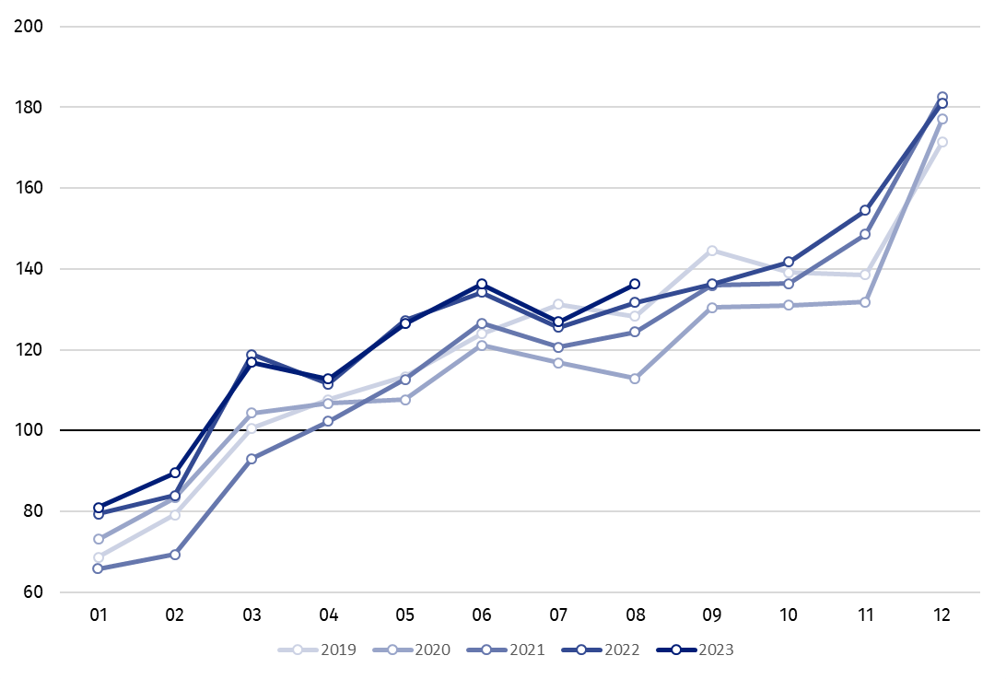

Index number of construction and assembly production in August 2023 (in constant prices), compared to the average monthly value of 2015, was 136.3.

In August 2023, after eliminating the seasonal factors, construction and assembly production reached the level by 3.5% higher than in the corresponding month of the previous year and higher by 2.0% in comparison to July 2023.

In case of quoting Statistics Poland data, please provide information: “Source of data: Statistics Poland” and in case of publishing calculations made on data published by Statistics Poland, please include the following disclaimer: “Own study based on figures from Statistics Poland”.

Prepared by:  Statistical Office in Lublin  Director Krzysztof Markowski, Ph.D.  Phone: (+48) 695 255 301 | Issued by:  The Spokesperson for the President of Statistics Poland  Karolina Banaszek  Phone: (+48) 695 255 011
Press Office  Phone: (+48 22) 608 38 04  e-mail: obslugaprasowa@stat.gov.pl |   www.stat.gov.pl/en/

@StatPoland

@GlownyUrzadStatystyczny

gus_stat

glownyurzadstatystycznygus

glownyurzadstatystyczny
Related information
Statistical Bulletin
Socio-economic situation of the country
Data available in databases
Knowledge Databases - Construction
Knowledge Databases - Construction (new)
Macroeconomic Data Bank
Macroeconomic indicators
Local Data Bank

Terms used in official statistics
Sale of construction and assembly production
Seasonally unadjusted index of sale of construction and assembly production in constant prices
Seasonally adjusted index of sale of construction and assembly production
Sale of construction works with an investment character
Sale of construction works with a restoration character and other works

Reported data; comprise enterprises employing over 9 persons, whose the main type of activity is included in the section F “Construction” in accordance with the Polish Classification of Activities (PKD 2007).
² Data including final information on production and prices in July and reported data in August.
Reported data for August 2023.

