Index numbers of construction and assembly
production in January 2023
Acording to preliminary data construction and assembly production (in constant prices) carried out carried out domestically by construction enterprises employing more than 9 persons was in January 2023 by 2.4% higher than a year before (an increase of 20.8% the year before) and by 55.1% lower compared with December 2022
(a decrease of 56.5% the year before).
102.4
Index number of construction and assembly production as compared to January of 2022

Table 1. Index numbers of construction and assembly production (constant prices)
SPECIFICATION | 01 2023
SPECIFICATION | 12 2022=100 | 01 2022=100
CONSTRUCTION | 44.9 | 102.4
Construction of buildings ^{Δ} | 58.2 | 89.3
Civil engineering works ^{Δ} | 33.1 | 115.0
Specialised construction activities | 53.1 | 107.5
^{Δ} Abbreviated form according PKD 2007.
Sales of construction and assembly production in January 2023, compared to the corresponding period of 2022, increased in entities whose basic type of activity were civil engineering works (15.0%) and performing specialised construction activities (7.5%). The decrease was recorded in entities dealing mainly with construction of buildings (10.7%).
Compared with December 2022, a decrease in the value of works carried out was noted in entities dealing mainly with civil engineering works by 66.9%. Decreases were recorded in performing specialised construction activities by 46.9% and in whose basic type of activity was constrution of buildings by 41.8%.
Value of construction and assembly production, compared to January 2022, increased both for investment works by 3.5% and restoration works by 0.9% (increases of 21.6% and 19.6% in the year before).

Chart 1. Index numbers of construction and assembly production (constant prices; average monthly base 2015=100)
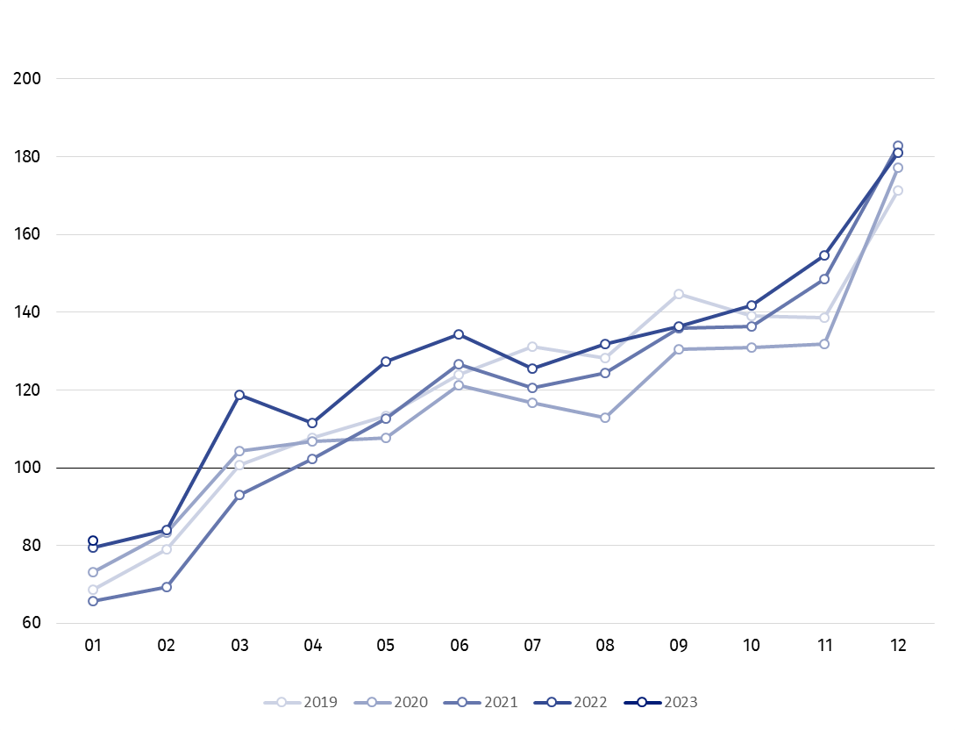
Index number of construction and assembly production in January 2023 (in constant prices), compared to the average monthly value of 2015, was 81.3.
After eliminating the seasonal factors, construction and assembly production reached the level by 0.1% lower than in January 2022 and by 7.0% higher in comparison to December 2022.

In case of quoting Statistics Poland data, please provide information: “Source of data: Statistics Poland” and in case of publishing calculations made on data published by Statistics Poland, please include the following disclaimer: “Own study based on figures from Statistics Poland”.

Prepared by:  Statistical Office in Lublin  Director Krzysztof Markowski  Phone: (+48) 695 255 301 | Issued by:  The Spokesperson for the President of Statistics Poland  Karolina Banaszek  Phone: (+48) 695 255 011
Press Office  Phone: (+48 22) 608 38 04  e-mail: obslugaprasowa@stat.gov.pl |   www.stat.gov.pl/en/

@StatPoland

@GlownyUrzadStatystyczny

gus_stat

glownyurzadstatystycznygus

glownyurzadstatystyczny
Related information
Statistical Bulletin
Socio-economic situation of the country
Data available in databases
Knowledge Database - Construction
Macroeconomic Data Bank
Macroeconomic indicators
Local Data Bank
Terms used in official statistics
Sale of construction and assembly production
Seasonally unadjusted index of sale of construction and assembly production in constant prices
Seasonally adjusted index of sale of construction and assembly production
Sale of construction works with an investment character
Sale of construction works with a restoration character and other works

Reported data; comprise enterprises employing over 9 persons, whose the main type of activity is included in the section F “Construction” in accordance with the Polish Classification of Activities (PKD 2007).
Reported data for January 2023.

