People over 50 on the labour market in 2021
In Poland, in 2021, the number of economically active people aged 50 and over was 4 811 thousand. The number of economically inactive people at this age was 8 723 thousand. The employment rate and activity rate were higher among men.
35.6%
Percentage of economically active people aged 50 and over in the total number of people aged 50-89 years.

Demographic situation
As at the last day of 2021, people aged 50 and over
accounted for nearly 38%
of Poland's population
Over the past 20 years, an increase in the share of people aged 50 and over in the Polish population can be observed. At the end of 2021, there were 14 277.9 thousand people aged 50 and over. They accounted for 37.7% of the total number of the population and, compared with 2001, this share increased by 9.2 percentage points and, in relation to the previous year, there was an increase of 0.2 percentage points.

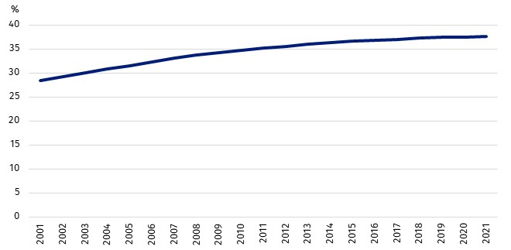
Chart 1. The share of people aged 50 and over in the total population
As at 31 December
The share of people aged 50 and over varied spatially. The highest share of people at this age was recorded in gminas located in the eastern part of the Podlaskie Voivodship. On the other hand, the relatively smallest share of the analysed group was recorded in gminas located
in the Wielkopolskie Voivodship around Poznań and in the rural gmina of Stawiguda located
in the Warmińsko-Mazurskie Voivodship.

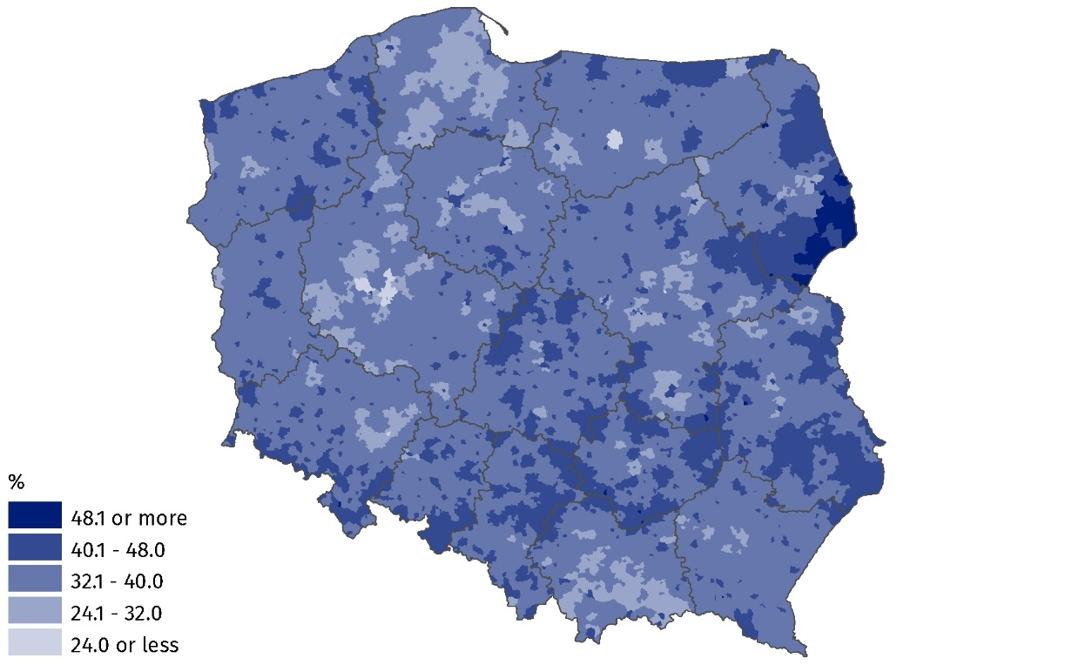
Map 1. The share of people aged 50 and over in the total population in 2021
As at 31 December

The situation of people aged 50 and over on the labour market
In 2021, the highest activity rate was among people aged 50-54

Demographic changes are having an impact on the structure of the labour force. According to the Labour Force Survey (LFS), in 2021 the activity rate among people aged 50 and over was 35.6%. Almost one in three women and almost one in two men surveyed were economically active. The highest activity rate was among people aged 50-54 (83.4%). Outside the labour market, there were 8 723 thousand people aged 50 and over. The main reasons for inactivity included: retirement, disability and illness.

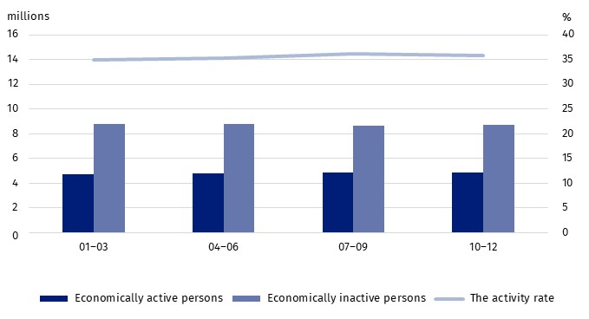
Chart 2. Economically active and inactive persons aged 50 and over (left axis)
and the activity rate (right axis) for people aged 50 and over in the quarters of 2021

One of the basic labour market indicators is the employment rate, i.e. the percentage of employed people in the surveyed population. This indicator, calculated on the basis of the LFS, shows that 34.7% of people aged 50 and over were working. In 2021, the employment rate
for men at this age was 43.6%, 15.9 percentage points higher than the employment rate
for women. The highest employment rate was recorded among those aged 50-54 (81.4%),
and the lowest for those aged 65 and over (6.2%).
The employment rate of men aged 50 and over was 43.6%, which was 15.9 percentage points higher than among women in the same age group

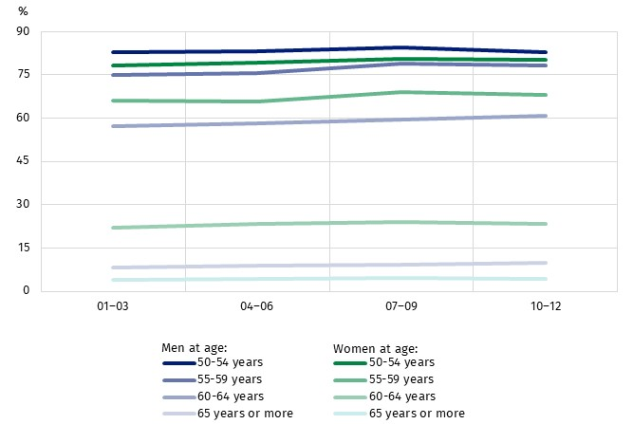
Chart 3. The employment rate for people aged 50 and over by sex and age group
in the quarters of 2021
In 2021, according to the Labour Force Survey, among economically active people
aged 50-89 there were 109.3 thousand unemployed people. The majority were men (62.2%).
The unemployment rate in the analysed age group was 2.3%. The highest unemployment
rate in the population of people aged 50 and over was among people aged 55-59 (2.8%).
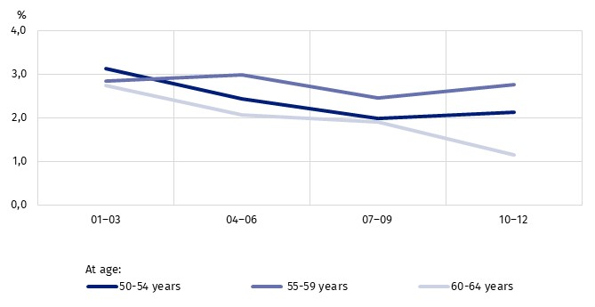
Chart 4. The unemployment rate for people aged 50 and over by age group
in the quarters of 2021
The source of data on unemployed persons are also data from official registers, whereby
the definition of an unemployed person and the methodology of surveying the registered unemployment differ from the definition of an unemployed persons and methodology
in the Labour Force Survey and are not comparable. According to the register data,
at the end of 2021, people aged 50 and over accounted for 26.9% of the total registered
unemployed people. The group of the unemployed aged 50 and over was dominated by people with basic vocational education and lower secondary, primary and incomplete primary
education. Such people constituted a total of 71.1% of the unemployed at this age. The group of the unemployed was also dominated by long-term unemployed people, for more than
24 months, who constituted 36.7%.
Due to the growing demand for data diagnosing the situation of the analysed age group
on the labour market, attempts are being made to search for new data sources. These include, among others, public administration information systems, which make it possible to compile data at lower levels of aggregation, including by individual single-year cohort.
Due to ongoing methodological work, analyses based on them have the status of experimental statistics.
When analysing the graphical presentation of the distribution of the employed population by individual single-year cohort and sex, it can be seen that in the employed population aged 50 and over, the number of employed persons is decreasing with each single-year
cohort. The predominance of employed women over employed men occurs between
the ages of 50 and 57. In older single-year cohorts, there are more employed men.
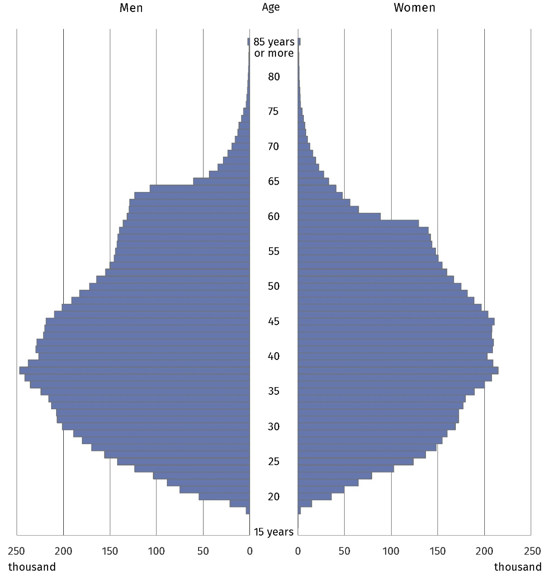
Chart 5. Age pyramid of employed persons in 2021
As at 31 December
The share of employed persons aged 50 and over in the total number of employed persons was also varied spatially. The highest percentage of this group of employed persons was
in gminas located in the Lubelskie Voivodship.
The lowest share of employed persons aged 50 and over in the total number of employed persons was observed in gminas located in the Wielkopolskie Voivodship.
Map 2. The share of employed persons aged 50 and over in the total number of employed persons in 2021
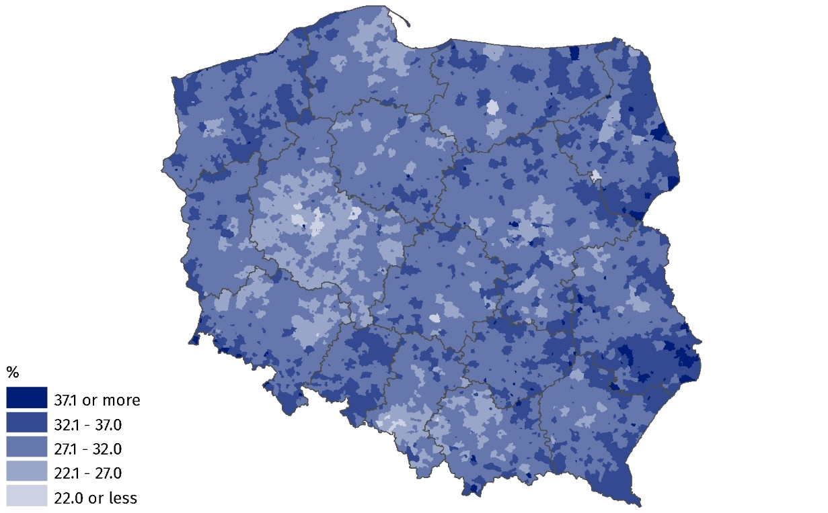
As at 31 December
The process of labour force ageing varies depending on the kind of activity. The conducted analysis based on administrative data indicates that in 2021 the highest percentage
of employed persons aged 50 and over were in the Electricity, gas, steam and air conditioning supply section. Employed persons of the analysed age constituted as many as 47.6%
of all employed persons in this section. A significant share of employed persons aged
50 and over in the total number of employed persons was also recorded in the following sections: Agriculture, forestry and fishing (45.9%), Real estate activities (43.8%) and Human health and social work activities (40.3%). The situation was different in the Information and communication section, where, nearly every tenth employed person was aged 50 and over.
In the remaining sections, the share of employed persons in this age bracket ranged
from almost 20% to 40%.

Chart 6. The share of employed persons aged 50 and over in the total number of employed persons by PKD/NACE section in 2021
As at 31 December
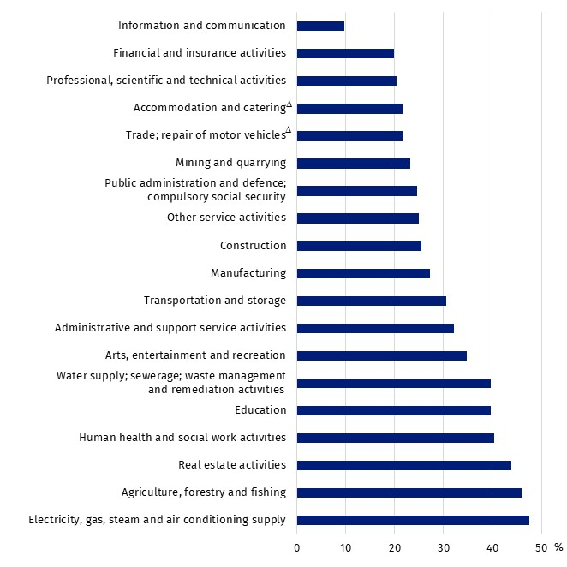

Prepared by:  Statistical Office in Bydgoszcz  Director Wiesława Gierańczyk, Ph.D.  Phone: (+48 52) 366 93 90 | Issued by:  The Spokesperson of the President of Statistics Poland  Karolina Banaszek  Mobile: (+48) 695 255 011
Press Office  Phone: (+ 48 22) 608 38 04  e-mail: obslugaprasowa@stat.gov.pl |   www.stat.gov.pl/en/

@GUS_STAT

@GlownyUrzadStatystyczny

gus_stat

glownyurzadstatystycznygus

glownyurzadstatystyczny
Related information
Methodological report Employment in the national economy according to administrative data sources
People over 50 on the labour market in 2019
People over 50 on the labour market in 2020
Data available in databases
Eurostat
Local Data Bank
Terms used in official statistics
Employment in national economy
Economically active population by LFS
Economically inactive population according to the LFS

Unemployed persons by LFS
Registered unemployed persons

The results of the Labour Force Survey refer to the population residing or intending to reside in the country for at least 12 months, living in households.
Due to the implementation of methodological changes in the Labour Force Survey, the analysis of the labour market situation in 2021 has been limited to the population aged 50-89, and all persons aged 90 and over are treated as economically inactive.

