The demand for labour in the first quarter of 2023
At the end of the first quarter of 2023, there were 114.9 thousand job vacancies in Poland, 0.7% fewer, as compared with the fourth quarter of 2022. The job vacancy rate was 0.90%. The highest value of this rate was recorded in the Information and communication section (2.03%).
⇩ 27.6%
Decrease in the number of job vacancies compared with the end of the first quarter of 2022

In Poland, at the end of the first quarter of 2023, 6.0% of the 636.1 thousand national economy entities had job vacancies. There were 16.1% more of them than in the fourth quarter of 2022, but 14.3% fewer than in the first quarter of the previous year.
At the end of the first quarter of 2023, 114.9 thousand job vacancies were reported, 0.8 thousand fewer than in the fourth quarter of 2022 and 43.8 thousand fewer than in the corresponding quarter of 2022. Employees were sought, among others, through labour offices, to which 14.0% of all job vacancies were reported. Nearly one in five job vacancies was newly created (20.8 thousand). The number of such jobs decreased by 8.7% and 32.7%, respectively, compared with the previous quarter and on a year-over-year basis.
One of the measures for assessing the labour market situation in terms of reported labour demand is the job vacancy rate, which measures the share of job vacancies in the total number of jobs (i.e. occupied and vacant). At the end of the first quarter of 2023, this rate stood at 0.90%, down from both the fourth quarter and the first quarter of 2022 (by 0.02 percentage points and 0.35 percentage points, respectively).
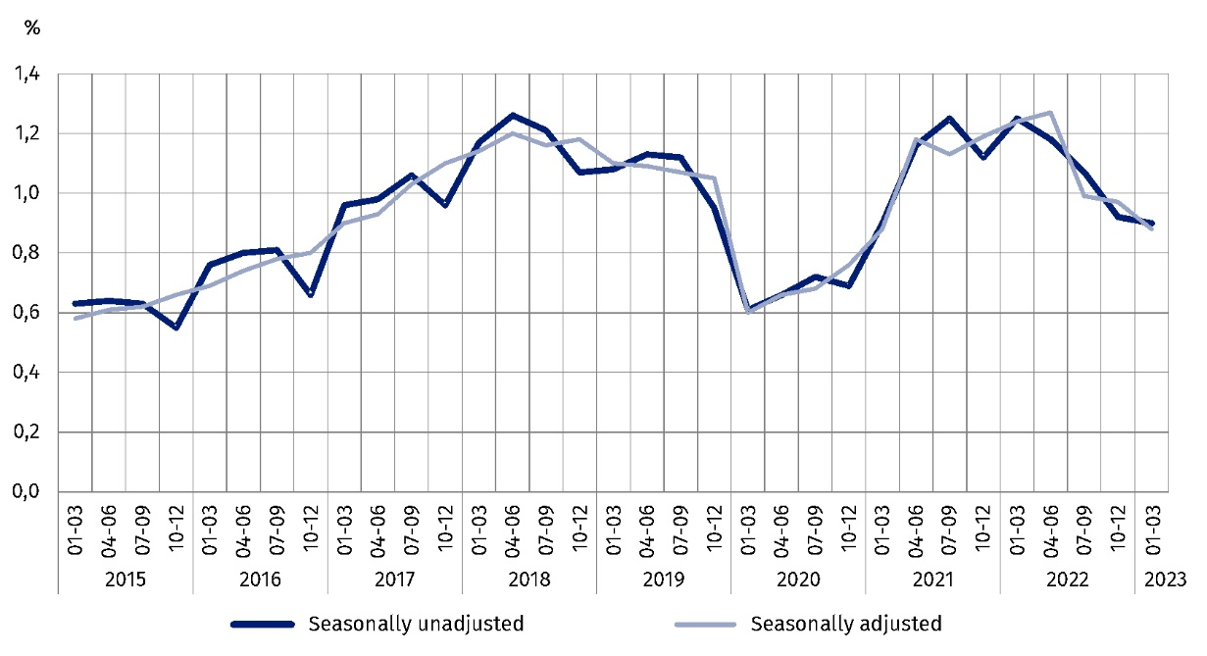
Chart 1 . Job vacancy rate
As at the end of the quarter

When analysing this measure in the territorial breakdown, using the NUTS 2 statistical classification, it can be seen that the highest job vacancy rate occurred in the Warszawski stołeczny region (1.17%). A high rate also occurred in the Zachodniopomorskie (1.13%) and Lubuskie (1.02%) regions. The lowest value of this rate was recorded in the Lubelskie region (0.40%).
The highest job vacancy rate at the end of the first quarter of 2023 was recorded in the Warszawski stołeczny region
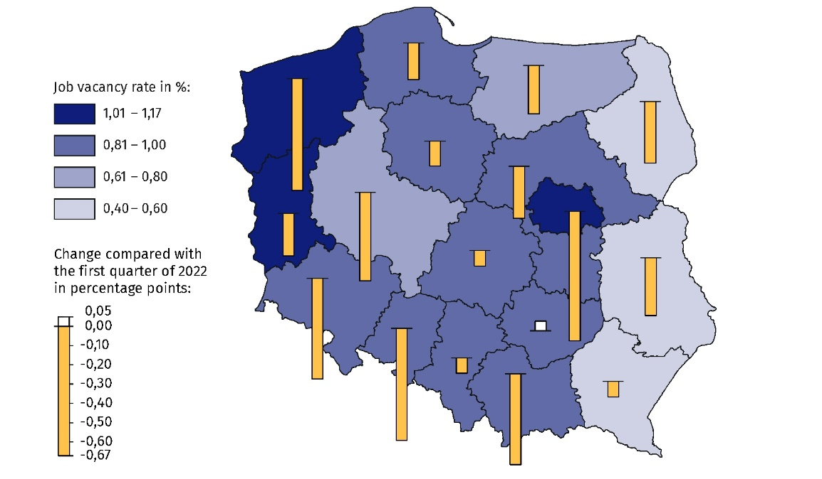
Map 1. Job vacancy rate by region (NUTS 2) in the first quarter of 2023
As at the end of the quarter

In terms of the kind of activity, the most job vacancies, 20.4%, were in national economy entities operating in the Manufacturing section. Their number decreased by 23.7% (to 23.5 thousand jobs) compared with the corresponding quarter of 2022. The largest annual decrease (by nearly 70%) in the number of job vacancies compared with the first quarter of 2022 was recorded in the Administrative and support service activities section (down to 3.7 thousand).
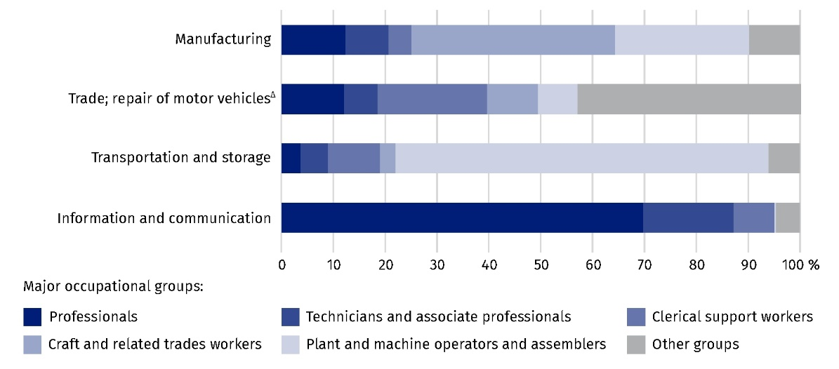
Chart 2. Structure of job vacancies in selected PKD/NACE sections by major occupational
group in the first quarter of 2023
As at the end of the quarter

As at the end of the first quarter of 2022, also at the end of the first quarter of this year, the highest job vacancy rate was recorded in the Information and communication section (2.03%, compared with 3.99% in 2022). The number of job vacancies in this section decreased by 47.5% on a year-over-year basis, to 7.5 thousand jobs.

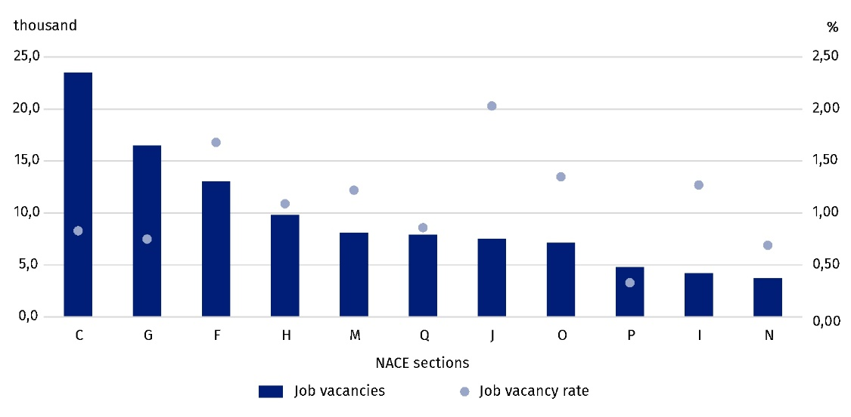
Chart 3 . Job vacancies and the job vacancy rate by selected PKD/NACE sections in the first quarter of 2023
As at the end of the quarter
At the end of the first quarter of the current year, the highest job vacancy rate occurred in the Information and communication section

Based on the results of the Labour Demand Survey, at the end of March 2023 there were 426.9 thousand people working remotely due to the state of epidemic threat, 32.3% fewer than in the first quarter of 2022. Those working remotely accounted for 3.4% of the total number of occupied jobs (5.0% a year ago), of which it was 4.1% in national economy entities belonging to the private sector and in large entities (50 employed persons or more) – 4.6%.
At the end of the first quarter of 2023, the largest number of people who worked remotely due to the state of epidemic threat were in national economy entities in the sections: Information and communication (they accounted for 33.4% of those working remotely), Professional, scientific and technical activities (18.8%), and Financial and insurance activities (14.7%). Those working remotely in these sections represented respectively: 39.2%, 12.2% and 20.0% of the total number of occupied jobs.
***
In this news release abbreviated names of NACE, Rev. 2 sections were used. Abbreviations are marked with a ‘Δ’ symbol. Full names are available on the Eurostat website at: https://ec.europa.eu/eurostat/data/classifications
Relative numbers (rates, percentages) were calculated on the basis of absolute data expressed with greater accuracy than given in the publication.

In the case of quoting Statistics Poland data, please provide information: ‘Source of data: Statistics Poland’, and in the case of publishing calculations made on data published by Statistics Poland, please provide information: ‘Own elaboration based on Statistics Poland data.’
Prepared by:  Statistical Office in Bydgoszcz  Director Wiesława Gierańczyk, Ph.D.  Phone: (+48 52) 366 93 90 | Issued by:  The Spokesperson for the President  of Statistics Poland  Karolina Banaszek  Phone: (+48) 695 255 011
Press Office  Phone: (+48 22) 608 38 04  e-mail: obslugaprasowa@stat.gov.pl |   stat.gov.pl/en/

@GUS_STAT

@GlownyUrzadStatystyczny

gus_stat

glownyurzadstatystycznygus

glownyurzadstatystyczny
Related information
The demand for labour in 2021 – annual publication
The demand for labour in the fourth quarter of 2022 – news release
Other publications that contain the results of these surveys: stat.gov.pl → Topics → Labour market
Methodological report. The demand for labour
Data available in databases
Strateg → Statistics by theme → Labour market
Local Data Bank → Labour market
Statistics for the SDGs – global indicators
Knowledge Databases → Society → Labor market
Terms used in official statistics
Demand for labour
Vacancies
Newly created jobs
Liquidated jobs

Data concerns entities of the national economy and their local units with 1 or more employed persons, conducting economic activity in the scope of PKD/NACE sections from A (excluding natural persons running individual agricultural holdings) to section S.

