The demand for labour in the fourth quarter of 2022
⇩ 14.6%
Decrease in the number of job vacancies compared with the end of the third quarter of 2022
At the end of the fourth quarter of 2022, there were 115.7 thousand job vacancies in Poland, 15.8% fewer than in the end of the fourth quarter of 2021. The job vacancy rate in the fourth quarter of 2022 was 0.92%. Both the number of newly created jobs and the number of liquidated jobs decreased on a year-over-year basis (by 21.3% and 14.3%, respectively).

The Labour Demand Survey is conducted using the representative method on a quarterly basis, on the Z–05 reporting form. It covers national economy entities employing at least one person. At the end of the fourth quarter of 2022, private sector entities constituted the vast majority, whereas in terms of entity size – entities with up to 9 employed persons dominated numerically (respectively 90.9% and 68.5% of the total number of entities, i.e. almost the same as at the end of the fourth quarter of 2021).
At the end of the fourth quarter of 2022, more than half
of the national economy entities with job vacancies were entities with up to 9 employed persons, while vacancies
in these entities accounted
for just over a quarter
of the total number of job
vacancies
In the fourth quarter of 2022, 5.2% out of 630.8 thousand national economy entities had job vacancies, 0.6 percentage points fewer than in the corresponding period of 2021. Among entities that had job vacancies, 81.1% were private sector entities. Nearly half of the entities with job vacancies (49.7%) had up to 9 employed persons.
Table 1. Basic results of the Labour Demand Survey
QUARTERS  A – correspond-ing quarter of the previous year = 100  B – previous quarter = 100 | Jobs |  |  |  | Newly  created jobs | Liquidated jobs
 | grand  total | occupied | vacant |  | Newly  created jobs | Liquidated jobs
 | grand  total | occupied | total | including newly created | Newly  created jobs | Liquidated jobs
 | as at the end of the quarter |  |  |  | during the quarter
 | in thousands
2021
Quarter 4 | 12 286.8 | 12 149.4 | 137.4 | 32.3 | 112.5 | 64.9
2022
Quarter 1 | 12 684.6 | 12 525.9 | 158.7 | 30.9 | 189.7 | 81.9
Quarter 2 | 12 659.3 | 12 510.0 | 149.3 | 28.5 | 136.0 | 65.9
Quarter 3 | 12 647.7 | 12 512.2 | 135.5 | 25.6 | 120.6 | 71.7
Quarter 4 | 12 520.9 | 12405.2 | 115.7 | 22.8 | 88.6 | 55.6
A | 101.9 | 102.1 | 84.2 | 70.5 | 78.7 | 85.7
B | 99.0 | 99.1 | 85.4 | 89.0 | 73.5 | 77.5
In Poland, at the end of the fourth quarter of 2022, there were slightly fewer occupied jobs than in the third quarter. The number of job vacancies (including newly created jobs) also
decreased compared with the previous quarter.
There were more occupied and vacant jobs at the end of the fourth quarter of 2022 than
in the corresponding quarter of 2021. In the quarter under review, both the number of newly created jobs and the number of liquidated jobs decreased on a year-over-year basis.
Table 2. Selected indicators from the Labour Demand Survey
QUARTERS | The share of national economy entities with job vacancies | Job vacancy rate | The ratio of the number of newly created jobs to the number  of liquidated jobs (during the quarter)
QUARTERS | in % (as at the end of the quarter)
2021
Quarter 4 | 5.8 | 1.12 | 1.7
2022
Quarter 1 | 6.7 | 1.25 | 2.3
Quarter 2 | 6.2 | 1.18 | 2.1
Quarter 3 | 5.9 | 1.07 | 1.7
Quarter 4 | 5.2 | 0.92 | 1.6

Occupied jobs and job vacancies at the end of the fourth quarter of 2022
The number of occupied jobs at the end of the fourth quarter of 2022 was higher than in the corresponding period of 2021, whereas the number of job vacancies was smaller
The met demand for labour is measured as the number of occupied jobs and in the fourth quarter of 2022, there were 12 405.2 thousand such jobs. It means an increase of 2.1%
on a year-over-year basis, but a decrease of 0.9% compared with the previous quarter.
The majority of the occupied jobs, i.e. 60.1%, were in national economy entities with 50
or more employed persons. Out of the total number of occupied jobs, 74.0% were in private sector entities.
The analysis of data on job vacancies as at the end of the fourth quarter of 2022 shows that there were 15.8% (115.7 thousand) fewer of them compared with the corresponding quarter of the previous year.
Compared with the third quarter of 2022 the number of job vacancies decreased by 14.6%
(a year ago it decreased by 10.5% on a quarterly basis).
Most of the job vacancies (55.7%) were in entities with 50 or more employed persons.
Of the total number of job vacancies, 79.8% were in private sector entities.
Chart 1. Structure of national economy entities and jobs by size of entities in the fourth quarter of 2022
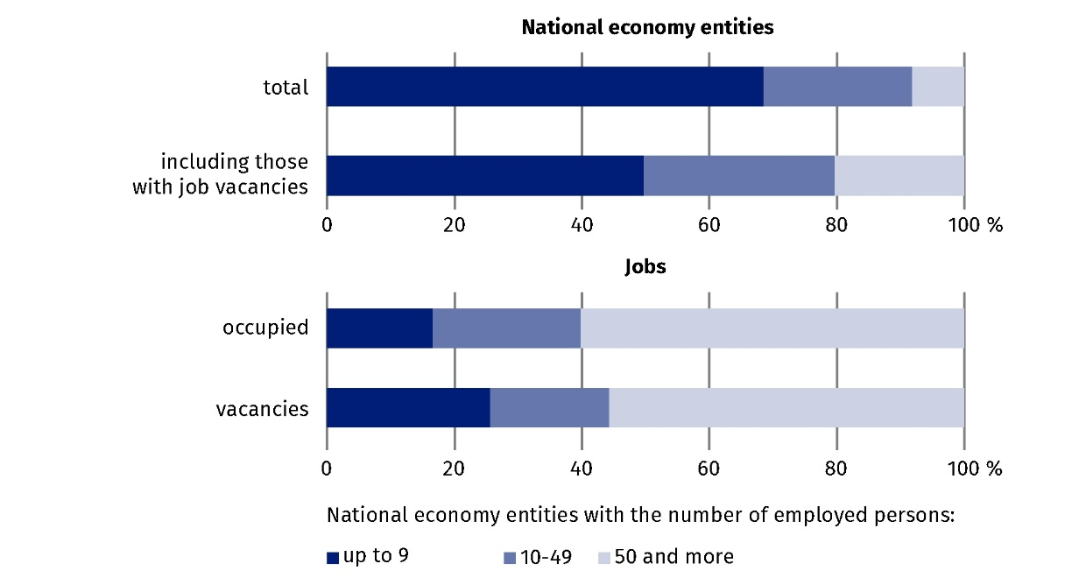
As at the end of the quarter

At the end of the fourth quarter of 2022, almost one in five job vacancies was a newly created job (22.8 thousand). The number of such jobs decreased by 29.5% on a year-over-year basis (in the corresponding quarter of 2021 it increased by 84.1%).
Employees were sought, i.a., through labour offices, to which 11.4% of the total number
of job vacancies were reported.
One of the measures for assessing the labour market situation in terms of reported labour
demand is the job vacancy rate, which measures the share of job vacancies in the total number of occupied posts and job vacancies in a given period. At the end of the fourth quarter of 2022, this rate was 0.92%. It was lower compared with the corresponding period of 2021 and the third quarter of 2022, by 0.20 percentage points and 0.15 percentage points, respectively.
Chart 2. Job vacancy rate
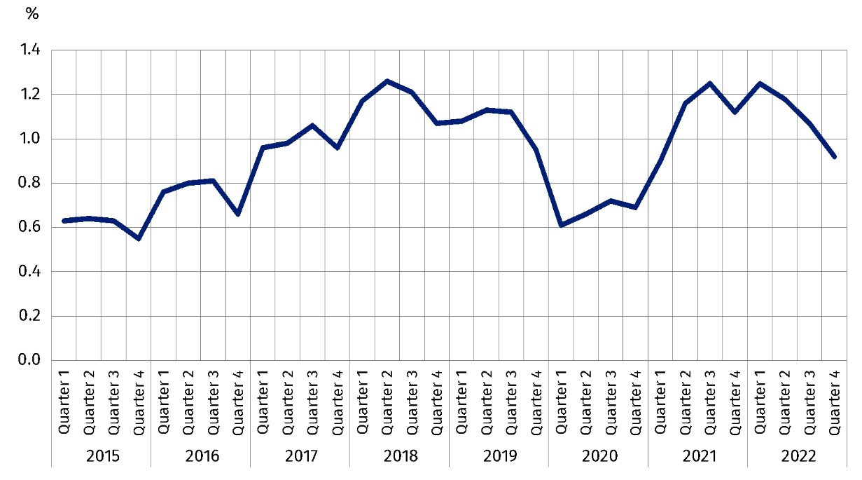
As at the end of the quarter
Looking at the job vacancy rate at the end of the fourth quarter of 2022 broken down by re-gion, it can be seen that its highest value was recorded in the Zachodniopomorskie region (1.67%), where the number of job vacancies increased by 29.6% on a year-over-year basis. High values of the rate were also found in the Dolnośląskie (1.29%), Warszawski stołeczny (1.19%) and Lubuskie regions (1.09%). The lowest value of the job vacancy rate was recorded in the Lubelskie region (0.46%), where the number of job vacancies decreased by 15.7% compared with the fourth quarter of 2021.
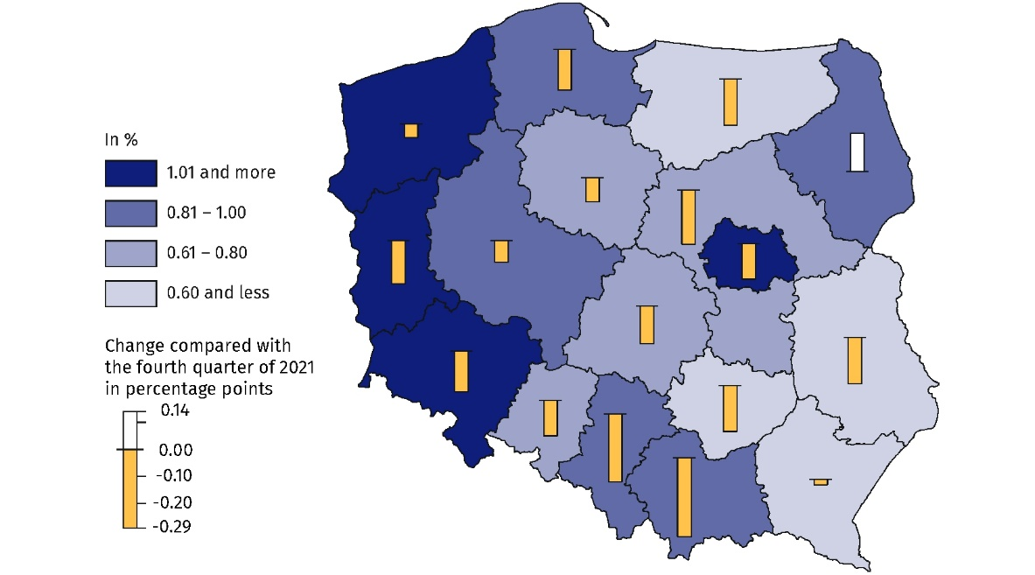
Map 1. Job vacancy rate by region (NUTS 2) in the fourth quarter of 2022
As at the end of the quarter
The highest value of the job vacancy rate at the end of the fourth quarter of 2022 was recorded in the Zachodniopomorskie
region
When analysing the structure of jobs by kind of conducted activity, it can be noted that
at the end of the fourth quarter of 2022 it was similar to that observed in the previous quarter. The largest number of jobs (22.8% of occupied jobs and 22.1% of job vacancies) was in entities in the Manufacturing section. These were respectively 2 823.5 thousand and 25.5 thousand jobs. Compared with the corresponding quarter of 2021, the number of jobs in this section increased by 2.4% in the case of occupied jobs and decreased by 21.6% in the case
of job vacancies.
The Trade; repair of motor vehicles∆ section also had a significant share in the structure
of jobs – at the end of the fourth quarter of 2022 occupied jobs accounted for 17.6% and job vacancies accounted for 12.8% of their total number.
Compared with the end of the fourth quarter of 2021, the largest increase in the number
of job vacancies occurred in the Education section (an increase of 81.6%; job vacancies
accounted for 5.4% of the total number). This section also recorded the largest increase
in the number of occupied jobs – by 12.5% (occupied jobs accounted for 11.4%). The number of job vacancies in the Construction section decreased the most, by 36.7% (they accounted
for 12.0% of the total number of job vacancies).
The highest value of the job vacancy rate at the end of the fourth quarter of 2022 was recorded in the Information and communication section, at 2.8%. This was 0.83 percentage points lower than the value recorded at the end of the fourth quarter of 2021.
When analysing jobs by major occupational group, it can be noted that the largest number of jobs were in the group of Professionals. Among occupied jobs, Professionals accounted for 23.9% (2 962.5 thousand jobs), while among job vacancies they accounted for 28.9%
(33.5 thousand jobs). Compared with the fourth quarter of 2021, the number of occupied
jobs in the occupational group of Professionals increased by 8.6%, while the number
of job vacancies decreased by 0.9%. The value of the job vacancy rate was 1.12%.
At the end of the fourth quarter of 2022, Craft and related trades workers accounted
for a significant share of occupied jobs (1 729.8 thousand jobs) and job vacancies (26.0 thousand jobs). Compared with the corresponding period of 2021, there was an increase of 0.5% in the number of occupied jobs and a decrease of 18.2% in the number of job vacancies.
For every 100 jobs in the occupational group of Craft and related trades workers, 1.48 jobs were vacant.
The highest value of the job vacancy rate was recorded in the major occupational group of Craft and related trades workers
Chart 3. Jobs by selected major occupational groups in the fourth quarter of 2022
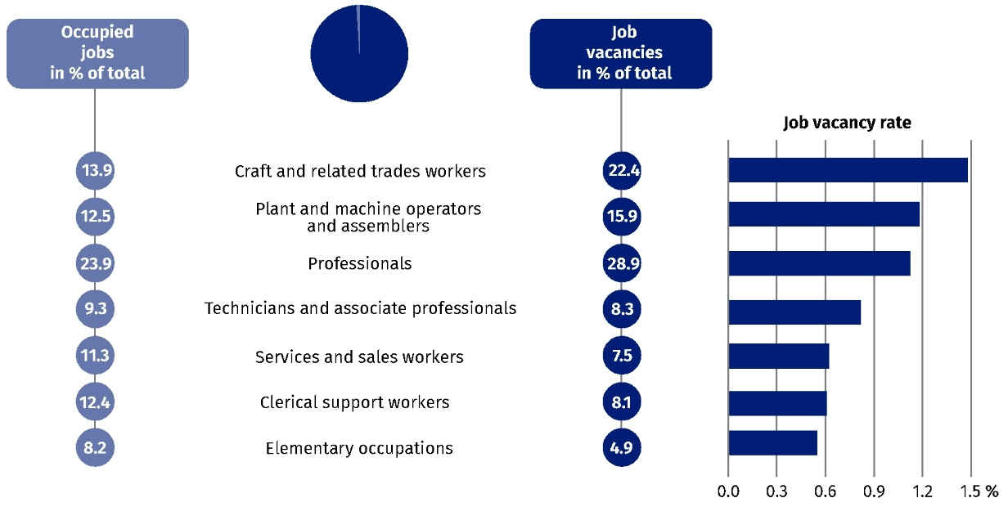
As at the end of the quarter
In the fourth quarter of 2022, despite an annual decrease
in the number of newly created jobs and the number
of liquidated jobs, there was still a surplus of newly
created jobs over those
liquidated

Newly created and liquidated jobs in the fourth quarter of 2022
The Labour Demand Survey also enables to analyse the situation on the labour market
in terms of newly created and liquidated jobs. During the fourth quarter of 2022, in Poland, 88.6 thousand new jobs were created and 55.6 were liquidated. As a result of these changes, the number of jobs increased by 33.0 thousand during the quarter.
Compared with the corresponding period of 2021, there was a decrease in the number
of newly created jobs (by 21.3%, compared with an increase of 23.1% in the fourth quarter
of 2021) and a decrease in the number of liquidated jobs (by 14.3%, compared with
an increase of 20.3%).
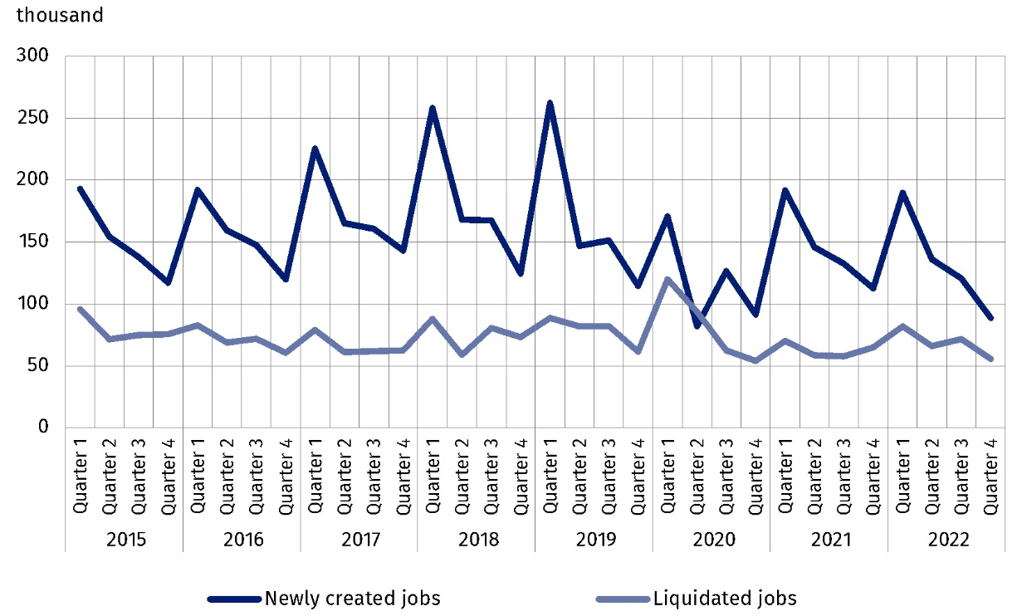
Chart 4. Newly created and liquidated jobs
When assessing the degree of adaptation of the labour market to the reported demand
for labour, the ratio of the number of newly created jobs to the number of liquidated jobs
in a given period can be used. In the fourth quarter of 2022, 1.6 new jobs were created per job liquidated (1.7 jobs a year ago).
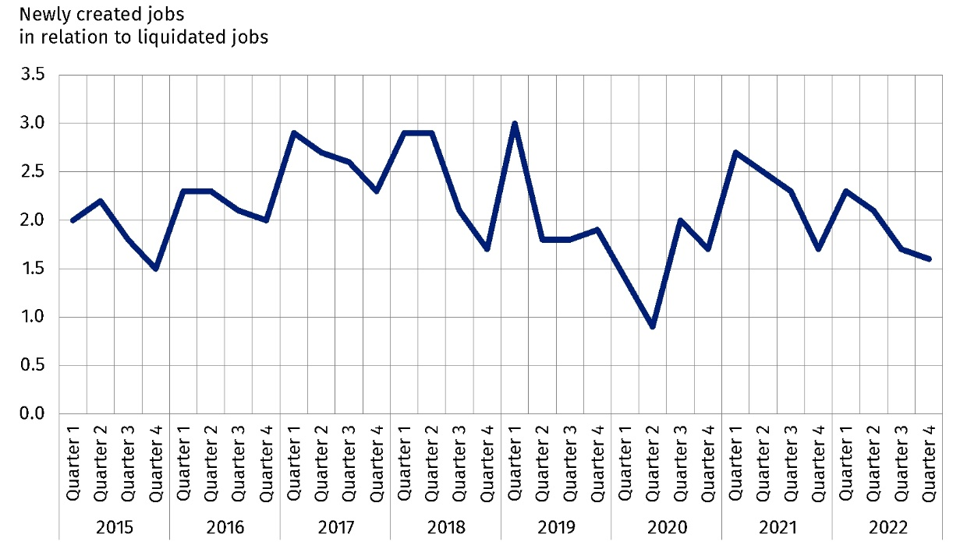
Chart 5. Ratio of the number of newly created jobs to the number of liquidated jobs

In the territorial breakdown, the largest number of newly created jobs per liquidated job
in the fourth quarter of 2022 was in the Lubuskie region (5.4 jobs). On the other hand,
the lowest ratio – 0.2 newly created jobs per liquidated job – occurred in the Warmińsko-mazurskie region.
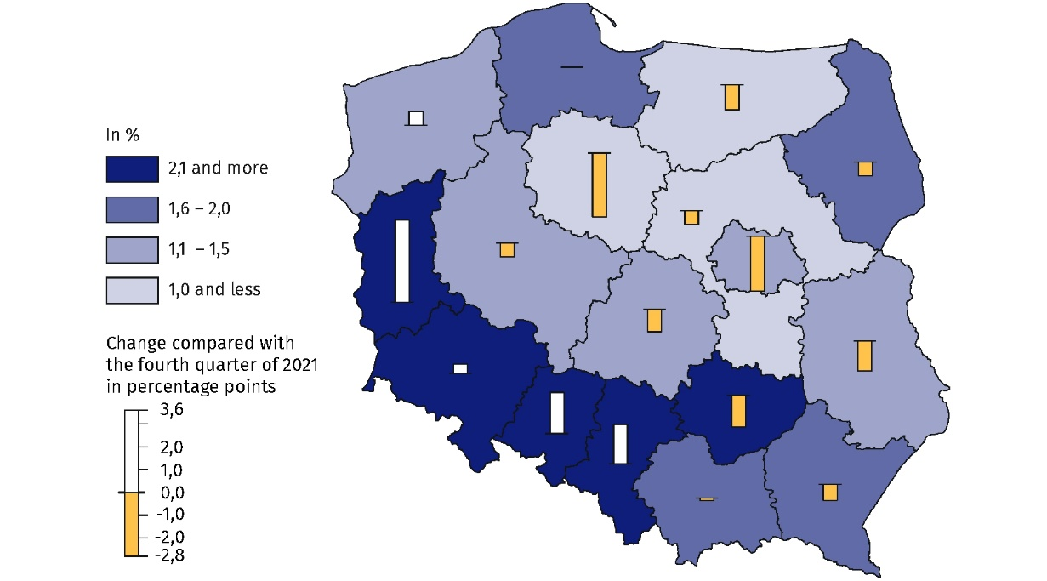
Map 2. Ratio of the number of newly created jobs to the number of liquidated jobs by region
(NUTS 2) in the fourth quarter of 2022
In the fourth quarter of 2022, the largest number of newly created jobs per liquidated job was in the Lubuskie
region
Differences in the structure of jobs broken down by PKD/NACE section were also visible – the largest number of new jobs were created in entities from the Trade; repair of motor vehicles∆ section (21.6 thousand jobs, but this was 11.8% more than in the fourth quarter of 2021). During the same period, 9.0 thousand jobs were liquidated in this section, an annual decrease of 35.3%. For every job liquidated in this section, there were 2.4 newly created jobs (1.0 jobs more than in the fourth quarter of 2021).
In the fourth quarter of 2022, the largest number of new jobs were created in the Trade; repair of motor vehicles∆ section, and liquidated in the Manufacturing section
The Manufacturing section also had a significant share in the structure of jobs. Newly created jobs in the fourth quarter of 2022 accounted for 24.3% of their total number, while liquidated jobs – 26.1% of their total number (16.6 thousand and 14.5 thousand jobs respectively). There were 1.1 newly created jobs per liquidated job.
In the fourth quarter of 2022, the largest number of newly created jobs per liquidated job was in the Education section (4.6 jobs, i.e. 1.1 jobs more than in the corresponding period
of 2021).

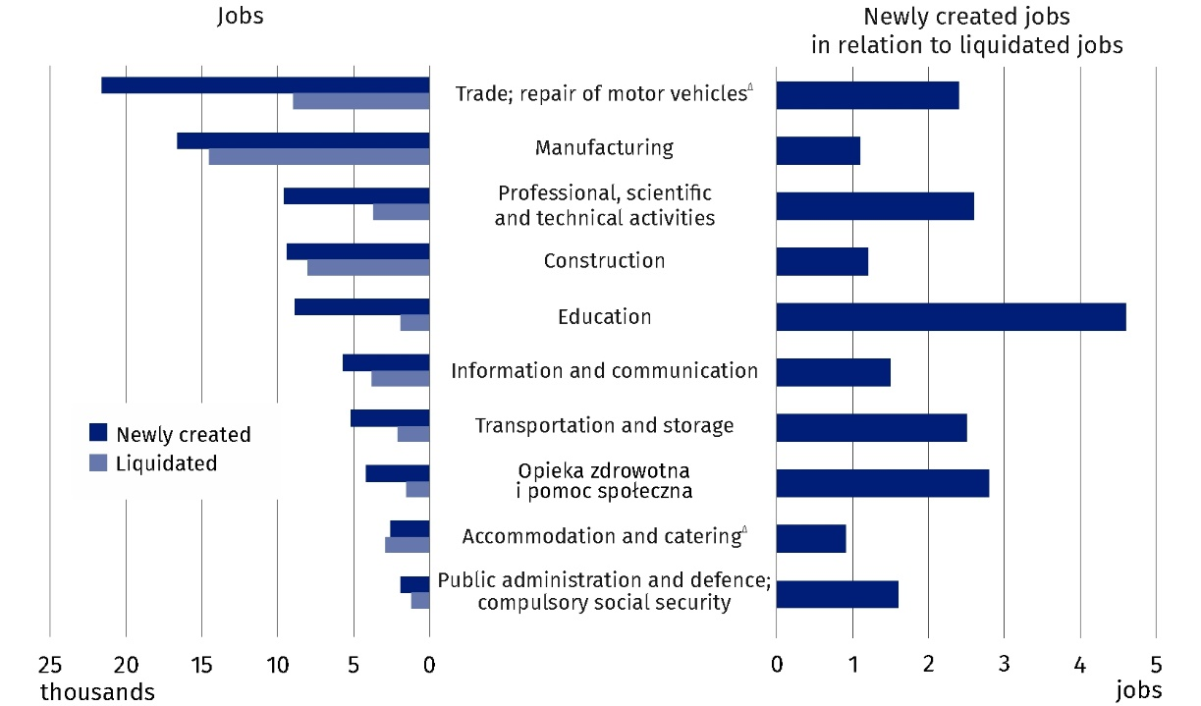
Chart 6. Newly created and liquidated jobs by selected PKD/NACE sections in the fourth quarter of 2022

In this news release abbreviated names of NACE, Rev. 2 sections were used. Abbreviations are marked with a ‘Δ’ symbol. Full names are available on the Eurostat website at: https://ec.europa.eu/eurostat/data/classifications
Relative numbers (rates, percentages) were calculated on the basis of absolute data expressed with greater accuracy than given in the publication.

In the case of quoting Statistics Poland data, please provide information: ‘Source of data: Statistics Poland’, and in the case of publishing calculations made on data published by Sta-tistics Poland, please provide information: ‘Own elaboration based on Statistics Poland data.’

Prepared by:  Statistical Office in Bydgoszcz  Director Wiesława Gierańczyk, Ph.D.  Phone: (+48 52) 366 93 90 | Issued by:  The Spokesperson for the President  of Statistics Poland  Karolina Banaszek  Phone: (+48) 695 255 011
Press Office  Phone: (+48 22) 608 38 04  e-mail: obslugaprasowa@stat.gov.pl |   stat.gov.pl/en/

@GUS_STAT

@GlownyUrzadStatystyczny

gus_stat

glownyurzadstatystycznygus

glownyurzadstatystyczny
Related information
The demand for labour in 2021 – annual publication
The demand for labour in the third quarter of 2022 — news release
The impact of the COVID-19 epidemic on selected elements of the labour market in Poland in the third quarter of 2022 – news release
Other publications that contain the results of these surveys: stat.gov.pl → Topics → Labour market
Methodological report. The demand for labour
Data available in databases
Knowledge Databases – Labour market
Strateg → Statistics by theme → Labour market
Local Data Bank → Labour market
Statistics for the SDGs – global indicators
Terms used in official statistics
Demand for labour
Vacancies
Newly created jobs
Liquidated jobs

Classification of Occupations and Specialisations (KZiS) – introduced by the Regulation of the Minister of Labour and Social Policy of 7 August 2014 on the classification of occupations and specialisations for the needs of the labour market and the scope of its applications (Journal of Laws (Dz. U.) item 1145 as amended).

