Residential construction in the period of January -November 2023

In the period of January - November 2023, there were less dwellings completed than the year before. The number of dwellings for which permits have been granted or which have been registered with a construction project as well as dwellings in which construction has begun also decreased.
92.9
Index number of dwellings
completed y/y

Dwellings completed
Developers and private investors completed respectively: 61.6% and 36.5% of the total number of dwellings
According to the preliminary data, 199.6 thousand dwellings were completed in the period of January - November 2023, i.e. 7.1% less than in the corresponding period of 2022. Developers completed 123.0 thousand dwellings – by 5.4% less than a year ago, whereas private investors completed 72.8 thousand dwellings, i.e. by 10.9% less. Within these forms of construction, 98.1% of the total number of newly completed dwellings was built. Within other forms of construction, i.e. cooperative, municipal, public building society and company construction 3.9 thousand dwellings were completed (3.3 thousand in the previous year).
The total useful floor area of dwellings completed amounted to 18.1 million m², i.e. by 8.9% less than a year ago and the average useful floor area of 1 dwelling was 90.5 m².

Table 1. Dwellings completed
SPECIFICATION | 11 2023 |  |  | 01-11 2023
SPECIFICATION | Number  of dwellings | 11 2022=100 | 10 2023=100 | Number  of dwellings | 01-11  2022=100
TOTAL | 18 905 | 73.0 | 96.7 | 199 607 | 92.9
Private | 5 949 | 69.5 | 100.6 | 72 757 | 89.1
For sale or rent | 12 591 | 75.0 | 95.0 | 122 982 | 94.6
of which for rent | 340 | 132.8 | 430.4 | 2 130 | 111.6
Cooperative | 53 | 15.1 | 182.8 | 932 | 67.2
Municipal | 105 | 525.0 | 150.0 | 1 099 | 234.8
Public building society | 193 | 102.1 | 68.9 | 1 805 | 132.5
Company | 14 | . | 200.0 | 32 | 88.9

Dwellings for which permits have been granted or which have been registered with
a construction project
In the period of eleven months of 2023, permits and registrations have been granted for con-struction of 219.1 thousand dwellings, i.e. by 21.1% less than in the corresponding period of 2022. Permits for construction of the biggest number of dwellings were given to developers (146.0 thousand, a decrease of 22.8% y/y) and to private investors (66.6 thousand, a decrease of 20.9%). Within these forms of construction, permits have been granted and registrations with a construction project were made for 97.0% of dwellings in total. In other forms of con-struction 6.5 thousand dwellings for which permits have been granted or which have been registered with a construction project were noted (in the previous year 4.3 thousand).

Table 2. Dwellings for which permits have been granted or which have been registered with a construction project
SPECIFICATION | 11 2023 |  |  | 01-11 2023
SPECIFICATION | Number  of dwellings | 11 2022=100 | 10 2023=100 | Number  of dwellings | 01-11  2022=100
TOTAL | 20 745 | 106.8 | 86.1 | 219 079 | 78.9
Private | 5 963 | 106.6 | 91.7 | 66 645 | 79.1
For sale or rent | 14 071 | 106.0 | 82.6 | 145 956 | 77.2
Cooperative | 50 | 192.3 | 555.6 | 487 | 76.2
Municipal | 160 | 62.7 | 142.9 | 1 866 | 96.0
Public building society | 499 | 178.2 | 115.2 | 4 025 | 245.0
Company | 2 | 33.3 | . | 100 | 204.1

Dwellings in which construction has begun
From January to November 2023, the number of dwellings in which construction has begun was 174.7 thousand, i.e. by 8.3% less than a year ago. Developers have started construction of 103.4 thousand dwellings (by 4.6% less), and private investors of 66.8 thousand (by 15.8% less). Altogether the share of these forms of construction was 97.4% of the total number of dwellings. In other forms of construction the number of dwellings in which construction has begun was 4.6 thousand (2.8 thousand in the previous year).

Table 3. Dwellings in which construction has begun
SPECIFICATION | 11 2023 |  |  | 01-11 2023
SPECIFICATION | Number  of dwellings | 11 2022=100 | 10 2023=100 | Number  of dwellings | 01-11  2022=100
TOTAL | 16 107 | 132.9 | 81.7 | 174 712 | 91.7
Private | 4 495 | 99.3 | 66.9 | 66 756 | 84.2
For sale or rent | 10 901 | 148.0 | 88.8 | 103 378 | 95.4
of which for rent | 75 | 267.9 | 937.5 | 310 | 75.2
Cooperative | 61 | 71.8 | 74.4 | 256 | 37.3
Municipal | 90 | 15-  fold more | 96.8 | 933 | 114.2
Public building society | 559 | 430.0 | 101.1 | 3 181 | 265.7
Company | 1 | 100.0 | . | 208 | 247.6

It is estimated that at the end of November 2023, there were 808.2 thousand dwellings under construction, i.e. by 4.6% less than in the corresponding month of 2022.

Chart 1. Residential construction in Poland
In November, compared to October 2023, the number of dwellings in which construction has begun, the number of dwellings for which permits have been granted or which have been registered with a construction project as well as the number of dwellings completed decreased (respectively by 18.3%, 13.9% and 3.3%)
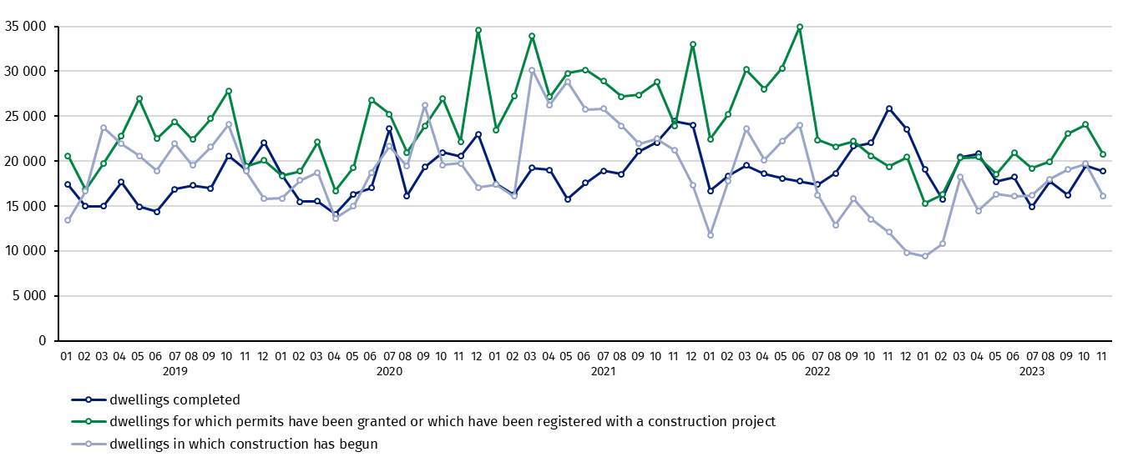

In the period of January - November 2023, the highest values of dwellings completed, as well as dwellings in which construction has begun and dwellings for which permits have been granted or which have been registered with a construction project, were recorded in Mazowieckie voivodship (respectively: 39.2 thousand, 33.7 thousand and 39.9 thousand dwellings). High values were also noted in Wielkopolskie (20.8 thousand, 14.8 thousand and 20.2 thousand) and Małopolskie (19.8 thousand, 17.3 thousand and 22.2 thousand).

Chart 2. Residential construction by voivodships in the period of January - November 2023
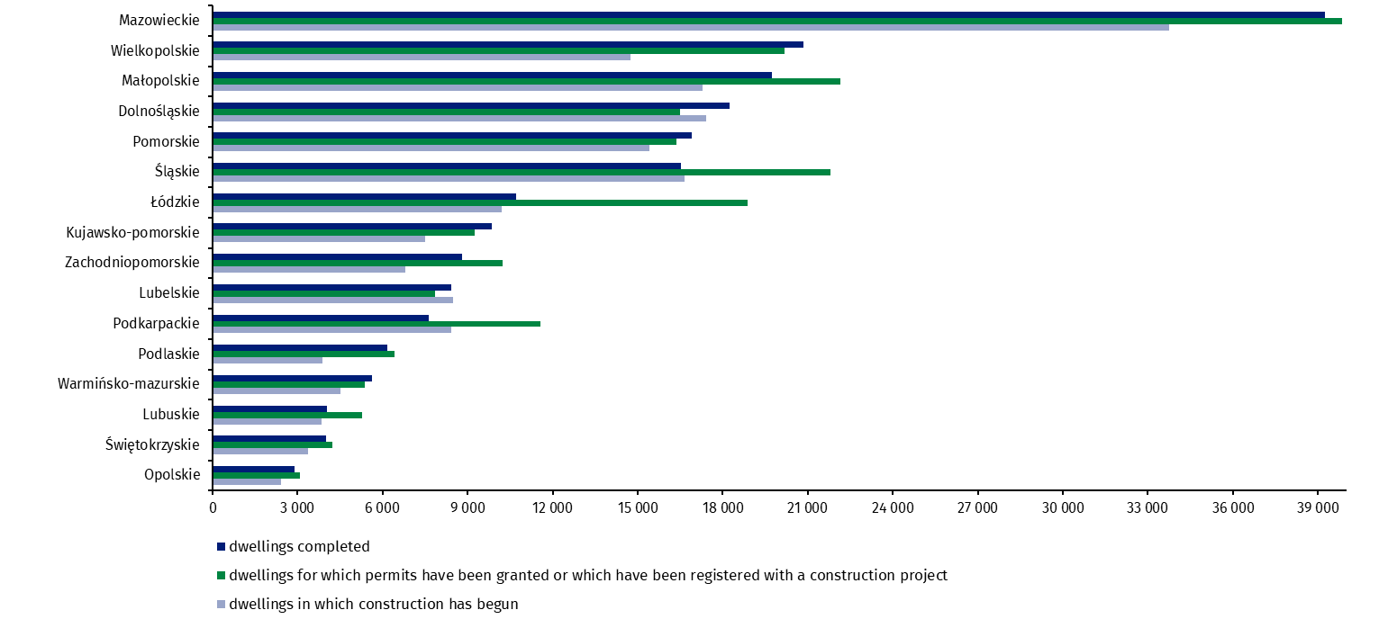

In case of quoting Statistics Poland data, please provide information: “Source of data: Statistics Poland” and in case of publishing calculations made on data published by Statistics Poland, please include the following disclaimer: “Own study based on figures from Statistics Poland”.
Prepared by:  Statistical Office in Lublin  Director Krzysztof Markowski, Ph.D.  Phone: (+48) 695 255 301 | Issued by:  The Spokesperson for the President  of Statistics Poland  Karolina Banaszek  Phone: (+48) 695 255 011
Press Office  Phone: (+48 22) 608 38 04  e-mail: obslugaprasowa@stat.gov.pl |   www.stat.gov.pl/en/

@StatPoland

@GlownyUrzadStatystyczny

gus_stat

glownyurzadstatystycznygus

glownyurzadstatystyczny
Related information
Statistical Bulletin
Socio-economic situation of the country
Construction results
Data available in databases
Dwellings in which construction has begun - monthly accruing data
Dwellings completed – quarterly accruing data
Knowledge Databases - Construction
Local Data Bank
Terms used in official statistics
Dwellings for which permits have been granted or which have been registered with a construction project
Dwellings in which construction has begun
Dwellings completed

Reported data – subject to change upon developing quarterly reports.

