Residential construction in the period of January -August 2023

In the first eight months of 2023, there were less dwellings completed than the year before. The number of dwellings for which permits have been granted or which have been registered with a construction project as well as dwellings in which construction has begun also decreased.
99.8
Index number of dwellings
completed y/y

Dwellings completed
Developers and private investors completed respectively: 59.8% and 38.4% of the total number of dwellings
According to the preliminary data, 145.0 thousand dwellings were completed in the period of January - August 2023, i.e. 0.2% less than in the corresponding period of 2022. Developers completed 86.7 thousand dwellings – by 1.8% more than a year ago, whereas private investors completed 55.7 thousand dwellings, i.e. by 4.4% less. Within these forms of construction, 98.2% of the total number of newly completed dwellings was built. Within other forms of construction, i.e. cooperative, municipal, public building society and company construction 2.6 thousand dwellings were completed (1.9 thousand in the previous year).
The total useful floor area of dwellings completed amounted to 13.3 million m², i.e. by 3.0% less than a year ago and the average useful floor area of 1 dwelling was 91.9 m².

Table 1. Dwellings completed
SPECIFICATION | 08 2023 |  |  | 01-08 2023
SPECIFICATION | Number  of dwellings | 08 2022=100 | 07 2023=100 | Number  of dwellings | 01-08  2022=100
TOTAL | 18 312 | 98.0 | 126.5 | 144 970 | 99.8
Private | 5 227 | 78.5 | 108.2 | 55 672 | 95.6
For sale or rent | 12 708 | 107.8 | 136.7 | 86 726 | 101.8
of which for rent | 30 | 23.1 | 75.0 | 765 | 50.8
Cooperative | 1 | 31-  fold less | 154-  fold less | 735 | 95.0
Municipal | 259 | 350.0 | 323.8 | 835 | 286.0
Public building society | 117 | 94.4 | 99.2 | 999 | 126.9
Company | - | . | . | 3 | 12- fold less

Dwellings for which permits have been granted or which have been registered with
a construction project
The number of dwellings for which permits have been granted or which have been registered with a construction project decreased in the period of January - August 2023 by 29.8% y/y
In the period of January - August 2023, permits and registrations have been granted for con-struction of 151.2 thousand dwellings, i.e. by 29.8% less than in the corresponding period of 2022. Permits for construction of the biggest number of dwellings were given to developers (98.5 thousand, a decrease of 32.9% y/y) and to private investors (47.9 thousand, a decrease of 26.7%). Within these forms of construction, permits have been granted and registrations with a construction project were made for 96.8% of dwellings in total. In other forms of con-struction 4.8 thousand dwellings for which permits have been granted or which have been registered with a construction project were noted (in the previous year 3.1 thousand).

Table 2. Dwellings for which permits have been granted or which have been registered with a construction project
SPECIFICATION | 08 2023 |  |  | 01-08 2023
SPECIFICATION | Number  of dwellings | 08 2022=100 | 07 2023=100 | Number  of dwellings | 01-08  2022=100
TOTAL | 20 006 | 92.5 | 104.2 | 151 163 | 70.2
Private | 6 535 | 91.9 | 97.2 | 47 894 | 73.3
For sale or rent | 12 754 | 89.4 | 106.5 | 98 494 | 67.1
Cooperative | - | . | . | 368 | 72.3
Municipal | 347 | 354.1 | 205.3 | 1 488 | 99.1
Public building society | 302 | 277.1 | 89.1 | 2 821 | 249.4
Company | 68 | . | . | 98 | over 32-  fold more

Dwellings in which construction has begun
In the period of January - August 2023, the number of dwellings in which construction has begun was 119.8 thousand, i.e. by 19.5% less than a year ago. Developers have started construction of 68.0 thousand dwellings (by 20.1% less), and private investors of 48.9 thousand (by 20.5% less). Altogether the share of these forms of construction was 97.6% of the total number of dwellings. In other forms of construction the number of dwellings in which construction has begun was 2.9 thousand (2.3 thousand in the previous year).

Table 3. Dwellings in which construction has begun
SPECIFICATION | 08 2023 |  |  | 01-08 2023
SPECIFICATION | Number  of dwellings | 08 2022=100 | 07 2023=100 | Number  of dwellings | 01-08  2022=100
TOTAL | 17 999 | 139.4 | 111.1 | 119 792 | 80.5
Private | 6 664 | 89.2 | 100.4 | 48 875 | 79.5
For sale or rent | 10 781 | 207.4 | 116.4 | 67 997 | 79.9
of which for rent | 45 | 642.9 | 166.7 | 221 | 61.2
Cooperative | 85 | 531.3 | . | 113 | 19.3
Municipal | 89 | 50.9 | 34.8 | 736 | 94.4
Public building society | 316 | over 13-  fold more | 718.2 | 1 864 | 210.1
Company | 64 | 228.6 | . | 207 | 249.4
It is estimated that at the end of August 2023, there were 807.9 thousand dwellings under construction, i.e. by 7.7% less than in the corresponding month of 2022.

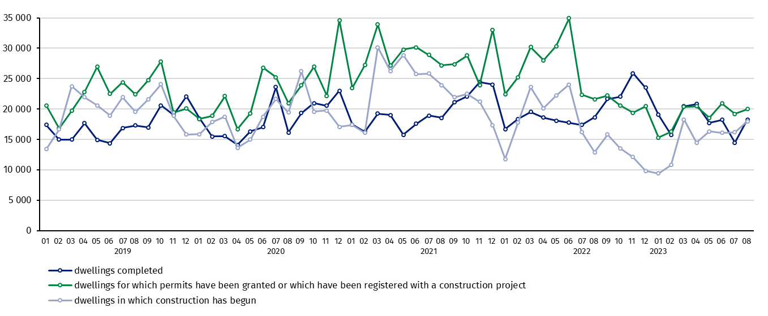
Chart 1. Residential construction in Poland
In August, compared to July 2023, the number of dwellings completed increased (by 26,5%) as well as the number of dwellings in which construction has begun and the number of dwellings for which permits have been granted or which have been registered with a construction project (respectively by 11.1% and 4.2%)

In the period of January - August 2023, the highest values of dwellings completed, as well as dwellings in which construction has begun and dwellings for which permits have been granted or which have been registered with a construction project, were recorded in Mazowieckie voivodship (respectively: 28.1 thousand, 23.9 thousand and 26.7 thousand dwellings). High values were also noted in Wielkopolskie (15.6 thousand, 10.0 thousand and 13.6 thousand) and Małopolskie (14.5 thousand, 12.1 thousand and 16.3 thousand).

Chart 2. Residential construction by voivodships in the period of January - August 2023
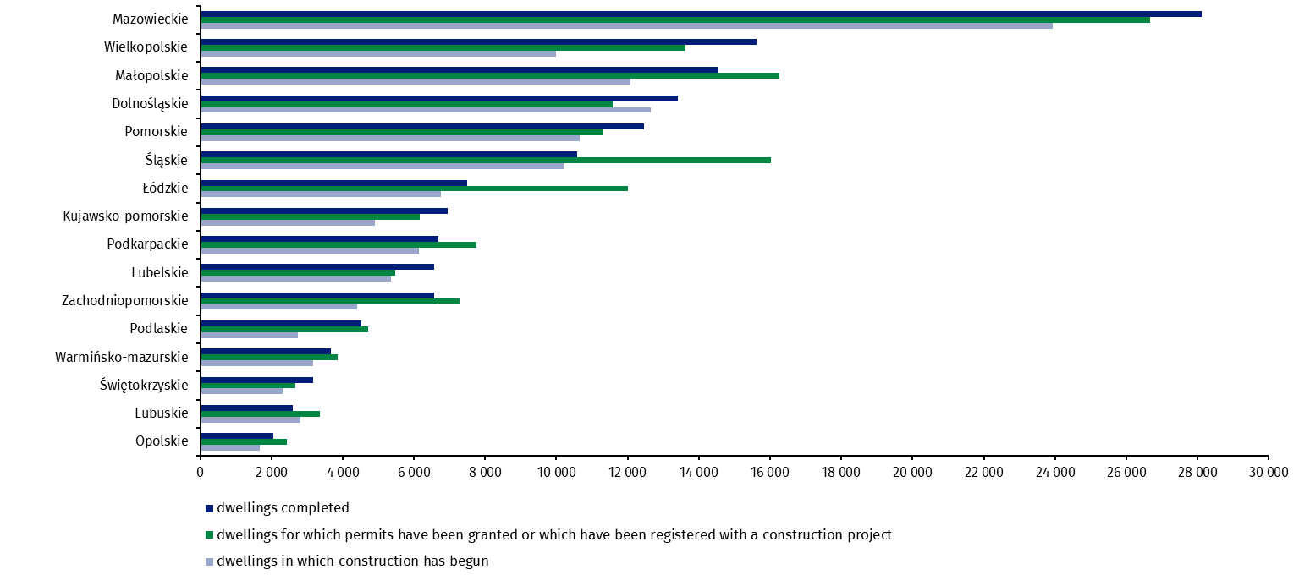

In case of quoting Statistics Poland data, please provide information: “Source of data: Statistics Poland” and in case of publishing calculations made on data published by Statistics Poland, please include the following disclaimer: “Own study based on figures from Statistics Poland”.
Prepared by:  Statistical Office in Lublin  Director Krzysztof Markowski, Ph.D.  Phone: (+48) 695 255 301 | Issued by:  The Spokesperson for the President  of Statistics Poland  Karolina Banaszek  Phone: (+48) 695 255 011
Press Office  Phone: (+48 22) 608 38 04  e-mail: obslugaprasowa@stat.gov.pl |   www.stat.gov.pl/en/

@StatPoland

@GlownyUrzadStatystyczny

gus_stat

glownyurzadstatystycznygus

glownyurzadstatystyczny
Related information
Statistical Bulletin
Socio-economic situation of the country
Construction results
Data available in databases
Dwellings in which construction has begun - monthly accruing data
Dwellings completed – quarterly accruing data
Knowledge Databases - Construction
Local Data Bank
Terms used in official statistics
Dwellings for which permits have been granted or which have been registered with a construction project
Dwellings in which construction has begun
Dwellings completed

Reported data – subject to change upon developing quarterly reports.

