Residential construction in the period of January -May 2023

In the first five months of 2023, there were more dwellings completed than the year before. Whereas the number of dwellings for which permits have been granted or which have been registered with a construction project as well as dwellings in which construction has begun decreased.
102.5
Index number of dwellings
completed y/y

Dwellings completed
Developers and private investors completed respectively: 54.5% and 43.9% of the total number of dwellings
According to the preliminary data, 93.7 thousand dwellings were completed in the period of January - May 2023, i.e. 2.5% more than in the corresponding period of 2022. Developers completed 51.0 thousand dwellings – by 1.3% less than a year ago, whereas private investors completed 41.2 thousand dwellings, i.e. by 7.6% more. Within these forms of construction, 98.4% of the total number of newly completed dwellings was built. Within other forms of construction, i.e. cooperative, municipal, public building society and company construction 1.5 thousand dwellings were completed (1.4 thousand in the previous year).
The total useful floor area of dwellings completed amounted to 9.1 million m², i.e. by 2.8% more than a year ago and the average useful floor area of 1 dwelling was 96.8 m².

Table 1. Dwellings completed
SPECIFICATION | 05 2023 |  |  | 01-05 2023
SPECIFICATION | Number  of dwellings | 05 2022=100 | 04 2023=100 | Number  of dwellings | 01-05  2022=100
TOTAL | 17 680 | 97.6 | 85.5 | 93 717 | 102.5
Private | 7 576 | 113.8 | 75.6 | 41 163 | 107.6
For sale or rent | 9 841 | 87.4 | 93.3 | 51 046 | 98.7
of which for rent | 202 | 219.6 | 310.8 | 605 | 139.4
Cooperative | 102 | . | 204.0 | 580 | 90.3
Municipal | 29 | 181.3 | 54.7 | 303 | 183.6
Public building society | 132 | 76.7 | . | 622 | 103.3
Company | - | . | . | 3 | almost 11- fold less

Dwellings for which permits have been granted or which have been registered with
a construction project
The number of dwellings for which permits have been granted or which have been registered with a construction project decreased in the period of January - May 2023 by 33.3% y/y
In the period of January - May 2023, permits and registrations have been granted for con-struction of 91.0 thousand dwellings, i.e. by 33.3% less than in the corresponding period of 2022. Permits for construction of the biggest number of dwellings were given to developers (60.2 thousand, a decrease of 34.6% y/y) and to private investors (28.2 thousand, a decrease of 32.9%). Within these forms of construction, permits have been granted and registrations with a construction project were made for 97.1% of dwellings in total. In other forms of con-struction 2.6 thousand dwellings for which permits have been granted or which have been registered with a construction project were noted (in the previous year 2.4 thousand).

Table 2. Dwellings for which permits have been granted or which have been registered with a construction project
SPECIFICATION | 05 2023 |  |  | 01-05 2023
SPECIFICATION | Number  of dwellings | 05 2022=100 | 04 2023=100 | Number  of dwellings | 01-05  2022=100
TOTAL | 18 574 | 61.2 | 90.8 | 91 006 | 66.7
Private | 6 637 | 73.8 | 111.8 | 28 157 | 67.1
For sale or rent | 11 268 | 53.5 | 78.6 | 60 200 | 65.4
Cooperative | 326 | . | 693.6 | 415 | 99.5
Municipal | 86 | 29.0 | 175.5 | 523 | 46.5
Public building society | 257 | almost 11-  fold more | 267.7 | 1683 | 206.0
Company | - | . | . | 28 | 933.3

Dwellings in which construction has begun
In the first five months of 2023, the number of dwellings in which construction has begun was 69.5 thousand, i.e. by 27.4% less than a year ago. Developers have started construction of 39.1 thousand dwellings (by 30.1% less), and private investors of 28.8 thousand (by 24.9% less). Altogether the share of these forms of construction was 97.7% of the total number of dwell-ings. In other forms of construction the number of dwellings in which construction has begun was 1.6 thousand (1.4 thousand in the previous year).

Table 3. Dwellings in which construction has begun
SPECIFICATION | 05 2023 |  |  | 01-05 2023
SPECIFICATION | Number  of dwellings | 05 2022=100 | 04 2023=100 | Number  of dwellings | 01-05  2022=100
TOTAL | 16 372 | 73.7 | 112.8 | 69 458 | 72.6
Private | 7 410 | 84.9 | 110.1 | 28 810 | 75.1
For sale or rent | 8 688 | 66.2 | 124.5 | 39 085 | 69.9
of which for rent | 60 | 857.1 | 157.9 | 129 | 60.6
Cooperative | - | . | . | 9 | almost 57-  fold less
Municipal | 43 | 33.3 | 477.8 | 229 | 72.0
Public building society | 91 | 189.6 | 11.5 | 1 183 | 215.5
Company | 140 | . | . | 142 | 443.8
It is estimated that at the end of May 2023, there were 808.8 thousand dwellings under construction, i.e. by 7.6% less than in the corresponding month of 2022.

Chart 1. Residential construction in Poland
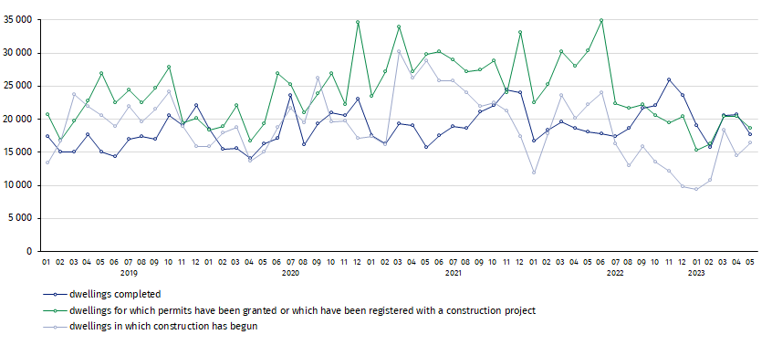
In May, compared to April 2023, the number of dwellings completed and for which permits have been granted or which have been registered with a construction project decreased (respectively by 14.5% and 9.2%), whereas the number of dwellings in which construction has begun increased (by 12.8%)

In the period of January - May 2023, the highest values of dwellings completed, as well as dwellings in which construction has begun and dwellings for which permits have been granted or which have been registered with a construction project, were recorded in Mazowieckie voivodship (respectively: 18.3 thousand, 13.8 thousand and 15.6 thousand dwellings). High values were also noted in Wielkopolskie (10.4 thousand, 5.7 thousand and 8.6 thousand) and Małopolskie (9.2 thousand, 7.2 thousand and 10.1 thousand).

Chart 2. Residential construction by voivodships in the period of January - May 2023
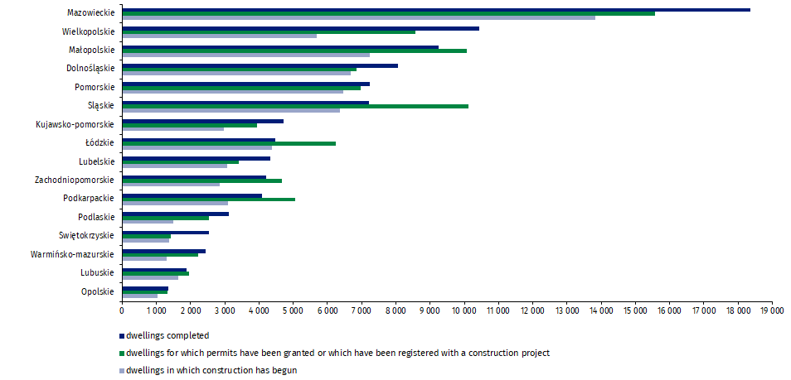

In case of quoting Statistics Poland data, please provide information: “Source of data: Statistics Poland” and in case of publishing calculations made on data published by Statistics Poland, please include the following disclaimer: “Own study based on figures from Statistics Poland”.
Prepared by:  Statistical Office in Lublin  Director Krzysztof Markowski  Phone: (+48) 695 255 301 | Issued by:  The Spokesperson for the President  of Statistics Poland  Karolina Banaszek  Phone: (+48) 695 255 011
Press Office  Phone: (+48 22) 608 38 04  e-mail: obslugaprasowa@stat.gov.pl |   www.stat.gov.pl/en/

@StatPoland

@GlownyUrzadStatystyczny

gus_stat

glownyurzadstatystycznygus

glownyurzadstatystyczny
Related information
Statistical Bulletin
Socio-economic situation of the country
Construction results
Data available in databases
Dwellings in which construction has begun - monthly accruing data
Dwellings completed – quarterly accruing data
Knowledge Databases
Local Data Bank
Terms used in official statistics
Dwellings for which permits have been granted or which have been registered with a construction project
Dwellings in which construction has begun
Dwellings completed

Reported data – subject to change upon developing quarterly reports.

