Residential construction in the period of January -April 2023

In the first four months of 2023, there were more dwellings completed than the year before. Whereas the number of dwellings for which permits have been granted or which have been registered with a construction project as well as dwellings in which construction has begun decreased.
103.1
Index number of dwellings
completed y/y

Dwellings completed
Developers and private investors completed respectively: 53.8% and 44.6% of the total number of dwellings
According to the preliminary data, 75.6 thousand dwellings were completed in the period of January - April 2023, i.e. 3.1% more than in the corresponding period of 2022. Developers completed 40.7 thousand dwellings – by 0.5% more than a year ago, whereas private investors completed 33.7 thousand dwellings, i.e. by 6.6% more. Within these forms of construction, 98.4% of the total number of newly completed dwellings was built. Within other forms of construction, i.e. cooperative, municipal, public building society and company construction 1.2 thousand dwellings were completed (1.3 thousand in the previous year).
The total useful floor area of dwellings completed amounted to 7.3 million m², i.e. by 2.5% less than a year ago and the average useful floor area of 1 dwelling was 97.1 m².

Table 1. Dwellings completed
SPECIFICATION | 04 2023 |  |  | 01-04 2023
SPECIFICATION | Number  of dwellings | 04 2022=100 | 03 2023=100 | Number  of dwellings | 01-04  2022=100
TOTAL | 20 678 | 111.0 | 99.4 | 75 563 | 103.1
Private | 10 025 | 130.1 | 112.7 | 33 694 | 106.6
For sale or rent | 10 550 | 97.4 | 93.8 | 40 650 | 100.5
of which for rent | 65 | 130.0 | 138.3 | 266 | 77.8
Cooperative | 50 | 67.6 | 20.7 | 453 | 70.6
Municipal | 53 | 407.7 | 88.3 | 273 | 183.2
Public building society | - | . | . | 490 | 114.0
Company | - | . | . | 3 | almost 11- fold less

Dwellings for which permits have been granted or which have been registered with
a construction project
The number of dwellings for which permits have been granted or which have been registered with a construction project decreased in the period of January - April 2023 by 32.0% y/y
In the period of January - April 2023, permits and registrations have been granted for construction of 72.1 thousand dwellings, i.e. by 32.0% less than in the corresponding period of 2022. Permits for construction of the biggest number of dwellings were given to developers (48.5 thousand, a decrease of 31.6% y/y) and to private investors (21.6 thousand, a decrease of 34.6%). Within these forms of construction, permits have been granted and registrations with a construction project were made for 97.3% of dwellings in total. In other forms of construction 2.0 thousand dwellings for which permits have been granted or which have been registered with a construction project were noted (similar amount in the previous year).

Table 2. Dwellings for which permits have been granted or which have been registered with a construction project
SPECIFICATION | 04 2023 |  |  | 01-04 2023
SPECIFICATION | Number  of dwellings | 04 2022=100 | 03 2023=100 | Number  of dwellings | 01-04  2022=100
TOTAL | 20 464 | 73.0 | 101.1 | 72 081 | 68.0
Private | 5 936 | 66.7 | 98.1 | 21 585 | 65.4
For sale or rent | 14 333 | 77.7 | 107.9 | 48 524 | 68.4
Cooperative | 47 | 39.5 | . | 89 | 21.3
Municipal | 49 | 23.8 | 61.3 | 429 | 51.9
Public building society | 96 | 27.4 | 11.9 | 1426 | 179.8
Company | 3 | . | 12.5 | 28 | 933.3

Dwellings in which construction has begun
In the first four months of 2023, the number of dwellings in which construction has begun was 53.1 thousand, i.e. by 27.7% less than a year ago. Developers have started construction of 30.4 thousand dwellings (by 28.9% less), and private investors of 21.4 thousand (by 27.8% less). Altogether the share of these forms of construction was 97.6% of the total number of dwell-ings. In other forms of construction the number of dwellings in which construction has begun was 1.3 thousand (1.0 thousand in the previous year).

Table 3. Dwellings in which construction has begun
SPECIFICATION | 04 2023 |  |  | 01-04 2023
SPECIFICATION | Number  of dwellings | 04 2022=100 | 03 2023=100 | Number  of dwellings | 01-04  2022=100
TOTAL | 14 513 | 71.9 | 79.3 | 53 086 | 72.3
Private | 6 733 | 76.6 | 94.0 | 21 400 | 72.2
For sale or rent | 6 981 | 62.9 | 63.4 | 30 397 | 71.1
of which for rent | 38 | 345.5 | 223.5 | 69 | 33.5
Cooperative | - | . | . | 9 | almost 36-  fold less
Municipal | 9 | 11.3 | 20.0 | 186 | 98.4
Public building society | 790 | over 13-  fold more | 963.4 | 1 092 | 218.0
Company | - | . | . | 2 | 16-fold less
It is estimated that at the end of April 2023, there were 810.5 thousand dwellings under construction, i.e. by 7.0% less than in the corresponding month of 2022.

Chart 1. Residential construction in Poland
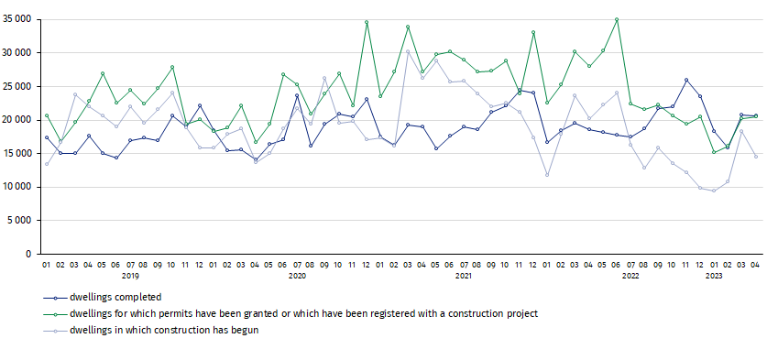
In April, compared to March 2023, the number of dwellings completed and in which construction has begun decreased (respectively by 0.6% and 20.7%), whereas the number of dwellings for which permits have been granted or which have been registered with a construction project increased (by 1.1%)

In the period of January - April 2023, the highest values of dwellings completed, as well as dwellings in which construction has begun and dwellings for which permits have been granted or which have been registered with a construction project, were recorded in Mazowieckie voivodship (respectively: 14.5 thousand, 11.4 thousand and 12.7 thousand dwellings). High values were also noted in Wielkopolskie (8.7 thousand, 4.5 thousand and 5.8 thousand) and Małopolskie (7.7 thousand, 5.2 thousand and 8.2 thousand).

Chart 2. Residential construction by voivodships in the period of January - April 2023

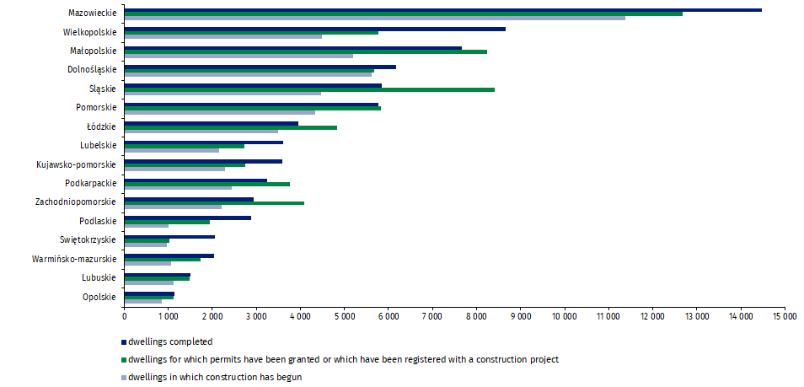

In case of quoting Statistics Poland data, please provide information: “Source of data: Statistics Poland” and in case of publishing calculations made on data published by Statistics Poland, please include the following disclaimer: “Own study based on figures from Statistics Poland”.
Prepared by:  Statistical Office in Lublin  Director Krzysztof Markowski  Phone: (+48) 695 255 301 | Issued by:  The Spokesperson for the President  of Statistics Poland  Karolina Banaszek  Phone: (+48) 695 255 011
Press Office  Phone: (+48 22) 608 38 04  e-mail: obslugaprasowa@stat.gov.pl |   www.stat.gov.pl/en/

@StatPoland

@GlownyUrzadStatystyczny

gus_stat

glownyurzadstatystycznygus

glownyurzadstatystyczny
Related information
Statistical Bulletin
Socio-economic situation of the country
Construction results
Data available in databases
Knowledge Databases Construction
Local Data Bank
Terms used in official statistics
Dwellings for which permits have been granted or which have been registered with a construction project
Dwellings in which construction has begun
Dwellings completed

Reported data – subject to change upon developing quarterly reports.

