Residential construction in the period of January-February 2023

In the first two months of 2023, there were less dwellings completed than the year before. The number of dwellings for which permits have been granted or which have been registered with a construction project as well as dwellings in which construction has begun also decreased.
97.1
Index number of dwellings
completed y/y

Dwellings completed
Developers and private investors completed respectively: 55.3% and 43.4% of the total number of dwellings
According to the preliminary data, 34.1 thousand dwellings were completed in the period of January-February 2023, i.e. 2.9% less than in the corresponding period of 2022. Developers completed 18.8 thousand dwellings – by 2.4% less than a year ago, whereas private investors completed 14.8 thousand dwellings, i.e. by 1.7% less. Within these forms of construction, 98.7% of the total number of newly completed dwellings was built. Within other forms of construction, i.e. cooperative, municipal, public building society and company construction 0.5 thousand dwellings were completed (0.8 thousand in the previous year).
The total useful floor area of dwellings completed amounted to 3.3 million m², i.e. by 3.5% less than a year ago and the average useful floor area of 1 dwelling was 96.5 m².

Table 1. Dwellings completed
SPECIFICATION | 02 2023 |  |  | 01-02 2023
SPECIFICATION | Number  of dwellings | 02 2022=100 | 01 2023=100 | Number  of dwellings | 01-02  2022=100
TOTAL | 15 838 | 86.1 | 86.8 | 34 082 | 97.1
Private | 7 165 | 93.1 | 94.2 | 14 775 | 98.3
For sale or rent | 8 433 | 81.5 | 81.0 | 18 847 | 97.6
of which for rent | 75 | 63.0 | 94.9 | 154 | 86.5
Cooperative | 141 | 293.8 | 671.4 | 162 | 51.3
Municipal | 49 | 38.3 | 44.1 | 160 | 113.5
Public building society | 48 | 27.9 | 54.5 | 136 | 48.7
Company | 2 | . | . | 2 | 15-fold less

Dwellings for which permits have been granted or which have been registered with
a construction project
The number of dwellings for which permits have been granted or which have been registered with a construction project decreased in the period of 01-02 2023 by 34.3% y/y
In the period of January-February 2023, permits and registrations have been granted for construction of 31.4 thousand dwellings, i.e. by 34.3% less than in the corresponding period of 2022. Permits for construction of the biggest number of dwellings were given to develo-pers (20.9 thousand, a decrease of 37.3% y/y) and to private investors (9.6 thousand, a decrease of 31.4%). Within these forms of construction, permits have been granted and registrations with a construction project were made for 97.2% of dwellings in total. In other forms of construction 0.9 thousand dwellings for which permits have been granted or which have been registered with a construction project were noted (0.4 thousand in the previous year).

Table 2. Dwellings for which permits have been granted or which have been registered with a construction project
SPECIFICATION | 02 2023 |  |  | 01-02 2023
SPECIFICATION | Number  of dwellings | 02 2022=100 | 01 2023=100 | Number  of dwellings | 01-02  2022=100
TOTAL | 16 186 | 64.0 | 106,6 | 31 375 | 65.7
Private | 4 803 | 64.1 | 100,2 | 9 598 | 68.6
For sale or rent | 10 739 | 61.5 | 105,6 | 20 913 | 62.7
Cooperative | 40 | 266.7 | 20-fold more | 42 | 64.6
Municipal | 277 | 152.2 | over 12-  fold more | 300 | 121.5
Public building society | 326 | 291.1 | 167.2 | 521 | 465.2
Company | 1 | 50.0 | . | 1 | 33.3

Dwellings in which construction has begun
In the first two months of 2023, the number of dwellings in which construction has begun was 20.3 thousand, i.e. by 31.7% less than a year ago. Developers have started construction of 12.4 thousand dwellings (by 33.5% less), and private investors of 7.5 thousand (by 28.9% less). Altogether the share of these forms of construction was 98.3% of the total number of dwell-ings. In other forms of construction the number of dwellings in which construction has begun was 0.4 thousand (similar amount in the previous year).

Table 3. Dwellings in which construction has begun
SPECIFICATION | 02 2023 |  |  | 01-02 2023
SPECIFICATION | Number  of dwellings | 02 2022=100 | 01 2023=100 | Number  of dwellings | 01-02  2022=100
TOTAL | 10 817 | 60.6 | 114.5 | 20 263 | 68.3
Private | 3 949 | 63.7 | 111.0 | 7 506 | 71.1
For sale or rent | 6 588 | 58.2 | 113.3 | 12 405 | 66.5
of which for rent | 5 | . | 55.6 | 14 | 9.0
Cooperative | - | . | . | - | .
Municipal | 132 | 244.4 | . | 132 | 161.0
Public building society | 148 | 53.0 | 205.6 | 220 | 61.3
Company | - | . | . | - | .
It is estimated that at the end of February 2023, there were 819.2 thousand dwellings under construction, i.e. by 5.4% less than in the corresponding month of 2022.

Chart 1. Residential construction in Poland
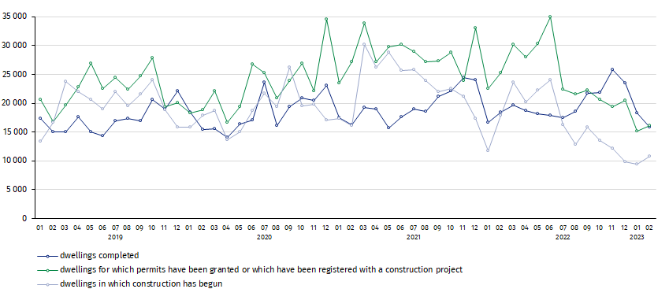
In February, compared to January 2023, the number of dwellings for which permits have been granted or which have been registered with a construction project increased (by 6.6%), as well as the number of dwellings in which construction has begun (by 14.5%), whereas the number of dwellings completed decreased (by 13.2%)

In the period of January- February 2023, the highest values of dwellings completed, as well as dwellings in which construction has begun and dwellings for which permits have been granted or which have been registered with a construction project, were recorded in Mazowieckie voivodship (respectively: 6.1 thousand, 4.5 thousand and 5.5 thousand dwellings). High values were also noted in Małopolskie (3.9 thousand, 1.3 thousand and 3.7 thousand) and Wielkopol-skie (3.8 thousand, 2.0 thousand and 2.2 thousand).

Chart 2. Residential construction by voivodships in the period of January- February 2023
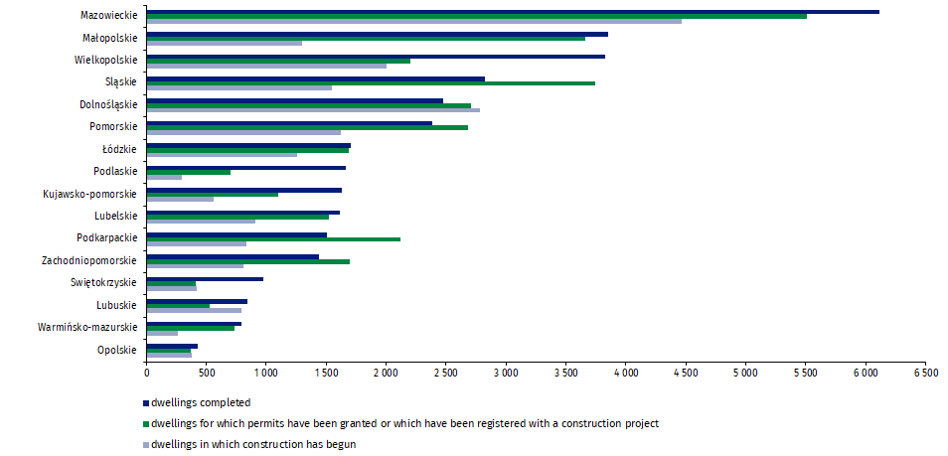

In case of quoting Statistics Poland data, please provide information: “Source of data: Statistics Poland” and in case of publishing calculations made on data published by Statistics Poland, please include the following disclaimer: “Own study based on figures from Statistics Poland”.
Prepared by:  Statistical Office in Lublin  Director Krzysztof Markowski  Phone: (+48) 695 255 301 | Issued by:  The Spokesperson for the President  of Statistics Poland  Karolina Banaszek  Phone: (+48) 695 255 011
Press Office  Phone: (+48 22) 608 38 04  e-mail: obslugaprasowa@stat.gov.pl |   www.stat.gov.pl/en/

@StatPoland

@GlownyUrzadStatystyczny

gus_stat

glownyurzadstatystycznygus

glownyurzadstatystyczny
Related information
Statistical Bulletin
Socio-economic situation of the country
Construction results
Data available in databases
Knowledge Databases Construction
Local Data Bank
Terms used in official statistics
Dwellings for which permits have been granted or which have been registered with a construction project
Dwellings in which construction has begun
Dwellings completed

Reported data – subject to change upon developing quarterly reports.

