Residential construction in January 2023

In January 2023, there were more dwellings completed than the year before. Whereas the number of dwellings for which permits have been granted or which have been registered with a construction project as well as dwellings in which construction has begun decreased.
109.1
Index number of dwellings
completed y/y

Dwellings completed
Developers and private investors completed respectively: 57.1% and 41.7% of the total number of dwellings
According to the preliminary data, 18.2 thousand dwellings were completed in January 2023, i.e. 9.1% more than in the corresponding month of 2022. Developers completed 10.4 thousand dwellings – by 16.1% more than a year ago, whereas private investors completed 7.6 thousand dwellings, i.e. by 3.7% more. Within these forms of construction, 98.8% of the total number of newly completed dwellings was built. Within other forms of construction, i.e. cooperative, municipal, public building society and company construction 0.2 thousand dwellings were completed (0.4 thousand in the previous year).
The total useful floor area of dwellings completed amounted to 1.7 million m², i.e. by 5.6% more than a year ago and the average useful floor area of 1 dwelling was 94.8 m².

Table 1. Dwellings completed
SPECIFICATION | 01 2023
SPECIFICATION | Number  of dwellings | 01 2022=100 | 12 2022=100
TOTAL | 18 244 | 109.1 | 74.9
Private | 7 610 | 103.7 | 79.6
For sale or rent | 10 414 | 116.1 | 73.1
of which for rent | 79 | 133.9 | 76.7
Cooperative | 21 | almost 13-fold less | 32.8
Municipal | 111 | 853.8 | 73.0
Public building society | 88 | 82.2 | 27.2
Company | - | . | .

Dwellings for which permits have been granted or which have been registered with
a construction project
The number of dwellings for which permits have been granted or which have been registered with a construction project decreased in January 2023 by 32.5% y/y
In January 2023, permits and registrations have been granted for construction of 15.2 thousand dwellings, i.e. by 32.5% less than in January 2022. Permits for construction of the biggest number of dwellings were given to developers (10.2 thousand, a decrease of 35.9% y/y) and to private investors (4.8 thousand, a decrease of 26.2%). Within these forms of construction, permits have been granted and registrations with a construction project were made for 98.6% of dwellings in total. In other forms of construction 0.2 thousand dwellings for which permits have been granted or which have been registered with a construction project were noted (0.1 thousand dwellings in the previous year).

Table 2. Dwellings for which permits have been granted or which have been registered with a construction project
SPECIFICATION | 01 2023
SPECIFICATION | Number  of dwellings | 01 2022=100 | 12 2022=100
TOTAL | 15 189 | 67.5 | 76.0
Private | 4 795 | 73.8 | 91.9
For sale or rent | 10 174 | 64.1 | 71.8
Cooperative | 2 | 25-fold less | 50.0
Municipal | 23 | 35.4 | almost 14-fold less
Public building society | 195 | . | 72.5
Company | - | . | .

Dwellings in which construction has begun
In January 2023, the number of dwellings in which construction has begun was 9.4 thousand, i.e. by 19.9% less than a year ago. Developers have started construction of 5.8 thousand dwellings (by 20.7% less), and private investors of 3.6 thousand (by 18.2% less). Altogether the share of these forms of construction was 99.2% of the total number of dwellings. In other forms of construction the number of dwellings in which construction has begun was 0.1 thousand (simillar amount in the previous year).

Table 3. Dwellings in which construction has begun
SPECIFICATION | 01 2023
SPECIFICATION | Number  of dwellings | 01 2022=100 | 12 2022=100
TOTAL | 9 446 | 80.1 | 96.0
Private | 3 557 | 81.8 | 125.8
For sale or rent | 5 817 | 79.3 | 83.7
of which for rent | 9 | over 17-fold less | almost 17-fold less
Cooperative | - | . | .
Municipal | - | . | .
Public building society | 72 | 90.0 | 156.5
Company | - | . | .
It is estimated that at the end of January 2023, there were 824.2 thousand dwellings under construction, i.e. by 4.9% less than in the corresponding month of 2022.

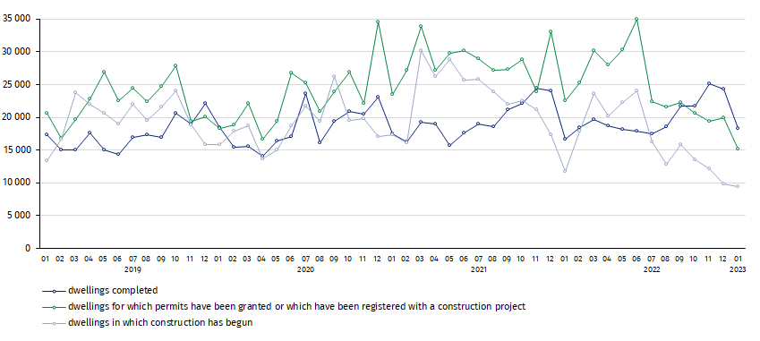
Chart 1. Housing construction in Poland
In January 2023, compared to December 2022, the number of dwellings completed decreased (by 25.1%), as well as the number of dwellings for which permits have been granted or which have been registered with a construction project and in which construction has begun (respectively by 24.0% and 4.0%)
In January 2023, the highest values of dwellings completed, as well as dwellings in which construction has begun and dwellings for which permits have been granted or which have been registered with a construction project, were recorded in Mazowieckie voivodship (respectively: 3.2 thousand, 2.0 thousand and 2.5 thousand dwellings). High values were also noted in Małopolskie (2.2 thousand, 0.7 thousand and 1.8 thousand) and Wielkopolskie (2.1 thousand, 1.1 thousand and 1.3 thousand).

Chart 2. Housing construction by voivodships in January 2023
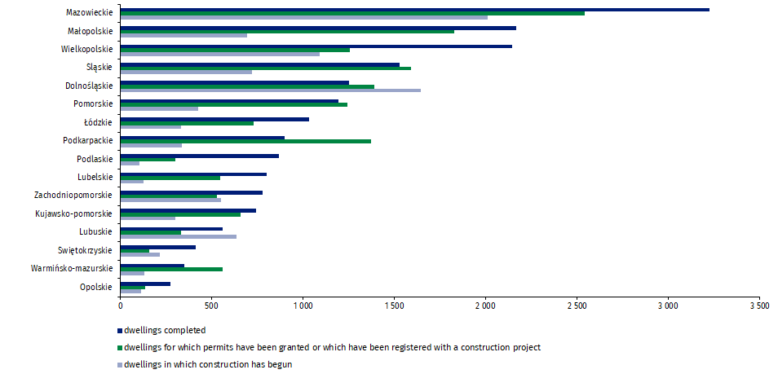

In case of quoting Statistics Poland data, please provide information: “Source of data: Statistics Poland” and in case of publishing calculations made on data published by Statistics Poland, please include the following disclaimer: “Own study based on figures from Statistics Poland”.
Prepared by:  Statistical Office in Lublin  Director Krzysztof Markowski  Phone: (+48) 695 255 301 | Issued by:  The Spokesperson for the President  of Statistics Poland  Karolina Banaszek  Phone: (+48) 695 255 011
Press Office  Phone: (+48 22) 608 38 04  e-mail: obslugaprasowa@stat.gov.pl |   www.stat.gov.pl/en/

@StatPoland

@GlownyUrzadStatystyczny

gus_stat

glownyurzadstatystycznygus

glownyurzadstatystyczny
Related information
Statistical Bulletin
Socio-economic situation of the country
Construction results
Data available in databases
Knowledge Databases Construction
Local Data Bank
Terms used in official statistics
Dwellings for which permits have been granted or which have been registered with a construction project
Dwellings in which construction has begun
Dwellings completed

Reported data – subject to change upon developing quarterly reports.

