Business tendency in manufacturing,
construction, trade and services – March 2023
In-depth questions about the current economic issues and the impact of war in Ukraine – assessment and expectations
General business climate indicator and its components in the last six months
In March the assessments of general business climate indicator in all of presented kinds of activities are at a higher or similar level as compared to the ones presented in February this year. In all areas it is below the long-term mean. In majority of the areas, the level of "diagnostic" components is similar as in February, while the "prognostic" ones improve.
-12.9
General business climate indicator for manufacturing
Only entities from financial and insurance activities section (plus 15.3) along with information and communication section (plus 10.4) assess business tendency as positive, however below the long-term mean (plus 25.9 and plus 18.3 respectively). The most pessimistic assessments are made by entities from the construction section (minus 16.9).
In the current month – answers provided between 1st and 10th of each month – supplementary set of questions has been added to the survey. This particular set aims to additionally diagnose the impact of war in Ukraine on business tendency and raises the issue of labour market (results in table 2).


Manufacturing (graph 1)
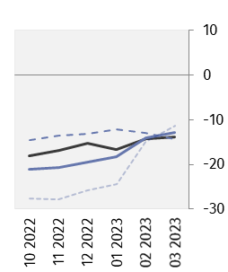
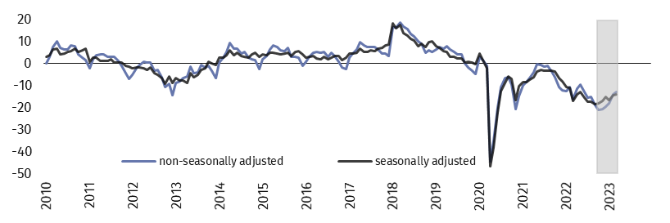
In the current month general business climate indicator (NSA) takes the value minus 12.9 – similar to the one reported in February (minus 14.0).



Construction (graph 2)
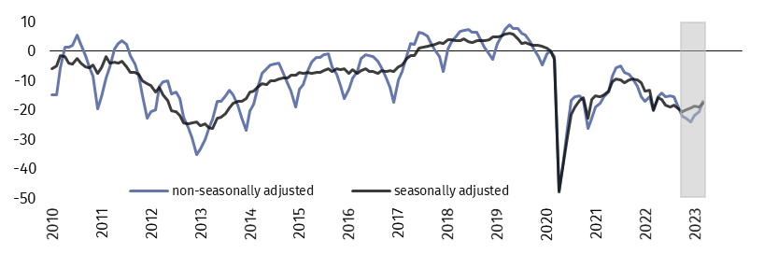
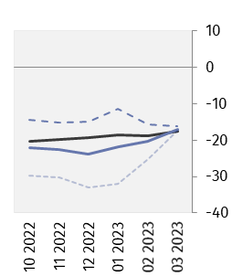
In March general business climate indicator (NSA) takes the value minus 16.9 and it is higher than the one recorded a month ago (minus 20.4).


Wholesale trade (graph 3)
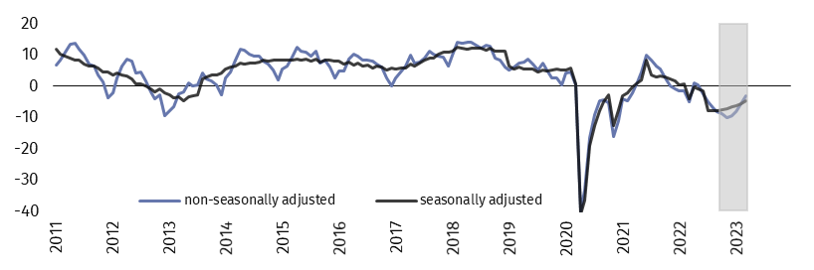
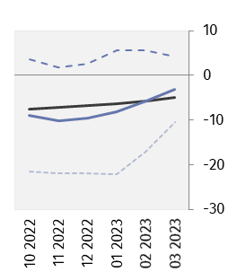
In the current month general business climate indicator (NSA) takes the value minus 3.1 – higher than in February (minus 5.7).

Retail trade (graph 4)
In March general business climate indicator (NSA) takes the value minus 5.5 and it is higher than the one reported in the previous month (minus 8.6).
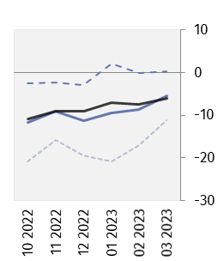
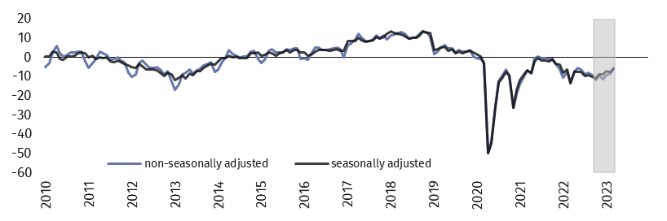


Transportation and storage (graph 5)
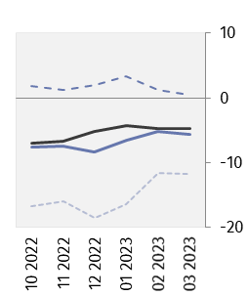
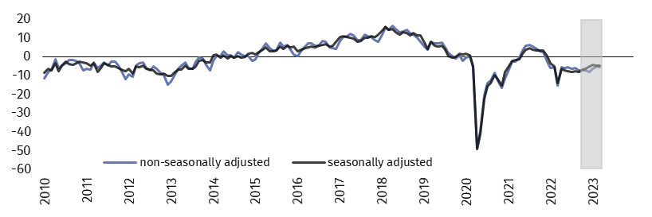
In the current month general business climate indicator (NSA) takes the value minus 5.6 – similar to the one reported in February (minus 5.2).

Accommodation and food service activities (graph 6)
In March general business climate indicator (NSA) takes the value minus 13.7, higher than the one recorded a month ago (minus 22.4).
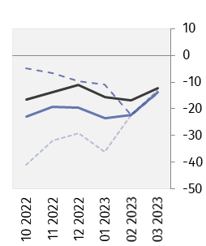
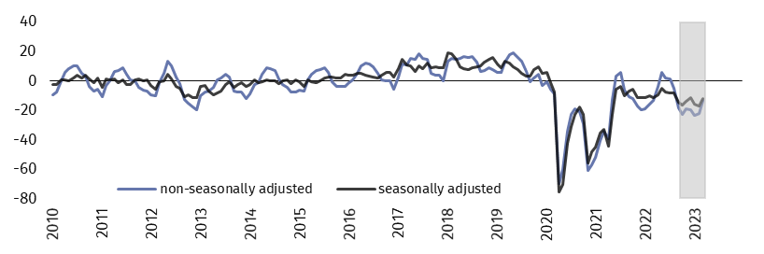


Information and communication (graph 7)
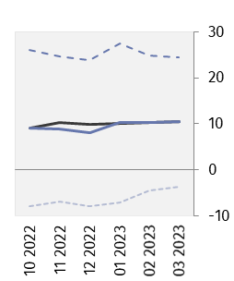
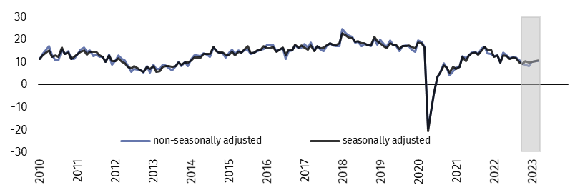
In the current month general business climate indicator (NSA) takes the positive value (plus 10.4) – similar to the one reported in February (plus 10.3).


Financial and insurance activities (graph 8)
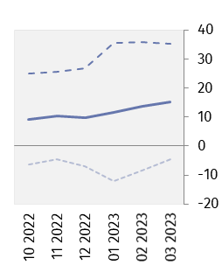
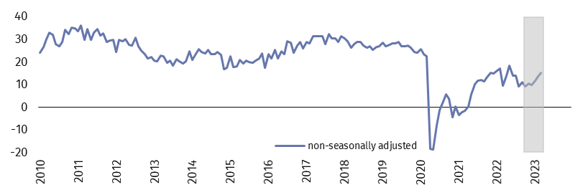
In March general business climate indicator (NSA) takes the value plus 15.3 and it is slightly higher than the one recorded a month ago (plus 13.7).

Table 1. General business climate indicators by kind of activity
SPECIFICATION |  | Analogous month of the previous year | Previous month | Current month | Long-term mean
Manufacturing | seasonally adjusted indicator (SA) | -17.0 | -14.3 | -13.8 | 1.7
 | non-seasonally adjusted indicator (NSA) | -16.2 | -14.0 | -12.9 | 1.7
 | “diagnostic” component (NSA) | -9.1 | -13.0 | -14.3 | -1.7
 | “forecast” component (NSA) | -23.2 | -15.0 | -11.4 | 5.0
Construction | seasonally adjusted indicator (SA) | -19.9 | -18.7 | -17.6 | -3.3
 | non-seasonally adjusted indicator (NSA) | -20.1 | -20.4 | -16.9 | -3.2
 | “diagnostic” component (NSA) | -13.7 | -15.6 | -16.2 | -6.3
 | “forecast” component (NSA) | -26.5 | -25.1 | -17.5 | -0.2
Wholesale trade | seasonally adjusted indicator (SA) | -4.2 | -5.7 | -4.9 | 3.2
 | non-seasonally adjusted indicator (NSA) | -5.2 | -5.7 | -3.1 | 3.2
 | “diagnostic” component (NSA) | 6.8 | 5.7 | 4.3 | 8.8
 | “forecast” component (NSA) | -17.2 | -17.1 | -10.4 | -2.4
Retail trade | seasonally adjusted indicator (SA) | -13.4 | -7.5 | -6.0 | -4.3
 | non-seasonally adjusted indicator (NSA) | -13.2 | -8.6 | -5.5 | -4.4
 | “diagnostic” component (NSA) | -3.4 | -0.1 | 0.2 | -3.6
 | “forecast” component (NSA) | -23.0 | -17.0 | -11.1 | -5.1
Transportation and storage | seasonally adjusted indicator (SA) | -14.2 | -4.7 | -4.7 | -0.6
 | non-seasonally adjusted indicator (NSA) | -15.2 | -5.2 | -5.6 | -0.6
 | “diagnostic” component (NSA) | -2.0 | 1.3 | 0.5 | 0.7
 | “forecast” component (NSA) | -28.3 | -11.6 | -11.7 | -2.0
  Accommodation and food service activities | seasonally adjusted indicator (SA) | -11.8 | -16.9 | -12.2 | -0.7
 | non-seasonally adjusted indicator (NSA) | -13.4 | -22.4 | -13.7 | -0.8
 | “diagnostic” component (NSA) | -14.4 | -22.5 | -14.2 | -2.5
 | “forecast” component (NSA) | -12.3 | -22.2 | -13.1 | 1.0
Information and communication | seasonally adjusted indicator (SA) | 9.8 | 10.3 | 10.6 | 18.3
 | non-seasonally adjusted indicator (NSA) | 9.6 | 10.3 | 10.4 | 18.3
 | “diagnostic” component (NSA) | 26.1 | 24.9 | 24.4 | 26.0
 | “forecast” component (NSA) | -6.9 | -4.4 | -3.7 | 10.5
Financial and insurance activities | seasonally adjusted indicator (SA) | . | . | . | .
 | non-seasonally adjusted indicator (NSA) | 9.4 | 13.7 | 15.3 | 25.9
 | “diagnostic” component (NSA) | 24.6 | 35.8 | 35.1 | 32.9
 | “forecast” component (NSA) | -5.9 | -8.4 | -4.5 | 18.9

In-depth questions about the current economic issues and the impact of war in Ukraine
Survey was conducted between 1st and 10th of the current month on a sample of entities operating in manufacturing, construction, trade as well as services. Questions were divided into two sections – questions regarding the impact of war in Ukraine and questions on labour market. Answers to this additional set are provided by respondents on a voluntary basis. The table below presents the percentage (weighted) of respondents' answers to a given question variant. Data were aggregated according to methodology of aggregation (weighing) which is used by default in regular survey.

Table 2. In-depth questions about the current economic issues
Questions |   Manufacturing |   Construction |   Wholesale trade |   Retail trade |   Transportation and storage |   Accommodation and food service activities
THE IMPACT OF WAR IN UKRAINE
1. Negative effects of the ongoing war in Ukraine and its impact on your business activity in the current month will be:
lack of negative effects | 15.2 | 22.7 | 22.3 | 28.1 | 22.2 | 28.7
minor | 62.9 | 54.5 | 60.5 | 54.9 | 52.6 | 48.1
serious | 19.0 | 15.1 | 12.6 | 12.6 | 17.8 | 13.3
a threat to company’s stability | 2.9 | 7.7 | 4.6 | 4.4 | 7.4 | 9.9
sum  (lack of negative effects + minor) | 78.1 | 77.2 | 82.8 | 83.0 | 74.8 | 76.8
sum  (serious + a threat to company’s stability) | 21.9 | 22.8 | 17.2 | 17.0 | 25.2 | 23.2
2. Out of negative effects of the ongoing war in Ukraine reported in the previous month, which of them relate to your company the most:
drop in sales – drop in revenues | 28.0 | 21.1 | 26.8 | 26.6 | 21.8 | 31.8
increase in costs | 67.8 | 77.8 | 61.7 | 67.5 | 72.6 | 77.0
disruption in supply chain | 38.1 | 30.1 | 30.6 | 24.4 | 22.8 | 13.4
large organizational disturbances in company’s functioning | 2.1 | 4.5 | 1.7 | 1.5 | 6.7 | 1.9
problems with current financing | 3.5 | 9.8 | 5.7 | 4.9 | 7.2 | 9.7
surplus stocks | 8.7 | 2.5 | 7.2 | 5.6 | 0.6 | 0.2
terminating contracts with eastern contractors | 15.2 | 2.2 | 9.7 | 5.6 | 10.4 | 0.2
3. If your company employs workers from Ukraine, did you report in the last month one of the following situations connected with the ongoing war:
outflow of workers from Ukraine | 32.5 | 20.4 | 12.3 | 18.1 | 31.4 | 33.2
minor | 31.6 | 17.8 | 11.8 | 17.9 | 27.8 | 32.2
serious | 0.9 | 2.6 | 0.5 | 0.2 | 3.6 | 1.0
inflow of workers from Ukraine | 32.3 | 18.9 | 12.2 | 17.9 | 29.3 | 37.4
minor | 30.9 | 17.9 | 11.8 | 17.5 | 27.1 | 33.9
serious | 1.4 | 1.0 | 0.4 | 0.4 | 2.2 | 3.5
does not concern | 64.9 | 78.7 | 86.5 | 80.6 | 66.4 | 61.3

Table 2. In-depth questions about the current economic issues (cont.)
Questions | Manufacturing | Construction | Wholesale trade | Retail trade | Transportation and storage | Accommodation and food service activities
LABOUR MARKET
4. Do you intend in the next three months:
in the case of workers relatively easy to replace – compared to the current situation:
increase the employment | 10.6 | 7.5 | 5.1 | 4.6 | 7.2 | 4.0
remain the employment unchanged | 77.7 | 78.9 | 85.9 | 83.8 | 83.0 | 81.6
decrease the employment | 11.7 | 13.6 | 9.0 | 11.6 | 9.8 | 14.4
in the case of workers relatively difficult to replace – compared to the current situation:
increase the employment | 8.2 | 8.0 | 3.2 | 1.6 | 9.4 | 2.4
remain the employment unchanged | 87.6 | 82.1 | 90.9 | 91.4 | 84.6 | 85.6
decrease the employment | 4.2 | 9.9 | 5.9 | 7.0 | 6.0 | 12.0
5. Which of the following factors and to what extend will have the biggest impact on salary level in your company in the next three months?
significantly
maintaining the real value of salaries  (inflationary increases) | 60.9 | 55.6 | 55.9 | 47.2 | 60.0 | 57.9
financial situation of the company | 61.4 | 66.5 | 59.8 | 62.3 | 64.4 | 61.6
maintaining the competitive salaries | 36.6 | 33.4 | 31.4 | 33.0 | 36.6 | 31.1
others | 18.3 | 20.1 | 19.4 | 21.7 | 19.1 | 17.8
insignificantly/no impact
maintaining the real value of salaries  (inflationary increases) | 32.9 | 36.0 | 33.5 | 41.6 | 34.1 | 33.3
financial situation of the company | 28.4 | 25.4 | 26.9 | 26.3 | 24.7 | 28.0
maintaining the competitive salaries | 48.3 | 46.7 | 44.7 | 41.9 | 48.2 | 46.5
others | 57.1 | 52.8 | 47.8 | 43.9 | 57.0 | 54.2
6. To what extend are your decisions concerning employment and salaries based on in the next three months:
significantly
based on current data | 69.5 | 63.2 | 57.8 | 57.6 | 64.6 | 57.9
based on expectations regarding changes  that may occur in the long term (a year | 44.3 | 44.8 | 41.7 | 40.8 | 47.2 | 41.2
insignificantly/no impact
based on current data | 30.1 | 36.0 | 41.1 | 41.1 | 35.1 | 42.0
based on expectations regarding changes  that may occur in the long term (a year | 54.1 | 52.6 | 54.9 | 55.9 | 49.8 | 55.2

In the case of quoting data from the Statistics Poland, please provide information: "Statistics Poland data source", and in the case of publishing calculations made on data published by the Statistics Poland, please provide information: "Own study based on Statistics Poland data".

Prepared by:  Macroeconomic Studies and Finance Statistics Department  Director Mirosław Błażej  Phone: (+48 22) 608 37 73 | Issued by:  The Spokesperson for the President  of Statistics Poland  Karolina Banaszek  Phone: (+48) 695 255 011
Press Office  Phone: (+48 22) 608 38 04  e-mail: obslugaprasowa@stat.gov.pl |   www.stat.gov.pl/en/

@StatPoland

@GlownyUrzadStatystyczny

gus_stat

glownyurzadstatystycznygus

glownyurzadstatystyczny
Related information
Business tendency in manufacturing, construction, trade and services

Data available in databases
Knowledge Database Business Tendency
Macroeconomic Data Bank

Terms used inn official statistics
Business tendency


This document was prepared with European Commission financial contribution. Ideas presented here are Statistics Poland notions, so they should not be seen in any cases as European Commission official opinions reflections.

Long-term mean (arithmetic mean for each general business climate indicator) covers time series since 2000, apart from services (since 2003) and wholesale trade (since 2011).
By the phrase „positive” (positive value of the indicator) we consider a situation when percentage of entrepreneurs expecting improvement of their entities’ economic situation in the next three months or observing such an improvement outweighs percentage of entrepreneurs expecting its deterioration.
NSA – non-seasonally adjusted indicator, SA – seasonally adjusted indicator.
Time series does not require to be seasonally adjusted. Non-seasonally adjusted data can be analyzed and interpreted in the same way as seasonally adjusted data.
Time series does not require to be seasonally adjusted. Non-seasonally adjusted data can be analyzed and interpreted in the same way as seasonally adjusted data.
It is permissible to choose one answer for each of variants at once (“outflow” and “inflow”), therefore the sum of variants can exceed 100%. The answer “does not concern” is ticked when company does not employ workers from Ukraine or has not observed their “outflow” or “inflow” in the last month.

