Financial results of insurance companies in 2022
The overall net financial result of insurance companies in 2022 was more favorable than a year ago and amounted to PLN 6.1 billion. This was due to a better result obtained by life insurance companies (division I) and despite the worse result of non-life insurance companies (division II).
104.5
Gross written premiums growth rate in 2022

Income and costs
Total gross written premium amounted to PLN 72.4 billion
Earned premium was the dominant item in the total income structure. In 2022, the total gross written premium amounted to PLN 72 359.0 million (increase by 4.5% compared to 2021), of which PLN 21 543.5 million was the premium of life insurance companies, and
PLN 50 815.5 million of non-life insurance. Claims incurred constituted the dominant position in the total cost structure. Total gross claims paid in 2022 amounted to PLN 44 385.7 million and increased by 7.5% compared to 2021; they increased to PLN 18 870.0 million in life insurance, and to PLN 25 515.7 million in non-life insurance.
Total gross claims paid amounted to PLN 44.4 billion

Chart 1. Life insurers financial results

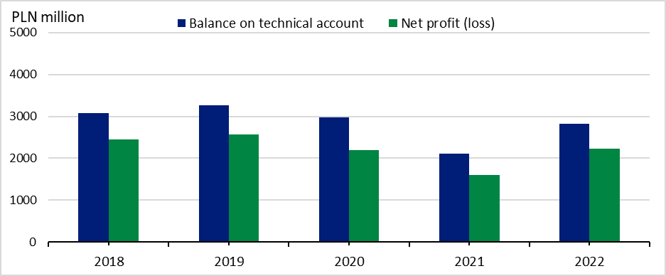

Chart 2. Non-life insurers financial results

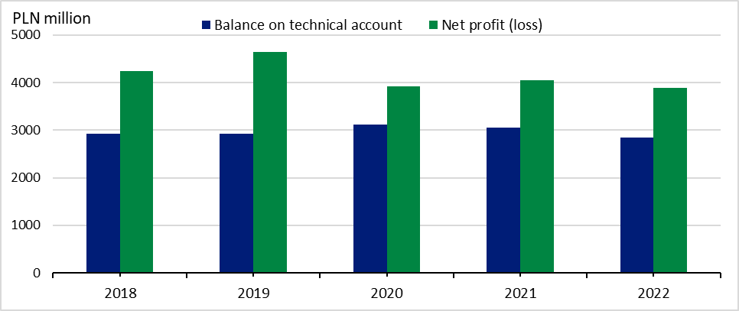

Profit (loss) and balance on technical account
Net financial result
amounted to PLN 2.2 billion in the life sector,
and PLN 3.9 billion
in non-life sector
The total net financial result of insurance companies amounted to PLN 6 125.9 million and was higher by 8.4% compared to 2021. Life insurance companies generated a result
of PLN 2 228.8 million, and non-life insurance profit amounted to PLN 3 897.1 million.
The technical result (in aggregated terms) was PLN 5 682.1 million and was 9.9% higher than in 2021. The technical result in life insurance increased to PLN 2 829.7 million, in non-life
insurance to PLN 2 852.4 million.
The technical profit of PLN 935.1 million was achieved compared to PLN 609.3 million of profit in 2021 on the casco insurance of land vehicles. In motor vehicle liability arising out
of the possession of land vehicles, the technical profit of PLN 250.5 million was achieved compared to PLN 656.2 million of profit in the previous year.

Table 1. Income, costs and balance on technical life and non-life insurance account
Specification | Life |  |  | Non-life
Specification | 2021 | 2022 | 2021=100 | 2021 | 2022 | 2021=100
Specification | million PLN |  | 2021=100 | million PLN |  | 2021=100
Total income | 29 341.6 | 28 330.2 | 96.6 | 40 677.9 | 44 482.1 | 109.4

of which:
Earned premiums | 21 650.1 | 21 159.5 | 97.7 | 35 645.5 | 38 756.6 | 108.7
Investment income | 7 373.5 | 7 027.9 | 95.3 | 4 117.3 | 4 672.4 | 113.5
Total costs | 27 742.7 | 26 101.3 | 94.1 | 36 626.9 | 40 585.0 | 110.8
of which:
Claims incurred  including change in provisions - net of reinsurance | 18 528.5 | 18 763.1 | 101.3 | 21 245.9 | 23 672.6 | 111.4
Change in other technical provisions - net of reinsurance | -1 458.7 | -8 618.0 | x | 17.5 | 12.2 | 69.7
Net operating  expenses | 5 437.5 | 5 777.7 | 106.3 | 10 911.8 | 12 024.6 | 110.2
Investment charges | 4 291.0 | 9 171.2 | 213.7 | 1 455.0 | 1 504.0 | 103.4
Net financial account | 1 598.9 | 2 228.8 | 139.4 | 4 051.0 | 3 897.1 | 96.2
***
Balance on technical account | 2 118.1 | 2 829.7 | 133.5 | 3 055.1 | 2 852.4 | 93.4

Gross written premiums and gross claims paid in direct activities
Gross written premiums
collected from
motor insurance amounted to PLN 26.1 billion

In total direct activities, the life gross written premiums accounted for 29.8%, and the
non-life gross written premiums – 70.2%. The "life insurance" class gained a dominant
position in division I in terms of the value of gross written premiums. The next item was taken by the class “accident and sickness insurance". The share of these two classes in life gross written premiums amounted to 44.7% and 34.9% respectively.
The gross written premiums from motor insurance were the largest item (51.3% of the value of premiums) in non-life insurance. These premiums increased by 5.8% compared to 2021 and amounted to PLN 26 051.4million. The share of casco insurance of land vehicles in the non-life gross written premiums amounted to 21.7%, and motor vehicle liability arising out of the possession of land vehicles 29.6%.

Table 2. Gross written premiums and gross claims paid in direct activities
Specification | Gross written premiums |  |  | Gross claims paid
Specification | 2021 | 2022 | 2021= =100 | 2021 | 2022 | 2021= =100
Specification | million PLN |  | 2021= =100 | million PLN |  | 2021= =100
LIFE
Total | 22 120.0 | 21 543.5 | 97.4 | 18 451.0 | 18 870.0 | 102.3

of which:
Life insurance | 9 060.2 | 9 728.4 | 107.3 | 7 487.6 | 6 756.1 | 90.2
Life insurance linked to capital insurance fund | 5 700.5 | 4 049.7 | 71.0 | 7 996.3 | 8 914.1 | 111.5
Accident and sickness insurance | 7 091.6 | 7 521.2 | 106.1 | 2 751.0 | 2 968.6 | 107.9
NON-LIFE
Total | 47 094.9 | 50 815.5 | 107.9 | 22 856.5 | 25 515.7 | 111.6
of which:
Accident and sickness insurance | 3 025.1 | 2 805.7 | 92.7 | 620.3 | 737.5 | 118.9
Casco insurance of land vehicles | 11 005.1 | 9 697.6 | 88.1 | 6 000.1 | 6 412.4 | 106.9
Insurance against fire  and natural forces | 4 414.6 | 5 104.3 | 115.6 | 2 020.5 | 2 364.1 | 117.0
Insurance against other damage and loss of property | 4 472.2 | 5 374.5 | 120.2 | 1 368.7 | 1 827.1 | 133.5
Motor vehicle liability  arising out of the possession  of land vehicles | 14 927.0 | 15 046.3 | 100.8 | 9 292.4 | 9 851.5 | 106.0
of which compulsory third-party liability insurance of owners of motor vehicle | 14 628.8 | 14 711.0 | 100.6 | 9 104.3 | 9 664.6 | 106.2
General third-party liability  insurance | 2 809.7 | 3 114.9 | 110.9 | 1 140.2 | 1 265.0 | 110.9

Assets and liabilities
The total assets decreased by 2.3% year-on-year
The total assets of insurance companies for the year ended 31 December 2022 amounted to PLN 196 890.1 million (decrease by 2.3% year-on-year), of which PLN 82 825.4 million was
allocated to life insurance companies, and PLN 114 064.7 million to non-life insurance
companies.

Table 3. Assets and liabilities of insurance companies (as of 31st December)
Specification | Life |  |  | Non-life
Specification | 2021 | 2022 | 2021=100 | 2021 | 2022 | 2021=100
Specification | million PLN |  | 2021=100 | million PLN |  | 2021=100
Total assets | 91 502.4 | 82 825.4 | 90.5 | 110 051.6 | 114 064.7 | 103.6

of which:
Investments | 39 655.4 | 39 896.1 | 100.6 | 87 084.6 | 88 878.3 | 102.1
Net assets for  life assuranceª | 46 876.2 | 37 392.5 | 79.8 | x | x | x
Total liabilities | 91 502.4 | 82 825.4 | 90.5 | 110 051.6 | 114 064.7 | 103.6

of which :
Capital and reserves | 10 319.1 | 10 242.2 | 99.3 | 29 571.4 | 28 455.4 | 96.2
Technical provisions | 77 693.5 | 69 118.1 | 89.0 | 79 348.1 | 86 204.0 | 108.6
a Where the investment risk is borne by the policyholders.

In case of quoting Statistics Poland data, please provide information: “Source of data: Statistics
Poland”, and in case of publishing calculations made on data published by Statistics Poland,
please include the following disclaimer: “Own study based on figures from Statistics Poland”.
This news release has been prepared on data received on 9/03/2023 from the Polish Financial Supervision Authority.

Prepared by:  Macroeconomics Studies  and Finance Department  Director Miroslaw Blazej  Phone: (+48 22) 608 37 73 | Issued by:  The Spokesperson for the President  of Statistics Poland  Karolina Banaszek  Phone: (+48) 695 255 011
Press Office  Phone: (+48 22) 608 38 04  e-mail: obslugaprasowa@stat.gov.pl |   www.stat.gov.pl/en/

@StatPoland

@GlownyUrzadStatystyczny

gus_stat

glownyurzadstatystycznygus

glownyurzadstatystyczny
Related information
Polish insurance market 2018
Annual bulletin. Insurance market 2020

Data available in databases
Financial Results of Insurance Companies
Quarterly bulletin. Insurance market

Terms used inn official statistics
Insurance undertaking
Gross written premium

