Employed, unemployed and economically inactive persons (preliminary results of the Polish Labour Force Survey)
In the third quarter of 2023, economically active persons accounted for 58.4% of the population aged 15-89 years. This indicator increased both compared to the second quarter of 2023 and the third quarter of 2022 (by 0.2 pp. and 0.6 pp., respectively).
58.4%
Activity rate of persons aged 15-89 years

Economic activity of the population aged 15-89 years by the LFS
Activity rate for the population aged 15-89 years compared to the previous quarter increased among women and there was no change among men. Over the year, it increased among both: men and women
In the third quarter of 2023, the number of economically active persons aged 15-89 years amounted to 17 348 thousand, of which: 16 873 thousand constituted employed persons, while 475 thousand – the unemployed. The population of economically inactive persons in the corresponding age group comprised 12 372 thousand persons.
In comparison to the second quarter of 2023 the population of economically active persons increased by 55 thousand, i.e. by 0.3%, however, a much larger increase – by 156 thousand, i.e. 0.9% – was recorded compared to the same period of the previous year.
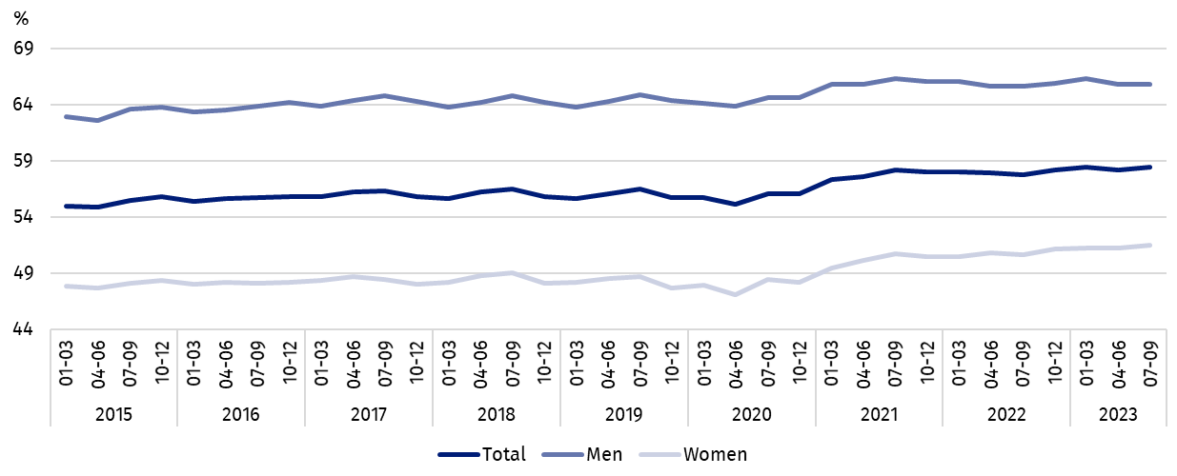
Chart 1. Activity rate of persons aged 15-89 years
The activity rate of persons aged 15-89 years in the third quarter of 2023 was higher among men and accounted for 65.8%, in the women population it stayed at the level of 51.5% (respective values for persons at working age were 83.7% and 78.0%). This indicator for persons aged 15-89 living in rural areas was higher than for urban residents – 58.9% compared to 58.0% (for persons of working age, the indicator was higher among urban residents than among rural residents and amounted to 82.6% and 78.9%, respectively).
The indicator describing the relation of jobless persons to the number of employed persons decreased compared to the previous quarter and over the year
Within the scope of population aged 15-89 years, the ratio of the number of not working persons (the unemployed or the economically inactive) to the number of employed persons decreased compared to the previous quarter and compared to the third quarter of 2022. In the third quarter of 2023, per 1 000 working people, there were 761 unemployed or economically inactive persons aged 15-89 (in the second quarter of 2023 there were 764 persons and in the third quarter of last year – 781 persons).
In the third quarter of 2023, employed persons accounted for 56.8% of the population aged
15-89 years. The employment rate increased slightly compared to the second quarter of 2023 (by 0.1 pp.), while compared to the third quarter of 2022, it incresed by 0.7 pp. The rate was higher in the male population (64.0%) than among women (50.1%).
56.8%
Employment rate
of persons aged 15-89 years

Employed persons aged 15-89 years by the LFS
The number of employed persons increased both over the quarter and over the year, whereby the growth of this population over the year was much higher
In the third quarter of 2023, population of employed persons aged 15-89 years amounted to 16 873 thousand persons and increased compared to the previous quarter by 23 thousand, i.e. by 0.1% , however, a much greater increase – by 183 thousand, i.e. 1.1% – occurred in relation to the third quarter of 2022.
Chart 2. Employed persons and employment rate of persons aged 15-89 years and in the
working age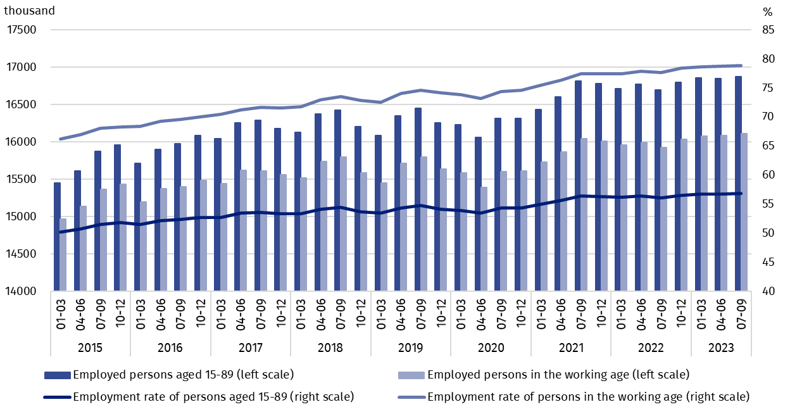
Taking into account the division by sex, the number of employed persons increased over the quarter only among women (an increase by 52 thousand, i.e. 0.7%), among men there was a decrease in this population (by 28 thousand, i.e. 0.3%). Considering the place of residence, the increase in the number of employed persons occurred only among rural residents (by 89 thousand persons, i.e. by 1.3%), while among urban residents there was a decrease (by 66 thousand, i.e. 0.7%).
Over the year, the increase of employed persons occurred in both sex groups, but among women it was decidedly higher (by 148 thousand., i.e. by 1.9%) than among men (by 35 thousand, i.e. by 0.4%). Taking into account the place of residence, the increase in this population was observed also among both rural and urban residents, but in the rural areas it was much greater (by 142 thousand, i.e. by 2.1% and by 41 thousand, i.e. by 0.4%, respectively).
In the population of employed persons, taking into account sex, men still predominated, who constituted 54.0% (i.e. 9 109 thousand) of this group, while regarding the place of residence, there were more employed persons living in urban areas (59.0%, i.e. 9 956 thousand persons), which is a direct consequence of the higher population in urban than rural areas (respectively 3/5 and 2/5 of the total population in Poland).
In the third quarter of 2023, total employment rate amounted to 56.8% and – in line with the observed trend – was higher among men (64.0%) than among women (50.1%) and regarding the place of residence a slightly higher level of the indicator was recorded in rural areas – 57.4% compared to 56.3% in urban areas.
Similarly to the population of employed persons, over the quarter the employment rate increased among women (by 0.3 pp.) and decreased among men (by 0.2 pp.) Taking into account the place of residence, the increase occurred among rural residents by 0.7 pp. – which is related to the intensification of work in agriculture in this period, while among urban residents there was a decrease of 0.4 pp.
Over the year, a growth in employment rate was observed in all independently analysed groups (among men by 0.3 pp., among women by 0.9 pp., in urban areas by 0.3 pp., in rural areas by 1.1 pp.).
The LFS results indicate that in the third quarter of 2023:
The number of persons employed full-time increased compared to the second quarter of 2023 and compared to the third quarter of 2022
- 15 805 thousand (i.e. 93.7%) persons performed full-time work, while 1 068 thousand (i.e. 6.3%) were employed part-time,
- the average number of hours worked in the reference week in the main job amounted to 40.0 hours,
- the share of employees employed in public companies/institutions or by a private employer in the total number of employed persons accounted for 79.8% (13 458 thousand persons), self-employed persons constituted 19.3%, while the share of contributing family workers accounted for 0.9%,
- a decided majority of employees employed in public companies/institutions or by a private employer performed their work on the basis on the contract for unlimited duration (84.9%, i.e. 11 431 thousand),
- the sections where the most people worked were: manufacturing – 18.3% of all employed persons (3 089 thousand); wholesale and retail trade – 13.4% (2 268 thousand) and 8.2% each: education (1 390 thousand) and agriculture, forestry, hunting and fishing (1 381 thousand persons).
Chart 3. Structure of employed persons aged 15-89 years by employment status in the main job in the third quarter of 2023 (in %)
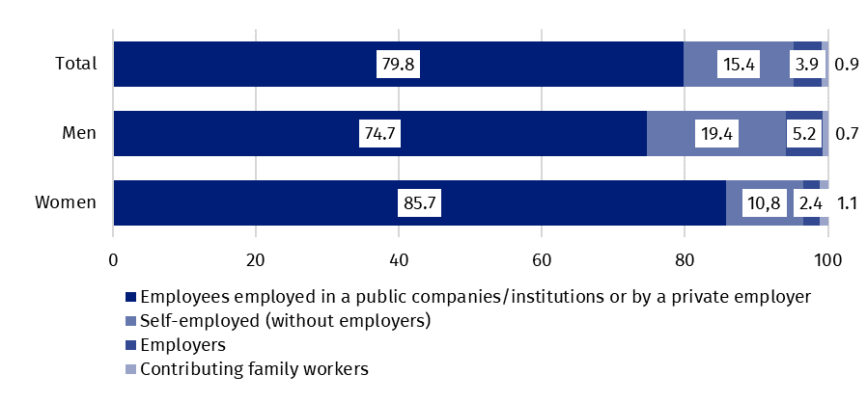
In the third quarter of 2023, the highest growth in the number of employed persons compared to the previous quarter was recorded in education (by 40 thousand) and in professional, scientific and technical activities section (by 36 thousand). The highest decline concerned the number of employed persons in construction (by 31 thousand) and in transportation and storage (by 24 thousand).
Compared to the third quarter of 2022, the highest growth in the number of employed persons occurred in information and communication (by 114 thousand) and in education (by 99 thousand), while the highest decline – in manufacturing (by 84 thousand) and in wholesale and retail trade (by 63 thousand).
In the third quarter of 2023, 1 442 thousand persons had a job, but were not performing the work in the reference week, which accounted for 8.5% of the total number of the employed (the corresponding population in the previous quarter comprised 823 thousand, i.e. 4.9%, while a year ago it was 1 430 thousand, i.e. 8.6%). The most common reasons for not performing work were own illness and paid, unpaid or occasional leave – they accounted for 79.5% of all causes of absence.
The number of persons performing their work usually or sometimes at home amounted to 2 386 thousand, which accounted for 14.1% of the total number of the employed. In a form of remote work (the place of performing work is not considered here), their work related responsibilities were performed usually or sometimes by 1 322 thousand persons, i.e. 7.8% of the total number of the employed.
7.8% of the total number of employed persons worked in a form of remote work

In the third quarter of 2023, unemployed persons accounted for 2.7% of the economically active population aged 15-89 years. Unemployment intensity (measured by the unemployment rate) increased compared to the previous quarter by 0.1 pp. and decreased by 0.2 pp. over the year. Unemployment rate was at the same level among men and women and amounted to 2.7%.
2.7%
Unemployment rate of persons aged 15-89 years

Unemployed persons aged 15-74 years by the LFS
The number of unemployed people increased compared to the previous quarter but decreased compared to the same period of the previous year
In the third quarter of 2023, population of unemployed persons aged 15-74 years comprised 475 thousand and increased in relation to the second quarter of this year by 32 thousand, i.e. by 7.2%, while in relation to the same period of the previous year it decreased by 27 thousand, i.e. by 5.4%.
In the third quarter of 2023, over a half of unemployed population constituted men – 53.9%, i.e. 256 thousand, while taking into account the place of residence – unemployed urban residents (63.4% of the total number of the unemployed, i.e. 301 thousand), which is also related to the higher population in urban than rural areas. It is worth noting, however, that the percentage of unemployed in the total population aged 15-89 years by sex and place of residence reaches similar values ranging from 1.4% to 1.8%.
Compared to the previous quarter, an increase in the number of unemployed persons was recorded among men (by 25 thousand, i.e. 10.8%), among women the number of unemployed remained at a similar level. Analysing this group according to the place of residence, an increase in the number of unemployed occurred among urban residents (by 45 thousand, i.e. 17.6%), while among rural residents was recorded a decrease (by 13 thousand, i.e. 7.0%).
A decrease in the number of unemployed persons over the year was mainly due to the decrease in this population among men (by 20 thousand, i.e. by 7.2%). Among unemployed persons separated by place of residence, a decrease was recorded among rural residents (by 52 thousand, i.e. 23.0%), and an increase among urban residents (by 25 thousand, i.e. 9.1%).
Compared to the previous quarter, the unemployment rate slightly increased (by 0.1 pp.), with an increase only in the male population (by 0.2 pp.) and among women this indicator has not changed. In the case of all rural residents, a decrease in this indicator amounted to 0.2 pp., while in urban areas there was an increase – by 0.4 pp.
Chart 4. Unemployed persons aged 15-74 years and unemployment rate of persons aged
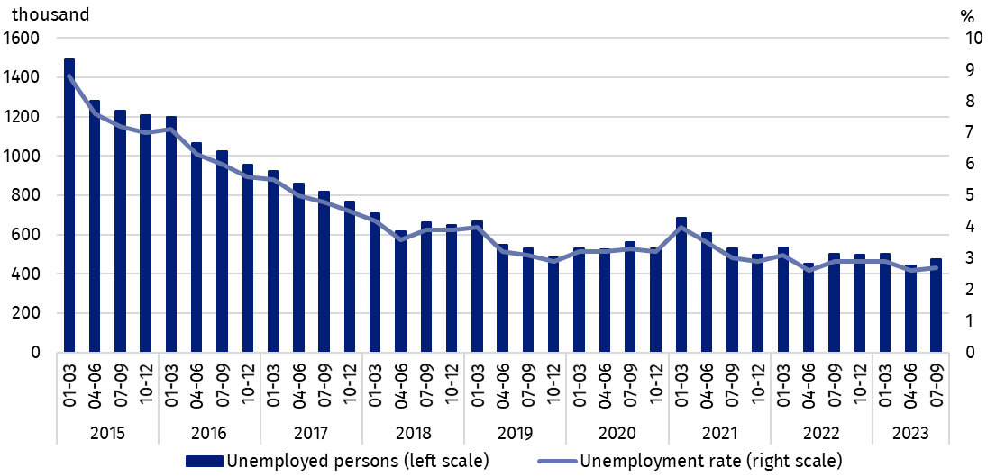
15-89 years
Over the year, the unemployment rate decreased among both men (by 0.3 pp.) and women (by 0.2 pp.). Taking into account the place of residence, a decline of this indicator was recorded among rural residents – by 0.7 pp., while among urban residents there was an increase – by 0.2 pp.
Changes in the level of unemployment rate are also noticeable when taking into account the division of population by analysed age groups. The increase in the unemployment rate compared to the previous quarter was recorded among persons aged 15-24 years (by 0.1 pp. to the level of 11.1%) and aged 25-34 years and 45-89 years (by 0.3 pp. in each group to the level of 2.8% and 2.0%, respectively). For people aged 35-44 years the unemployment rate remained at the same level. Over the year the intensity of unemployment increased only among persons aged 35-44 years (by 0.2 pp. to 2.0%), while in the remaining analysed age groups there were decreases in the rate (the highest decrease by 0.9 pp. among persons aged 15-24 years).
As in previous periods, the highest unemployment rate was for the youngest i.e. aged 15-24, while it increased in comparison to the previous quarter but decreased over the year
When analysing the intensity of unemployment by level of education of the unemployed, it should be noted that its value decreases with the increase in education attained. The highest unemployment rate is observed among people with the lowest level of education, i.e. with lower secondary education or less. In the third quarter the intensity of unemployment amounted to 5.8% and decreased (to the greatest extent compared to other groups of unemployed persons separated by their level of education) both in relation to the previous quarter (by 1.0 pp.) and over the year (by 2.0 pp.) Among persons with basic vocational or basic sectoral vocational education the unemployment rate in the third quarter of 2023 amounted to 4.4% and in this group the highest increase in unemployment rate was recorded in comparison to the second quarter of 2023 and the third quarter of 2022 (over the quarter by 0.7 pp., over the year by 0.9 pp.). For persons with general secondary education, the unemployment rate was 4.1% and over the quarter the value of this indicator did not change, but decreased over the year (by 0.6 pp.). Persons with post-secondary or technical secondary or secondary sectoral vocational education already had a significantly lower unemployment rate – in the third quarter of 2023, its value amounted to 2.7% and increased compared to the previous quarter (by 0.1 pp.) but decreased over the year (by 0.4 pp.). Among people with tertiary education the unemployment rate in the third quarter of 2023 was the lowest and amounted to 1.3% (over the quarter was noticed an increase by 0.2 pp. and over the year a decrease by 0.1 pp.).
To the greatest extent, unemployment affected persons with the lowest level of education

The analysis of the sources of inflow to unemployment indicates that the largest population of the unemployed constituted persons who lost a job during the last 3 months (39.5%, i.e. 188 thousand). The share of persons re-entering work after a break (longer than 3 months) accounted for 26.3% (125 thousand), the share of persons taking up their first job – 19.7% (94 thousand) and persons who resigned from work – 14.5% (69 thousand).
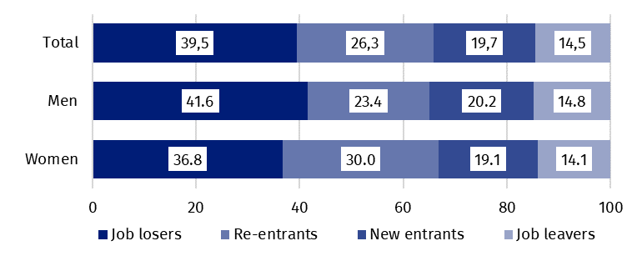
Chart 5. Structure of unemployed persons by the source of unemployment in the third quarter of 2023 (in %)
In the third quarter of 2023, unemployed persons had been looking for a job 7.6 months on average (in the previous quarter 7.5 months, in the third quarter of 2022 – 8.7 months). Persons who were seeking a job for the longest duration were the ones aged 55-74 years (10.7 months) and aged 30-34 years (8.6 months), while the shortest job search duration was observed for the youngest persons, in the age group 15-19 years (3.9 months).
The average duration of job search by unemployed persons was 7.6 months

In the third quarter of 2023, economically inactive persons accounted for 41.6% of the total number of population aged 15-89 years. The percentage was at a lower level compared to the previous quarter (a decrease by 0.2 pp.) and in relation to the third quarter of 2022 (a decrease by 0.6 pp.).
41.6%
The share of economically
inactive persons in the total number of the population aged 15–89 years

Economically inactive persons aged 15-89 by the LFS
In the third quarter of 2023, population of economically inactive persons aged 15-89 years amounted to 12 372 thousand and decreased in relation to the second quarter of 2023 (a decrease by 55 thousand, i.e. 0.4%) and compared to the third quarter of last year (a decrease by 160 thousand, i.e. by 1.3%).
Over a half of the population of economically inactive persons constituted women – in the analysed age group their share was 60.7% (7 504 thousand). Taking into account division into urban and rural areas, a majority of economically inactive persons constituted urban residents (59.9%; 7 414 thousand), which is connected with a higher population in urban than in rural areas. Economically inactive women accounted for 48.5% of all women aged 15-89 years, while analogous indicator for men was 34.2%. On the other hand, the share of economically inactive among all urban residents in the analysed age group was at the level 42.0% and among rural residents amounted to 41.1%.
Women still constitute a majority of economically inactive population
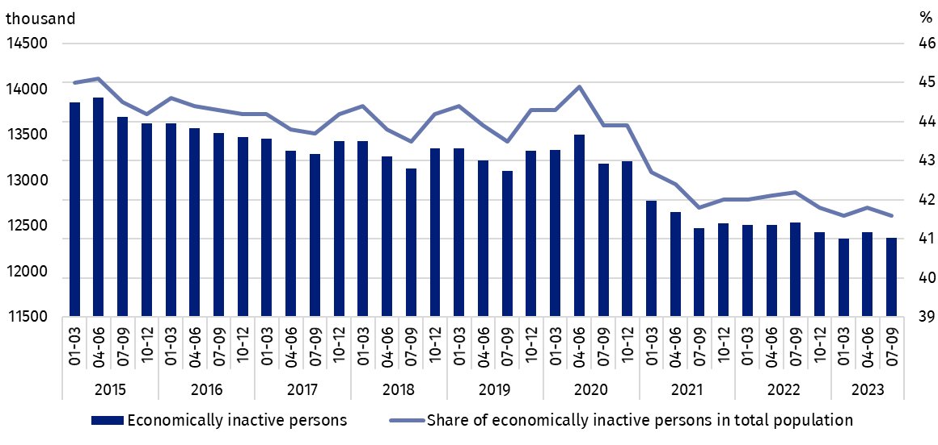
Chart 6. Economically inactive persons and the share of economically inactive persons in population aged 15-89 years
Compared to the previous quarter, the number of economically inactive women decreased (by 59 thousand, i.e. 0.8%), while no significant change was observed among men. There was a decrease in the number of economically inactive among all rural residents (by 76 thousand, i.e. 1.5 %), and an increase among urban residents (by 21 thousand, i.e. by 0.3%).
Over the year number of economically inactive persons decreased taking into account both sex and the place of residence.
The economically inactive population is a specific one in respect to the labour market resources. Its scope includes persons who have not entered the labour market yet (including the majority of the youth still participating in education) and persons who have definitely left the labour market or will never enter the labour market (some retirees, pensioners, persons maintaining themselves from other sources than work), but also persons who entered the labour market, then partially deactivated and who will want to re-enter the labour market after a break.
In the third quarter of 2023, over a half of the economically inactive persons aged
15-74 years comprising 10 008 thousand (the reason for inactivity was determined for this age group) constituted retirees (51.2%), while the second largest group were students (21.5%). It is worth noting that education and training as well as illness and disability were more often the reasons for inactivity among men (respectively 26.2% and 17.9%) than among women (respectively 18.5% and 6.9%). On the other hand, family responsibilities were much more often the reason for inactivity among women (12.7%) than men (1.8%).
Participating in education and improving qualification were the most often reason for economic inactivity of persons at working age
In the case of 3 877 thousand economically inactive persons at working age (women aged
18-59 and men aged 18-64 years), the most often reasons for inactivity were: education and training – 29.0%, illness and disability – 25.5% and family responsibilities – 20.5%. Retirement as the reason for inactivity on the labour market indicated 8.0% persons at working age, while persons discouraged with unsuccessful job search constituted 1.1% of this group.
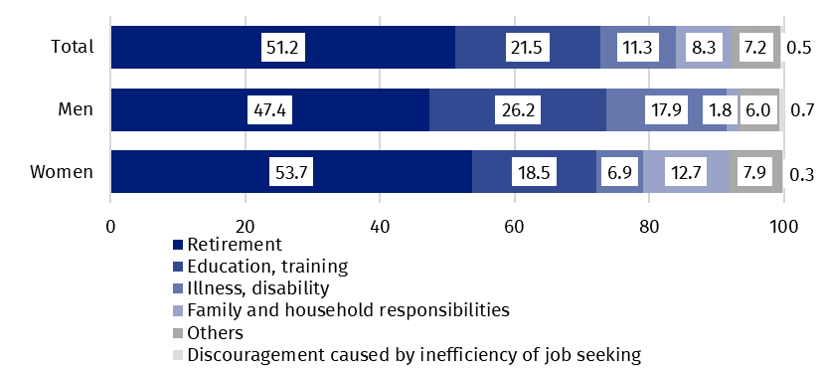
Chart 7. Structure of economically inactive persons aged 15-74 years by sex and reasons for inactivity in the third quarter of 2023 (in %)

Methodological notes

The presented news release was prepared on the basis of the generalised results of the sample survey Badanie Aktywności Ekonomicznej Ludności/BAEL in the third quarter of 2023.
Badanie Aktywności Ekonomicznej Ludności (Eng. Labour Force Survey) has been carried out in Poland quarterly since May 1992 and it has been improved in accordance with the International Labour Organization and Eurostat recommendations.
From the first quarter of 2021 onwards, the base of the EU-LFS methodology are definitions of the employed, the unemployed and economically inactive persons in accordance with the Resolution concerning statistics of work, employment and labour underutilization adopted in 2013 on the 19th International Conference of Labour Statisticians in Geneva (ICLS) and re-commended by the International Labour Organization (ILO) for the use in all countries. The survey object is the situation within the scope of economic activity of the population, i.e. the fact of performing work, being unemployed or economically inactive persons in the reference week. In the European Union, the implementation of the provisions of the above mentioned Resolution was carried out through introduction of new legal acts. From 2021 onwards, EU-LFS has been one of the key surveys embraced by the framework regulation for social statistics (the so-called IESS FR). Accompanying IESS FR implementing regulations in the domain of the labour force specify the range of the core survey and module surveys, determine survey organisation and define in detail particular populations specified according to the status of persons in the labour market.
Due to the implementation of the methodological changes, from the first quarter of 2021, the BAEL data cannot be compared with the previous periods (with the exception of the recalculated data). For the purposes of carrying out comparative analyses for longer time series, Statistics Poland prepared historical data from the BAEL for the years 2010–2020 compiled in accordance with definitions of the main population categories specified according to their labour market status, i.e. the employed, the unemployed and economically inactive persons, obligatory from 2021 onwards. The data are available on the Statistics Poland website: recalculated LFS data for the years 2010-2020
Detailed results of the survey as well as the up-dated methodology – obligatory from the first quarter of 2021, are included in the quarterly publication “Labour Force Survey in Poland” and in the Methodological report available on the Statistics Poland website:
https://stat.gov.pl/en/topics/labour-market/working-unemployed-economically-inactive-by-lfs/labour-force-survey-in-poland-quarter-22023,2,50.html
https://stat.gov.pl/en/topics/labour-market/yearbook-of-labour/methodological-report-labour-force-survey,8,2.html
Prepared by:  Social Surveys and Labour Market Department  Director Piotr Łysoń, Ph.D.  Phone: (+48 22) 449 40 27 | Issued by:  The Spokesperson for the President  of Statistics Poland  Karolina Banaszek  Phone: (+48) 695 255 011
Press Office  Phone: (+48 22) 608 38 04  e-mail: obslugaprasowa@stat.gov.pl |   www.stat.gov.pl/en/

@StatPoland

@GlownyUrzadStatystyczny

gus_stat

glownyurzadstatystycznygus

glownyurzadstatystyczny
Related information
Methodological report. Labour Force Survey
Labour Force Survey in Poland
Other publications containing the results of LFS and its module surveys
stat.gov.pl → Topics → Labour Market
Data available in databases
Strateg → Topics → Labour Market
Local Data Bank → labour Market
Terms used in official statistics
Economic activity by LFS
Economically active population by LFS
Employed persons by LFS
Unemployed persons by LFS
Economically inactive population according to the LFS

Activity rate by LFS
Employment rate by LFS
Unemployment rate by LFS

The LFS results refer to the population staying or intending to stay in the country’s territory for at least 12 months, living in private households. The data gathered in the sample survey were generalised on the basis of the balances for which the base (initial base) are the results of the Population and Housing Census 2011 – NSP 2011 (in the later period the results will be recalculated with use of the balances based on the Population and Housing Census 2021 – NSP 2021).
The data from the first quarter of 2015 to the fourth quarter of 2020 were recalculated in accordance with the definitions obligatory in the LFS from 2021 onwards. See methodological notes at the end of the news release.
Men aged 18-64 years and women aged 18-59 years.
The data from the first quarter of 2015 to the fourth quarter of 2020 were recalculated in accordance with the definitions obligatory in the LFS from 2021 onwards. See methodological notes at the end of the news release.
The data from the first quarter of 2015 to the fourth quarter of 2020 were recalculated in accordance with the definitions obligatory in the LFS from 2021 onwards. See methodological notes at the end of the news release.
The average job search time is the period from which unemployed persons look for a job, because in most cases they have not found a job yet.
The data from the first quarter of 2015 to the fourth quarter of 2020 were recalculated in accordance with the definitions obligatory in the LFS from 2021 onwards. See methodological notes at the end of the news release.

