Employed, unemployed and economically inactive persons (preliminary results of the Polish Labour Force Survey)
In the first quarter of 2023, economically active persons accounted for 58.4% of the population aged 15-89 years. The rate increased as compared to both the fourth quarter of 2022 – by 0.2 pp., and the first quarter of the last year – by 0.4 pp.
58.4%
Activity rate of persons aged 15-89 years

Economic activity of the population aged 15-89 years by the LFS
Activity rate for the population aged 15-89-years compared to the previous quarter and over the year increased among both men and women
In the first quarter of 2023, the number of economically active persons aged 15-89 years amounted to 17357 thousand, of which: 16852 thousand constituted employed persons, while 505 thousand – the unemployed. The population of economically inactive persons in the corresponding age group comprised 12363 thousand persons.
Population of economically active persons increased both compared to the fourth quarter of 2022 by 63 thousand, i.e. by 0.4%, and the first quarter of last year, by 107 thousand, i.e. by 0.6%.
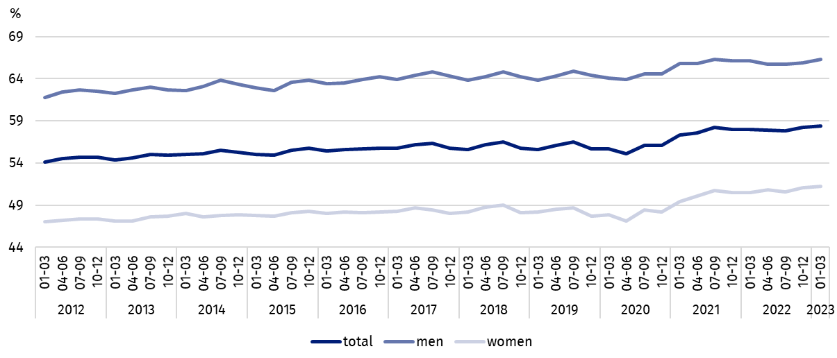
Chart 1. Activity rate of persons aged 15-89 years
In the first quarter of 2023, the share of economically active persons in the total number of persons aged 15-89 years was higher among men and accounted for 66.3%, in the female population it stayed at the level of 51.2% (respective values for persons at working age were 84.2% and 77.5%). The activity rate of persons aged 15-89 years for urban and rural residents assumed the same value 58.4% (at working age: 83.1% and 78.3%).
The index describing the relation of jobless persons to the number of employed persons decreased compared to both the previous quarter, as well as over the year

Within the scope of population aged 15-89 years, the ratio of the number of not working persons (the unemployed and the economically inactive) to the number of employed persons decreased compared to both the previous period and the first quarter of 2022. In the first quarter of 2023, there were 764 jobless persons aged 15-89 years per 1000 employed persons (in the fourth quarter of 2022 it was 770 persons and in the first quarter of last year there were 781 persons).
In the first quarter of 2023, employed persons accounted for 56.7% of the population aged
15-89 years. Compared with both the fourth quarter of 2022, as well as the same period of the last year, employment rate increased respectively by 0.2 pp. and 0.5 pp. The rate was higher in the male population (64.3%) than among women (49.7%).
56.7%
Employment rate
of persons aged 15-89 years

Employed persons aged 15-89 years by the LFS
The number of employed persons increased compared with both the previous quarter, as well as over the year
In the first quarter of 2023, population of employed persons aged 15-89 years amounted to 16852 thousand persons and it increased both compared to the previous quarter by 56 thousand, i.e. by 0.3%, and the first quarter of 2022 – by 138 thousand, i.e. by 0.8%.
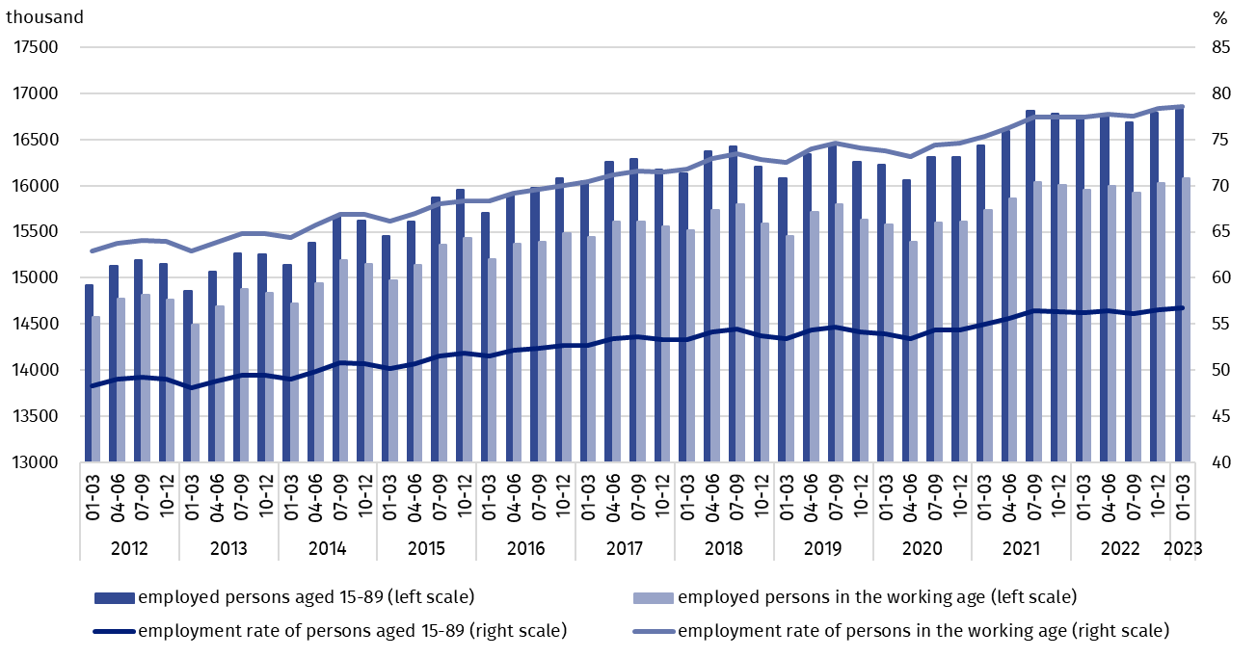
Chart 2. Employed persons and employment rate of persons aged 15-89 years and in the working age
Compared to the fourth quarter of 2022, the number of employed men increased (by 52 thousand, i.e. 0.6%), and the number of women remained at a similar level, while regarding the place of residence – the number of employed urban residents increased by 47 thousand, i.e. by 0.5%, while employed rural residents did not change significantly.
Over the year, a growth in the number of employed persons was observed among women – by 116 thousand, i.e. by 1.5%, as well as men – by 22 thousand, i.e. by 0.2%. As regards the place of residence, the number of employed rural residents increased to a greater extent by 90 thousand, i.e. by 1.3%, among employed urban residents there was an increase by 48 thousand, i.e. by 0.5%.
Among the employed, taking into account the sex breakdown, men still predominated accounting for 54.3% (i.e. 9149 thousand) of this population, while regarding the place of residence, there were more urban residents (59.5%, i.e. 10028 thousand persons), which is a direct consequence of the higher number of urban than rural population.
In the first quarter of 2023, total employment rate accounted for 56.7% and was higher among men (64.3%) than among women (49.7%). Taking into account the place of residence a similar level of the rate was recorded in both urban areas (56.7%) and in the rural areas (56.6%).
Over the quarter, the employment rate increased among men (by 0.4 pp.) and remained at the same level among women. There was an increase in the rate among urban residents (by 0.2 pp.), while no change was recorded for rural residents.
Over the year, a growth in employment rate was observed in all independently analysed groups (among men by 0.3 pp., in the population of women by 0.8 pp., in urban areas by 0.4 pp., in rural areas by 0.7 pp.).
The LFS results indicate that in the first quarter of 2023:
The number of persons employed full-time decreased compared with the previous quarter, while it increased compared with the first quarter of 2022

- 15691 thousand persons performed full-time work, while 1161 thousand were employed part-time,
- the average number of hours worked in the reference week in the main job amounted to 39.4 hours,
- the share of employees employed in public companies/institutions or by a private employer in the total number of employed persons accounted for 80.2% (13515 thousand persons), self-employed persons constituted 18.8%, while the share of contributing family workers accounted for 1.0%,
- a decided majority of employees employed in public companies/institutions or by a private employer performed their work on the basis on the contract for unlimited duration (84.3%, i.e. 11393 thousand),
- the largest number of persons were employed in manufacturing – 19.4% of all employed persons (3267 thousand); 13.6% (2286 thousand) in wholesale and retail trade. The next place belonged to persons employed in education – 8.0% of all employed persons (1342 thousand persons), while 7.7% (1291 thousand persons) were employed in section agriculture, forestry, hunting and fishing.
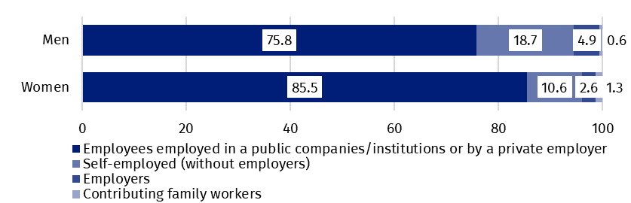
Chart 3. Structure of employed men and women aged 15-89 years by employment status in the main job in the first quarter of 2023 (in %)
In the first quarter of 2023, the highest growth in the number of employed persons compared to the previous quarter was recorded in transportation and storage (by 46 thousand) and construction (by 40 thousand). The highest decline concerned however the number of persons employed in private farms in agriculture (by 47 thousand) and in manufacturing (by 39 thousand).
Compared to the first quarter of 2022, the highest growth in the number of employed persons was observed in public administration and national defence (by 122 thousand) and in information and communication (by 100 thousand), while the highest decline – in private farms in agriculture (by 91 thousand) and construction (by 86 thousand).
In the first quarter of 2023, 774 thousand persons had a job, but were not performing work in the reference week, which accounted for 4.6% of the total number of the employed (the corresponding population in the previous quarter comprised 818 thousand, i.e. 4.9%, while a year ago it was 822 thousand, i.e. 4.9%).
7.1% of the total number of employed persons worked in a form of remote work

The number of persons performing their work usually or sometimes at home amounted to 2344 thousand, which accounted for 13.9% of the total number of the employed. In a form of remote work (the place of performing work is not considered here), 1201 thousand persons, i.e. 7.1% of the total number of the employed, performed their work related responsibilities usually or sometimes.
In the first quarter of 2023, unemployed persons accounted for 2.9% of the economically active population aged 15-89 years. The unemployment rate stayed at the same level as in the previous quarter, but decreased compared to the same period last year. Unemployment intensity was lower in population of women than among men (respectively 2.8% vs. 3.0%).
2.9%
Unemployment rate of persons aged 15-89 years

Unemployed persons by the LFS
The number of unemployed persons stayed at the level recorded in the previous quarter, while it decreased compared to the corresponding period of the previous year
In the first quarter of 2023, population of unemployed persons aged 15-74 years comprised 505 thousand and remained at a similar level compared to the fourth quarter of 2022, while it decreased compared to the first quarter of 2022, by 31 thousand, i.e. by 5.8%.
In the first quarter of 2023, over a half of unemployed population constituted men – 56.4%, i.e. 285 thousand, while taking into account the place of residence – unemployed urban residents prevailed (56.8% of the total number of the unemployed, i.e. 287 thousand).
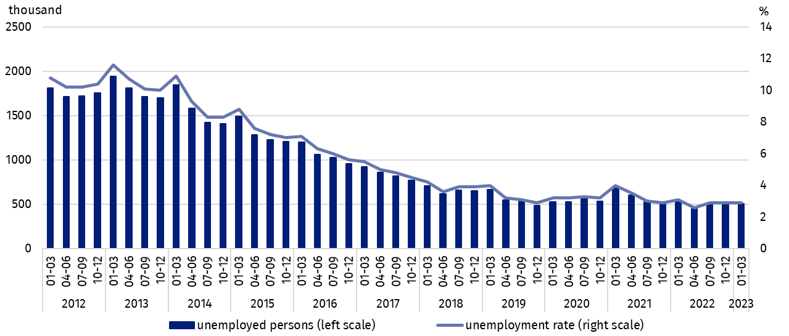
Chart 4. Unemployed persons aged 15-74 years and unemployment rate in population of persons aged 15-89 years
Over the quarter, the population of unemployed men and women remained at a similar level. Minor changes (taking into account the representative character of the survey and the random error of the sample) occurred among the unemployed by place of residence – among rural residents there was a decrease in the number of unemployed – by 15 thousand, i.e. by 6.4%, and an increase of 21 thousand, i.e. by 7.9%, in the number of unemployed persons among urban residents.
Compared to the first quarter of 2022, a decrease in the number of unemployed people was recorded regardless of sex, whereas it was greater among women (by 18 thousand, i.e. 7.6%) than men (12 thousand, or 4.0%). Taking into account the place of residence, a greater decrease occurred among urban residents (by 22 thousand, i.e. 7.1%) than among rural residents (by 8 thousand, i.e. by 3.5%).
In the first quarter of 2023, unemployment rate accounted for 2.9%. The unemployment rate was lower in the female population than in men (respectively 2.8% and 3.0%).
Compared to the previous quarter, the unemployment intensity in the entire population of persons aged 15-89 years stayed at the same level. There was also no change taking into account the sex breakdown. However, taking into account the place of residence, the intensity of unemployment had different directions – among rural residents there was a decrease (by 0.2 pp.), and in urban areas an increase (by 0.2 pp.).
Over the year, the unemployment rate decreased by 0.2 pp. for the entire population. The same decrease was observed among both men and women. According to the place of residence, there was a greater decrease among urban residents (by 0.2 pp.) than among rural residents (by 0.1 pp.).
Slightly larger changes in the level of unemployment rate are noticeable taking into account the division of population by analysed age groups. Persons aged 15-24 were the only group for which the unemployment rate decreased by 1.3 pp. to 10.8% in the quarter and increased of 0.6 pp. over the year. In the 25-34-year-old group, the unemployment rate amounted to 3.2% in the first quarter of 2023 and remained unchanged compared to the previous quarter, but to the greatest extent decreased compared to the first quarter of 2022 (by 0.4 pp.). The unemployment rate among persons aged 35-44 and 45-89 years increased over the quarter respectively by 0.2 pp. (up to 2.3%) and 0.1 pp. (to 2.0%) and decreased over the year by 0.3 pp. and 0.2 pp. respectively.
As in previous periods, the highest unemployment rate was for the youngest but decreased compared to the previous quarter, but increased over the year
When analysing the value of unemployment rate by level of education of economically active persons, it should be noted that its highest value concerned persons with the lowest level of education, i.e. with lower secondary and below this level of education. In the first quarter of 2023, it accounted for 6.9% and decreased (to the greatest extent) both in relation to the previous quarter (by 1.3 pp.) and over the year (by 2.4 pp.). The decline in the unemployment rate in the quarter and the year was also observed in people with post-secondary and technical secondary or secondary sectoral vocational education, respectively by 0.4 pp. and 0.3 pp. to 2.8%. On the other hand, an increase in the unemployment rate compared to the fourth quarter and the first quarter of 2022 was recorded in people with basic vocational or basic sectoral vocational education (over the quarter by 0.4 pp., over the year by 0.3 pp.) to 4.2%. For people with general secondary education, the unemployment rate also amounted to 4.2% and increased over the quarter (by 0.4 pp.), while it decreased over the year (by 0.2 pp.). The increase in the unemployment rate over the quarter was also observed among people with tertiary education (by 0.2 pp. to 1.5%), but over the year the value of this indicator did not change.
The largest population of the unemployed constituted persons who lost their job
To the greatest extent, unemployment affected persons with the lowest level of education

The analysis of the sources of inflow to unemployment indicates that the largest population of the unemployed constituted persons who lost a job during the last 3 months (44.3%, i.e. 224 thousand). The share of persons re-entering work after a break (longer than 3 months) accounted for 27.1% (137 thousand), the share of persons taking up their first job and those who resigned from work – was 14.3% (72 thousand) for each group.
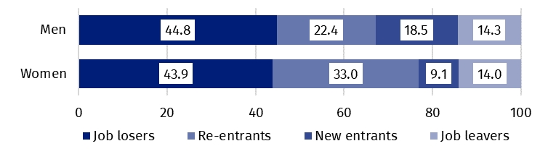
Chart 5. Structure of unemployed men and women by the source of unemployment in the first quarter of 2023 (in %)
In the analysed period, the average duration of a job search by unemployed persons comprised 8.1 months (in the previous quarter 8.3 months, in the first quarter of 2022 – 8.2 months). Persons who were seeking a job for the longest duration were the oldest ones, i.e. aged 55-74 years (11.3 months), aged 45-54 years (10.5 months) and aged 35-44 years (8.4 months), while the shortest job search duration was observed for the youngest persons, in the age group 15-19 years (3.7 months).
The average duration of job search by unemployed persons was 8.1 months
In the first quarter of 2022, economically inactive persons accounted for 41.6% of the total number of population aged 15-89 years. The percentage reached a lower level compared with both the previous quarter (a drop by 0.2 pp.) and compared with the first quarter of 2022 (a drop by 0.4 pp.).
41.6%
The share of economically
inactive persons in the total number of the population aged 15–89 years

Economically inactive persons aged 15-89 by the LFS
In the first quarter of 2023, population of economically inactive persons aged 15-89 years amounted to 12363 thousand and it decreased in respect to both the fourth quarter of 2022 (a drop by 63 thousand, i.e. by 0.5%) and the first quarter of the last year (a drop by 148 thousand, i.e. by 1.2%).
Women still constitute a majority of economically inactive population
Over a half of the population of economically inactive persons constituted women – in the analysed age group their share was 61.2% (7564 thousand). Taking into account the place of residence, a majority of economically inactive persons constituted urban residents (59.5%; 7356 thousand), which is connected with a higher number of population living in urban than in rural areas.
Over the quarter, the number of economically inactive men decreased (by 58 thousand, i.e. 1.2%), while no significant change was observed among women. In the case of the place of residence, decrease in the number of economically inactive persons was recorded among urban residents (by 67 thousand, i.e. by 0.9%), and among rural residents there was no significant change in this population.
Observed over the year a significant decrease in the economically inactive population was irrespective of sex and the place of residence (analysing the breakdown by sex the highest drop was observed among women – by 119 thousand, i.e. by 1.5%, while taking into account the place of residence – among persons living in urban areas – by 80 thousand, i.e. by 1.1%).
The economically inactive population is a specific one in respect to the labour market resources. Its scope includes persons who have not entered the labour market yet (including the majority of the youth still participating in education), persons who have definitely left the labour market or will never enter the labour market (some retirees, pensioners, persons maintaining themselves from other sources than work), but also persons who entered the labour market, then partially deactivated and who will want to re-enter the labour market after a break.
In the first quarter of 2023, over a half of the economically inactive persons aged 15-74 years comprising 10081 thousand (the reason for inactivity was determined for this age group) constituted retirees (51.9%), while the second largest group were students (21.8%).
Participating in education and improving qualification were the most often reason for economic inactivity of persons at working age
In the case of economically inactive persons at the working age (3875 thousand), the most often reasons for inactivity were: education and training – 29.9%, illness and disability –22.9% and family responsibilities – 18.8%. Retirement as the reason for inactivity on the labour market indicated 9.0% persons, while persons discouraged with unsuccessful job search constituted 1.1%.
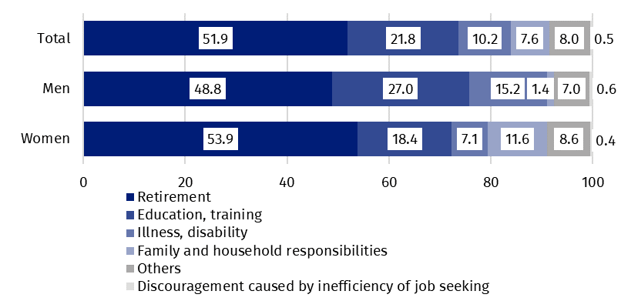
Chart 6. Structure of economically inactive persons aged 15-74 years by sex and reasons for inactivity in the first quarter of 2023 (in %)

Methodological notes

The presented news release was prepared on the basis of the generalised results of the sample survey Badanie Aktywności Ekonomicznej Ludności/BAEL in the first quarter of 2023.
Badanie Aktywności Ekonomicznej Ludności (Eng. Labour Force Survey) has been carried out in Poland quarterly since May 1992 and it has been improved in accordance with the and International Labour Organization and Eurostat recommendations.
From the first quarter of 2021 onwards, the base of the EU-LFS methodology are definitions of the employed, the unemployed and economically inactive persons in accordance with the Resolution concerning statistics of work, employment and labour underutilization adopted in 2013 on the 19th International Conference of Labour Statisticians in Geneva (ICLS) and re-commended by the International Labour Organization (ILO) for the use in all countries. The survey object is the situation within the scope of economic activity of the population, i.e. the fact of performing work, being unemployed or economically inactive persons in the refe-rence week. In the European Union, the implementation of the provisions of the above mentioned Resolution was carried out through introduction of new legal acts. From 2021 onwards, EU-LFS has been one of the key surveys embraced by the framework regulation for social statistics (the so-called IESS FR). Accompanying IESS FR implementing regulations in the domain of the labour force specify the range of the core survey and module surveys, determine survey organisation and define in detail particular populations specified according to the status of persons in the labour market.
Due to the implementation of the methodological changes, from the first quarter of 2021, the BAEL data cannot be compared with the previous periods (with the exception of the recalculated data). For the purposes of carrying out comparative analyses for longer time series, Statistics Poland prepared historical data from the BAEL for the years 2010–2020 compiled in accordance with definitions of the main population categories specified according to their labour market status, i.e. the employed, the unemployed and economically inactive persons, obligatory from 2021 onwards. The data are available on the Statistics Poland website: recalculated LFS data for the years 2010-2020
Detailed results of the survey as well as the up-dated methodology – obligatory from the first quarter of 2021, are included in the quarterly publication “Labour Force Survey in Poland” and in the Methodological report available on the Statistics Poland website:
https://stat.gov.pl/en/topics/labour-market/working-unemployed-economically-inactive-by-lfs/labour-force-survey-in-poland-quarter-42022,2,48.html
https://stat.gov.pl/en/topics/labour-market/yearbook-of-labour/methodological-report-labour-force-survey,8,2.html
Prepared by:  Labour Market Department  Director Agnieszka Zgierska  Phone: (+48 22) 608 30 15 | Issued by:  The Spokesperson for the President  of Statistics Poland  Karolina Banaszek  Phone: (+48) 695 255 011
Press Office  Phone: (+48 22) 608 38 04  e-mail: obslugaprasowa@stat.gov.pl |   www.stat.gov.pl/en/

@StatPoland

@GlownyUrzadStatystyczny

gus_stat

glownyurzadstatystycznygus

glownyurzadstatystyczny
Related information
Methodological report. Labour Force Survey
Labour Force Survey in Poland
Other publications containing the results of LFS and its module surveys
stat.gov.pl → Topics → Labour Market
Data available in databases
Strateg → Topics → Labour Market
Local Data Bank → labour Market
Terms used in official statistics
Economic activity by LFS
Economically active population by LFS
Employed persons by LFS
Unemployed persons by LFS
Economically inactive population according to the LFS

Activity rate by LFS
Employment rate by LFS
Unemployment rate by LFS

The LFS results refer to the population staying or intending to stay in the country’s territory for at least 12 months, living in private households. The data gathered in the sample survey were generalised on the basis of the balances for which the base (initial base) are the results of the Population and Housing Census 2011 – NSP 2011 (in the later period the results will be recalculated with use of the balances based on the Population and Housing Census 2021 – NSP 2021).
The data from the first quarter of 2012 to the fourth quarter of 2020 were recalculated in accordance with the definitions obligatory in the LFS from 2021 onwards. See methodological notes at the end of the news release.
Men aged 18-64 years and women aged 18-59 years.
The data from the first quarter of 2012 to the fourth quarter of 2020 were recalculated in accordance with the definitions obligatory in the LFS from 2021 onwards. See methodological notes at the end of the news release.
The data from the first quarter of 2012 to the fourth quarter of 2020 were recalculated in accordance with the definitions obligatory in the LFS from 2021 onwards. See methodological notes at the end of the news release.

