Employed, unemployed and economically inactive persons (preliminary results of the Polish Labour Force Survey)
In the fourth quarter of 2022, economically active persons accounted for 58.2% of the population aged 15-89 years. The rate increased as compared with both: the third quarter of 2022 – by 0.4 pp., and the fourth quarter of 2021 – by 0.2 pp.
58.2%
Activity rate of persons aged 15-89 years

Economic activity of the population aged 15-89 years by the LFS
Compared with the previous quarter, economic activity rate for persons aged 15-89 years increased among both men and women. Compared with the same period of the last year, the indicator increased among women, while a decrease was recorded among men

In the fourth quarter of 2022, the number of economically active persons aged 15-89 years comprised 17294 thousand, of which: 16796 thousand constituted employed persons, while 499 thousand – the unemployed. The population of economically inactive persons in the corresponding age group comprised 12426 thousand persons.
Compared with the third quarter of 2022, population of economically active persons increased – by 102 thousand, i.e. by 0.6%, while compared with the fourth quarter of 2021, it stayed at a similar level (a slight increase by 16 thousand, i.e. by 0.1%).
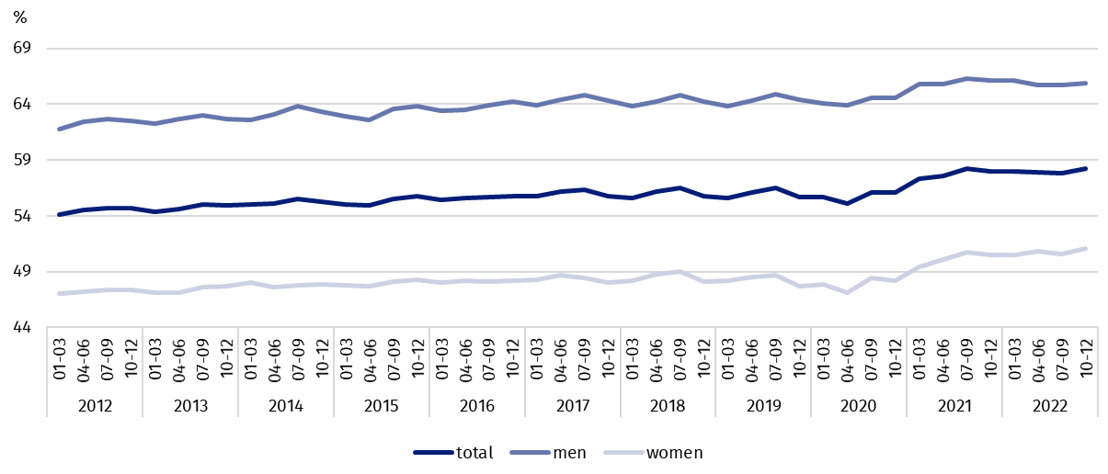
Chart 1. Activity rate of persons aged 15-89 years

In the fourth quarter of 2022, the share of economically active persons in the total number of persons aged 15-89 years was higher among men and accounted for 65.9%, in the female population it stayed at the level of 51.1% (respective values for persons at working age comprised 83.8% and 77.5%). Corresponding indicators for urban and rural residents accounted respectively for: 58.0% and 58.5% (at working age: 82.6% and 78.3%).
The index describing the relation of jobless persons to the number of employed persons decreased compared to both: the previous quarter, as well as over the year

Within the scope of population aged 15-89 years, the ratio of the number of not working persons (the unemployed and the economically inactive) to the number of employed persons decreased compared with both: the previous period and the fourth quarter of 2021. In the fourth quarter of 2022, there were 770 jobless persons aged 15-89 years per 1000 employed persons (in the third quarter of 2022 it was 781 persons and in the fourth quarter of 2021 there were 776 persons).
In the fourth quarter of 2022, employed persons accounted for 56.5% of the population aged 15-89 years. Compared with both the previous quarter of 2022, as well as the same period of 2021, employment rate increased respectively by 0.4 pp. and 0.2 pp. The rate was higher in the male population (63.9%) than among women (49.7%).
56.5%
Employment rate
of persons aged 15-89 years

Employed persons aged 15-89 years by the LFS
The number of employed persons increased compared with the previous quarter, but it stayed at similar level compared with the fourth quarter of 2021
In the fourth quarter of 2022, population of employed persons aged 15-89 years comprised 16796 thousand persons and it increased compared with the previous quarter by 106 thousand, i.e. by 0.6%, while compared with the fourth quarter of 2021, it stayed at a similar level.
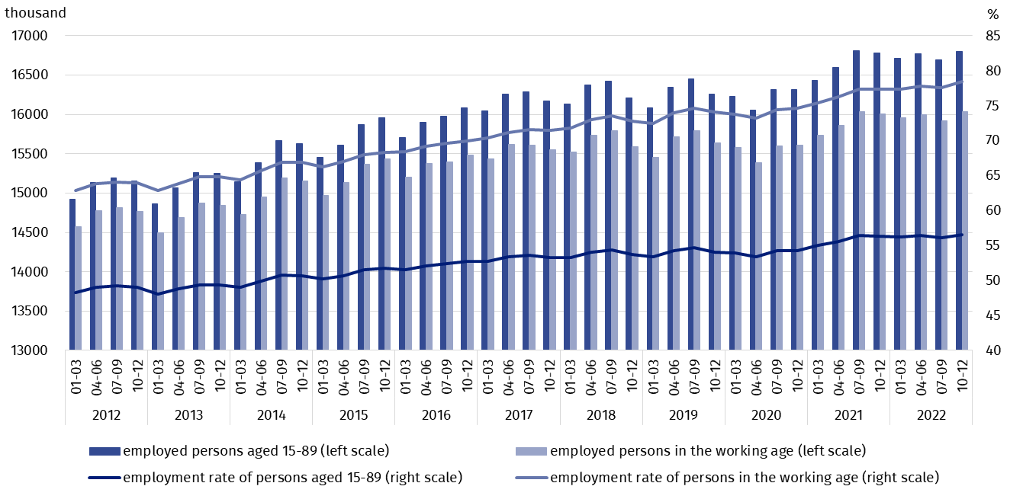
Chart 2. Employed persons and employment rate of persons aged 15-89 years and in the working age
Compared with the third quarter of 2022, the number of employed men slightly increased (by 23 thousand, i.e. 0.3%), and to some greater extent also the number of employed women increased – by 82 thousand, i.e. by 1.1%, while regarding the place of residence – the number of employed urban residents increased by 66 thousand, i.e. by 0.7%, while employed rural residents – by 39 thousand, i.e. by 0.6%.
Over the year, a growth in the number of employed persons was observed among women – by 90 thousand, i.e. by 1.2%, with a simultaneous decline in the number of employed men – by 75 thousand, i.e. by 0.8%. As regards the place of residence, the number of employed rural residents increased by 88 thousand, i.e. by 1.3%, while the number of employed urban residents decreased – by 74 thousand, i.e. by 0.7%.
The dominant among the employed were still men, who constituted 54.2% (i.e. 9097 thousand) of this population, while regarding the place of residence, there were more urban residents (59.4%, i.e. 9981 thousand persons), which is a direct consequence of the higher number of urban than rural population.
In the fourth quarter of 2022, total employment rate accounted for 56.5% and was higher among men (63.9%), than among women (49.7%). Taking into account the place of residence a similar level of the rate was recorded in both urban areas (56.5%), and in the rural areas (56.6%).
Over the quarter, a growth in employment rate was observed in all irrespectively analysed above groups (among men by 0.2 pp., in the population of women by 0.5 pp., in urban areas by 0.5 pp., in rural areas by 0.3 pp.).
Over the year, employment rate increased in the population of women (by 0.7 pp.) and at the same time it declined in the population of men (by 0.3 pp.). In case of persons living in urban areas the rate decreased slightly (by 0.1 pp.), while it increased among rural residents (by 0.7 pp.).
The LFS results indicate that in the fourth quarter of 2022:
The number of persons employed full-time increased compared with the previous quarter, while it decreased compared with the fourth quarter of 2021

- 15763 thousand persons performed full-time work, while 1032 thousand were employed part-time,
- the average number of hours worked in the reference week in the main job comprised 38.7 hours,
- the share of employees employed in public companies/institutions or by a private employer in the total number of employed persons, accounted for 80.4% (13510 thousand persons), self-employed persons constituted 18.7%, while the share of contributing family workers accounted for 0.9%,
- a decided majority of employees employed in public companies/institutions or by a private employer performed their work on the basis on the contract for unlimited duration (84.8%, i.e. 11456 thousand),
- the largest number of persons were employed in manufacturing – 19.7% of all employed persons (3306 thousand); 13.6% (2284 thousand) were employed in wholesale and retail trade; repair of motor vehicles and motorcycle. The next place belonged to persons employed in education – 8.0% of all employed persons (1344 thousand persons), while 7.8% (1314 thousand persons) were employed in section agriculture, forestry, hunting and fishing.
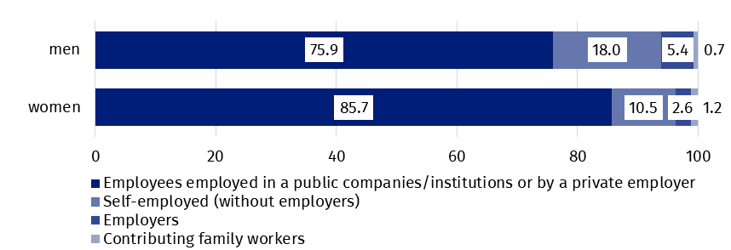
Chart 3. Structure of employed men and women aged 15-89 years by employment status in the main job in the fourth quarter of 2022 (in %)

In the fourth quarter of 2022, the highest growth in the number of employed persons compared with the previous quarter was recorded in manufacturing (by 133 thousand) and public administration and national defence (by 66 thousand). While the highest decline concerned the number of persons employed in construction (by 95 thousand) and in section agriculture, forestry, hunting and fishing (by 71 thousand).
Compared with the fourth quarter of 2021, the highest growth in the number of employed persons was observed in public administration and national defence (by 78 thousand) and in manufacturing (by 56 thousand), while the highest decline – in construction (by 117 thousand) and transportation and storage (by 77 thousand).
In the fourth quarter of 2022, 818 thousand persons had a job, but were not performing work in the reference week, which accounted for 4.9% of the total number of the employed (the corresponding population in the previous quarter comprised 1430 thousand, i.e. 8.6%, while a year ago it was 872 thousand, i.e. 5,2%).
6.2% of the total number of employed persons worked in a form of remote work

The number of persons performing their work usually or sometimes at home comprised 2132 thousand, which accounted for 12.7% of the total number of the employed. In a form of remote work (the place of performing work is not considered here), 1034 thousand persons, i.e. 6.2% of the total number of the employed, performed their work related responsibilities usually or sometimes.
2.9%
Unemployment rate of persons aged 15-89 years
In the fourth quarter of 2022, unemployed persons accounted for 2.9% of the economically active population aged 15-89 years. The unemployment rate stayed at the same level as compared with the previous quarter, as well as the fourth quarter of 2021. Unemployment intensity was lower in population of women than among men (respectively 2.8% vs. 3.0%).

Unemployed persons by the LFS
The number of unemployed persons stayed at the level recorded in the previous quarter and the same period of the last year
In the fourth quarter of 2022, population of unemployed persons aged 15-74 years comprised 499 thousand and compared with both the previous quarter, and over the year no significant changes were recorded in its size.
In the fourth quarter of 2022, over a half of unemployed population constituted men – 55.7%, i.e. 278 thousand, while as regards the place of residence – prevailed unemployed urban residents (53.3% of the total number of the unemployed, i.e. 266 thousand).
The changes in the population of the unemployed in respect to periods analysed in this publication were low and they stayed within the limits of statistical error, it regards both: comparison by sex as well as the place of residence.
In the fourth quarter of 2022, unemployment rate accounted for 2.9% and it was lower among women than men (respectively 2.8% and 3.0%).
Compared with the previous quarter, the unemployment intensity in the entire population of persons aged 15-89 years stayed at the same level, while as regards division by sex – among women a slight drop in this indicator was observed (by 0.1 pp.), while in the population of men no change was recorded. Taking into account the place of residence, a slight drop in unemployment rate among urban residents (by 0.1 pp.) was recorded, accompanied by a slight increase in this indicator among rural residents (by 0.1 pp.).
Over the year, similarly to the quarter, no changes in unemployment rate for the total population were observed. Then changes in unemployment intensity with opposite directions depending on sex of economically active persons (including the unemployed) took place - among women a drop (by 0.2 pp.) was observed, while among men an increase (by 0.2 pp.). Even smaller changes in unemployment intensity were observed in respect to the place of residence, where a slight decrease observed in the indicator among urban residents (by 0.1 pp.) was accompanied by the same increase among rural residents (by 0.1 pp.).
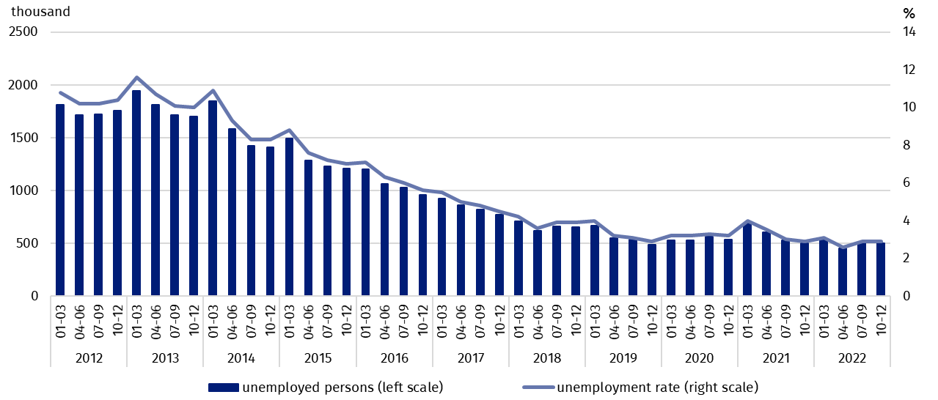
Chart 4. Unemployed persons aged 15-74 years and unemployment rate in population of persons aged 15-89 years
Similarly to the previous periods, the highest unemployment rate concerned the youngest persons and it was the highest among the all analysed age groups, it increased compared with both: the previous quarter, as well as over the year
Slightly larger changes in the level of unemployment rate are noticeable taking into account the division of population by age. Among persons aged 25-34 years, unemployment rate (3.2% in the fourth quarter of 2022) decreased compared to both the third quarter of 2022, as well as the fourth quarter of 2021 – respectively by 0.3 pp. and by 0.5 pp. The next group for which a drop in unemployment rate was recorded in these two periods were persons aged 45-89 years (1.9%; over the quarter a drop by 0.2 pp., while over the year – by 0.1 pp.). For persons aged 35-44 years (2.1%) an increase in unemployment rate was observed compared with the third quarter of 2022 – by 0.3 pp., but at the same time its value slightly decreased over the year – by 0.1 pp.
The only group for which a growth in unemployment rate was observed compared with both the third quarter of 2022, as well as with the fourth quarter of 2021, were the youngest persons, i.e. aged 15-24 years. Over the quarter, a growth in this indicator was low (by 0.1 pp.), while over the year it was significant (by 3.0 pp.). The unemployment rate for these persons in the fourth quarter of 2022 reached value of 12.1% and it was the highest among all analysed age groups.
To the greatest extent, unemployment affected persons with the lowest level of education

When analysing the value of unemployment rate by level of education of economically active persons, it may be observed that its highest value concerned persons with the lowest level of education, i.e. with lower secondary and below this level of education. In the fourth quarter of 2022, it accounted for 8.2% and increased to a greatest extent compared to both the previous quarter (by 0.4 pp.), and over the year (by 1.3 pp.). An increase in unemployment rate was also observed among persons with post-secondary and technical secondary/secondary sectoral vocational education (over the quarter a slight growth by 0.1 pp., over the year by 0.4 pp. to 3.2%),as well as among persons with basic vocational/basic sectoral vocational education (over the quarter a growth by 0.3 pp., over the year a lower increase – by 0.1 pp. to the value of 3.8%).
Whereas, a decline in unemployment rate compared to third quarter of 2022 as well as the fourth quarter of 2021, was recorded in the two groups specified by level of education. A higher drop was observed among persons with general secondary education – over the quarter by 0.9 pp., while over the year by 0.6 pp. to the level of 3.8%, while in the case of persons with tertiary education, for whom unemployment rate in the fourth quarter of 2022 was the lowest and accounted for 1.3%, changes in the value of the indicator were low (a drop by 0.1 pp. compared with the previous quarter, and the previous year).
The largest population of the unemployed constituted persons who lost their job
The analysis on the sources of inflow to unemployment indicates that the largest population of the unemployed constituted persons who lost a job during the last 3 months (43.4%, i.e. 216 thousand). The share of persons re-entering work after a break (longer than 3 months) accounted for 26.9% (134 thousand), the share of persons taking up their first job – 16.9% (84 thousand), while the share of persons who resigned from work was the lowest – 12.8% (64 thousand).
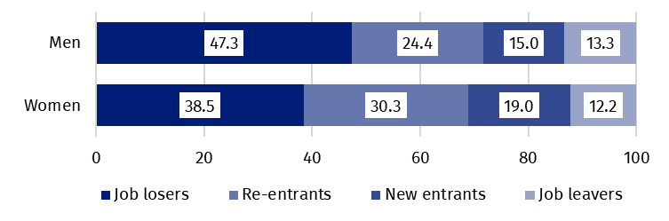
Chart 5. Structure of unemployed men and women by the source of unemployment in the fourth quarter of 2022 (in %)
The average duration of job search by unemployed persons was 8.3 months
In the analysed period, the average duration of a job search by unemployed persons comprised 8.3 months (the same duration as in the previous year, while in the previous quarter it was 8.7 months). Persons who were seeking a job for the longest duration were the oldest ones, i.e. aged 55-74 years (11.1 months), aged 35-44 years (9.5 months) and aged 45-54 years (9.4 months), while the shortest job search duration was observed for the youngest persons, in the age group 15-19 years (3.5 months).

In the fourth quarter of 2022, economically inactive persons accounted for 41.8% of the total number of population aged 15-89 years. The percentage reached a lower level compared with both the previous quarter (a drop by 0.4 pp.), and compared with the fourth quarter of 2021 (a drop by 0.2 pp.).
41.8%
The share of economically
inactive persons in the total number of the population aged 15–89 years

Economically inactive persons aged 15-89 by the LFS
In the fourth quarter of 2022, population of economically inactive persons aged 15-89 years comprised 12426 thousand and it decreased to the same extent in respect to both: the third quarter of 2022 (a drop by 106 thousand, i.e. by 0.8%), and the fourth quarter of 2021 (a drop by 103 thousand, i.e. by 0.8%).
Women still constitute a majority of economically inactive population
Over a half of the population of economically inactive persons comprised women – in the analysed age group their share was 60.9% (7569 thousand). Taking into account the place of residence, a majority of economically inactive persons constituted urban residents (59.7%; 7423 thousand), which is connected with a higher number of population living in urban than in rural areas.
Recorded over the quarter a significant decrease in the economically inactive population was irrespective of sex and the place of residence (the highest drop was observed among women – by 79 thousand, i.e. by 1.0%, while taking into account the place of residence – among persons living in urban areas – by 76 thousand, i.e. by 1.0%).
Recorded over the year decrease in the economically inactive population was caused mainly by a drop in the number of economically inactive women (by 121 thousand, i.e. by 1.6%), while among men, the number of the group slightly increased (by 18 thousand, i.e. by 0.4%). Taking into account the place of residence, a higher drop was recorded in rural areas (by 93 thousand, i.e. by 1.8%), than in the urban areas where a decline in the number of economically inactive persons was relatively low (a drop by 11 thousand, i.e. by 0.1%, within the limit of statistical error measurement).
The economically inactive population is a specific one in respect to the labour market resources. Its scope includes persons who have not entered the labour market yet (including the majority of the youth still participating in education), persons who have definitely left the labour market or will never enter the labour market (some retirees, pensioners, persons maintaining themselves from other sources than work), but also persons who entered the labour market, then partially deactivated and who will want to re-enter the labour market after a break.
In the fourth quarter of 2022, over a half of the economically inactive persons aged
15-74 years comprising 10147 thousand (the reason for inactivity was determined for this age group) constituted retirees (51.5%), while the second largest group were students (22.1%).
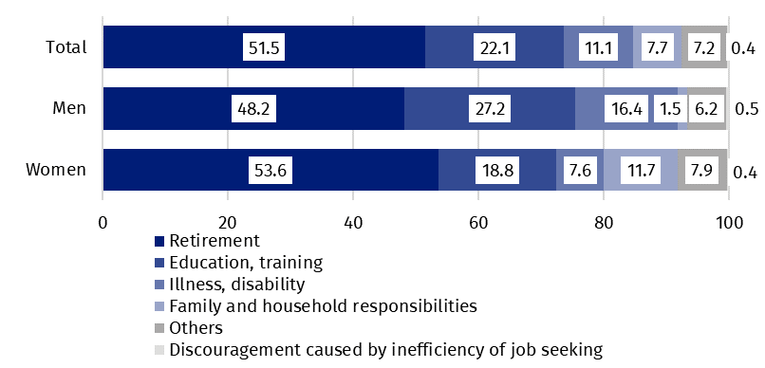
Chart 6. Structure of economically inactive persons aged 15-74 years by sex and reasons for inactivity in the fourth quarter of 2022 (in %)
Participating in education and improving qualification were the most often reason for economic inactivity of persons at working age
In the case of economically inactive persons at the working age (3927 thousand), the most often reasons for inactivity were: education and training – 30.6%, illness and disability –24.9% and family responsibilities – 18.9%. Retirement as the reason for inactivity on the labour market indicated 8.2% persons, while persons discouraged with unsuccessful job search constituted 1.0%.

Methodological notes

The presented news release was prepared on the basis of the generalised results of the sample survey Badanie Aktywności Ekonomicznej Ludności/BAEL in the fourth quarter of 2022.
Badanie Aktywności Ekonomicznej Ludności (Eng. Labour Force Survey) has been carried out in Poland quarterly since May 1992 and it has been improved in accordance with the and International Labour Organization and Eurostat recommendations.
From the first quarter of 2021 onwards, the base of the EU-LFS methodology are definitions of the employed, the unemployed and economically inactive persons in accordance with the Resolution concerning statistics of work, employment and labour underutilization adopted in 2013 on the 19th International Conference of Labour Statisticians in Geneva (ICLS) and re-commended by the International Labour Organization (ILO) for the use in all countries. The survey object is the situation within the scope of economic activity of the population, i.e. the fact of performing work, being unemployed or economically inactive persons in the refe-rence week. In the European Union, the implementation of the provisions of the above mentioned Resolution was carried out through introduction of new legal acts. From 2021 onwards, EU-LFS has been one of the key surveys embraced by the framework regulation for social statistics (the so-called IESS FR). Accompanying IESS FR implementing regulations in the domain of the labour force specify the range of the core survey and module surveys, determine survey organisation and define in detail particular populations specified according to the status of persons in the labour market.
Due to the implementation of the methodological changes, from the first quarter of 2021, the BAEL data cannot be compared with the previous periods (with the exception of the recalculated data). For the purposes of carrying out comparative analyses for longer time series, Statistics Poland prepared historical data from the BAEL for the years 2010–2020 compiled in accordance with definitions of the main population categories specified according to their labour market status, i.e. the employed, the unemployed and economically inactive persons, obligatory from 2021 onwards. The data are available on the Statistics Poland website: recalculated LFS data for the years 2010-2020
Detailed results of the survey as well as the up-dated methodology – obligatory from the first quarter of 2021, are included in the quarterly publication “Labour Force Survey in Poland” available on the Statistics Poland website:
Statistics Poland / Topics / Labour Market / Working. Unemployed. Economically inactive by LFS / Labour force survey in Poland – quarter 3/2022

Prepared by:  Labour Market Department  Director Agnieszka Zgierska  Phone: (+48 22) 608 30 15 | Issued by:  The Spokesperson for the President  of Statistics Poland  Karolina Banaszek  Phone: (+48) 695 255 011
Press Office  Phone: (+48 22) 608 38 04  e-mail: obslugaprasowa@stat.gov.pl |   www.stat.gov.pl/en/

@StatPoland

@GlownyUrzadStatystyczny

gus_stat

glownyurzadstatystycznygus

glownyurzadstatystyczny
Related information
Methodological report. Labour Force Survey (the methodology valid until the end of 2020)
Labour Force Survey in Poland
Other publications containing the results of LFS and its module surveys
stat.gov.pl → Topics → Labour Market
Data available in databases
Strateg → Topics → Labour Market
Local Data Bank → labour Market
Terms used in official statistics
Economic activity by LFS
Economically active population by LFS
Employed persons by LFS
Unemployed persons by LFS
Economically inactive population according to the LFS

Activity rate by LFS
Employment rate by LFS
Unemployment rate by LFS

The LFS results refer to the population staying or intending to stay in the country’s territory for at least 12 months, living in private households. The survey results gathered in sample survey were generalised on the basis of the balances for which the base (initial base) are the results of the Population and Housing Census 2011 – NSP 2011 (in the later period the results will be recalculated with use of the balances based on the Population and Housing Census 2021 – NSP 2021).
The data from the first quarter of 2012 to the fourth quarter of 2020 were recalculated in accordance with the definitions obligatory in the LFS from 2021 onwards.
Men aged 18-64 years and women aged 18-59 years.
The data from the first quarter of 2012 to the fourth quarter of 2020 were recalculated in accordance with the definitions obligatory in the LFS from 2021 onwards.
The data from the first quarter of 2012 to the fourth quarter of 2020 were recalculated in accordance with the definitions obligatory in the LFS from 2021 onwards.

