Value chains of national enterprises in 2021

At the end of 2021, most (59.0%) of the surveyed enterprises with 10 or more persons employed performed business functions only internally and did not source them outside. The phenomenon of external sourcing concerned 41.0% of the surveyed enterprises, most of which (91.4%) contracted out functions only to other domestic enterprises. Business functions abroad were contracted out mainly to European Union countries.
41,0%
of enterprises sourced business functions externally at the end of 2021

Place of performance of business functions
At the end of 2021, three-fifths (25,570) of the surveyed enterprises (legal entities) with 10 or more persons employed performed business functions entirely within the enterprise, and two-fifths (17,761) sourced functions externally to be performed completely or partially to others units. In comparison with previous year, the structure slightly changed – the share of enterprises sourcing functions to other units increased by 7.8 percentage point.

Chart 1. Structure of the surveyed enterprises by size class and place of business functions performance in 2021
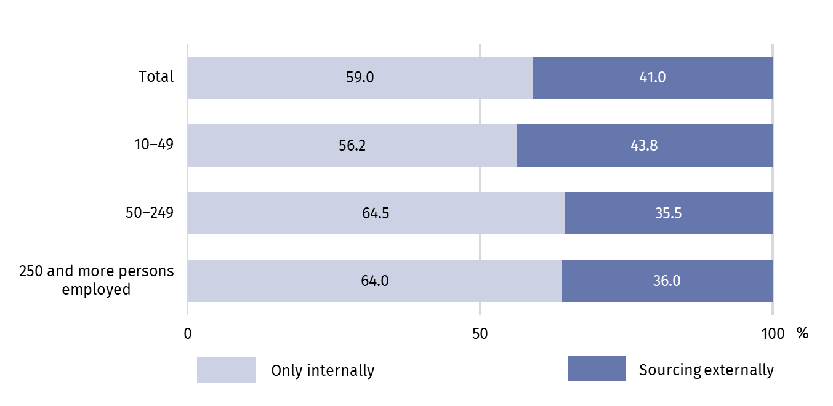 In 2021, functions were sourced externally more often by small enterprises (with 10‒49 persons employed) ‒ 43.8% of entities belonging to this size class, and less frequently by medium-sized enterprises (with 50‒249 persons employed) ‒ 35.5% and large (with 250 or more persons employed) ‒ 36.0%. In the previous year, these shares were different and amounted to 30.4%, 36.8% and 44.7%, respectively. Enterprises owned by domestic capital sourced functions externally slightly less frequently (40.7%) than enterprises with foreign capital (42.3%).
In 2021, functions were sourced externally more often by small enterprises, i.e. with 10‒49 persons employed ‒ 43.8% of entities in this size class compared to 41.0% for the total
Enterprises owned by domestic capital sourced functions externally slightly less frequently (40.7%) than enterprises with foreign capital (42.3%).
Implementation of functions to external entities was most often sourced by units dealing with education, human health and social work activities (they constituted more than 50% of entities within these sections). A high share of enterprises sourcing externally business functions (nearly 50%) was also observed in the case of other service activities and construction. Industrial enterprises were characterized by a slightly lower share of entities commissioning the implementation of functions to other enterprises than entities conducting other types of activity. The lowest percentage of such entities was observed among enterprises operating in the field of water supply, sewerage, waste management and remediation activities, as well as mining and quarrying (about 30% each).
In 2021, the implementation of functions was most often entrusted to external entities by enterprises from the education, and human health and social work activities sections

Chart 2. Percentage of enterprises sourcing business functions externally by NACE sections in 2021
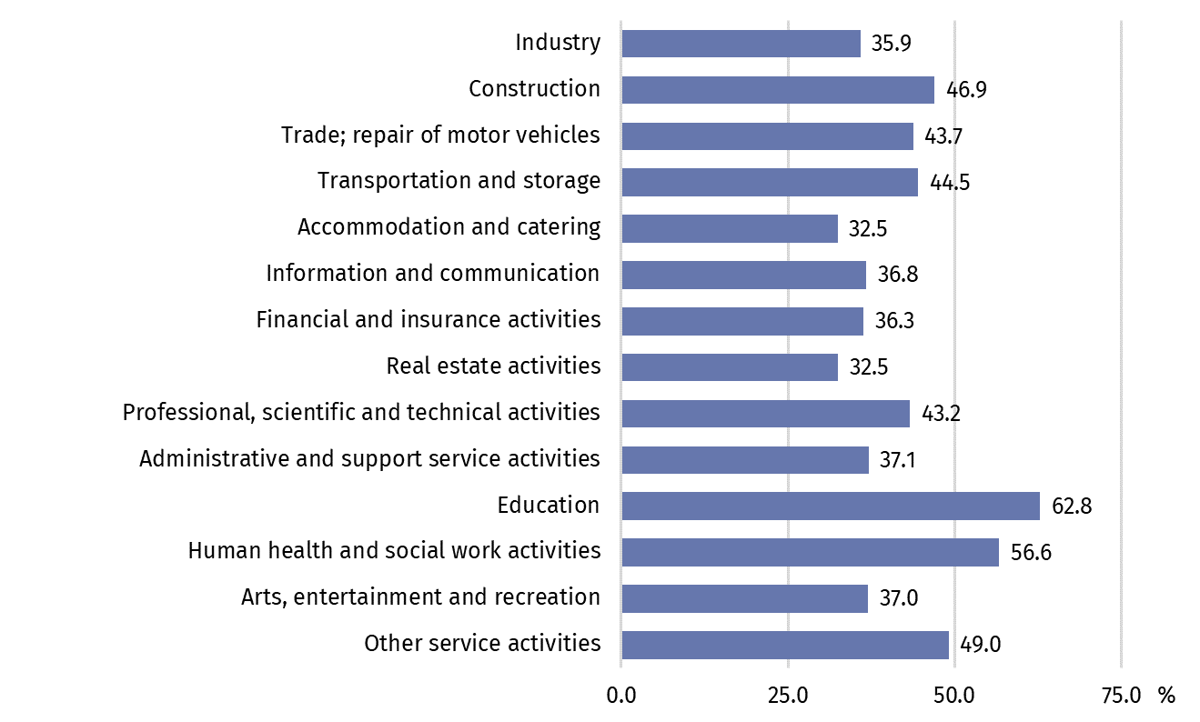
In terms of location of the surveyed enterprises, the share of enterprises sourcing functions externally differed slightly in particular voivodships. The performance of functions was sourced externally more often by enterprises located in the following voivodships: Pomorskie (44.5%), Podlaskie (44.0%), Wielkopolskie (42.1%). Enterprises from the Opolskie Voivodeship performed all functions entirely on their own more often than entities from other voivodships (63.6%).

Activities performed independently by enterprises
At the end of 2021, the most frequently performed function within enterprises was marketing, sales and after-sales services ‒ it was performed by 60.8% of the surveyed entities
At the end of 2021, similarly like in the previous year, the surveyed enterprises with 10 or more persons employed most often performed on their own functions related to marketing, sales and after-sales services (in 60.8% of the surveyed enterprises), management and administration (57.7%), other business functions (46.7%) and production (45.8%). In total, four-fifths (4,089.4 thousand persons) of the total number of persons employed in the surveyed enterprises were involved in the implementation of these functions. The least frequently performed functions by the surveyed units were engineering and related technical services (in 13.5% of the surveyed enterprises) and research and development (6.1%). These functions also involved the smallest number of persons employed.

Table 1. Enterprises and persons employed by business function (as of 31 December 2021)
Business functions | Number of enterprisesª | Number of persons employed
Business functions | Number of enterprisesª | In absolute number | in %
Total | 43 331 | 5 010 822 | 100.0
Production | 19 863 | 1 656 649 | 33.1
Management and administration | 24 999 | 542 818 | 10.8
Engineering and related technical services | 5 861 | 130 135 | 2.6
Research and development | 2 649 | 59 711 | 1.2
Information technologies | 7 833 | 202 896 | 4.0
Marketing, sales, and after-sales service | 26 354 | 945 097 | 18.9
Transport, logistics and storage | 14 083 | 528 709 | 10.6
Other business functions^{b} | 20 245 | 944 807 | 18.9
a Due to the possibility of performing many functions within the enterprise, the functions do not add up to the "total" value. b Includes inter alia facility management, repair and maintenance services and other services.
Large enterprises (with 250 and more persons employed) were characterized by a slightly different structure ‒ the most frequently performed function was management and administration (in 80.7% of the surveyed enterprises). In addition, enterprises of this size class almost 3 times more often than all surveyed enterprises indicated the independent implementation of the information technologies function (52.5% against 18.1% in total) and almost 4 times – the research and development function (23.0% against 6.1% in total).

Chart 3. Percentage of surveyed enterprises in each size class by type of business functions performed internally in 2021
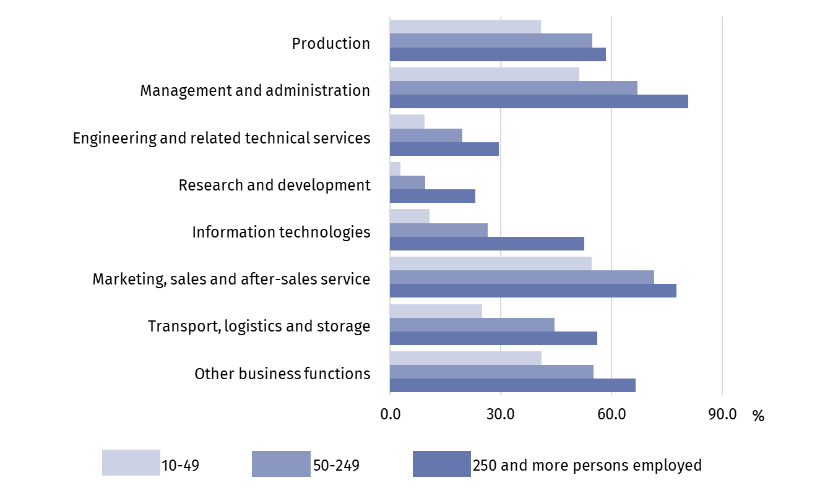

Enterprises with foreign capital accounted for 18.9% of all surveyed enterprises and for 40.2% of all persons employed. In particular business functions performing internally, their share varied between 17.0% in other business functions and 33.9% in the information technologies function. In the function related to information technologies, persons employed in enterprises with foreign capital dominated in the total number of persons employed there (61.6%).

Directions of ordering selected activities
Among enterprises sourcing business functions externally at the end of 2021, the vast majority (91.4%) performed them only in other domestic enterprises
Out of 17,761 surveyed enterprises with 10 or more persons employed, which sourced functions externally completely or partially at the end of 2021, the vast majority (91.4%) indicated only other domestic enterprises as the place of performing the functions, 7.1% both domestic and foreign enterprises, and 1.5% only foreign enterprises. Compared to the previous year, this structure changed respectively by: +3.4 percentage point, -3.0 percentage point, - 0.4 percentage point. The increase in the share of enterprises commissioning functions exclusively to domestic contractors was influenced primarily by the increase in this share (by 3.5 percentage point) by small enterprises (with 10‒49 employed persons).

Chart 4. Structure of enterprises sourcing business functions externally by size class and place of sourcing in 2021
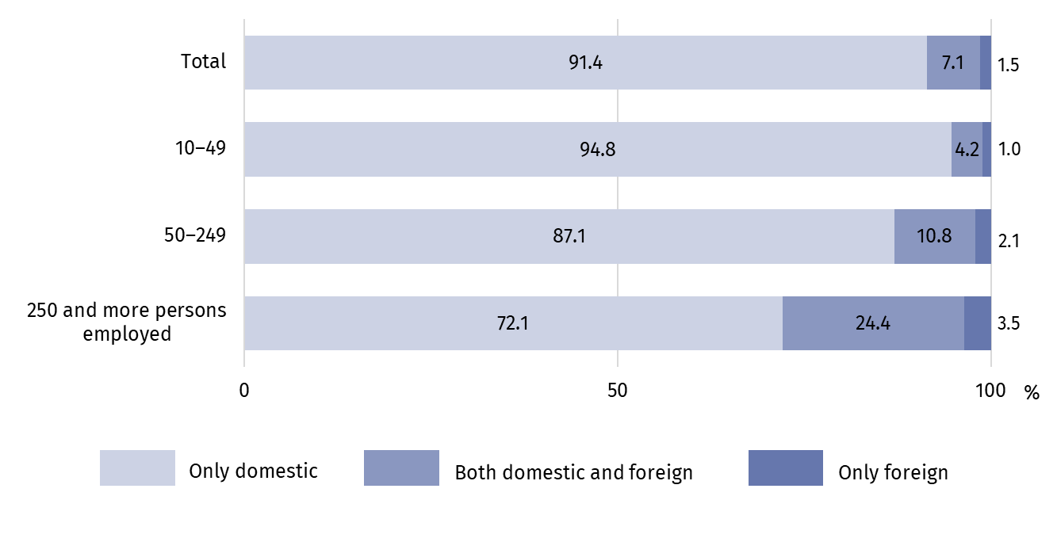
Large enterprises (with 250 and more persons employed) more often than entities from other size classes contracted functions to foreign entities, i.e. both domestic and foreign or only foreign ones (a total of 27.9% of entities within this size class) – increase compared to the previous year by 1.8 percentage point.
Enterprises with foreign capital accounted for about 70% of all enterprises commissioning functions abroad.
Activities abroad were more often commissioned by enterprises from the information and communication section (14.5% of entities within this section), manufacturing (12.9%) and mining and quarrying (12.7%).
The place of performance of business functions outside Poland was most often chosen by enterprises located in the Mazowieckie Voivodship (a total of 12.3% of enterprises from this Voivodship), Lubuskie (11.5%) and Opolskie (11.2%), and the least frequently enterprises from the Lubelskie (3.0%) and Podlaskie (4.0%) voivodships.

Chart 5. Percentage of enterprises sourcing business functions externally by type of function and place of sourcing 2021
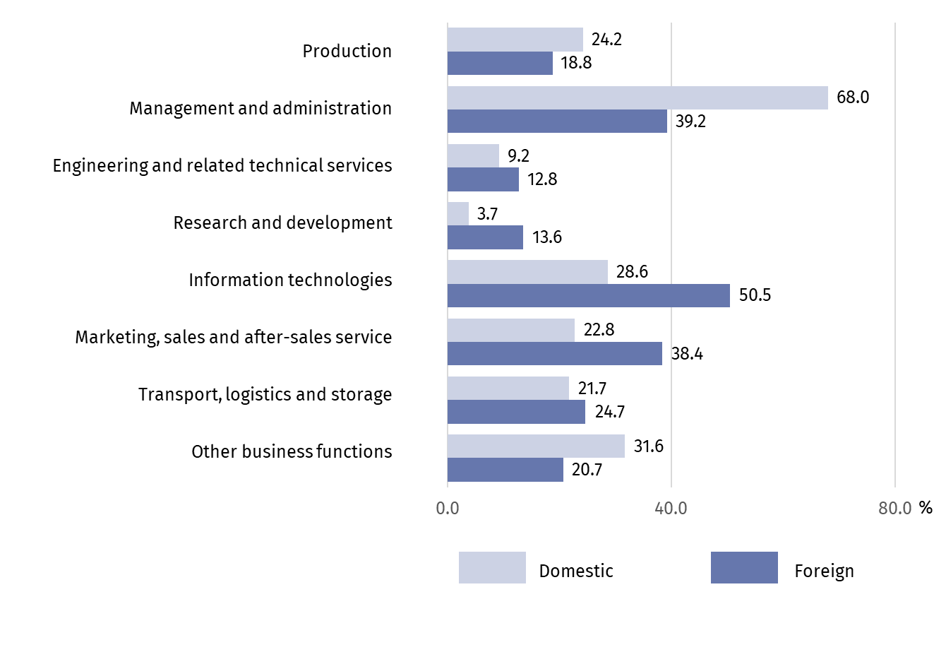Taking into account the type of business function, in 2021 other domestic enterprises were most often contracted out with tasks related to management and administration. Functions sourced externally within the country were performed mainly by unrelated enterprises, i.e. outside the same enterprise group.
Outside Poland, tasks related to information technology were mainly performed, as well as (to a lesser extent) activities in the field of management and administration and marketing, sales and after-sales services. Functions sourced externally abroad were mostly performed by other related enterprises, i.e. belonging to the same enterprise group.
The overwhelming majority (88.4%) of enterprises sourcing business functions abroad at the end of 2021 indicated enterprises from the European Union as the place of performance of the function
Among the total of 1,520 enterprises sourcing business functions abroad at the end of 2021, the largest percentage of enterprises (95.8%) indicated European enterprises as the place of performance of functions, including 88.4% enterprises from the European Union. Compared to 2020, these shares slightly increased ‒ by 0.9 percentage point and by 1.5 percentage point, respectively.

Chart 6. Percentage of enterprises sourcing business functions externally in the European Union countries in 2021
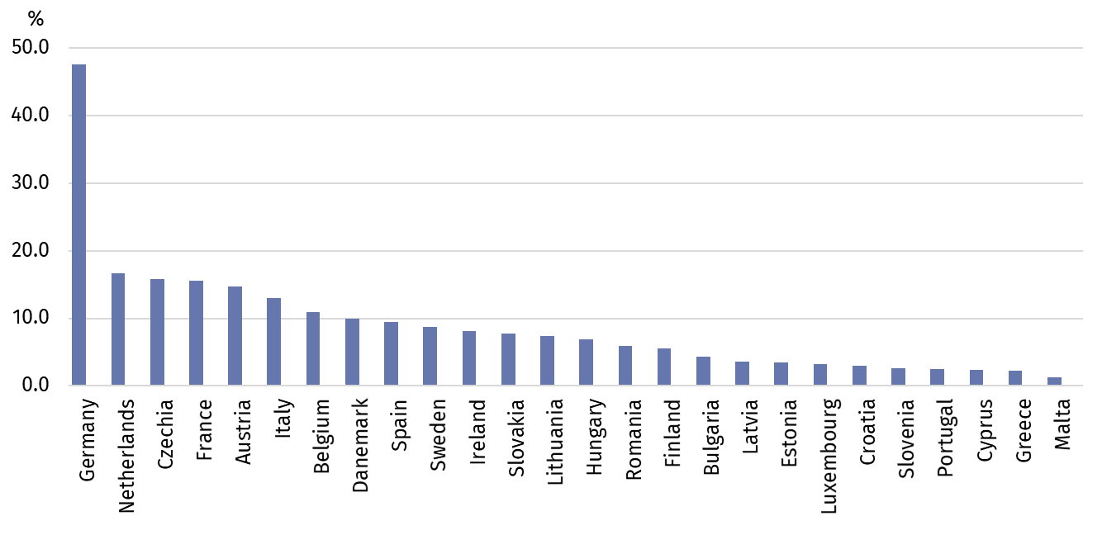
Germany (47.6%), United Kingdom (17.8%) and the Netherlands (16.6%) were the most frequently chosen countries of performing functions abroad. Among countries outside Europe, most functions were performed in the United States and Canada (14.3%). In the countries of the Visegrad Group, functions were performed by 20.7% of all enterprises commissioning activities abroad (15.8% in the Czechia, 7.8% in Slovakia, 6.8% in Hungary).

Table 2. Percentage of enterprises sourcing business functions externally abroad by selected areas in 2021
Business functions | Total | Europe | United States and Canada | China | India
Business functions | in %
Production | 100.0 | 94.7 | 5.6 | 5.6 | 1.8
Management and administration | 100.0 | 94.8 | 13.4 | 1.2 | 4.2
Engineering and related technical services | 100.0 | 94.8 | 12.9 | 3.1 | 3.1
Research and development | 100.0 | 88.8 | 13.6 | 5.3 | 1.9
Information technologies | 100.0 | 92.3 | 14.6 | 0.8 | 3.5
Marketing, sales and after-sales service | 100.0 | 96.2 | 9.9 | 1.2 | 1.2
Transport, logistics and storage | 100.0 | 97.9 | 4.5 | 2.7 | 1.3
Other business functions | 100.0 | 96.8 | 11.1 | 2.2 | 2.9

The data presented in this study concern 43,331 legal entities with 10 or more persons employed, organized in the form of civil law partnerships, partnerships, capital companies, branches of foreign entrepreneurs, state-owned enterprises, whose predominant type of activity is classified into the following sections according to the Polish Classification of Activities (PKD 2007): B, C, D, E, F, G, H, I, J (excluding cultural institutions with legal personality), K (excluding banks, cooperative savings and credit unions, insurance companies, brokerage houses, investment companies and funds as well as pension companies and funds), L, M, N, P (excluding higher education), Q (excluding independent health care facilities), R (excluding cultural institutions with legal personality), S (excluding division 94).
The study of global value chains has been conducted at the Statistics Poland since 2021. The first results of the study so far have allowed for a preliminary analysis of the value chains of domestic enterprises, based on the business function. The following 8 business functions have been distinguished:
- Production (manufacturing and assembly, production of energy and extraction of raw materials, construction);
- Management and administration;
- Engineering and related technical services;
- Research and development;
- Information technology (information technology services, software programming, IT system installation, maintenance, help desk services, telecommunication);
- Marketing, sales and after-sales services;
- Transportation, logistics and storage;
- Other business functions (facility management, maintenance and repair services and other services).
In case of quoting Statistics Poland data, please provide information: “Source of data: Statistics Poland”, and in case of publishing calculations made on data published by Statistics Poland, please include the following disclaimer: “Own study based on figures from Statistics Poland”.
Prepared by:  Enterprises Department  Director Katarzyna Walkowska  Phone: (+48 22) 608 35 66 | Issued by:  The Spokesperson for the President  of Statistics Poland  Karolina Banaszek  Phone: (+48) 695 255 011
Press Office  Phone: (+48 22) 608 38 04  e-mail: obslugaprasowa@stat.gov.pl |   stat.gov.pl/en/

@StatPoland

@GlownyUrzadStatystyczny

gus_stat

glownyurzadstatystycznygus

glownyurzadstatystyczny
Related publications
Value chains of national enterprises in 2020
Terms used in official statistics
Business function
An enterprise group
Foreign capital

Business function is a set of tasks that an enterprise must carry out on a regular basis in order to bring goods or services to market. These tasks may be performed internally by an enterprise or sourced externally.
The term „Industry” includes sections: B (Mining and quarrying), C (Manufacturing), D (Elec-tricity, gas steam and air conditioning supply), E (Water supply; sewerage, waste manage-ment and remediation activities).

