Financial results of non-financial enterprises
in the 1st half of 2023
In the 1st half of 2023 financial results of the surveyed non-financial enterprises were similar to those obtained a year earlier. The economic and financial indicators decreased. Investment outlays were higher by 10.4% than those recorded in the 1st half of 2022 (when there was an increase by 4.6%).
11.5%
Increase in total revenues y/y
Total revenues were higher by 11.5% comparing to the previous year and total costs of obtaining the revenues increased by 12.3%. The cost level indicator deteriorated from 93.2% in the previous year to 93.9%. Net revenues from sale of products, goods and materials increased by 11.2% and the costs of obtaining them – by 12.2%.
The financial result from the sale of products, goods and materials amounted to 146.7 bn PLN and was by 2.2% lower than in the 1st half of 2022. The financial result from other operating activity amounted to 9.4 bn PLN and was higher by 6.8 bn PLN over the year. There was a deterioration observed in the result on financial activities (6.5 bn PLN compared to 8.7 bn PLN in the 1st half of 2022).
In the 1st half of 2023 net financial result of non-financial enterprises was by 0.4% lower than the year before
Gross financial result amounted to 162.6 bn PLN compared to 161.2 bn PLN a year ago and its obligatory encumbrances amounted to 28.5 bn PLN (compared to 26.7 bn PLN a year ago). Net financial result amounted to 134.1 bn PLN and was by 0.4% lower than the year before. Net profit amounted to 163.6 bn PLN and was higher by 6.9 bn PLN than in the 1st half of 2022 while net loss was 29.5 bn PLN and increased by 7.4 bn PLN over the year. Net profit was recorded by 75.6% of all enterprises (compared to 76.3% a year ago) and the revenues obtained by them constituted 81.3% of total revenues of the surveyed enterprises (compared to 86.7% the year before). In manufacturing, net profit was recorded by 77.9% of all enterprises (it was 80.2% a year ago) and the share of the total revenues generated by these enterprises in the total revenues of all enterprises in this section was 80.6% (compared to 87.0% a year ago).
Chart 1. Profitability indicators in the 1st half of the year from 2004 to 2023
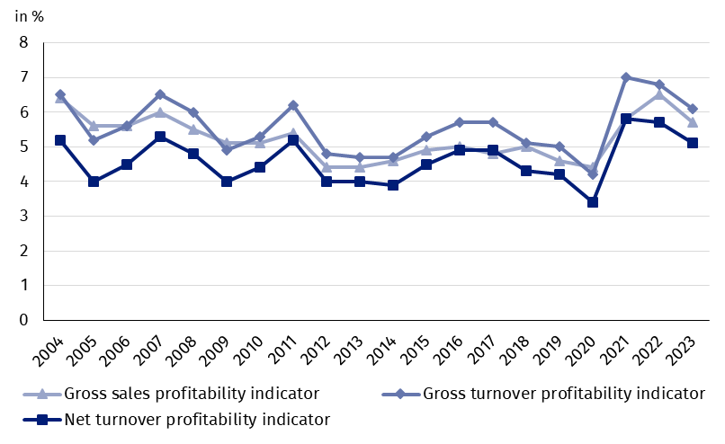
Table 1. Basic financial data of surveyed non-financial enterprises
SPECIFICATION | Jan.-June 2022 | Jan.-June 2023 | Jan.-June 2022  = 100
SPECIFICATION | in million PLN |  | Jan.-June 2022  = 100
Total revenues | 2 373 597.2 | 2 647 610.6 | 111.5
of which net revenues from sale  of products, goods and materials | 2 300 906.3 | 2 559 625.0 | 111.2
Total costs | 2 212 358.6 | 2 484 990.0 | 112.3
of which cost of products,  goods and materials sold | 2 150 954.4 | 2 412 920.1 | 112.2
Financial result from the sale of products,  goods and materials | 149 951.9 | 146 704.9 | 97.8
Financial result from other  operating activity | 2 573.6 | 9 418.3 | 366.0
Result on financial activity | 8 713.1 | 6 497.4 | 74.6
Gross financial result | 161 238.7 | 162 620.6 | 100.9
Net financial result | 134 556.5 | 134 080.8 | 99.6
Net profit | 156 694.1 | 163 607.8 | 104.4
Net loss | 22 137.6 | 29 527.0 | 133.4
 | %
Cost level indicator | 93.2 | 93.9 | x
Gross sales profitability indicator | 6.5 | 5.7 | x
Gross turnover profitability indicator | 6.8 | 6.1 | x
Net turnover profitability indicator | 5.7 | 5.1 | x
First degree financial liquidity indicator | 40.9 | 37.3 | x
Second degree financial liquidity indicator | 105.6 | 105.8 | x
Cost level indicator for all surveyed enterprises was 93.9% (compared to 93.2% a year ago). Gross sales profitability indicator decreased from 6.5% to 5.7%, gross turnover profitability indicator – from 6.8% to 6.1% as well as net turnover profitability indicator – from 5.7% to 5.1%.
The most significant decrease in net turnover profitability indicator was recorded in mining and quarrying (by 7.1 pp.)

A decrease in net turnover profitability indicator was recorded i.a. in mining and quarrying (from 18.8% to 11.7%), professional, scientific and technical activities (from 10.0% to 5.6%), electricity, gas, steam and air conditioning supply (from 7.8% to 5.2%), water supply; sewerage, waste management and remediation activities (from 8.1% to 6.5%), manufacturing (from 5.9% to 5.1%) as well as information and communication (from 8.4% to 8.0%). An increase in net turnover profitability indicator was recorded i.a. in real estate activities (from 4.9% to 8.6%), accommodation and catering (from 7.0% to 8.8%), other service activities (from 4.9% to 6.4%), construction (from 5.8% to 7.0%), transportation and storage (from 4.6% to 5.8%), administrative and support service activities (from 6.9% to 7.5%), as well as trade; repair of motor vehicles (from 3.5% to 3.8%).
First degree financial liquidity indicator was 37.3% (compared to 40.9% a year ago) and second degree financial liquidity indicator was 105.8% (compared to 105.6% in the previous year). First degree financial liquidity indicator at the level over 20% was achieved by 55.2% of the surveyed enterprises (compared to 53.3% a year ago). Second degree financial liquidity indicator, which ranged from 100% to 130%, was recorded by 12.3% of the surveyed enterprises (compared to 12.7% a year ago).
Chart 2. Net turnover profitability indicator
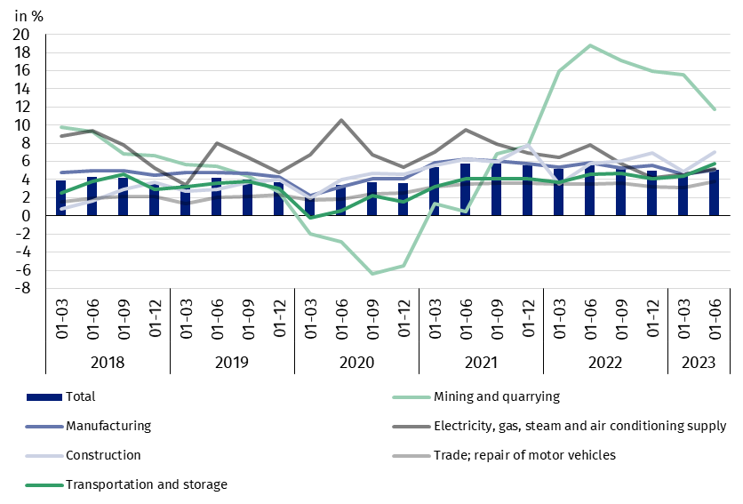

In the structure of total costs, there was an increase in the share of taxes and fees (by 0.8 pp.), wages and salaries (by 0.7 pp.), comsumption of energy (by 0.6 pp.), external services (by 0.5 pp.), other costs by kind (by 0.3 pp.) as well as social insurances and other benefits (by 0.2 pp.). There was a decrease in the share of consumption of materials (by 3.0 pp.) as well as depreciation (by 0.1 pp.).

Chart 3. Structure of costs by type in the 1st half of 2023

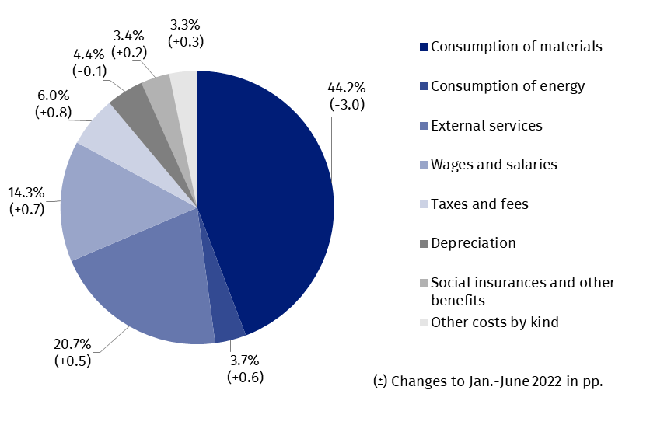

53.8% of the surveyed enterprises reported net revenues from sale of products, goods and materials for export in the 1st half of 2023 (compared to 53.2% in the previous year). The revenues from export sales were by 9.5% higher than a year before. The share of export in total sales revenues of all surveyed enterprises decreased from 25.2% to 24.8%. The share of the exporting enterprises which reported net profit was 77.5% (compared to 80.5% in the previous year). The basic economic and financial relations of the exporting enterprises decreased and these relations were similar to total surveyed enterprises.
There was an increase in investment outlays of the surveyed enterprises by 10.4% compared to the 1st half of 2022
In the 1st half of 2023 investment outlays of the surveyed enterprises amounted to 92.2 bn PLN and were (in constant prices) by 10.4% higher than in the previous year (when an increase by 4.6% was recorded). The expenditures on buildings and structures increased by 2.0% (in the previous year they increased by 8.8%). Expenditures on purchases increased by 15.6%, including increase of outlays on transport equipment – by 19.7% (in comparison to the increase in the previous year – 4.5%), while outlays on machinery, technical equipment and tools – by 14.1% (in comparison to the increased in the previous year – 1.6%).
The increase in investment outlays (in current prices) was recorded in most of the sections, i.a. for mining and quarrying (by 64.5% compared to the increase by 4.6% the year before), electricity, gas, steam and air conditioning supply (by 55.2% compared to the decrease of 11.0% in the previous year), construction (by 50.7% compared to the decrease by 14.9% the year earlier), manufacturing (by 16.3% compared to the increase of 25.6% the year before), real estate activities (by 14.0% compared to the increase of 24.4% the year before), trade; repair of motor vehicles (by 9.3% compared to the increase of 30.1% in the previous year).
Chart 4. Dynamics of investment outlays - increase/decrease compared to the corresponding period of the previous year
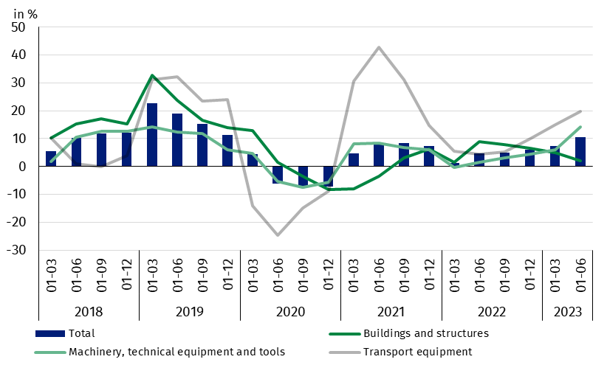

The data refer to 17 360 non-financial enterprises (legal entities) with 50 and more persons employed keeping accounting ledgers. The data do not include agriculture, forestry, hunting and fishing (section A according to NACE rev. 2); financial and insurance activities (section K according to NACE rev. 2); higher education institutions; independent public health care facilities; cultural institutions with legal personality; trade unions, religious and political organisations.
In the case of quoting Statistics Poland data, please provide information: “Source of data: Statistics Poland” and in the case of publishing calculations made on data published by Statistics Poland, please include the following disclaimer: “Own study based on figures from Statistics Poland”.
Prepared by:  Enterprise Department  Director Katarzyna Walkowska  Phone: (+48 22) 608 31 25 | Issued by:  The Spokesperson for the President  of Statistics Poland  Karolina Banaszek  Phone: (+48) 695 255 011
Press Office  Phone: (+48 22) 608 38 04  e-mail: obslugaprasowa@stat.gov.pl |   stat.gov.pl/en/

@StatPoland

@GlownyUrzadStatystyczny

gus_stat

glownyurzadstatystycznygus

glownyurzadstatystyczny
Related information
Statistical Bulletin
Information on the socio-economic situation of the country
News releases. Financial results of non-financial enterprises
Methodological report. Non-financial enterprises surveys
Data available in databases
Local Data Bank
Knowledge Database Non-financial Enterprises
Macroeconomic Data Bank
Terms used inn official statistics
Total revenues
Total costs
Gross financial result
Net financial result
Cost level indicator
Gross turnover profitability indicator
Net turnover profitability indicator
First degree financial liquidity indicator
Second degree financial liquidity indicator
Investment outlays

