Production of industrial products in 2022⁾
The value of sold production of own products by producers in 2022 increased in relation to 2021 by 30.4% and amounted to 1 872 227.2 million PLN.
30.4%
Index of value of sold production of own products by manufacturers

Sold production of industrial products

In 2022, compared to the previous year, the value of sold production of products increased in all divisions of the sections Products of mining and quarrying and Manufactured products, except for the Metal ores division (a decrease by 0.6% was recorded) and Textiles (by 0.5%).
Compared to the previous year, in 2022 the largest increase in the share in the value of sold production of products was recorded for the division Coke, briquettes and similar solid fuels manufactured from coal or peat and refined petroleum products (by 2.9 percentage points). The largest decrease in the share (by 0.6 percentage points) was recorded for the divisions Rubber and plastic products, Computers, electronic and optical products and Motor vehicles, trailers and semi-trailers.
Chart 1. Share in the value of sold production in 2022, by groupings of divisions of the Polish Classification of Goods and Services (PKWiU)
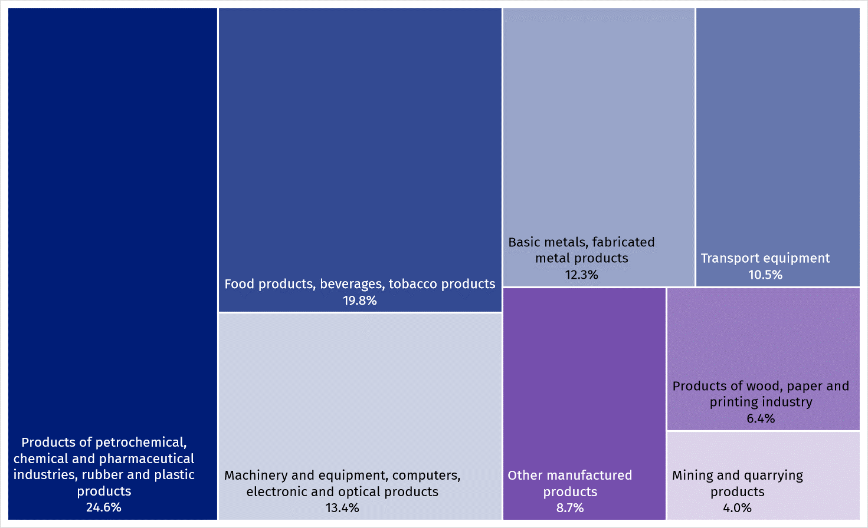

Table 1. Sold production of products by PKWiU sections and divisions (current prices)
The largest share in the value of sold production was recorded for section Food products (16.6%)

Sections and divisions | 2022
Sections and divisions | in milion PLN | in percent | 2021=100
Total | 1 872 227.2 | 100.0 | 130.4
Products of mining and quarrying | 74 045.2 | 4.0 | 193.7
of which Hard coal and lignite | 37 455.4 | 2.0 | 175.5
Manufactured products | 1 798 182.0 | 96.0 | 128.6
of which:
Food products | 309 975.6 | 16.6 | 132.8
Beverages | 41 444.0 | 2.2 | 113.9
Tobacco products | 18 526.9 | 1.0 | 107.4
Textiles | 10 954.2 | 0.6 | 99.5
Wearing apparel | 5 498.0 | 0.3 | 117.8
Leather and leather products | 3 075.5 | 0.2 | 102.0
Wood and products of wood and cork, except furniture; articles of straw and plaiting materials | 46 617.8 | 2.5 | 122.3
Paper and paper products | 69 113.4 | 3.7 | 130.6
Coke, briquette and similar solid fuels from coal and peat, refined petroleum products | 194 825.9 | 10.4 | 181.3
Chemicals and chemical products | 123 632.9 | 6.6 | 139.3
Basic pharmaceutical products, medicaments and pharmaceutical preparations | 14 314.6 | 0.8 | 119.1
Rubber and plastic products | 127 764.9 | 6.8 | 120.8
Other non-metallic mineral products | 73 763.8 | 3.9 | 122.7
Basic metals | 126 576.2 | 6.8 | 123.2

Table 1. Sold production of products by PKWiU sections and divisions (current prices) (cont.)
Sections and divisions | 2022
Sections and divisions | in milion PLN | in percent | 2021=100
Fabricated metal products, except machinery and equipment | 103 534.0 | 5.5 | 122.7
Computers, electronic and optical products | 51 379.5 | 2.7 | 107.7
Electrical equipment | 134 268.4 | 7.2 | 126.6
Machinery and equipment n.e.c. | 67 644.8 | 3.6 | 121.9
Motor vehicles, trailers and semi-trailers | 172 062.8 | 9.2 | 121.7
Other transport equipment | 24 812.2 | 1.3 | 128.5
Furniture | 54 218.6 | 2.9 | 109.6
Other manufactured goods | 15 390.1 | 0.8 | 121.9
Out of 4574 products and assortment groups of products covered by observation in physical units of measure according to the PRODPOL nomenclature, entities of the national economy reported sold production for 3584 headings. An increase in sold production was recorded for 1393 products, and a decrease for 1998.
The following were among the products with largest value of sold production: gas oils for high-speed compression ignition engines (diesel fuel); lithium-ion accumulators; parts and accessories for motor vehicles, n.e.c.; hard coal; unleaded motor gasoline; hot rolled products (excluding semi-finished products); prepared feeds for farm animals; high-methane natural gas, other than from direct extraction; television receivers with built-in digital TV tuner; goods vehicles, with compression-ignition piston engine; fresh or chilled pig meat; structures and parts of structures of iron or steel, n.e.c. (including weirs, sluices, lock-gates, etc.); cartons, boxes and cases, of corrugated paper or paperboard; fresh or chilled cuts of chicken; seats with wooden frames; cigarettes.

Manufactured production of industrial products
Out of 4574 products and assortment groups of products covered by observation in physical units of measure according to the PRODPOL nomenclature, entities of the national economy reported manufactured production for 3632 headings. Increase in manufactured production was noted in the case of 1491 products and decrease – 1960 products.

Table 2. Manufactured production of major industrial products in 2022
Specification | Volume unit | Volume | 2021=100
Hard coal | thousand  tonnes | 53 239 | 96.2
Lignite | thousand  tonnes | 54 621 | 104.3
Natural gas | cubic  hectometres | 5 172 | 98.1
Slaughter products of cattle and calves and pigs included in slaughter capacity | tonnes | 1 558 790 | 98.1
Poultry meat | tonnes | 3 349 924 | 106.1
Milk | hectolitres | 37 210 643 | 103.7
Butter | tonnes | 251 529 | 104.3
Fresh bread | tonnes | 1 449 011 | 108.1
Sugar in terms of white sugar | tonnes | 2 145 620 | 99.7
Prepared feeds for farm animals | thousand  tonnes | 11 639 | 108.5
Vodka in terms of 100% | hectolitres | 1 017 713 | 94.2
Beer from malt | hectolitres | 37 933 190 | 97.7
Cigarettes | million p/st | 231 736 | 107.4
Footwear (including rubber footwear) | thousand  pairs | 25 148 | 95.9
Sawnwood | cubic  decametres | 4 584 | 91.7
Fibreboard | thousand m² | 681 014 | 88.8
Pellets and briquettes of wood | thousand  tonnes | 1 152 | 70.7
Paper and paperboard | thousand  tonnes | 5 238 | 98.3
Coke | tonnes | 8 485 978 | 91.4
Motor gasoline (including aviation gasoline) | tonnes | 4 335 371 | 103.9
Diesel oils | tonnes | 14 587 413 | 106.9
Ethylene | tonnes | 459 065 | 131.7
Mineral or chemical fertilizers in terms of pure component, including multiingredient fertilizers | tonnes | 2 401 297 | 81.6
Pesticides | tonnes | 114 906 | 105.4

Table 2. Manufactured production of major industrial products in 2022 (cont.)
Specification | Volume unit | Volume | 2021=100
Plastics in primary forms | tonnes | 3 667 593 | 99.3
Disinfectant liquids and gels | kg | 12 629 648 | 124.6
Tires (excluding retreaded) | thousand  p/st | 53 089 | 89.3
Builders’ ware of plastic | tonnes | 1 236 616 | 98.6
Cement | thousand  tonnes | 19 503 | 99.4
Bricks | thousand bricks | 561 125 | 94.8
Crude steel | tonnes | 7 521 057 | 87.9
Hot rolled products (excluding semi-finished products) | tonnes | 7 712 606 | 83.5
Steel tubes | tonnes | 1 030 029 | 108.1
Unwrought, unalloyed refined copper | tonnes | 587 909 | 101.5
Computers | p/st | 3 368 573 | 96.0
Television receivers | thousand  p/st | 17 173 | 88.9
Accumulators for starting piston engines for motor vehicles | thousand  p/st | 5 819 | 77.3
Refrigerators and freezers, including combined refrigerators-freezers | thousand  p/st | 3 508 | 98.0
Dish washing machines | thousand  p/st | 5 581 | 94.8
Washing machines (including machines which both wash and dry) | thousand  p/st | 6 329 | 90.2
Electric cookers, including gas-electric cookers | thousand  p/st | 1 076 | 67.1
Agricultural tractors | p/st | 3 219 | 104.4
Machinery and equipment for construction, road and drainage work | tonnes | 14 265 | 117.3
Passenger cars | p/st | 255 140 | 97.9
Public transport vehicles | p/st | 5 089 | 96.9
Lorries and road tractors for semi-trailers | p/st | 223 689 | 129.0
Bicycles (including children's bicycles) | p/st | 1 337 014 | 109.0
Upholstered seats with wooden frames | p/st | 13 492 347 | 86.3

Table 2. Manufactured production of major industrial products in 2022 (cont.)
Specification | Volume unit | Volume | 2021=100
Wooden furniture for dining and living room | thousand  p/st | 39 219 | 116.4
Face masks used in medicine | p/st | 345 466 547 | 35.5
Other protective face masks | p/st | 121 903 872 | 62.9

In case of quoting Statistics Poland data, please provide information: “Source of data: Statistics Poland”, and in case of publishing calculations made on data published by Statistics Poland, please include the following disclaimer: “Own study based on figures from Statistics Poland”.

Prepared by:  Enterprises Department  Katarzyna Walkowska  Phone: (+48 22) 608 31 25 | Issued by:  The Spokesperson for the President  of Statistics Poland  Karolina Banaszek  Phone: (+48) 695 255 011
Press Office  Phone: (+48 22) 608 38 04  e-mail: obslugaprasowa@stat.gov.pl |   stat.gov.pl/en/

@StatPoland

@GlownyUrzadStatystyczny

gus_stat

glownyurzadstatystycznygus

glownyurzadstatystyczny
Related information
Production of industrial products in 2021
Production of major industrial products
Production of industrial products 2017-2021
Data available in databases
Knowledge Databases Industry
Terms used inn official statistics
Sold production of industry products
Manufactured production
Finished products

Data refer to enterprises in which the number of persons employed is 10 and more

