Human resources in selected medical professions based on administrative sources in 2022
The study is the result of an analysis of administrative sources, including registers,
in relation to four medical professions: doctors, dentists, nurses and midwives. It showcases the resulting statistical data for the resources of the medical staff, as well as methodological information describing the assumptions of the method based only on several administrative sources obtained by official, public statistics.
In 2022, the number of doctors working directly with their patients amounted to 35.1 per 10 thousand population, while in case of dentists the number was 9.3

In 2022, the number of doctors working directly with patients was 132,527, dentists – 35,016, nurses – 215,064 and midwives – 28,534.

Persons authorized to practice medical professions (doctors, dentists,
nurses and midwives)
An increase in the number
of doctors with a license
to practice by 3.3 thousand
in 2022 compared to 2021
In 2022, the number of doctors living in Poland with a license to practice their profession amounted to 158.9 thousand (in 2021 – 155.6 thousand).
Among doctors authorized to practice, the dominant group – over 20% – were people aged 50-59 (similarly to the previous year). The dominance of this age group was greater among men than among women doctors.

Table 1. Doctors entitled to perform proffesion by sex and age
As of 31 December
Specification | 2021 |  |  |  | 2022
Specification | total |  | males | females | total |  | males | females
Specification | in thousands | in % | in thousands |  | in thousands | in % | in thousands
Grand total | 155,6 | 100,0 | 63,5 | 92,1 | 158,9 | 100,0 | 64,4 | 94,5
to 29 years | 18,2 | 11,7 | 6,8 | 11,5 | 16,9 | 10,6 | 6,3 | 10,6
30–39 | 28,5 | 18,3 | 10,5 | 18,0 | 30,8 | 19,4 | 11,3 | 19,5
40–49 | 23,3 | 15,0 | 9,8 | 13,5 | 22,6 | 14,2 | 9,1 | 13,5
50–59 | 32,0 | 20,5 | 14,8 | 17,2 | 32,1 | 20,2 | 14,7 | 17,3
60–69 | 29,1 | 18,7 | 12,6 | 16,5 | 30,1 | 19,0 | 13,2 | 17,0
70–79 | 14,4 | 9,2 | 5,4 | 9,0 | 16,0 | 10,1 | 6,2 | 9,9
80 years and more | 10,2 | 6,5 | 3,6 | 6,5 | 10,5 | 6,6 | 3,7 | 6,8

Differences in the age structure of male and female physicians were reported. Among men, the dominant group (approximately 23% in both analyzed years) were people aged 50–59, while among women, people aged 30–39 dominated (approximately 20% in both analyzed years).

Chart 1. Structure of doctors entitled to perform profession by sex and age
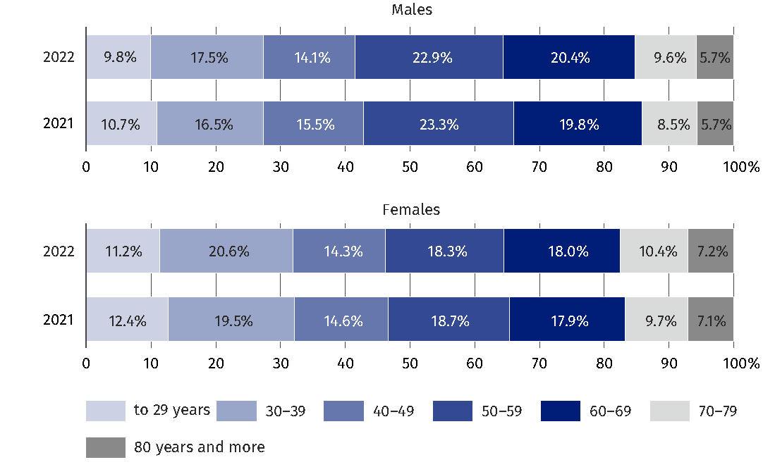
As of 31 December

In 2022, the number of dentists living in Poland with the legal right to practice their profession was 44.3 thousand (in 2021 – 43.8 thousand), of which 592 people were authorized to practice medicine both as a doctor and a dentist.
An increase in the number
of dentists with a license
to practice by 0.5 thousand
in 2022 compared to 2021
Among dentists authorized to practice their profession the largest group represented people aged 30-39 (21.0% in 2022 – 0.3 percentage points more than in 2021), although the group
of people aged 50–59 was only slightly smaller and amounted to 20.8% in 2022
(0.4 percentage points more than in the previous year).

Table 2. Dentists entitled to perform profession by sex and age
As of 31 December
Specification | 2021 |  |  |  | 2022
Specification | total |  | males | females | total |  | males | females
Specification | in thousands | in % | in thousands |  | in thousands | in % | in thousands
Grand total | 43,8 | 100,0 | 10,4 | 33,4 | 44,3 | 100,0 | 10,5 | 33,8
to 29 years | 5,2 | 12,0 | 1,4 | 3,8 | 4,6 | 10,3 | 1,2 | 3,4
30–39 | 9,1 | 20,7 | 2,6 | 6,5 | 9,3 | 21,0 | 2,6 | 6,7
40–49 | 7,9 | 18,0 | 2,2 | 5,7 | 7,9 | 17,8 | 2,3 | 5,6
50–59 | 8,9 | 20,4 | 2,0 | 6,9 | 9,2 | 20,8 | 2,1 | 7,1
60–69 | 6,1 | 13,9 | 1,3 | 4,8 | 6,3 | 14,2 | 1,4 | 4,9
70–79 | 3,7 | 8,5 | 0,5 | 3,2 | 4,0 | 9,1 | 0,6 | 3,5
80 years and more | 2,9 | 6,6 | 0,3 | 2,6 | 3,0 | 6,7 | 0,3 | 2,6

A clear distinction in the age structure between female and male dentists was noted: among men, the dominant group (about 25% in both analyzed years) were people aged 30–39, while among women, dentists aged 50–59 were dominant (about 21% in both analyzed years).
Chart 2. Structure of dentists entitled to perform profession by sex and age
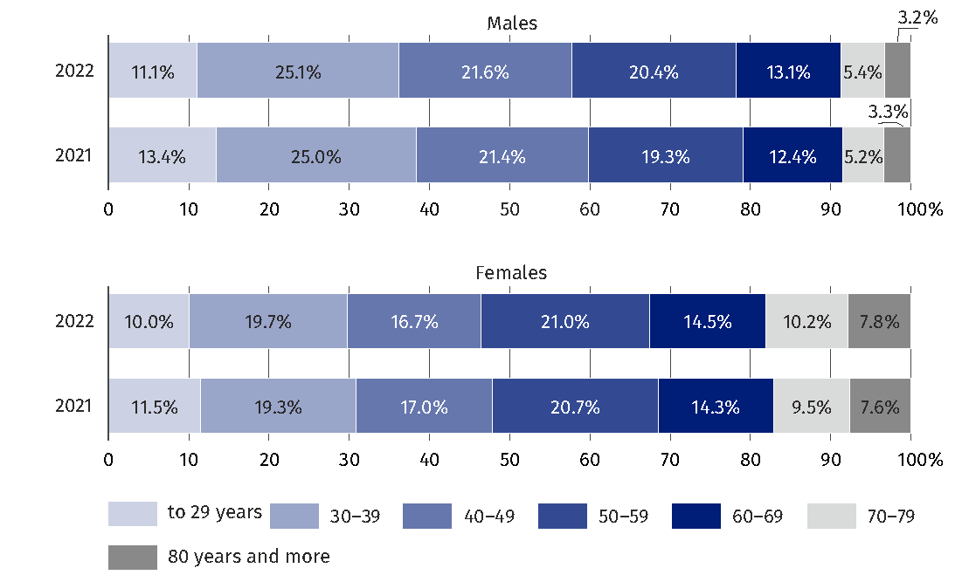
As of 31 December

Similarly to the previous year, in 2022 feminization of doctor and dentist professions was observed, although it was much more evident among dentists than among doctors. In 2022, women represented 59.5% of doctors, while in the group of dentists, 76.3% of them were women.
In 2022, the number of nurses living in Poland and having the right to practice was 310.0 thousand (in 2021 – 305.8 thousand).
An increase in the number of nurses with a license to practice by 4.2 thousand in 2022 compared to 2021

Among people entitled to practice this profession, the dominant group, almost 1/3 of the total, were people aged 50–59. Among the nurses, women were definitely dominant (97.2% in 2022) and the number of male nurses, especially in older age groups (over 60), was negligible.

Table 3. Nurses entitled to perform profession by sex and age
As of 31 December
Specification | 2021 |  |  |  | 2022
Specification | total |  | males | females | total |  | males | females
Specification | in thousands | in % | in thousands |  | in thousands | in % | in thousands
Grand total | 305,8 | 100,0 | 8,2 | 297,7 | 310,0 | 100,0 | 8,7 | 301,3
to 29 years | 23,4 | 7,7 | 1,5 | 22,0 | 22,5 | 7,2 | 1,4 | 21,1
30–39 | 26,2 | 8,6 | 2,5 | 23,7 | 27,9 | 9,0 | 2,6 | 25,3
40–49 | 68,3 | 22,3 | 2,3 | 66,0 | 55,3 | 17,8 | 2,5 | 52,8
50–59 | 96,1 | 31,4 | 1,3 | 94,8 | 98,0 | 31,6 | 1,5 | 96,4
60–69 | 73,7 | 24,1 | 0,5 | 73,2 | 79,2 | 25,5 | 0,6 | 78,6
70–79 | 17,1 | 5,6 | 0,0 | 17,0 | 25,5 | 8,2 | 0,1 | 25,5
80 years and more | 1,0 | 0,3 | 0,0 | 1,0 | 1,7 | 0,5 | 0,0 | 1,7

Among nurses, differences in the age structure of men and women were also observed: among men, the dominant group (over 30% in both analyzed years) were people in two age groups: 30–39 years and 40–49 years (over 28%), while among women people aged 50–59 definitely dominated (about 32% in both analyzed years).

Chart 3. Structure of nurses entitled to perform profession by sex and age
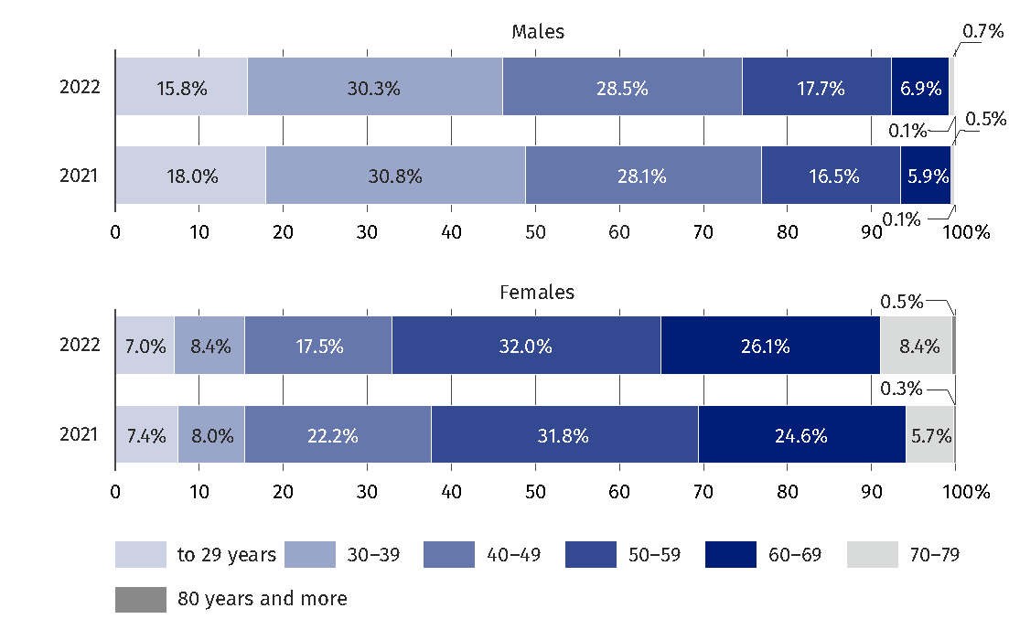
As of 31 December

In 2022, the number of midwives living in Poland and having the right to practice
the profession amounted to 41.1 thousand (in 2021 – 40.3 thousand).
An increase in the number of midwives with a license to practice by 0.7 thousand in 2022 compared to 2021

Among midwives entitled to practice the profession, as in the case of nurses, the dominant group represented people aged 50–59 (29.5% in 2022 and 30.1% in 2021).

Table 4. Midwives entitled to perform profession by sex and age
As of 31 December
Specification | 2021 |  |  |  | 2022
Specification | total |  | males | females | total |  | males | females
Specification | in thousands | in % | in thousands |  | in thousands | in % | in thousands
Grand total | 40,3 | 100,0 | 0,1 | 40,3 | 41,1 | 100,0 | 0,1 | 41,0
to 29 years | 5,8 | 14,3 | 0,0 | 5,8 | 5,6 | 13,5 | 0,0 | 5,6
30–39 | 4,5 | 11,2 | 0,0 | 4,5 | 4,9 | 12,0 | 0,0 | 4,9
40–49 | 7,4 | 18,3 | 0,0 | 7,4 | 6,1 | 14,9 | 0,0 | 6,1
50–59 | 12,2 | 30,1 | 0,0 | 12,2 | 12,1 | 29,5 | 0,0 | 12,1
60–69 | 8,1 | 20,2 | 0,0 | 8,1 | 9,1 | 22,2 | 0,0 | 9,1
70–79 | 2,2 | 5,5 | 0,0 | 2,2 | 3,0 | 7,2 | 0,0 | 3,0
80 years and more | 0,2 | 0,4 | 0,0 | 0,2 | 0,3 | 0,7 | 0,0 | 0,3

The vast majority of midwives were women (99.8% in both analyzed years). The total number of men working in this profession in 2022 was 78, in 2021 – 76, therefore the data
of men from this occupational group was limited to general data.

Chart 4. Structure of midwives entitled to perform profession by sex and age
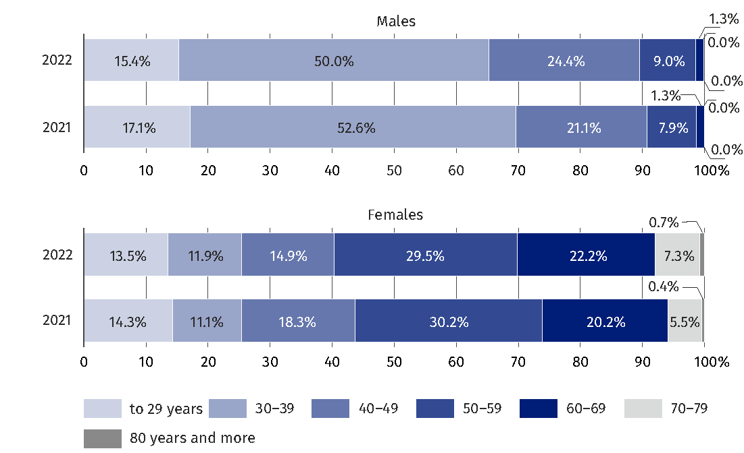
As of 31 December

Medical staff working directly with the patient (doctors, dentists, nurses and midwives)
The overall population of doctors and dentists authorized to practice their professions
in Poland includes all persons with such a right, regardless of their status on the labor market and place of work, therefore the number of persons working directly with the patient is more reliable data.
An increase in the number of doctors working directly with patients by 2.6 thousand and dentists by 0.1 thousand in 2022 compared to 2021
In 2022, the number of doctors working directly with patients amounted to – 132.5 thousand (129.9 thousand in 2021).

Table 5. Doctors working directly with patient by sex and age
As of 31 December
Specification | 2021 |  |  |  | 2022
Specification | total |  | males | females | total |  | males | females
Specification | in thousands | in % | in thousands |  | in thousands | in % | in thousands
Grand total | 129,9 | 100,0 | 54,4 | 75,5 | 132,5 | 100,0 | 54,9 | 77,6
to 29 years | 16,6 | 12,8 | 6,2 | 10,4 | 15,1 | 11,4 | 5,7 | 9,4
30–39 | 27,0 | 20,8 | 10,0 | 17,0 | 29,2 | 22,0 | 10,7 | 18,5
40–49 | 21,7 | 16,7 | 9,1 | 12,6 | 20,8 | 15,7 | 8,3 | 12,5
50–59 | 29,5 | 22,7 | 13,6 | 15,9 | 29,4 | 22,2 | 13,4 | 16,0
60–69 | 25,1 | 19,3 | 11,1 | 14,0 | 26,2 | 19,7 | 11,6 | 14,5
70–79 | 8,3 | 6,4 | 3,5 | 4,8 | 9,9 | 7,5 | 4,2 | 5,7
80 years and more | 1,7 | 1,3 | 0,8 | 0,9 | 2,0 | 1,5 | 0,9 | 1,0

Among physicians working directly with patients in 2022, the largest group (22.2%) were people aged 50–59 (a year earlier – about 22.7%). It was also the largest group among men – – 24.4% (0.7 percentage points less than in 2021). In the case of women, in 2022 the largest group were people aged 30–39 (23.8% – 1.3 percentage points more than in 2021).
The second, similarly numerous part of the structure among female doctors represented people aged 50–59 (20.6% in 2022, 0.5 percentage points less than in the previous analyzed year).

Chart 5. Structure of doctors working directly with patient by sex and age
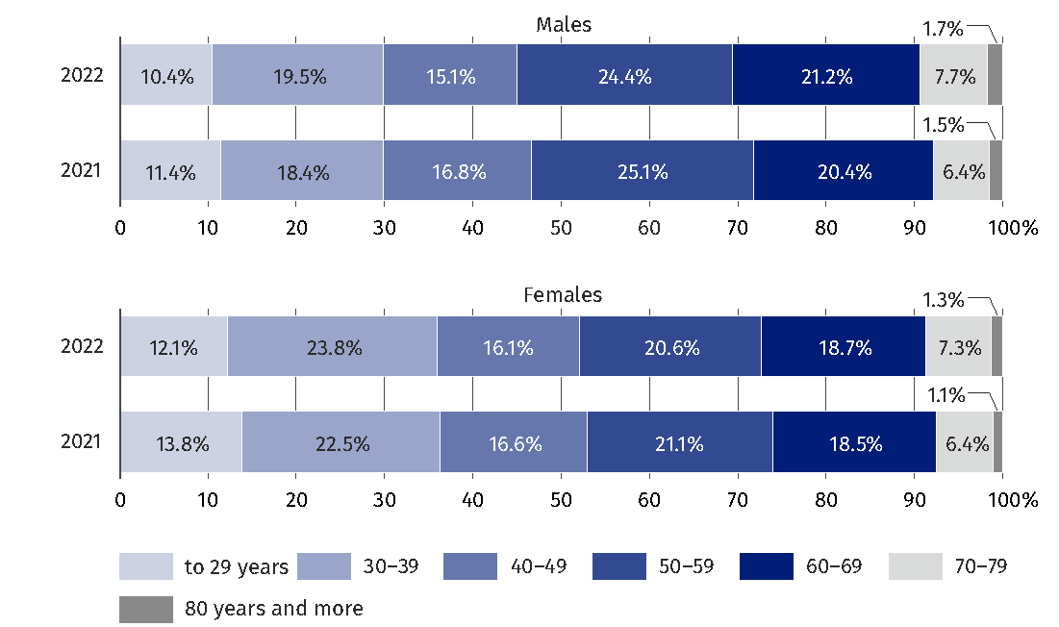
As of 31 December

In 2022, the number of dentists working directly with the patient amounted to – 35.0 thousand (34.9 thousand in 2021).

Table 6. Dentists working directly with patient by sex and age
As of 31 December
Specification | 2021 |  |  |  | 2022
Specification | total |  | males | females | total |  | males | females
Specification | in thousands | in % | in thousands |  | in thousands | in % | in thousands
Grand total | 34,9 | 100,0 | 9,1 | 25,8 | 35,0 | 100,0 | 9,1 | 25,9
to 29 years | 5,0 | 14,2 | 1,3 | 3,6 | 4,3 | 12,3 | 1,1 | 3,2
30–39 | 8,5 | 24,4 | 2,5 | 6,0 | 8,7 | 24,8 | 2,5 | 6,2
40–49 | 7,3 | 20,9 | 2,1 | 5,2 | 7,2 | 20,5 | 2,1 | 5,1
50–59 | 8,3 | 23,7 | 1,8 | 6,4 | 8,4 | 24,0 | 1,9 | 6,5
60–69 | 4,5 | 12,9 | 1,1 | 3,4 | 4,8 | 13,6 | 1,2 | 3,6
70–79 | 1,2 | 3,5 | 0,3 | 1,0 | 1,5 | 4,3 | 0,3 | 1,2
80 years and more | 0,1 | 0,4 | 0,0 | 0,1 | 0,2 | 0,5 | 0,0 | 0,1

Among dentists working directly with the patient in 2022, the largest number of people belonged to the 30–39 age group (24.8%, a year earlier – 24.4%) and this group was also
the largest among men (27.2% and in the previous year – 27.3%). Among women, the largest group in the analyzed medical profession were people aged 50–59, which accounted
for 24.9% in both analyzed years.

Chart 6. Structure of dentist working directly with patient by sex and age
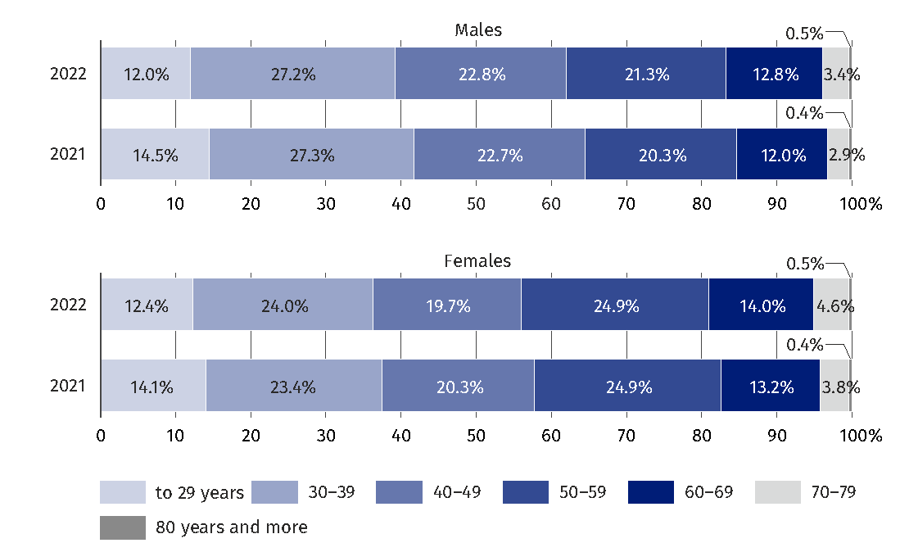
As of 31 December

Similarly to the overall group of people licensed to practice a medical profession, the feminization of the professions of doctors and dentists working directly with the patient was observed, more pronounced among dentists (74.0% of women in 2022 – 0.1 percentage point more in the previous year), than among doctors, where women accounted for more than 58% in both years.
In 2022, the number of nurses working directly with patients was 215.1 thousand (214.5 thousand in 2021).
An increase in the number of nurses working directly with the patient by 0.5 thousand in 2022 compared to 2021

Table 7. Nurses working directly with patient by sex and age
As of 31 December
Specification | 2021 |  |  |  | 2022
Specification | total |  | males | females | total |  | males | females
Specification | in thousands | in % | in thousands |  | in thousands | in % | in thousands
Grand total | 214,5 | 100,0 | 6,5 | 208,0 | 215,1 | 100,0 | 7,0 | 208,1
to 29 years | 20,8 | 9,7 | 1,3 | 19,5 | 19,8 | 9,2 | 1,2 | 18,6
30–39 | 22,1 | 10,3 | 2,2 | 20,0 | 24,4 | 11,3 | 2,3 | 22,0
40–49 | 56,3 | 26,2 | 1,8 | 54,5 | 45,6 | 21,2 | 1,9 | 43,7
50–59 | 81,6 | 38,0 | 1,0 | 80,6 | 84,2 | 39,1 | 1,1 | 83,0
60–69 | 31,8 | 14,8 | 0,3 | 31,5 | 37,9 | 17,6 | 0,4 | 37,6
70–79 | 1,9 | 0,9 | 0,0 | 1,9 | 3,2 | 1,5 | 0,0 | 3,2
80 years and more | 0,0 | 0,0 | 0,0 | 0,0 | 0,0 | 0,0 | 0,0 | 0,0

Among all nurses working directly with patients in 2022, the largest group (39.1%) represented people aged 50-59 (a year earlier – about 38.0%).

Chart 7. Structure of nurses working directly with patient by sex and age
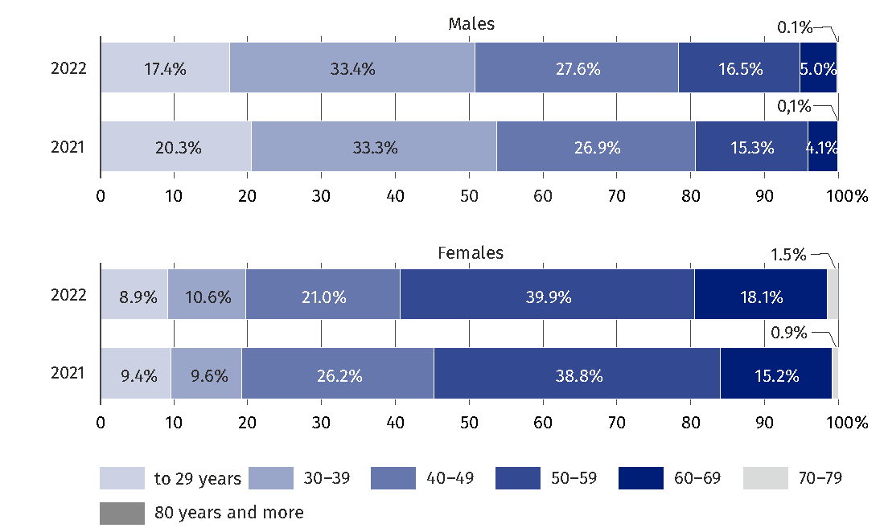
As of 31 December

Among women working as nurses, the largest group was also people aged 50–59, which accounted for 39.9% in 2022 and 38.8% a year earlier. On the other hand, among men, people aged 30–39 were the most numerous (33.4%, 0.1 percentage point more than a year earlier).
In 2022, the number of midwives working directly with the patient was 28.5 thousand (28.4 thousand in 2021).
An increase in the number of midwives working directly with the patient by 0.1 thousand in 2022 compared to 2021
The total number of men working directly with the patient in this profession in 2022 was 61 people, in 2021 – 57, therefore the data of men from this occupational group were limited to general data.

Table 8. Midwives working directly with patient by sex and age
As of 31 December
Specification | 2021 |  |  |  | 2022
Specification | total |  | males | females | total |  | males | females
Specification | in thousands | in % | in thousands |  | in thousands | in % | in thousands
Grand total | 28,4 | 100,0 | 0,1 | 28,3 | 28,5 | 100,0 | 0,1 | 28,5
to 29 years | 4,8 | 16,9 | 0,0 | 4,8 | 4,5 | 15,9 | 0,0 | 4,5
30–39 | 3,6 | 12,8 | 0,0 | 3,6 | 4,2 | 14,5 | 0,0 | 4,1
40–49 | 5,8 | 20,4 | 0,0 | 5,8 | 4,8 | 16,7 | 0,0 | 4,8
50–59 | 10,2 | 35,8 | 0,0 | 10,2 | 10,1 | 35,4 | 0,0 | 10,1
60–69 | 3,7 | 13,1 | 0,0 | 3,7 | 4,6 | 16,0 | 0,0 | 4,6
70–79 | 0,3 | 1,0 | 0,0 | 0,3 | 0,4 | 1,4 | 0,0 | 0,4
80 years and more | 0,0 | 0,0 | 0,0 | 0,0 | 0,0 | 0,0 | 0,0 | 0,0

Similarly to the overall group of people with the right to practice as a nurse or midwife, there was a dominant share of women practicing this profession and working directly
with the patient, which was much more evident among midwives (of which 99.8% were women in both years) than among nurses, where women accounted for 96.8% in 2022,
– 0.2 percentage points less in 2021.

Chart 8. Structure of midwives working directly with patient by sex and age
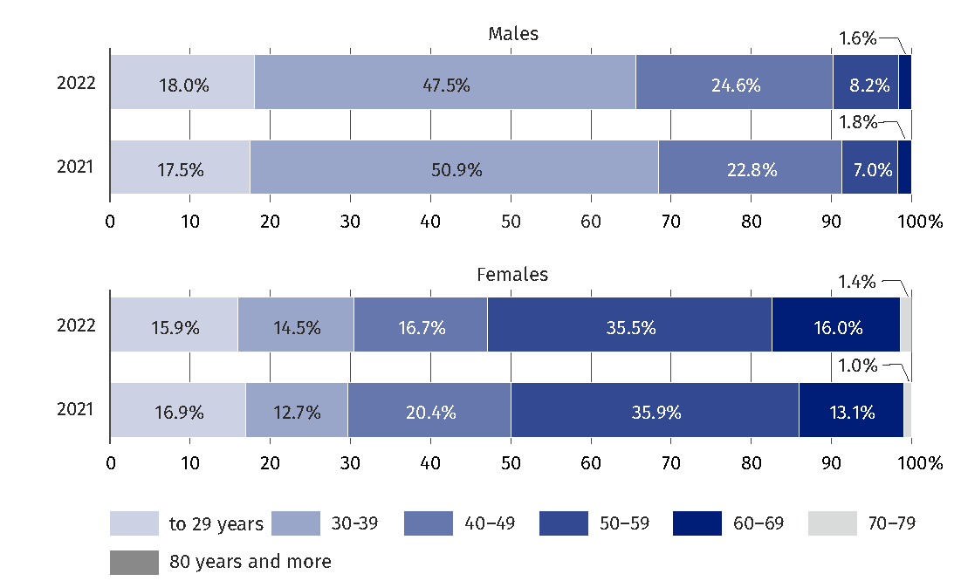
As of 31 December

Due to minor differences between 2021 and 2022, the description of medical professions analyzed by voivodships applies only to 2022, while the tables (for comparison) also show data for 2021.

Table 9. Doctors working directly with patient by voivodships
As of 31 December
Voivodships | 2021 |  |  | 2022
Voivodships | in thousands | in % | per 10 000 population | in thousands | in % | per 10 000 population
Poland | 129,9 | 100,0 | 34,3 | 132,5 | 100,0 | 35,1
Dolnośląskie | 10,6 | 8,1 | 36,4 | 10,8 | 8,2 | 37,5
Kujawsko-pomorskie | 5,9 | 4,6 | 29,3 | 6,1 | 4,6 | 30,3
Lubelskie | 7,4 | 5,7 | 36,5 | 7,8 | 5,9 | 38,6
Lubuskie | 2,3 | 1,8 | 23,3 | 2,3 | 1,7 | 23,8
Łódzkie | 9,7 | 7,5 | 40,5 | 10,2 | 7,7 | 42,8
Małopolskie | 11,8 | 9,1 | 34,4 | 12,3 | 9,3 | 35,9
Mazowieckie | 23,9 | 18,4 | 43,3 | 22,8 | 17,2 | 41,4
Opolskie | 2,3 | 1,8 | 24,4 | 2,3 | 1,7 | 24,3
Podkarpackie | 5,5 | 4,3 | 26,6 | 5,9 | 4,5 | 28,3
Podlaskie | 4,3 | 3,3 | 37,6 | 4,6 | 3,5 | 39,9
Pomorskie | 8,1 | 6,2 | 34,4 | 8,4 | 6,3 | 35,7
Śląskie | 15,6 | 12,0 | 35,6 | 16,2 | 12,2 | 37,3
Świętokrzyskie | 3,6 | 2,8 | 30,1 | 3,7 | 2,8 | 31,2
Warmińsko-mazurskie | 3,4 | 2,7 | 25,1 | 3,5 | 2,6 | 25,7
Wielkopolskie | 10,1 | 7,8 | 28,8 | 10,2 | 7,7 | 29,3
Zachodniopomorskie | 5,3 | 4,1 | 32,2 | 5,4 | 4,1 | 32,7

In 2022, the largest number of doctors worked directly with the patient in the 2 largest voivodships: Mazowieckie – 22.8 thousand; and Śląskie – 16.2 thousand and the least
in the following voivodships: Lubuskie and Opolskie (2.3 thousand each).

With regard to the number of inhabitants in 2022, the following voivodships were ranked first: Łódzkie and Mazowieckie (42.8 and 41.4 doctors per 10,000 population, respectively). The smallest number of doctors per 10,000 population in 2022 occurred in the following voivodships: Lubuskie (23.8) and Opolskie (24.3), which belong to the group of smaller voivodships with a relatively small number of population in cities, which are the government seats of voivodship authorities, other than them also Warmińsko-Mazurskie (25.7)
and Podkarpackie (28.3).

Map 1. Doctors working directly with patient per 10 thousand of the population
by voivodships in 2022
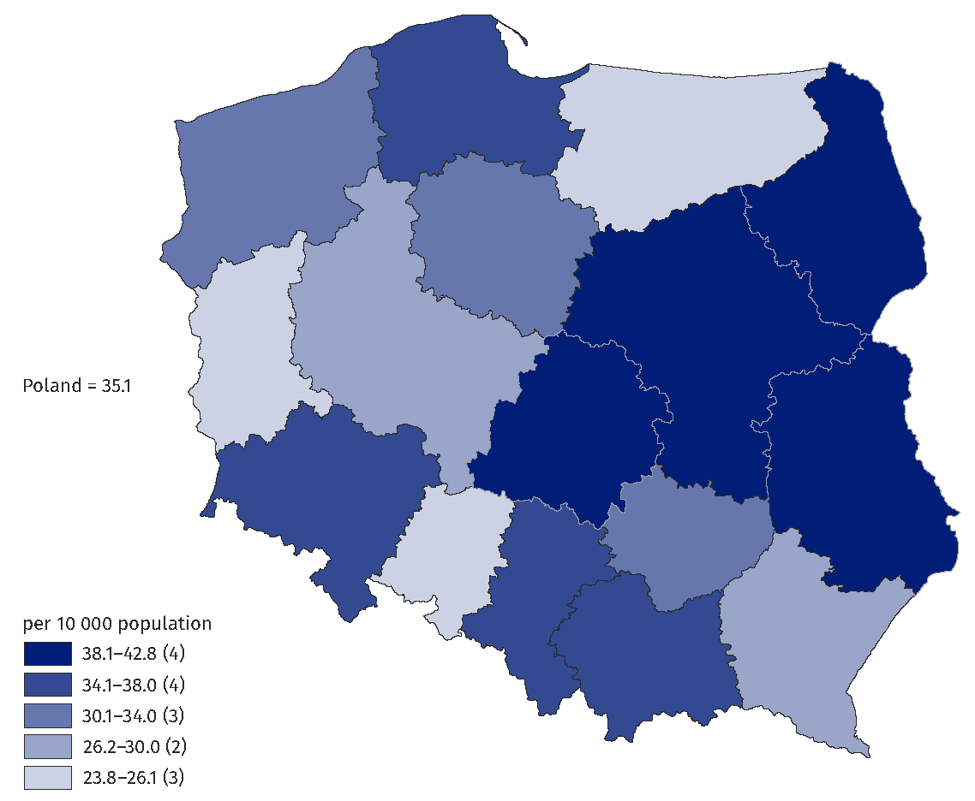
As of 31 December

Among dentists, in 2022, the largest number of people worked directly with the patient
in the following voivodships: Mazowieckie (6.0 thousand) and Śląskie (3.8 thousand)
and the least in the following voivodships: Opolskie and Lubuskie (0.7 thousand each).

Table 10. Dentists working directly with patient by voivodships
As of 31 December
Voivodships | 2021 |  |  | 2022
Voivodships | in thousands | in % | per 10 000 population | in thousands | in % | per 10 000 population
Poland | 34,9 | 100,0 | 9,2 | 35,0 | 100,0 | 9,3
Dolnośląskie | 3,0 | 8,5 | 10,2 | 3,0 | 8,5 | 10,3
Kujawsko-pomorskie | 1,2 | 3,5 | 6,1 | 1,2 | 3,5 | 6,1
Lubelskie | 2,0 | 5,8 | 9,9 | 2,0 | 5,8 | 10,0
Lubuskie | 0,7 | 2,1 | 7,4 | 0,7 | 2,1 | 7,4
Łódzkie | 2,6 | 7,6 | 11,0 | 2,6 | 7,6 | 11,1
Małopolskie | 3,2 | 9,2 | 9,3 | 3,3 | 9,4 | 9,6
Mazowieckie | 6,0 | 17,2 | 10,9 | 6,0 | 17,0 | 10,8
Opolskie | 0,7 | 1,9 | 7,0 | 0,7 | 1,9 | 7,0
Podkarpackie | 1,7 | 4,7 | 7,9 | 1,6 | 4,7 | 7,9
Podlaskie | 1,2 | 3,5 | 10,7 | 1,2 | 3,5 | 10,8
Pomorskie | 2,2 | 6,4 | 9,4 | 2,3 | 6,5 | 9,7
Śląskie | 3,8 | 10,9 | 8,7 | 3,9 | 11,1 | 8,9
Świętokrzyskie | 1,0 | 2,8 | 8,3 | 1,0 | 2,8 | 8,2
Warmińsko-mazurskie | 0,9 | 2,7 | 6,7 | 0,9 | 2,5 | 6,5
Wielkopolskie | 2,9 | 8,4 | 8,4 | 2,9 | 8,4 | 8,4
Zachodniopomorskie | 1,7 | 4,8 | 10,1 | 1,7 | 10,3 | 10,3

With regard to the number of population – in 2022 the largest number of dentists working directly with the patient was in the following voivodships: Łódzkie (11.1), followed by: Podlaskie and Mazowieckie (10.8 dentists each) and the lowest in the Kujawsko-Pomorskie voivodships (6.1 dentists per 10,000 population) and Warmińsko-Mazurskie (6.5).

Map 2. Dentists working directly with patient per 10 thousand of the population
by voivodships in 2022
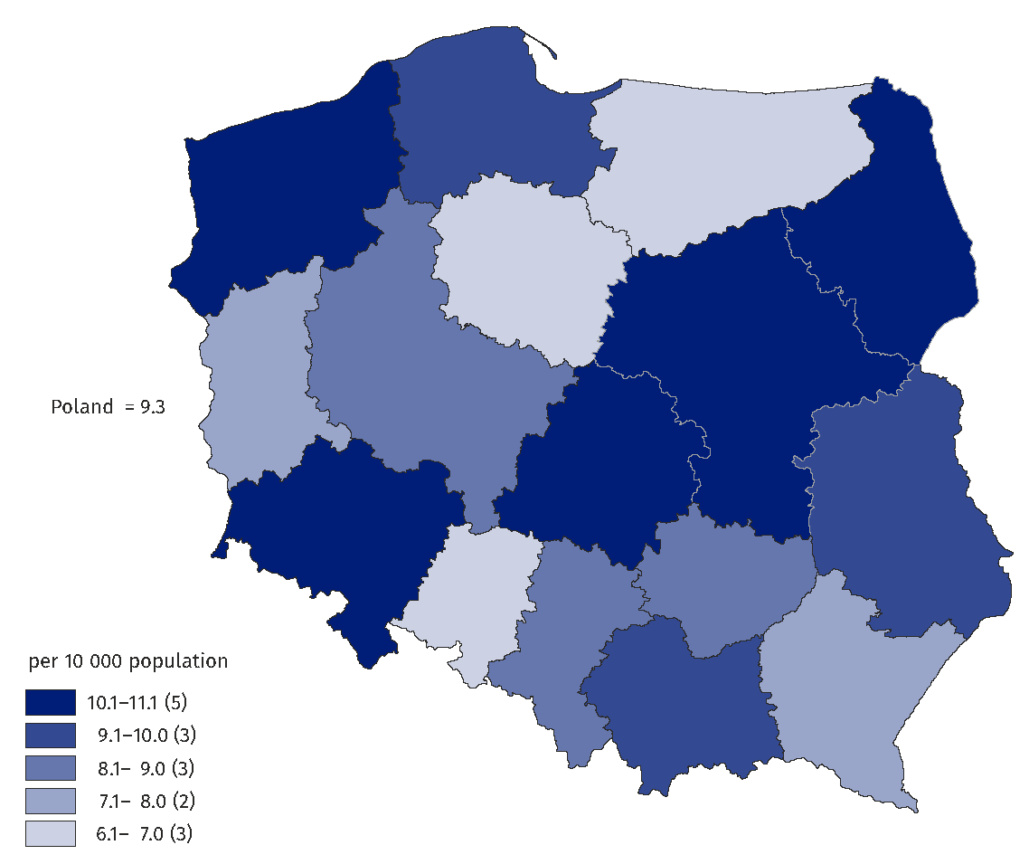
As of 31 December

Among nurses working directly with patients, the largest number in 2022 was recorded
in the following voivodships: Mazowieckie (34.9 thousand) and Śląskie (25.0 thousand).
The lowest number of nurses working directly with the patient was in the smallest voivodships: Lubuskie (4.1 thousand) and Opolskie (4.7 thousand).

Table 11. Nurses working directly with patient by voivodships
As of 31 December
Voivodships | 2021 |  |  | 2022
Voivodships | in thousands | in % | per 10 000 population | in thousands | in % | per 10 000 population
Poland | 214,5 | 100,0 | 56,6 | 215,1 | 100,0 | 56,9
Dolnośląskie | 16,3 | 7,6 | 56,3 | 15,8 | 7,4 | 54,8
Kujawsko-pomorskie | 11,0 | 5,1 | 54,3 | 10,2 | 4,8 | 50,9
Lubelskie | 13,7 | 6,4 | 67,1 | 13,7 | 6,4 | 67,8
Lubuskie | 4,6 | 2,1 | 46,4 | 4,1 | 1,9 | 41,6
Łódzkie | 12,9 | 6,0 | 53,7 | 14,5 | 6,8 | 61,0
Małopolskie | 19,5 | 9,1 | 56,7 | 21,0 | 9,8 | 61,4
Mazowieckie | 33,7 | 15,7 | 61,1 | 34,9 | 16,2 | 63,4
Opolskie | 5,2 | 2,4 | 54,9 | 4,7 | 2,2 | 49,9
Podkarpackie | 13,5 | 6,3 | 64,5 | 12,8 | 5,9 | 61,3
Podlaskie | 7,0 | 3,3 | 60,8 | 7,4 | 3,4 | 64,6
Pomorskie | 10,8 | 5,0 | 45,6 | 12,8 | 6,0 | 54,3
Śląskie | 26,6 | 12,4 | 60,8 | 25,0 | 11,6 | 57,5
Świętokrzyskie | 8,1 | 3,8 | 68,3 | 7,6 | 3,5 | 64,5
Warmińsko-mazurskie | 7,2 | 3,3 | 52,1 | 6,0 | 2,8 | 44,0
Wielkopolskie | 16,8 | 7,8 | 48,0 | 16,4 | 7,6 | 47,0
Zachodniopomorskie | 7,9 | 3,7 | 48,0 | 8,1 | 3,8 | 49,2

The largest number of nurses working directly with the patient per 10,000 population in 2022 occurred in the following voivodships: Lubelskie (67.8 nurses), Podlaskie (64.6)
and Świętokrzyskie (64.5) and the lowest in the following voivodships: Lubuskie (41.6), Warmińsko-Mazurskie (44.0) and Wielkopolskie (47.0).

Map 3. Nurses working directly with patient per 10 thousand of the population
by voivodships in 2022
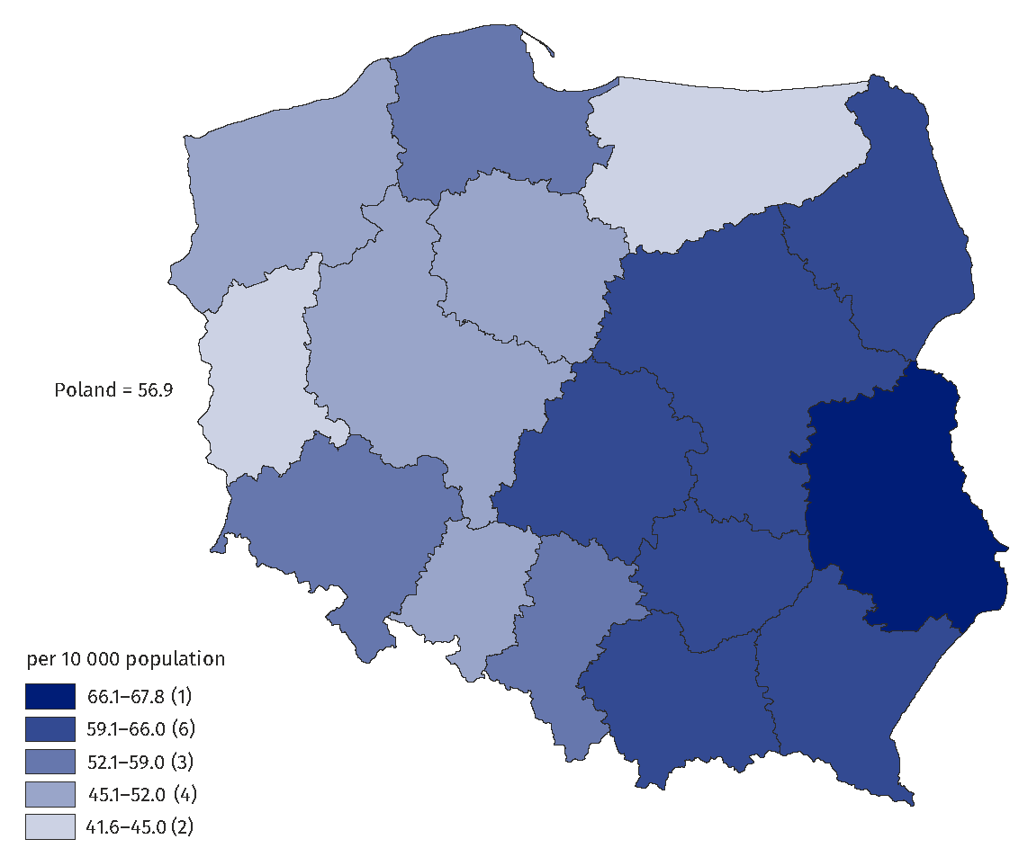
As of 31 December

Among midwives, in 2022 the largest number of people worked directly with the patient
in the following voivodships: Mazowieckie (4.8 thousand people), Śląskie (3.3 thousand)
and Wielkopolskie (2.8 thousand) and the least in Lubuskie (0.5 thousand), Opolskie
and Warmińsko-Mazurskie (0.6 thousand midwives each).

Table 12. Midwives working directly with patient by voivodships
As of 31 December
Voivodships | 2021 |  |  | 2022
Voivodships | in thousands | in % | per 10 000 females | in thousands | in % | per 10 000 females
Poland | 28,4 | 100,0 | 14,4 | 28,5 | 100,0 | 14,6
Dolnośląskie | 1,8 | 6,5 | 12,3 | 2,0 | 6,9 | 13,2
Kujawsko-pomorskie | 1,4 | 5,1 | 13,6 | 1,1 | 4,0 | 11,0
Lubelskie | 1,8 | 6,4 | 16,9 | 1,8 | 6,4 | 17,4
Lubuskie | 0,6 | 2,0 | 10,8 | 0,5 | 1,6 | 9,0
Łódzkie | 2,0 | 7,2 | 16,1 | 2,2 | 7,6 | 17,5
Małopolskie | 2,6 | 9,1 | 14,7 | 2,4 | 8,5 | 13,7
Mazowieckie | 4,3 | 15,0 | 15,1 | 4,8 | 17,0 | 16,9
Opolskie | 0,6 | 2,2 | 12,5 | 0,6 | 2,3 | 13,2
Podkarpackie | 1,8 | 6,5 | 17,1 | 1,6 | 5,6 | 15,2
Podlaskie | 1,0 | 3,5 | 16,5 | 0,9 | 3,3 | 16,0
Pomorskie | 1,4 | 5,1 | 12,0 | 1,7 | 6,9 | 13,9
Śląskie | 3,3 | 11,5 | 14,1 | 3,3 | 11,6 | 14,7
Świętokrzyskie | 1,0 | 3,5 | 16,0 | 1,0 | 3,4 | 16,1
Warmińsko-mazurskie | 0,8 | 2,9 | 11,4 | 0,6 | 2,2 | 9,0
Wielkopolskie | 2,8 | 9,9 | 15,7 | 2,8 | 9,8 | 15,5
Zachodniopomorskie | 1,1 | 3,8 | 12,4 | 1,1 | 3,9 | 13,2

With regard to the number of population (females) – in 2022, the largest number of midwives occurred in the following voivodships: Łódzkie (17.5 people per 10,000 population – females), Lubelskie (17.4) and Mazowieckie (16.9 people) and the lowest in the following voivodships: Lubuskie, Warmińsko-Mazurskie (9.0 each) and Kujawsko-Pomorskie (11.0 midwives per 10,000 population – females in the voivodship).

Map 4. Midwives working directly with patient per 10 thousand females by voivodships
in 2022
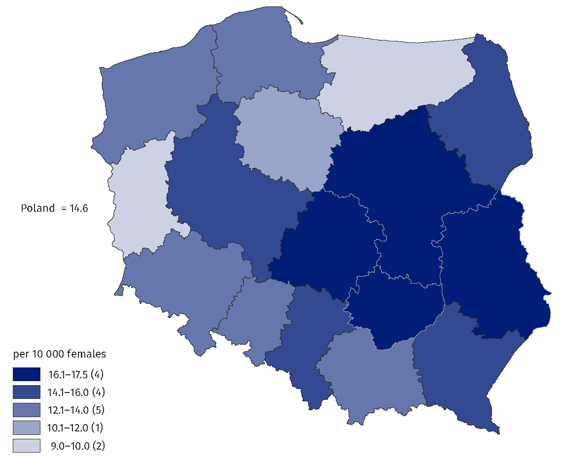
As of 31 December

Specialties of physicians authorized to practice or working directly with patients
Within the group of physicians authorized to practice, the number of specialist physicians in 2022 was 102.9 thousand, which accounted for 64.7% of the total number of physicians
(in 2021 – 101.4 thousand, or 65.2% of the total number of physicians), while among dentists, the number of specialists amounted in 2022 to 8.6 thousand (19.4%), similar to the previous year.
Among doctors working directly with patients, there were 88.2 thousand specialists
in 2022 (66.6%), while 87.3 thousand a year earlier. Among dentists the number
of specialists was 6.4 thousand (18.2%), 0.1 thousand higher than the previous year
(6.3 thousand).
In 2021–2022, the largest number of doctors (more than 18 thousand in each of the years shown) had a specialization in internal medicine. In second place was family medicine
(10.6 thousand in 2022 and 10.1 thousand the year before) and the next was pediatrics
(more than 7 thousand in both years analyzed).

Table 13. Most common specializations of doctors working directly with patient
As of 31 December
Specializations | 2021 |  | 2022
Specializations | in thousands | in % of all specialist doctors | in thousands | in % of all specialist doctors
Internal diseases | 18,0 | 20,6 | 18,1 | 20,5
Family medicine | 10,1 | 11,6 | 10,6 | 12,0
Paediatrics | 7,1 | 8,1 | 7,2 | 8,2
Obstetrics and gynaecology | 6,1 | 7,0 | 6,1 | 6,9
General surgery | 5,8 | 6,6 | 5,7 | 6,5
Anaesthesiology and intensive care | 5,4 | 6,2 | 5,4 | 6,1
Cardiology | 4,8 | 5,5 | 4,9 | 5,6
Orthopaedics and traumatology of the musculoskeletal system | 3,7 | 4,2 | 3,7 | 4,2
Psychiatry | 3,5 | 4,0 | 3,6 | 4,1
Ophthalmology | 3,5 | 4,0 | 3,5 | 4,0
Neurology | 3,4 | 3,9 | 3,4 | 3,9
Radiology and imagining diagnostics | 3,3 | 3,8 | 3,4 | 3,9
Lung diseases | 2,4 | 2,7 | 2,4 | 2,7
Otorhinolaryngology | 2,0 | 2,3 | 2,0 | 2,3
Dermatology and venereology | 1,8 | 2,1 | 1,8 | 2,0
Medical rehabilitation | 1,8 | 2,1 | 1,7 | 1,9
Rheumatology | 1,6 | 1,8 | 1,6 | 1,8
Endocrinology | 1,6 | 1,8 | 1,6 | 1,8
Occupational medicine | 1,5 | 1,7 | 1,5 | 1,7
Neonatology | 1,5 | 1,7 | 1,5 | 1,7
Diabetology | 1,5 | 1,7 | 1,5 | 1,7
Allergology | 1,4 | 1,6 | 1,4 | 1,6
Nephrology | 1,3 | 1,5 | 1,4 | 1,6
Urology | 1,3 | 1,5 | 1,3 | 1,5

Note: the sum of the number of specializations held is greater than the total number of specialists in these fields due to the possibility of one person having more specializations.

Conclusions
The method of estimating the resources of medical personnel based on administrative sources, allowed a significant reduction in the information gap resulting from
the incomplete completeness of the survey conducted using only reports. This allowed
a significant improvement in the quality of the results for medical personnel working directly with the patient.
In addition, the simultaneous use of several sources of administrative data has minimized data gaps, which are a significant problem with reporting. In addition, there is room
for improvement (to a certain, limited degree) in the quality of these sources, either
by correcting errors or filling in missing data. It is also much more possible to analyze,
on the basis of the information obtained, such characteristics as gender and age of those working with the patient or place of work.

Methodological notes
Until 2022 (the first results were for 2019), the official resultant information published
by public statistics on medical Staff resources, was primarily based on data from reporting by the Ministry of Health (MZ) and, consistent with it, reporting by the Ministry of Internal Affairs and Administration (MSWiA). The survey forms capture information on medical personnel working in a given unit, including those based on subcontracts, such as civil law contracts.
According to information from the Ministry of Health (MZ), the completeness of the survey
to date, based on the Report on Employed Persons in Entities Performing Medical Activities (MZ-88), has been about 70% for medical entities and about 13% for individual or group practices of doctors, doctors-dentists, nurses or nurse practitioners and midwives.
Since 2018, work has been carried out on the use of alternative sources of information, initially only for public health services, and then for the entire health care system.
An amendment to the Law on Public Statistics in 2019 made it possible to obtain
and use for analytical purposes, micro-data from registers of the right to practice doctors, dentists, nurses and midwives. Thus, it has become possible to assess the quality of the data contained in these registers, in terms of their usability for the purposes of public statistics.
In the course of the work, the possibility of using various datasets from administrative sources containing information on working medical staff was recognized.
In particular, new opportunities for the analysis of the professional activity of people
with the right to practice medicine were opened by the Statistics Poland, gaining access
to data from the registers of people with the right to practice medicine, maintained
by the Supreme Chamber of Physicians and the Supreme Chamber of Nurses and Midwives, along with the PESEL identifier, allowing the integration of data with other registers.

Algorithm
In developing the algorithm to estimate the number of doctors, dentists, nurses and midwives, the following administrative sources were used:
- Social Insurance Institution’s list of premium payers (Social Insurance Institution –ZUS),
- Register of entities performing medical activities (Ministry of Health),
- Registers of medical practices (Ministry of Health),
- List of entities with which the National Health Fund has signed a contract
for the provision of medical services,
- Central Register of Nurses and Midwives (NIPiP),
- Central Register of Physicians and Dentists (NIL),
- PESEL,
- Central list of insured persons (CWU from the National Health Fund),
- Agricultural Social Insurance Fund’s list (Agricultural Social Insurance Fund – KRUS).
The work also made use of collections developed at the CSO for other statistical surveys, such as the collection of people working in the national economy developed by the Statistical Office in Bydgoszcz and the BJS (Database of Statistical Units), which made it possible to avoid duplication of some of the work.
The algorithm for each group of medical workers was developed based on the administrative data obtained and consisted of several steps described below:
- Determination of the population of persons with the right to practice the proffession of doctor, doctor-dentist, nurse and midwife, residing in Poland
From the collections of the Supreme Chamber of Physicians (NIL) and the Supreme Chamber of Nurses and Midwives (NIPiP), registers of persons with the right to practice a profession, persons who appeared simultaneously in the PESEL, Social Insurance Institution (ZUS)
or Central list of insured persons (CWU) collections were selected.
On the basis of the Supreme Chamber of Physicians (NIL) and Supreme Chamber of Nurses and Midwives (NIPiP) collections, as well as the Social Insurance Institution (ZUS), Agricultural Social Insurance Fund (KRUS), PESEL and Central list of insured persons (CWU) collections, the actual residence of these persons in the country was established. Persons who had been removed from the register and had at least one of the following characteristics were removed from the list of practitioners: left the country, persons residing and receiving benefits outside the territory of Poland, persons with a foreign address, and persons who had died.
In this way, a population of PWZs residing in Poland was obtained with a unique identifier (ID) and right to practice number, which was supplemented with demographic data (age, gender) and residential address. In the final stage of the work, the ID was removed.
- Identify the population of people working with the patient in the group deescribed in step A
It was assumed that a person working with a patient is a person shown as working in at least one of the sources: RPWDL (Register of Health Care Providers), National Health Fund (list
of entities with a contract with the National Health Fund), BJS (entities from the Database
of Statistical Units, operating according to the PKD in section Q Health care and social assistance) or active practice (individual or group).
In order to obtain the population of people working with patients, for each of the above-mentioned entities considered to provide health care to patients:
- the existence of entities in the set of Social Insurance Institution (ZUS) contributors was verified (merging key: REGON/NIP);
- then, among the individuals for whom these entities pay premiums, working individuals were selected (working status was determined based on insurance title codes).

- Determination of the main work according to administrative sources
The determination of main work for those working according to administrative sources
is based on the determination of main work according to Agricultural Social Insurance Fund (KRUS) and Social Insurance Institution (ZUS).
If a person appears as working only according to Agricultural Social Insurance Fund (KRUS)
or only according to Social Insurance Institution (ZUS), his main work becomes his main work according to one of these registers.
If one person performs work according to Agricultural Social Insurance Fund (KRUS) and work according to Social Insurance Institution (ZUS), the amount of time of main work according
to Social Insurance Institution (ZUS) is of key importance in the selection of main work. It is assumed that if a person according to Social Security works full time, it is this work that is considered his main work. If, on the other hand, the main job according to Social Insurance Institution (ZUS) is a part-time job, it is assumed that the main job for that person is his main job according to Agricultural Social Insurance Fund (KRUS).

Prepared by:  Social Surveys and Labour Market Department  Director Piotr Łysoń, Ph.D.  Phone: (+48 22) 449 40 27 | Issued by:  The Spokesperson for the President  of Statistics Poland  Karolina Banaszek  Phone: (+48) 695 255 011
Press Office  Phone: (+48 22) 608 38 04  e-mail: obslugaprasowa@stat.gov.pl |   stat.gov.pl/en/

@StatPoland

@GlownyUrzadStatystyczny

gus_stat

glownyurzadstatystycznygus

glownyurzadstatystyczny
Related information
Health and health care in 2021
Data available in databases
OECD database
Terms used in official statistics
doctor
dentist
nurse
midwife

The presented data include: doctors and dentists (of any gender), as well as nurses and midwives (of any gender) residing in Poland.
The number of doctors, dentists, nurses and midwives is given as it is recorded on the 31st of December of a given year.
The voivodships have been determined on the basis of the location of the place of residence.
In order to become a specialist, a doctor must meet additional requirements prescribed by law. The data on specialists refers to physicians and dentists with a second-degree specialization and, since 2005, holding the title of a specialist in the relevant field of medicine, in accordance with the Regulation of the Minister of Health dated 29 March 2019 on the specialization of physicians and dentists (Journal of Laws of 2020, item 1566, as amended).
The results of surveys on Ministry of Health (MZ) reports are supplemented by the results of surveys of units not classified as medical entities, but providing health care services (social welfare institutions, nurseries, pharmacies).
Public Health Services, Warsaw 2018, Development of the results of experimental work conducted at the CSO within the project "Statistics for Cohesion Policy", co-financed by the Operational Program Technical Assistance 2014-2020: https://stat.gov.pl/statystyki-eksperymentalne/uslugi-publiczne/uslugi-publiczne-w-zakresie-ochrony-zdrowia,3,1.html
In 2019, as part of the project "Non-financial data on health statistics" co-financed by the with funding from the European Union, an attempt was made at the CSO to calculate the stock of medical personnel based solely on administrative sources.
Amendments to the Law on Public Statistics by the Law of February 21, 2019 on amending certain laws in connection with ensuring the application of Regulation (EU) 2016/679 of the European Parliament and of the Council of April 27, 2016 on the protection of natural persons with regard to the processing of personal data and on the free flow of such data and repealing Directive 95/46/EC (General Data Protection Regulation) Journal of Laws 2019 item 730 - Art. 31.
More information on the method of determining the main study can be found in the Methodological report Employment in the national economy in accord to administrative sources: https://stat.gov.pl/obszary-tematyczne/rynek-pracy/zasady-metodyczne-rocznik-pracy/zeszyt-metodologiczny-pracujacy-w-gospodarce-narodowej-wedlug-zrodel-administracyjnych,9,1.html

