Environment in 2022

In 2022, there was’t no significant increase noticed in water withdrawal for the needs of the national economy and population and the amount of generated industrial and municipal wastewater (increase by approximately 1%) compared to the previous year. There was a reduction of emission of particulate pollutants from plants of significant nuisance to air quality by 9% and gaseous pollutants by 3%. There was an increase of the amount of total waste generated by 6% - there was an increse of industrial waste by 7% and a decline of municipal waste by 2%.
4.1 pp.
Increase in the amount of industrial and municipal wastewater treated in wastewater treatment plants, with increased biogene removal compared to the previous year

Water and wastewater
In 2022, water withdrawal amounted to 9.4 km³
Water withdrawal and consumption

In 2022, there was increase in water withdrawal observed, for needs of the national economy and population, by approximately 1% compared to the previous year (from 9.3 km³ to 9.4 km³). The largest share of water withdrawal (approximately 69%) was for production purposes (6.4 km³, compared to 6.3 km³ in 2021). Water withdrawal for the purpose of filling in and refilling fishponds decreased by 1% and it was approximately 0.8 km³. However, water withdrawal for the purpose of exploitation of water supply network increased by 1% compared 2021, and it was approximately 2.1 km³.
The main source of water supply for the national economy was surface water. In 2022, the withdrawal of surface water amounted to 7.6 km³ and it covered 81% of the needs. Surface water was mainly used for production purposes in industry. The withdrawal of groundwater was approximately 1.8 km³ and has increased compared to 2021 by approximately 1%.
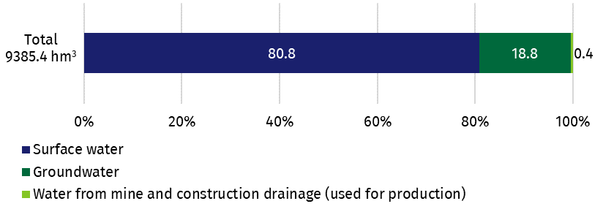
Figure 1. Structure of water withdrawal for the needs of the national economy and population by source in 2022
In 2022, 9.0 km³ of water was consumed (101% of the consumption recorded during the previous year)
In 2022, water consumption was approximately 9.0 km³, which was 101% of the total consumption of water recorded the previous year. As during the years before, the largest share of water consumption for the needs of the national economy and population was recorded by industry 72% (6.4 km³). Consumption of water by the fishing industry was approximately 10% (0.8 km³) of the total amount of water consumption for the purpose of the national economy. Water consumption by the municipal sector, for the purpose of operation of the water supply network, amounted to 1.7 km³ (approximately 19%). In 2022, water consumption by households, from the water supply system, was similar to the level recorded in the previous year, and it amounted to 1.3 km³.

Wastewater
In 2022, the amount of generated industrial and municipal wastewater, that required treatment, has decreased compared to the previous year by approximately 5%, and it amounted to 2.1 km³, while the amount of untreated wastewater was 0.1 km³. The amount of wastewater treated in wastewater treatment plants, with increased biogene removal increased by 4.1 pp. compared to the previous year and amounted to 1.19 km³, which was 59% of treated wastewater, while the amount of wastewater treated with the use of mechanical treatment technology amounted to 0.37 km³ (20% of treated wastewater).
In 2022, the amount of wastewater discharged without treatment was 137.9 hm³
Some part of wastewater that required treatment (6%) was not subjected to the processes of treatment. In 2022, the amount of wastewater discharged without treatment was 137.9 hm³, compared to 124.3 hm³ the previous year.
In 2022, there was an increase in the number of industrial wastewater treatment plants (from 851 in 2021, to 854 in 2022). The number of municipal wastewater treatment plants (3,260) decreased, compared to the previous year (3,276). In 2022, the share of population connected to wastewater treatment plants was 75%, while in urban areas it was approximately 95%, and in rural areas it was 47%.

Liquid waste
In 2022, the number of septic tanks was 2.1 million

Due to insufficiently developed sewage infrastructure, some residents continued to use household wastewater disposal systems. In 2022, the number of septic tanks was 2.1 million, similar to the previous year. The amount of liquid waste, collected and delivered to wastewater treatment plants or dump stations, was 38.0 hm³ compared to 37.6 hm³ in 2021.
Pollution and protection of air
In 2022, there was a decline recorded in the amount of emission of particulate pollutants by 9%, compared to the previous year
In 2022, the amount of emission of particulates, from plants of significant nuisance to air quality, i.e. plants with the highest level of emission of pollutants into the air in the country (1,844 plants) amounted to approximately 20 thousand tonnes and it declined by 9% compared to the previous year. Emission of pollutants was mainly the result of fuel combustion processes (54% of dust emission was from plants of significant nuisance to air quality). The main source of emission was industrial processing (52%) and also the entities that produce and supply electricity, gas, steam and hot water (38%).
In 2022, there was a decline in the amount of emitted gaseous pollutants by 3%, compared to the previous year
In 2022, the gaseous pollutants emission from plants of significant nuisance to air quality was at a level of 204 million tonnes and it decline by 3% compared to 2021. Over 99% of the above-mentioned emissions were carbon dioxide and 0.1% each: sulphur dioxide, carbon oxide and nitrogen oxides. The predominant sources of industrial emission of gaseous pollutants were the entities that operated in the field of generation and supply of electricity, gas, steam and hot water (almost 70%) and industrial processing plants (28%).
Table 1. Emission and air pollutant reduction from plants of a significant nuisance to air quality
Specification | 2021 | 2022
Number of plants | 1,841 | 1,844
Emission of pollution in thousand tonnes:
particulate pollutants | 22.2 | 20.2
of which from combustion of fuels | 12.0 | 10.8
gaseous pollutants | 209,490.2 | 203,623.4
of which carbon dioxide | 208,385.8 | 202,572.9
sulphur dioxide | 180.9 | 162.7
nitrogen oxides (expressed as NO₂) | 179.7 | 166.7
Level of reduction of generated pollution in %
particulate pollutants | 99.9 | 99.9
gases (without carbon dioxide) | 73.5 | 75.7
In 2022, with the use of air pollution control devices, 18.3 million tonnes (99.9%) of particulate and 3.3 million tonnes (75.7%) of gases (excluding CO₂) emitted by plants of significant nuisance to air quality, were retained. In 2021, the amount of retained or neutralised pollution, according to particular types of gaseous pollutants were: 93.9% of sulfur dioxide, 81.8% of hydrocarbons, 48.1% of nitrogen oxides, 37.2% of carbon monoxide, 47.0% of other pollutants (mainly ammonia, carbon disulphide, fluorine, hydrogen sulphide, organochlorine compounds).

Nature and landscape protection
In 2022, the area of special natural value under legal protection was 32.3% of site the total area of the country
Poland belongs to the group of European countries of high biodiversity, both in terms of the number of species and environmental values. At the end of 2022, the area of the sites under legal protection (including that parts of Natura 2000 sites located within the boundaries of areas under legal protection) was over 10.1 million ha, which was, similarly to 2021, 32.3% of the total area of the country.
The indicator of areas of the sites under legal protection per capita was 2 678 m², compared to 2 655 m² in 2021.
Table 2. The area of special natural value under legal protection in 2022
Specification | The number of objects | Total area
Specification | The number of objects | in thousand ha | percentage | % of the total area of the country | per capita in m²
TOTAL | 10,878 | 10,113.9 | 100.0 | 32.3 | 2,678.0
National parks | 23 | 315.2 | 3.1 | 1.0 | 83.5
Nature reserves | 1,512 | 171.3 | 1.7 | 0.5 | 45.4
Landscape parksª | 126 | 2,523.8 | 25.0 | 8.1 | 668,7
Protected landscape areaª | 388 | 6,929.4 | 68.5 | 22.2 | 1,834.9
Ecological areas | 8,329 | 56.1 | 0.6 | 0.2 | 12.1
Documentation sites | 182 | 0.9 | 0.0 | 0.0 | 0.2
Nature and landscape complexes | 324 | 117.1 | 1.2 | 0.4 | 31.1
a With the exception of nature reserves and other forms of nature protection located within the boundaries of landscape parks and protected landscape areas.
At the end of 2022, 34,977 natural monuments were registered, which was a decline by 66 objects compared to 2021.
Apart from forms of nature protection, including biodiversity, the creation of green areas are also a way of protecting the natural environment and its components. In 2022, the area of publicly accessible strolling-recreational parks amounted to 24.7 thousand ha, and the area of lawns 12.7 thousand ha, which is an increase in the area of strolling-recreational parks by 0.3 thousand ha and the area of lawns by 0.1 thousand ha compared to 2021.

Waste
An increase of 6.8% was recorded in the amount of generated industrial waste, compared to the previous year

Industrial waste
In 2022, 115 million tonnes of industrial waste was generated (an increase by 6.8% compared to the previous year).
The main sources of waste, as in the previous years, were: mining and quarrying (61.3 million tonnes), manufacturing (21.3 million tonnes), electricity, gas, steam supply (13.3 million tonnes).
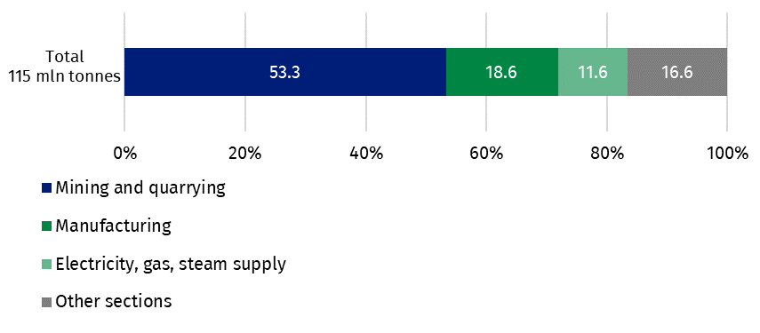
Figure 2. Structure of generated waste by types of activities in 2022
The largest share in the amount of generated waste was wastes resulting from exploration, mining, quarrying and physical and chemical treatment of minerals (55%), and waste from thermal processes (19%).
The share of recovered industrial waste was 48.4%

The predominant ways of treating waste that was generated in 2022 were recovery (48.4%) and landfilling (41.7%).
At the end of 2022, the amount of landfilled waste (accumulated) at the facilities of plants was 1,829 million tonnes. The non-reclaimed landfill area (excluding municipal waste) was 8 thousand ha, out of which landfills, mine waste treatment facilities, including heaps accounted for 54.6%, and tailings ponds accounted for 45.4%. During the year, 57.2 ha of the waste landfill area was reclaimed.

Municipal waste
There was a decline recorded, of 1.9%, in the amount of generated municipal waste, compared to the previous year
In 2022, 13.4 million tonnes of municipal waste were collected (a decline by 1.9% compared to 2021). There was 355 kg of collected municipal waste per capita recorded, on average, a decline of 5 kg compared to the previous year.
11.6 million tonnes of waste were collected from households, which was 86.3% of the total amount of generated municipal waste.
Table 3. Generated municipal waste
Specification | 2021 | 2022
Specification | in thousand tonnes |  | 2021 = 100
Total | 13,673.6 | 13,420.3 | 98.1
Received or collected separately | 5,439.5 | 5,361.0 | 98.6
Mixed | 8,234.0 | 8,059.3 | 97.9

In 2022, there were 2,301 municipal waste separate collection points in operation. Municipal waste collection service was provided by 1,325 entities.
In 2022, collected municipal waste was designated for the following processes:
- recovery – 8,199.1 thousand tonnes (61.1%), including:
The share of municipal waste that was designated for recovery was 61.1%

    - recycling – 3,585.4 thousand tonnes (26.7%),
    - biological treatment processes (composting or digestion) – 1,899.5 thousand tonnes (14.2%),
    - incineration with energy recovery – 2,714.1 thousand tonnes (20.2%),
- disposal – 5,221.2 thousand tonnes (38.9%), including:
    - incineration without energy recovery – 113 thousand tonnes (0.8%),
    - landfilling – 5,108.2 thousand tonnes (38.1%).
At the end of 2022, there were 259 landfills in operation that received municipal waste and they covered a total area of 1,624 ha. 92% of those landfills were equipped with degassing facilities, as a result of which approximately 111,162 thousand MJ of thermal energy and approximately 102,487 thousand kWh of electricity was recovered. In 2022, 11 landfills, of a total area of approximately 45.3 ha, were closed down. In 2022, 10,714 uncontrolled landfill sites were closed down, out of which a total of approximately 25 thousand tonnes of municipal waste was collected. At the end of 2022, 2,217 uncontrolled landfill sites were reported.
In 2022, 10,714 uncontrolled landfill sites were closed down

In the case of quoting Statistics Poland data, please provide information: “Source of data: Statistics Poland” and in the case of publishing calculations made with the use of data published by Statistics Poland, please include the following statement: “Own study based on data from Statistics Poland”.

Prepared by:  Spatial and Environmental Surveys  Department  Deputy Director Wiesława Domańska  Phone: (+48 22) 608 32 58 | Issued by:  The Spokesperson for the President  of Statistics Poland  Karolina Banaszek  Phone: (+48) 695 255 011
Press Office  Phone: (+48 22) 608 38 04  e-mail: obslugaprasowa@stat.gov.pl |   www.stat.gov.pl/en/

@StatPoland

@GlownyUrzadStatystyczny

gus_stat

glownyurzadstatystycznygus

glownyurzadstatystyczny
Related information
Environment 2022
Data available in databases
Local Data Bank
Terms used inn official statistics
Environment protection
Consumption of water
Wastewater
Liquid waste
Air pollution protection
Protection of nature
Waste

Excluding agriculture and forestry

