Index numbers of construction and assembly
production in December 2022
According to preliminary data construction and assembly production (in constant prices) carried out domestically by construction enterprises employing more than 9 persons was in December 2022 by 0.8% lower than in the same period in 2021 (an increase of 3.1% in the corresponding period of 2021) and by 17.3% higher compared with November 2022 (an increase of 22.9% in the corresponding period of 2021).
99.2
Index number of construction and assembly production as compared to December of 2021

Table 1. Index numbers of construction and assembly production (constant prices)
SPECIFICATION | 12 2022 |  | 01-12 2022
SPECIFICATION | 11 2022=100 | 12 2021=100 | 01-12 2021=100
CONSTRUCTION | 117.3 | 99.2 | 106.2
Construction of buildings ^{Δ} | 118.4 | 96.3 | 111.7
Civil engineering works ^{Δ} | 121.4 | 101.4 | 102.8
Specialised construction activities | 109.1 | 98.3 | 105.4

^{Δ} Abbreviated form according PKD 2007.

Sales of construction and assembly production in December 2022 compared to the corresponding period of 2021, increased in entities dealing mainly with civil engineering works (1.4%). The decrease was in entities performing specialised construction activities (1.7%)
and in whose basic type of activity was construction of buildings (3.7%).
Compared with November 2022 the increase was noted in all division of construction, in entities whose basic type of activity was civil engineering works of 21.4%, in entities dealing mainly with construction of buildings of 18.4% and performing specialised construction activities of 9.1%.
In period of January-December 2022, sales of construction and assembly production, compared to the corresponding period of 2021, increased in all division of contruction,
in entities whose basic type of activity was construction of buildings (11.7%), performing specialised construction activities (5.4%) and dealing mainly with civil engineering works (2.8%).
Sales of construction and assembly production including investment works, in December 2022, compared to corresponding period of 2021 decreased for investment works by 10.0% (while in 2021 it was at the level of the previous year) and for restoration works increased by 13.3% (an increase of 8.4% in 2021).
In the period of January-December 2022, in relation in the corresponding period of 2021, there were increases of 1.1% in the value of investment works (a decrease of 1.3% in 2021) and of 13.9% in the value of works with a restoration character (an increase of 10.7% in 2021).
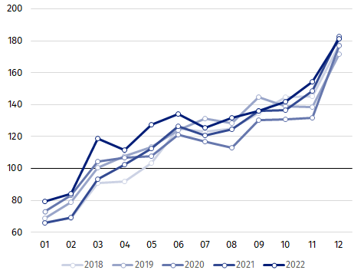
Chart 1. Index numbers of construction and assembly production (constant prices; average monthly base 2015=100)

Index number of construction and assembly production in December 2022 (in constant prices), compared to the average monthly value of 2015, was 181.2.
After eliminating the seasonal factors, construction and assembly production reached the level by 6.1% higher than in December 2021 and by 3.7% lower in comparison to November 2022.

In case of quoting Statistics Poland data, please provide information: “Source of data: Statistics Poland” and in case of publishing calculations made on data published by Statistics Poland, please include the following disclaimer: “Own study based on figures from Statistics Poland”.

Prepared by:  Statistical Office in Lublin  Director Krzysztof Markowski  Phone: (+48) 695 255 301 | Issued by:  The Spokesperson for the President of Statistics Poland  Karolina Banaszek  Phone: (+48) 695 255 011
Press Office  Phone: (+48 22) 608 38 04  e-mail: obslugaprasowa@stat.gov.pl |   www.stat.gov.pl/en/

@StatPoland

@GlownyUrzadStatystyczny

gus_stat

glownyurzadstatystycznygus

glownyurzadstatystyczny
Related information
Statistical Bulletin
Socio-economic situation of the country
Data available in databases
Knowledge Database - Construction
Macroeconomic Data Bank
Macroeconomic indicators
Local Data Bank
Terms used in official statistics
Sale of construction and assembly production
Seasonally unadjusted index of sale of construction and assembly production in constant prices
Seasonally adjusted index of sale of construction and assembly production
Sale of construction works with an investment character
Sale of construction works with a restoration character and other works

Reported data; comprise enterprises employing over 9 persons, whose the main type of activity is included in the section F “Construction” in accordance with the Polish Classification of Activities (PKD 2007).
² Data including final information on production and prices in November and reported data in December.
Reported data for December 2022.

