Price indices of sold production of industry in September 2023
According to preliminary data, the prices of sold production of industry in September 2023 increased compared to August 2023 by 0.3% and decreased compared to the corresponding month of the previous year - by 2.8%.
2.8%
the decrease of producer prices in industry compared to September 2022

Table 1. Price indices of sold production of industry in August and September 2023

 | 08 2023 |  | 09 2023 |  |  | 01-09 2023
SPECIFICATION | 07 2023 = 100 | corresponding period 2022=100 |  | 08 2023=100 | 12 2022=100 | 01-09 2022=100
TOTAL | 99.9* | 97.1* | 97.2 | 100.3 | 96.1 | 105.1
Mining and quarrying | 99.3 | 105.6* | 102.7 | 102.3 | 106.1 | 116.2
Manufacturing | 100.1* | 94.5* | 94.4 | 100.3 | 94.5 | 100.4
Electricity. gas. steam and air conditioning supply | 99.1* | 105.2* | 109.2 | 99.5 | 99.0 | 134.2
Water supply; sewerage. waste management and remediation activities | 100.0* | 103.2* | 103.1 | 100.4 | 102.8 | 104.0

* Data revised.

Prices changes of sold production of industry in September 2023 compared to August 2023
Among divisions of manufacturing in September 2023 in comparison to the previous month the biggest increase in prices was recorded in manufacture of other transport equipment
According to preliminary data, the prices of sold production of industry in September 2023 were 0.3% higher than in August 2023. The prices increased the most in mining and quarrying by 2.3%, of which in mining of coal and lignite by 4.4% and mining of metal ores by 1.7%. In water supply; sewerage, waste management and remediation activities section the prices increased by 0.4%. In the manufacturing section prices have risen by 0.3%. Among divisions of manufacturing the biggest increase in prices was recorded in manufacture of other transport equipment (by 1.0%). The prices dropped the most in manufacture of coke and refined petroleum products (by 1.4%).

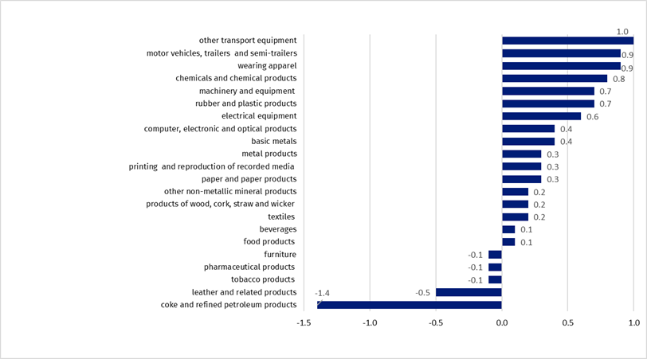
Chart 1. Prices changes of sold production of industry by sections in September 2023 compared to August 2023

A price drop was recorded in electricity, gas, steam and air conditioning supply section by 0.5%.

Prices changes of sold production of industry in September 2023 compared to September 2022
In September 2023 the prices of sold production of industry compared to the corresponding month of the previous year decreased by 2.8%. The decrease was recorded in manufacturing by 5.6%, of which in manufacture of coke and refined petroleum products by 22.6%. The prices were increased the most in production of beverages by 11.8%.

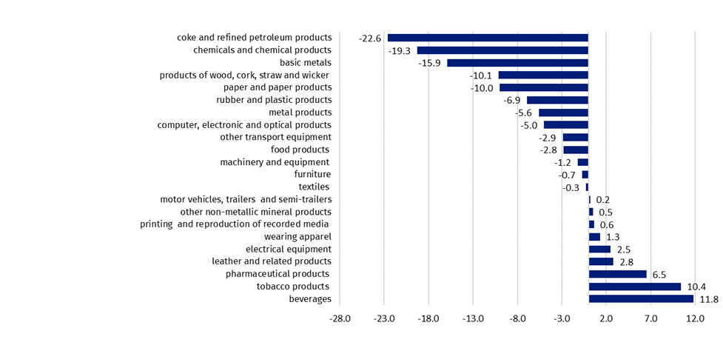
Chart 2. Prices changes of sold production of industry in September 2023 compared to September 2022
In September 2023 in comparison to the corresponding month of the previous year, the prices in manufacture of coke and refined petroleum products decreased the most. The highest increase in prices was recorded in manufacture of beverages

In mining and quarrying section the prices increased in annual terms by 2.7%, of which in mining of coal and lignite by 2.5%, as well as in the mining of metal ores by 0.7%. The price increase was recorded in the section water supply; sewerage, waste management and remediation activities by 3.1%, as well as electricity, gas, steam and air conditioning supply by 9.2%.

Chart 3. Prices changes of sold production of industry in 2022-2023 in relation to the previous period
In September 2023 in relation to August 2023 the prices increase of sold production of industry was recorded by 0.3%

Chart 4. Prices changes of sold production of industry in 2022-2023 in relation to the same period of the previous year
In September 2023, a further slowdown was observed, with a decrease in price growth dynamics of sold production of industry was recorded in annual terms

Chart 5. Prices changes of sold production of industry by sections NACE in 2022-2023 in relation to December 2021

In case of quoting Statistics Poland data, please provide information: “Source of data: Statistics Poland”, and in case of publishing calculations made on data published by Statistics Poland, please include the following disclaimer: “Own study based on figures from Statistics Poland”.
Prepared by:  The Trade and Services Department  Director Ewa Adach-Stankiewicz  Phone: (+48 22) 608 31 24 | Issued by:  The Spokesperson for the President  of Statistics Poland  Karolina Banaszek  Phone: (+48) 695 255 011
Press Office  Phone: (+48 22) 608 38 04  e-mail: obslugaprasowa@stat.gov.pl |   stat.gov.pl/en/

@StatPoland

@GlownyUrzadStatystyczny

gus_stat

glownyurzadstatystycznygus

glownyurzadstatystyczny
Related information
Statistical Bulletin
News Releases
Data available in databases
Analytical Platform - Knowledge Databases
Macroeconomic Data Bank
Prices indices (Topics: Prices. Trade)
Terms used inn official statistics
Price index of sold production of industry

