Flash estimate of the consumer price index
in March 2023
16.2%
an increase compared with the corresponding month of the previous year
Consumer prices according to the flash estimate in March 2023, compared with the corresponding month of the previous year, increased by 16,2% (price index 116,2) and as related to the previous month increased by 1,1% (price index 101,1).

Table 1. Flash estimate of the consumer price index in March 2023
SPECIFICATION | 03 2023
SPECIFICATION | 03 2022=100 | 02 2023=100
TOTAL | 116,2 | 101,1
Food and non-alcoholic beverages | 124,0 | 102,3
Electricity, gas and other fuels | 126,0 | 99,4
Fuels for personal transport equipment | 100,2 | 98,2

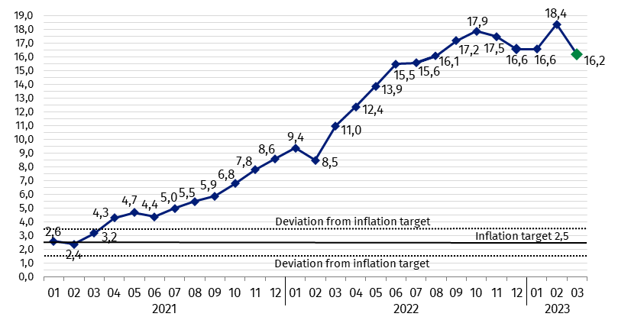
Chart 1. Changes in consumer pricesª as related to the corresponding period of the previous year (in %)

a Final data with the exception of the information prepared according to the flash estimate in March 2023
In case of quoting Statistics Poland data, please provide information: “Source of data:
Statistics Poland”, and in case of publishing calculations made on data published
by Statistics Poland, please include the following disclaimer: “Own study based on figures from Statistics Poland”.
Prepared by:  Trade and Services Department  Director Ewa Adach-Stankiewicz  Phone: (+48 22) 608 31 24 | Issued by:  The Spokesperson for the President  of Statistics Poland  Karolina Banaszek  Phone: (+48) 695 255 011
Press Office  Phone: (+48 22) 608 38 04  e-mail: obslugaprasowa@stat.gov.pl |   www.stat.gov.pl/en/

@StatPoland

@GlownyUrzadStatystyczny

gus_stat

glownyurzadstatystycznygus

glownyurzadstatystyczny
Related information
Communications and Announcements
News releases
Data available in databases
Knowledge Database Prices
Macroeconomic Data Bank
Local Data Bank
Price indices (Topics: Prices, Trade)
Prices (Topics: Prices, Trade)
Terms used in official statistics
Price index of consumer goods and services
Retail price

