Prices of agricultural products in November 2023
Procurement prices of basic agricultural products increased in November 2023 in comparison with the previous month (by 0.4%), while compared to the corresponding period of the last year decreased (by 18.6%).
18.6%
a decrease in procurement prices of basic agricultural products in comparison with November 2022

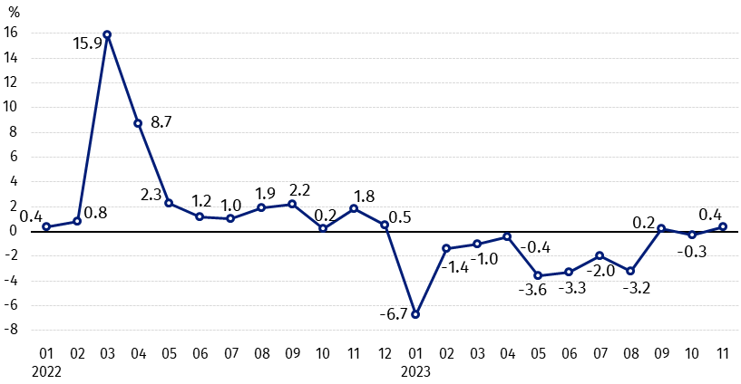
Chart 1. Changes in procurement prices of basic agricultural products in relation to the previous month
In November 2023 compared to October 2023 the procurement prices of cows’ milk increased

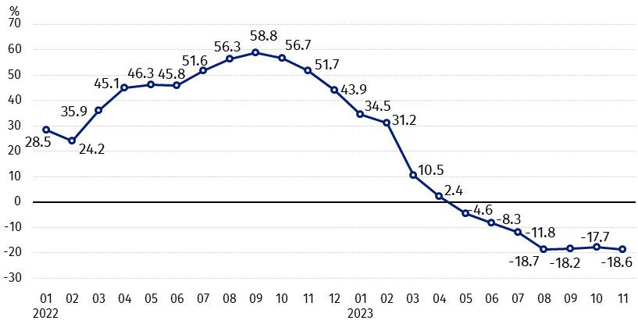
Chart 2. Changes in procurement prices of basic agricultural products in relation to the corresponding month of the previous year
Procurement prices of basic agricultural products, except pigs for slaughter, in November 2023 were lower than those recorded in November 2022

Procurement prices and marketplace prices received by farmers
In November 2023, in comparison with the previous month, as well as compared to the corresponding period of the last year, both in procurement and on marketplaces, prices of most agricultural products were lower. On a monthly basis the prices of barley, maize and cows’ milk in procurement, cattle for slaughter on marketplaces as well as oats and potatoes on both markets increased. On an annual basis more was paid for cattle for slaughter on marketplaces, pigs for slaughter in procurement, and also for potatoes in procurement and on marketplaces.

Table 1. Prices of agricultural products (excluding VAT) in November 2023
Specification | Procurement prices |  |  | Marketplaces prices
Specification | 11 2023
Specification | in zloty | 10 2023=100 | 11 2022=100 | in zloty | 10 2023=100 | 11 2022=100
Cereal grain – per 1 dt
Wheat | 87.94 | 97.8 | 57.4 | 115.43 | 97.8 | 67.0
Rye | 63.79 | 93.4 | 51.5 | 90.19 | 97.1 | 64.8
Barley | 82.85 | 100.9 | 60.3 | 108.22 | 99.1 | 68.3
Triticale | 73.22 | 92.0 | 51.9 | 99.22 | 97.2 | 64.9
Oat | 95.68 | 115.8 | 69.5 | 102.49 | 100.6 | 73.5
Maize | 61.04 | 111.9 | 56.5 | 132.50 | 96.6 | 75.4
Potatoes– per 1 dt | 77.15 | 116.4 | 122.5 | 227.00 | 100.4 | 133.3
Animals for slaughter – per kg
Cattle (excl. calves) | 9.88 | 97.4 | 91.1 | 11.46 | 103.0 | 113.2
of which young cattle | 10.20 | 96.8 | 93.2 | . | . | .
Pigs ª | 7.80 | 97.9 | 105.0 | . | . | .
Poultry | 5.34 | 96.9 | 80.9 | . | . | .
Cows’ milk – per 1 hl | 207.22 | 105.9 | 76.6 | . | . | .
a – No data.
Data on procurement prices were calculated on the basis of information on value and quantity of procurement by legal persons and independent organizational entities without legal personality (without natural persons).
Indices of procurement prices and prices received by farmers on marketplaces were calculated on the basis of absolute data expressed with more precision than In the tables.

Prices of major agricultural products in November 2023
In November 2023 procurement price of wheat (87.94 PLN per dt) decreased in comparison with October this year (by 2.2%), as well as with the corresponding period of the last year (by 42.6%). On marketplaces, wheat was sold for 115.43 PLN per dt, i.e. by 2.2% cheaper than in the previous month and by 33.0% – than in November 2022.
The price of rye in procurement (63.79 PLN per dt) was lower by 6.6% compared to October this year and by 48.5% in comparison with November last year. The transaction price of rye on marketplace (90.19 PLN per dt) decreased by 2.9% on a monthly basis and by 35.2% on an annual basis.
In November 2023 77.15 PLN was paid per dt of potatoes in procurement, i.e. by 16.4% more than in the previous month and by 22.5% – than in the corresponding period 2022. The price of potatoes on marketplaces (227.00 PLN per dt) increased by 0.4% as related to October this year and by 33.3% compared to November 2022.
The procurement price of cattle for slaughter (9.88 PLN per kg) was lower on a monthly basis (by 2.6%), as well as on an annual basis (by 8.9%). On marketplaces cattle for slaughter (11.46 PLN per kg) was sold by 3.0% more expensive than in October this year and by 13.2% – than in the corresponding period of the last year.
In November 2023 7.80 PLN was paid per kg of pigs for slaughter in procurement, i.e. by 2.1% less than a month ago, but by 5.0% more than a year ago.
The procurement price of poultry for slaughter (5.34 PLN per kg) decreased in comparison with October this year (by 3.1%), as well as compared to the same period of the last year (by 19.1%).
207.22 PLN was paid in procurement per hl of cows’ milk, i.e. by 5.9% more than in the previous month, but by 23.4% less than in November 2022.

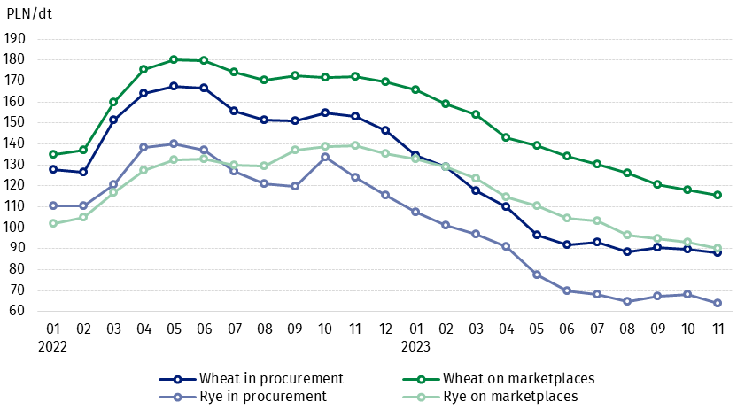
Chart 3. Procurement and marketplaces prices of wheat and rye

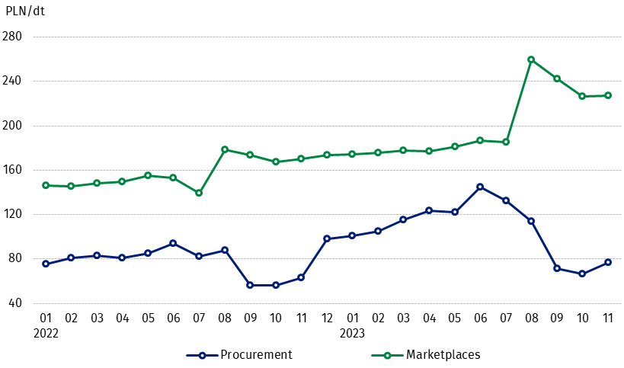
Chart 4. Procurement and marketplaces prices of potatoes

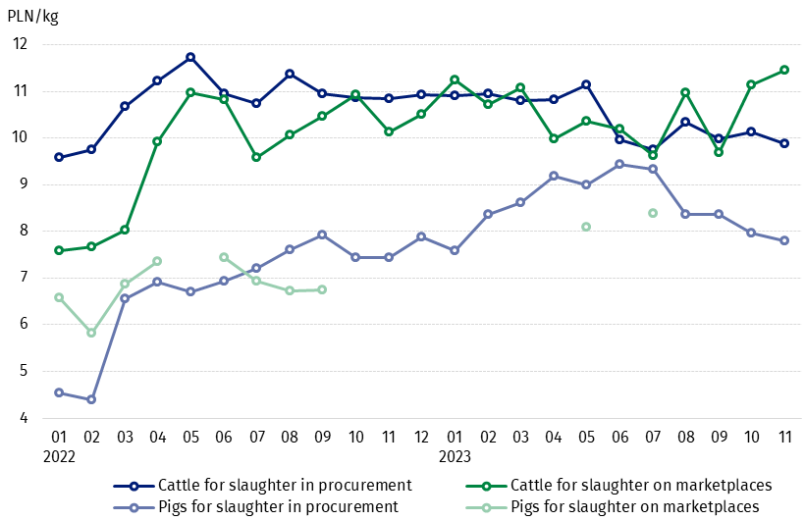
Chart 5. Procurement and marketplaces prices of cattle for slaughter and pigs for slaughter

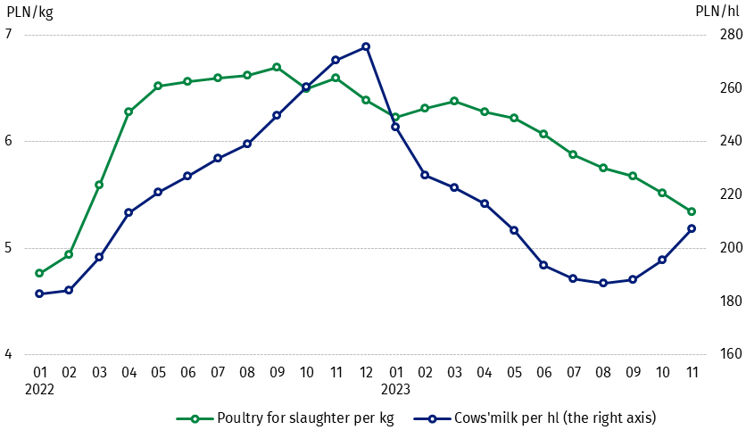
Chart 6. Procurement prices of poultry for slaughter and cows’ milk

The differentiation of the level of prices of basic agricultural products in particular voivodships is presented in Table 2 for procurement prices and in Table 3 for prices obtained by farmers on marketplaces (Excel sheet).
In case of quoting Statistics Poland data, please provide information: “Source of data: Statistics Poland”, and in case of publishing calculations made on data published by Statistics Poland, please include the following disclaimer: “Own study based on figures from Statistics Poland”.

Prepared by:  Trade and Services Departament  Director Ewa Adach-Stankiewicz  Phone: (+48 22) 608 31 24 | Issued by:  The Spokesperson for the President  of Statistics Poland  Karolina Banaszek  Phone: (+48) 695 255 011
Press Office  Phone: (+48 22) 608 38 04  e-mail: obslugaprasowa@stat.gov.pl |   www.stat.gov.pl/en/

@StatPoland

@GlownyUrzadStatystyczny

gus_stat

glownyurzadstatystycznygus

glownyurzadstatystyczny
Related information
Socio-economic situation of the country in 2023
Procurement and prices of agricultural products in 2022
Prices in the national economy in 2021

Data available in databases
BDL - Prices in agriculture (monthly and annual data)
DBW - Prices in agriculture (monthly and annual data)

Terms used in official statistics
Procurement of agricultural products
Procurement prices
Marketplace
Marketplace prices

Wheat, rye, cattle for slaughter, pigs for slaughter, poultry, cows’ milk
Procurement prices – excluding sowing seed.
Procurement prices – total (of which: edible early kinds, seed, edible late, industrial, of which starch). Marketplaces prices – edible excluding early kinds.
Marketplaces prices – average weighted price of cattle for slaughter calculated with the adoption of the structure of procurement quantity of young cattle and cows for slaughter.

