Prices of agricultural products in September 2023
Procurement prices of basic agricultural products increased in September 2023 in comparison with the previous month (by 0.2%), while compared to the corresponding period of the last year decreased (by 18.2%).
18.2%
a decrease in procurement prices of basic agricultural products in comparison with September 2022

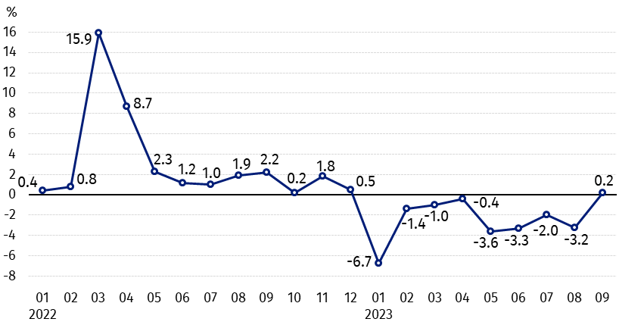
Chart 1. Changes in procurement prices of basic agricultural products in relation to the previous month
The growth in procurement prices of basic agricultural products in September 2023 compared to August 2023 was caused by an increase in the prices of wheat, rye, pigs for slaughter and cows’ milk

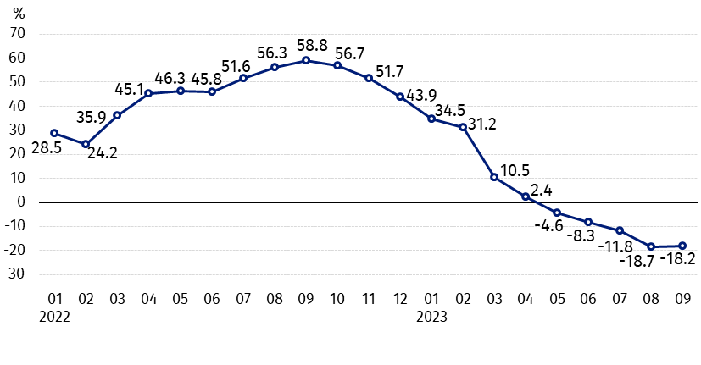
Chart 2. Changes in procurement prices of basic agricultural products in relation to the corresponding month of the previous year
Procurement prices of basic agricultural products, except pigs for slaughter, in September 2023 were lower than those recorded in September 2022

Procurement prices and marketplace prices received by farmers
In September 2023, in comparison with the previous month, procurement prices of most agricultural products increased while the drop in prices of barley, maize, potatoes, cattle for slaughter and poultry. On marketplaces all agricultural products were sold cheaper than in August this year.
Compared to the corresponding month of the previous year, both in procurement and on marketplaces the drop in prices of most agricultural products was recorded, except pigs for slaughter in procurement and potatoes on both markets.

Table 1. Prices of agricultural products (excluding VAT) in September 2023
Specification | Procurement prices |  |  | Marketplaces prices
Specification | 09 2023
Specification | in zloty | 08 2023=100 | 09 2022=100 | in zloty | 08 2023=100 | 09 2022=100
Cereal grain – per 1 dt
Wheat | 90.51 | 102.3 | 60.0 | 120.64 | 95.8 | 69.8
Rye | 67.29 | 103.9 | 56.1 | 94.87 | 98.2 | 69.1
Barley | 85.07 | 92.9 | 63.3 | 112.15 | 96.1 | 72.1
Triticale | 79.68 | 100.3 | 56.4 | 105.47 | 97.3 | 69.9
Oat | 77.20 | 101.0 | 62.9 | 105.58 | 96.9 | 80.2
Maize | 80.31 | 88.1 | 59.1 | 139.68 | 98.7 | 80.4
Potatoes– per 1 dt | 71.56 | 62.9 | 126.5 | 242.52 | 93.5 | 140.0
Animals for slaughter – per kg
Cattle (excl. calves) | 9.98 | 96.5 | 91.1 | 9.69 | 88.3 | 92.6
of which young cattle | 10.31 | 96.7 | 93.1 | 10.40 | 90.6 | 93.4
Pigs ª | 8.37 | 100.2 | 105.6 | . | . | .
Poultry | 5.68 | 98.7 | 84.8 | . | . | .
Cows’ milk – per 1 hl | 188.38 | 100.9 | 75.5 | . | . | .
a – No data.
Data on procurement prices were calculated on the basis of information on value and quantity of procurement by legal persons and independent organizational entities without legal personality (without natural persons).
Indices of procurement prices and prices received by farmers on marketplaces were calculated on the basis of absolute data expressed with more precision than In the tables.

Prices of major agricultural products in September 2023
In September 2023 procurement price of wheat (90.51 PLN per dt) increased in comparison with the previous month (by 2.3%), while decreased with the corresponding period of the last year (by 40.0%). On marketplaces, wheat was sold for 120.64 PLN per dt, i.e. by 4.2% cheaper than in August this year and by 30.2% – than in September 2022.
The price of rye in procurement (67.29 PLN per dt) was increased compared to August this year (by 3.9%), but it was decreased in comparison with September last year (by 43.9%). The transaction price of rye on marketplace (94.87 PLN per dt) decreased by 1.8% on a monthly basis and by 30.9% on an annual basis.
In September 2023 71.56 PLN was paid per dt of potatoes in procurement, i.e. by 37.1% less than in the previous month, while by 26.5% more than in the corresponding period 2022. The price of potatoes on marketplaces (242.52 PLN per dt) decreased as related to August this year (by 6.5%), but increased compared to September 2022 (by 40.0%).
The procurement price of cattle for slaughter (9.98 PLN per kg) was lower on a monthly basis (by 3.5%), as well as on an annual basis (by 8.9%). On marketplaces cattle for slaughter (9.69 PLN per kg) was sold by 11.7% cheaper than in August this year and by 7.4% – than in the corresponding period of the last year.
In September 2023 8.37 PLN was paid per kg of pigs for slaughter in procurement, i.e. by 0.2% more than a month ago and by 5.6% – than a year ago.
The procurement price of poultry for slaughter (5.68 PLN per kg) decreased in comparison with August this year (by 1.3%), as well as compared to the same period of the last year (by 15.2%).
188.38 PLN was paid in procurement per hl of cows’ milk, i.e. by 0.9% more than in the previous month, but by 24.5% less than in September 2022.

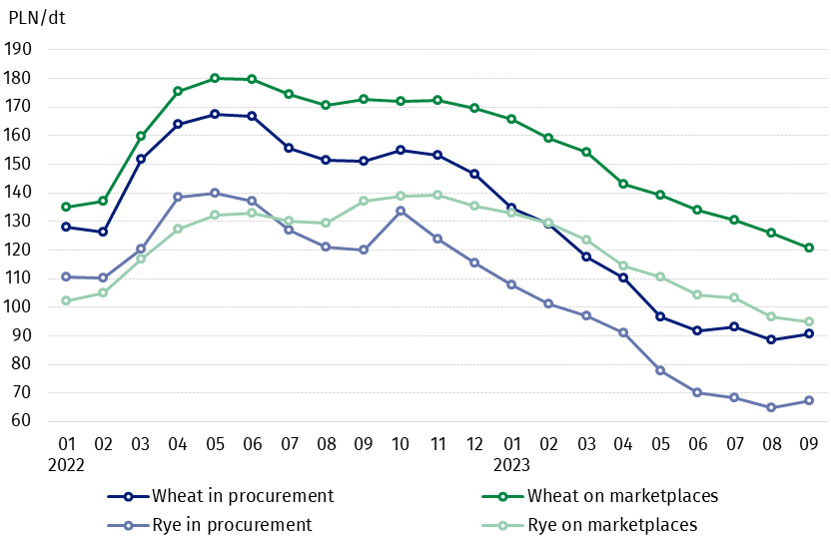
Chart 3. Procurement and marketplaces prices of wheat and rye

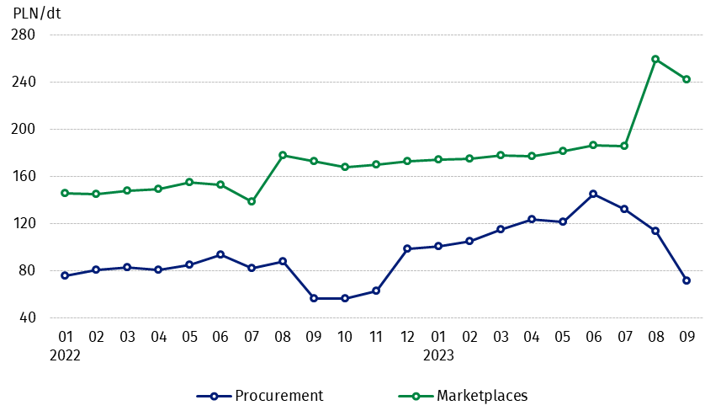
Chart 4. Procurement and marketplaces prices of potatoes

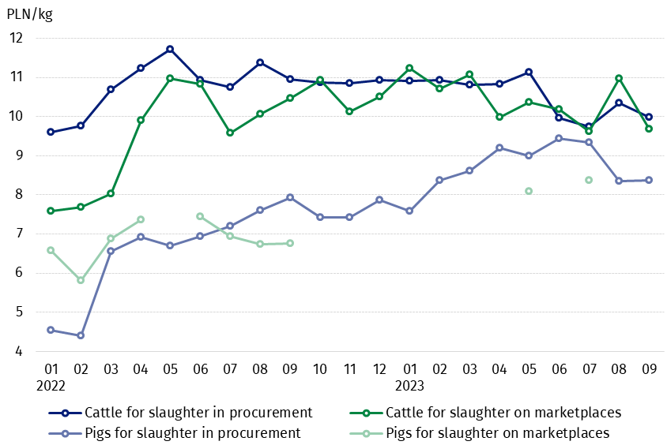
Chart 5. Procurement and marketplaces prices of cattle for slaughter and pigs for slaughter

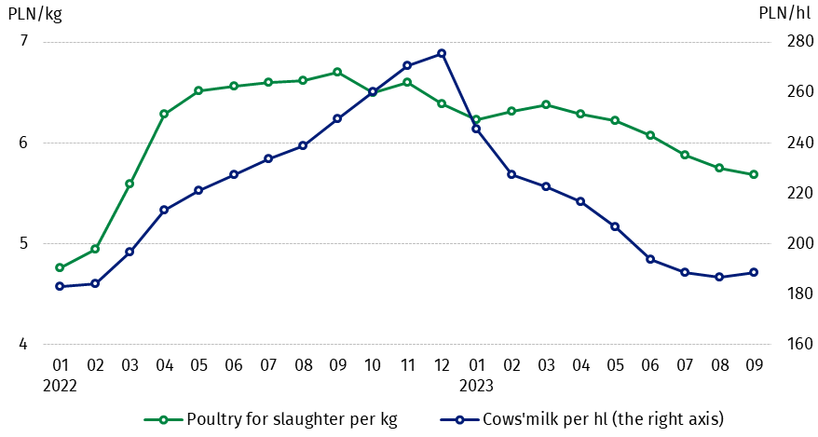
Chart 6. Procurement prices of poultry for slaughter and cows’ milk

The differentiation of the level of prices of basic agricultural products in particular voivodships is presented in Table 2 for procurement prices and in Table 3 for prices obtained by farmers on marketplaces (Excel sheet).
In case of quoting Statistics Poland data, please provide information: “Source of data: Statistics Poland”, and in case of publishing calculations made on data published by Statistics Poland, please include the following disclaimer: “Own study based on figures from Statistics Poland”.

Prepared by:  Trade and Services Departament  Director Ewa Adach-Stankiewicz  Phone: (+48 22) 608 31 24 | Issued by:  The Spokesperson for the President  of Statistics Poland  Karolina Banaszek  Phone: (+48) 695 255 011
Press Office  Phone: (+48 22) 608 38 04  e-mail: obslugaprasowa@stat.gov.pl |   www.stat.gov.pl/en/

@StatPoland

@GlownyUrzadStatystyczny

gus_stat

glownyurzadstatystycznygus

glownyurzadstatystyczny
Related information
Socio-economic situation of the country in 2023
Procurement and prices of agricultural products in 2022
Prices in the national economy in 2021

Data available in databases
BDL - Prices in agriculture (monthly and annual data)
DBW - Prices in agriculture (monthly and annual data)

Terms used in official statistics
Procurement of agricultural products
Procurement prices
Marketplace
Marketplace prices

Wheat, rye, cattle for slaughter, pigs for slaughter, poultry, cows’ milk
Procurement prices – excluding sowing seed.
Procurement prices – total (of which: edible early kinds, seed, edible late, industrial, of which starch). Marketplaces prices – edible excluding early kinds.
Marketplaces prices – average weighted price of cattle for slaughter calculated with the adoption of the structure of procurement quantity of young cattle and cows for slaughter.

